NAME:GEORGE KUNDA
STUDENT ID:202407907
PSEUDOCODES
INFIX TO POSTFIX
function infixToPrefix(expression):
reverse expression

for each character:
if '(' → replace with ')'
if ')' → replace with '('

postfix = infixToPostfix(reversed expression)

reverse postfix → prefix

return prefix
INFIX TO POSTFIX
function infixToPostfix(expression):
create empty stack
create empty result

for each character ch in expression:
if ch is operand:
add ch to result

else if ch == '(':
push to stack

else if ch == ')':
while top of stack != '(':
pop and add to result
pop '(' from stack

else (operator):
while stack not empty AND precedence(top) >= precedence(ch):
pop and add to result
push ch to stack

while stack not empty:
pop and add to result

return result
FLOW CHARTS
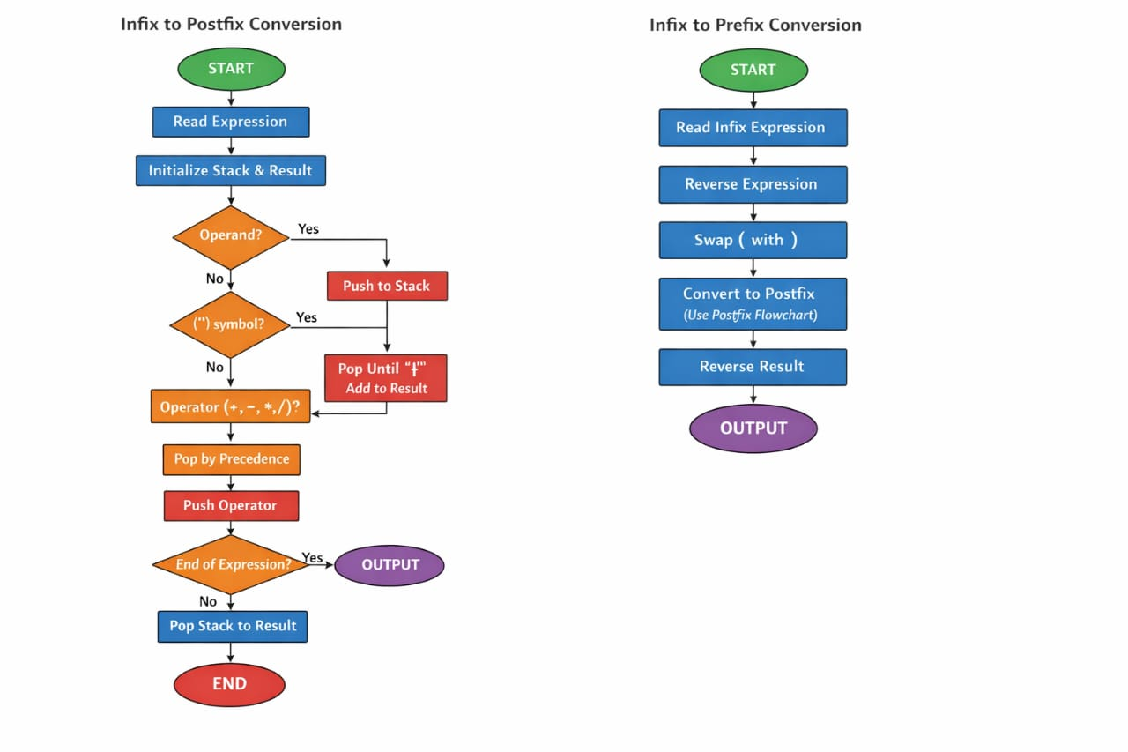
JAVA CODE
import java.util.Stack;

public class InfixConversion {

// Function to check precedence
static int precedence(char ch) {
switch (ch) {
case '+':
case '-':
return 1;

case '*':
case '/':
return 2;
}
return -1;
}

// Function to convert infix to postfix
static String infixToPostfix(String exp) {
String result = "";
Stack<Character> stack = new Stack<>();

for (int i = 0; i < exp.length(); i++) {
char ch = exp.charAt(i);

// If operand → add to result
if (Character.isLetterOrDigit(ch)) {
result += ch;
}

// If '(' → push
else if (ch == '(') {
stack.push(ch);
}

// If ')' → pop until '('
else if (ch == ')') {
while (!stack.isEmpty() && stack.peek() != '(') {
result += stack.pop();
}
stack.pop(); // remove '('
}

// Operator
else {
while (!stack.isEmpty() &&
precedence(stack.peek()) >= precedence(ch)) {
result += stack.pop();
}
stack.push(ch);
}
}

// Pop remaining operators
while (!stack.isEmpty()) {
result += stack.pop();
}

return result;
}

// Reverse string
static String reverse(String str) {
return new StringBuilder(str).reverse().toString();
}

// Infix to Prefix
static String infixToPrefix(String exp) {
// Step 1: Reverse
exp = reverse(exp);

// Step 2: Swap brackets
char[] chars = exp.toCharArray();
for (int i = 0; i < chars.length; i++) {
if (chars[i] == '(')
chars[i] = ')';
else if (chars[i] == ')')
chars[i] = '(';
}

// Step 3: Convert to postfix
String postfix = infixToPostfix(String.valueOf(chars));

// Step 4: Reverse again
return reverse(postfix);
}

public static void main(String[] args) {
String infix = "A+B*(C-D)";

System.out.println("Infix: " + infix);
System.out.println("Postfix: " + infixToPostfix(infix));
System.out.println("Prefix: " + infixToPrefix(infix));
}
}

