Ocean Sound Lab / Ocean-SL

User manual
Documentation V4.0.x

Overview
Ocean Sound Lab is a C++Project that provides a set of Sound Managing Applications, such as Synthesizer, AudioServer, Composer with Graphical User Interface for Linux based Operating Systems, that allows to generate, play and record sound. It includes interfaces for musicxml-files and supports the sound drivers: -> native ALSA and -> Pulse audio and consists of a direct interface to musescore3 and sound converting tools like ffmpeg and id3tool. The binary distribution of Ocean-SL is limited to the x86_64 architecture (Nov.2025). This distribution includes the 3rd party libraries for Qt6, RtAudio and tinyxml2 and is tested and compiled on ubuntu 2025-10 with x86_64.

Table of Contents
Overview 2
Architecture 4
Synthesizer 4
Configuration file etc/synthesizer.cfg 5
Synthesizer Syntax, start&stop 6
Keyboard 7
Keyboard Dialog on OceanGUI 8
AudioServer 9
AudioServer Syntax start&stop 9
OceanGUI 9
Storage Area devices (StA) Controls 11
Managing Applications 13
GUI Dialoges 16
Cut Desk 16
GUI ADSR 18
SDSview 19
Workflows 20
Composer 20
Programming/ main.synth 22
add/ Play notes using an instrument 24
ADSR 26
call / return subroutine 27
Dynamic vol/frq 27
exit 27
Instrument 28
Notes - notation 29
Oscillator/OSC 30
play 31
Pause 32
random /generate notes 32
Field specification 32
rec / manage StAs 34
Record / to file 35
Reset 35
Return / from subroutine 35
Set 35
start 36
stop 36
Setup 37
Appendix 37
Full Example 37
3rd party products 40
Glossary 40
Planning features 41
License notice 42
Table of Figures
Figure 1: Storage Area 10
Figure 2: Managing Applications 12
Index of Tables
Table 1: Keywords and special characters 19
Table 2: add/ play Notes 20
Table 3: Standard Waveforms 25
Table 4: Generating Notes 27

Architecture

Drawing 1: Ocean-SLAchitecture
SDS
Audio Data B
Audio Data A
Synthesizer
Audioserver
Ocean GUI
Composer
Program files
Pulse audio
Files
Synthesizer
Synthesizer
Synthesizer

read
read
write
write
read/write

Synthesizer
The synthesizer process executes the control data of the shard data segment (SDS). The execution has impact on the processing of waveforms and data I/O in conjunction with sound generation. Synchronization of different io channels, StAs and files.
The synthesizer generates audio data, that is processed by the AudioServer. It is possible to run 4 Synthesizer processes in parallel. These are orchestrated be the Graphical User Interface, OceanGUI.
The Synthesizer generates sound waves in up to five stages:
The Main Osc generates a base waveform on a harmonic frequency band between 0 and 7 octaves.. The VCO generates a waveform that control the volume of the base waveform. The FMO generates a waveform that controls the frequency of the base waveform. This behavior is switchable by connection setting. The waveform can be manipulated by adding higher frequency modes to the waveform individually for each of the oscillators, main OSC, VCO and FMO. The ADSR behavior can be controlled individually as well. The ADSR consists of an attack and release only, while DS is provided by adding low frequency waveforms.
Combining these features carefully allow us to generate fantastic sound experiences.

Configuration file etc/synthesizer.cfg
Table 1: Synthesizer.cfg
Key= | Value | short description
SEMkey= | 64485 | choose a unique value on the machine according to the os specification e.g. by using ipcs -a. This value is used for ipc by semaphores.
SDSkey= | 0x6663 | choose a unique value on the machine according to the os specification e.g. by using ipcs -a. The Open-SL needs four unique numbers. The SDSkey specifies the first of these four numbers.
SHMKey= | 0x12 | choose a unique value on the machine according to the os specification e.g. by using ipcs -a. The Open-SL needs two unique numbers. The SHMkey specifies the first of these two numbers.
temp_sec= | 40 | max number of seconds to store user wave data
record_sec= | 200 | max number of seconds to store wav file data
kbd_sec= | 16 | max number of seconds to store keyboard or notes data. Both StAs are of the same capacity
Title= | Experimental | String used by id3tool to add the title to the mp3 file
Genre= | Alternative | see man page of the id3tool
Author= | U-G | for more information
Album= | Ocean Sound | on these switches.
TERM | xterm -geometry 80x31 -bg white -fg black -e | Define the terminal command that is used by OceanGUI to fork certain subroutines
ffmpeg | ffmpeg -loglevel 16 | ffmpeg command that is used to convert wav files to mp3 files  This tool should be installed on the machine to record music.
MAXWAVFILES= | 2 | max numbers of wav-file names generated automatically. in this case use number set {1,2} will be overwritten periodically.
test= | n | permanent test only switch (y/n)
debug= | n | permanent debug mode switch (y/n)

Synthesizer Syntax, start&stop
Command | Switch | short description
Synthesizer |  | starts the program in a terminal
 | -v | print additional information
 | -t | test run for classes
Keyboard |  | starts the keyboard. See manual description in the terminal window of available option. Make sure the checkbox keyboard of the GUI is checked to received sound from this device. Use also the GUI to start the keyboard terminal as separate synthesizer/instrument instance.  The surface of the GUI also accepts keyboard keys if the focus is on the background. But this should be a separate section.
<ESC>-key |  | in a command line window terminates  the program.  Use SDSview, menu item F2,s to stop, or OceanGUI to manage start&stop of the Instrument aka Synthesizer

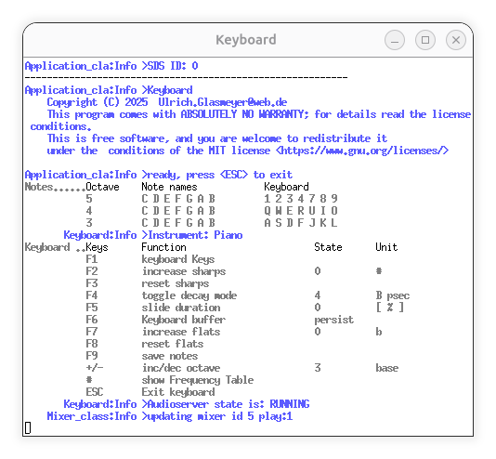
Keyboard
The Keyboard process is a Synthesizer with special characteristics. Contrary to the Synthesizer it starts in a Terminal window, having an own menu.
The Note name and Octave row shows, how the "Keyboard" key is mapped to a Note.
The available Function Keys F1...F9 are described below. If Keyboard is started from the OceanGUI there is a dialog box, where these functions are also implemented.

Function | Value | Short description
F1 |  | this menu
F2 | # | increase number of sharps #, doing this you can reach certain half tones. The keyboard layout is showing them.
F3 | #=0 | reset sharps
F4 | 1 | adsr mode
F4 | beats per sec | bps: from instrument
F5 | 0 | slide duration from glide freq. (see GUI)
F6 | persist | The keyboard buffer will not deleted. The duration of the keyboard buffer is given by the (kbd_sec) described in Table 1: Synthesizer.cfg . It will cycle. You can permanently add notes to the sound
F6 | forget | The keyboard buffer will be played a last time and will reach volume 0 depending on the vol slider position (see GUI description)
F7 | # | increase number of flats b, doing this you can reach certain half tones. The keyboard layout is showing them.
F8 | b=0 | reset flats
F9 |  | save notes to file keyboard_notes.musicxml. This file is editable via musescore3. (see Notes&Instruments
+/- | 1 ..3 | Change the base octave of the keyboard (row A)
# |  | show the frequency table.
<ESC>-key |  | in a command line window terminates  the program.  Use SDSview, menu item F2,s to stop, or OceanGUI to manage start&stop of the Keyboard aka Synthesizer

Keyboard Dialog on OceanGUI

The Dialog appears if StA Keyboard is in play mode.

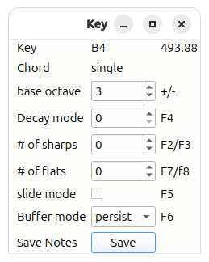
Action | short Description
base octave | Defines the octave in the A-row on the keyboard
Decay mode | The beats per measure of the key pressed note
# of sharps | Gives the number of sharps to be applied. This feature give access to half tones
# of flats | Sames as before, but decreases the base note by one half tone for the specified number of flats.
slide mode | If on, the tone changes continuously from the last note to the current note.
Buffer mode | If persistent the sound is stored to StA5. The storage volume can be adjusted by the keyboard slider,
Save Notes | The keyboard notes will be stored to file "keyboardnotes.musicxml". These notes can be edited.

AudioServer
The AudioServer process is the device driver for audio data, that is generated by the Synthesizer process. It writes this data directly to the RtAudio API (github). The API is configured to work together with the UNIX Pulse Audio and native ALSA facility. The properties of the AudioServer are fixed to a sampling rate of 48000 and to 16-bit of stereo output.

AudioServer Syntax start&stop
Command | Switch | short description
AudioServer |  | starts the program in a terminal
 | -d # | by default=0 the RtAudio API selects the default device. If there is no default available you can specify the device id by #. A list of available devices is printed at startup. Look for "Available audio devices :"
 | -v | print additional information
<ESC>-key |  | in a command line window terminates  the program.  Use SDSview, menu item F2,a to stop, or OceanGUI to manage start&stop.

OceanGUI
The OceanGUI is based on QT6. It was developed in parallel to the synthesizer after having a working AudioServer.
But after the Composer is available the OceanGUI is preferably used to check out sounds and store them into instrument files as well as note sentence fragments. It is also useful to extend the standard waveforms by a spectrum and the adsr oscillator. The spectrum is related to an instrument, so that specific characteristics are enabled. It also visualizes the sound generation of the different IO-channels as there are user defined storage areas, instrument, keyboard, notes and external music files, that can be mixed together.
During the composer run the GUI functionality is switched into an observer mode.
The GUI surface uses the same nouns as the Composer. For more details refer to the Composer section of this manual. The impact of special functions is also visible on the screen.

Storage Area devices (StA) Controls
The following behavior is valid for each StA ( see Figure 1: Storage Area), if not otherwise stated.
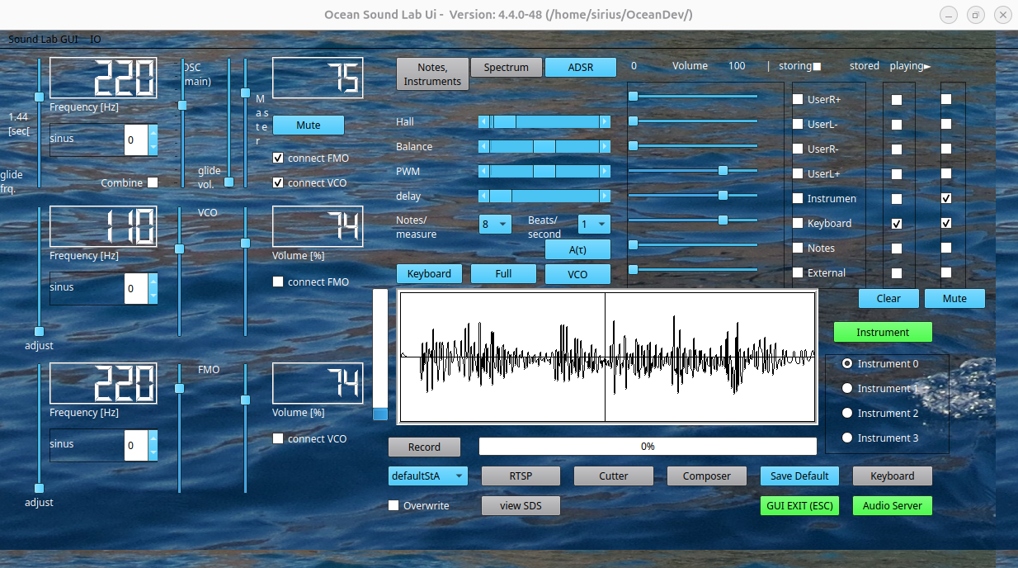Figure 1: Storage Area
Table 2: OceanGUI StA control
Control | Value / Action | Description
Slider Volume | 0% ... 100% | the volume of Notes, Keyboard and External is automatically set from 0% to a default value of 75%, if one of these functions is activated. On SDS reset the initial value of the instrument volume is used (75%).  Note: the speed of the volume change is controlled by the "glide vol." slider.
Checkbox Storing | check  unchecked | store the output of the Synthesizer sound to one of the StAs (user0...user3). The progress is indicated by the progress bar. If the StA is filled the recording is stopped. The checkbox turns to the unchecked state automatically in this case.  the action stops the recording to the StA.  Note: The actions have no impact on Instrument, Keyboard, Notes and External. These StAs are filled by the underlying generators.
Checkbox Stored | check  unchecked | is automatically set to checked, if storing was checked, because the StA contains sound data by storing or generated sound. If storing is checked again, the output sound will be appended to user0...user3 accordingly.  Clears the StA
Checkbox Playing | check  unchecked | activates the StA device output, whether it is generated sound, or stored in sta (user0..user3).  disables the StA device output

Managing Applications
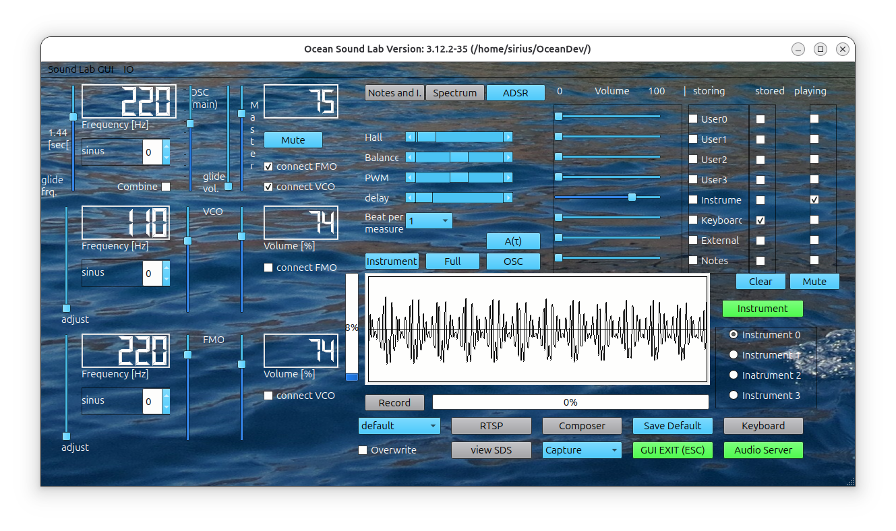Figure 2: Managing Applications
The following section describes, how to manage the application (see Figure 2: Managing Applications )
Table 3: Radio buttons
OceanGUI Control | Radio button state | Description
instrument 0..3 | checked | indicates the active synthesizer instance. All control elements of the GUI are connected to this specific instance.
instrument 0..3 | unchecked | the instance is not connected to any GUI control, but might work in background and can be revisited on demand.

Table 4: Push Buttons
OceanGUI Control | Color code | Description
Instrument | green | The Synthesizer and the AudioServer are running. If pressed the Synthesizer process will terminate.
Instrument | gray (initial state) or red | The Synthesizer is not running. If pressed the process will start.
Instrument | yellow | The Synthesizer is running, but the AudioServer is not.
Keyboard | green/gray/yellow | same as for Instrument, but starts the Synthesizer using a terminal. In addition to that, ihe Keyboard checkbox is switch on, the sound volume is set and the keyboard dialog window is shown. The AudioServer is required to get a working keyboard.
AudioServer | green | the AudioServer is running. If pressed the process will terminate.
AudioServer | yellow | over modulated sound. The sum of all sound sources like instrument, keyboard, notes, external or user StAs on all synthesizers together exceeds the value of abs(16384) within the last 125 msec.
AudioServer | gray (initial state) or red | The AudioServer is not running. If pressed the process will start
GUI exit (ESC) | green (always) | If this button is pressed or if the <ESC>-key is pressed the GUI will terminate. This does not effect running processes. To step into the active synthesizer/AudioServer session, the GUI can be restarted at any time.
Composer | green | The composer is running either in a terminal or in dialog mode (Composer -D). The GUI is switched into an observer mode (cannot send commands). The AudioServer and Synthesizer instrument0 must run to take any effects on composer commands, otherwise:  "Interpreter_cla:Info> Waiting for synthesizer to start" is shown in the terminal.
Composer | gray | The composer is inactive
RTSP | green | The rtsp dialog view is started. This dialog window provides an overview about active synthesizer and AudioServer sessions. If this push button is pressed the dialog box will disappear.
RTSP | gray | rtsp view is inactive. If push button is pressed the dialog box will appear.
SDSview | green | The SDSview is started in any terminal window. If pressed the SDSview process will terminate.
SDSview | gray | SDSview is inactive. If this push button is pressed it will start.
Save Default | blue (always) | The sound settings of the default.snd are activated after a reset of the SDS e.g. by using clearipc.sh.  If this push button is pressed the current sound settings will be used a the default.
select wav file | drop down box | If a wav-file is selected the content will be stored in StA External. The play checkbox is activated the volume is set to 75% if it was zero before.
overwrite check box | checked | the next record session will overwrite the selected wav file in $OCEANDIR/var/wav
 | unchecked | the next record session will create a wav file with the name "synthesizer#.wav", where # is a number of the range 1..MAXWAVFILES (see section syntheziser.cfg). The range is a cyclic number range.
Record | gray | recording is inactive. If pressed, the recording to wav file will start. The progress bar indicates the % of filled storage of the selected StA.
Record | yellow | recording will start after one of the triggers is reached
Record | red | recording is active. If pressed recording to StA will stop and the selected wav file and a personalized mp3 file will be written.

Some process will start in a terminal window. The terminal can be configured by the Configuration file etc/synthesizer.cfg file.

GUI Dialogs

Cut Desk
A recorded sound track might not consist of matching folding between begin and end, or for other reasons should be shorted at all. With the Cut Desk it is possible to change the recorded content of USERxy and External StA.
The StA must be selected at first by checking one of these playing check boxes. The Cut Facility takes the StA and creates a sound window out of it that is continuously played, while all other StA output is muted. The sound window starts a the beginning of the StA content and ends 4 seconds later. Each step will change the window size by 1/8 seconds.
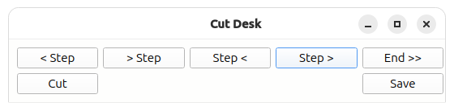
The action of Cut Desk push buttons is described here:
Table 5: Cut Desk Buttons
Push Button |  | short Description
< Step,  >Step |  | move the beginning of the window left or right
Step <,  Step > |  | move the end of the window left or right
Step end |  | move the right window boundary to the end of the recorded content. (original size)
Cut |  | Change the content of the StA.
Save |  | Save the content of the StA to the filename_SDSID_StAId.wav and synthesizer.mp3  The filename is given by the name listed in the filename combo box.

Note: By using the Cut Desk it is obviously possible to create mp3 files out of the content of USER StAs. (to store the content of UserL- to defaultStA.wav, select "default"
The Ocean GUI does not manage files. To prevent unwanted overwriting please use a system file manager

GUI ADSR
The envelope shape of a note, short ADSR, is basically controlled by two parameters. The attack, this is the linear raising part and the exponential decay.
Intermediate deviations from the basis shape can be arranged by the Adsr sub window controls for the Oscillators OSC, VCO and FMO for Instrument, Notes and Keyboard. It consists of control and display elements.

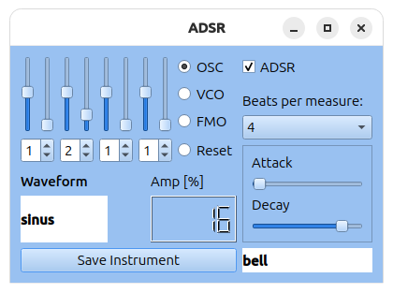
Hint: Settings here for VCO and FMO requires, that these Oscillator are activated to have impact on the OSC by connect them to the OSC and tune their volume respectively. Both can be done with the Main Window of the GUI.

Table 6: ADSR control elements
Control Element | Display | short Description
four Slider groups  right slider  left slider | Amp [%]  [Hz] | Amp. default 0. increase the impact on the shape by the selected waveform  Hz default 0 deviation from Beats per measure. The base frequency comes from the Beats per measure selection. The first group is responsible for 2 multiple of this entry. Subsequently 3,4,5 . ranges  [ 2..2.8 ],[ 3..3.8 ],[ 4..4.8 ],[ 5..5.8 ]
four index Spin Boxes | waveform | Select the waveform index to change the shape of the envelope.  The change of the shape is simultaneously displayed in the wave form display at the center of the OceanGUI.
Oscgroup  OSC, VCO, FMO, Reset | Radio Button | Select the Osc or reset slider group settings and waveform to default.

Beat controls overview
Decay mode Bps | Keyboard Dialog | Controls the Decay duration of the Osc-ADSR of Keyboard strokes.
Keyboard Bps | Main Dialog | Controlls the duration between separate keyboard strokes.
Instrument Bps | Main Dialog | Controlls the beat of the Instrument. Temporary adjustment of Beats per measure. Not saved with the instrument but stored with the SDS.
Beats per measure | Spectrum Dialog | Controlls the beat of the instrument, saved as intrument feature.

SDSview
Is a tool to inspect the content of the four Shared Data Segments for debugging purposes. In addition to that you can safely shutdown all processes and destroy allocated shared memory of Ocean-SL processes by using
# SDSview -i
This is necessary in case of a version change of the Shared Data Structure. Important notice: This action must be performed before the new SDSview is installed.
Example View:
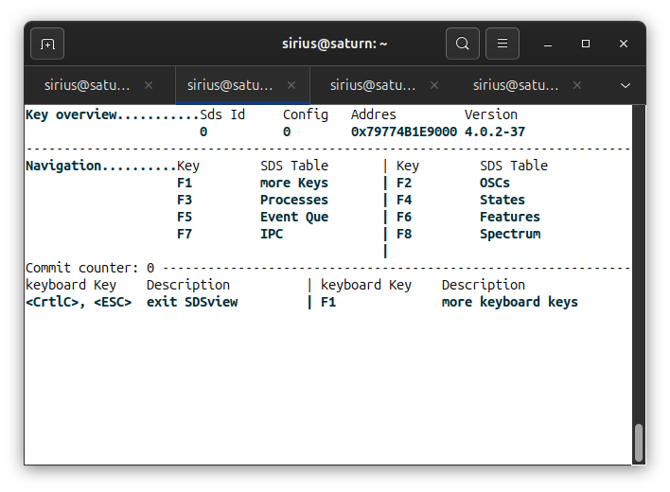
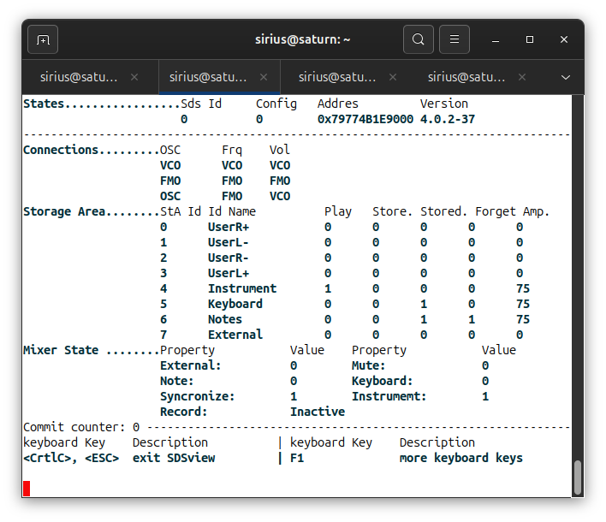

This section is incomplete

Workflows
This section is outdated and needs a review!
Record Sound in StA
1. Select StA to start recording
2. Select StA again to stop recording
3. Use one of the check boxes to play sound of the checked StA
Clear Storage Area:
1. Select StA by one of the radio buttons. It starts to add sound to this StA.
2. Push button <Clear> atz any moment..
Save Sound to File:
1. Push radio button <External> to record sound (the Progress bar shows the record progress)
2. Push radio button <External> again to stop recording
3. Use push button <Save> to store the content of the StA External into a file.
The file name the wav file is generated automatically. The mp3 file synthesizer.mp3 is located in directory OCEANDIR/var/wav . If the content of this file shall survive the next "Save to sound file" action it must be renamed manually.
Note: to recover an overwritten mp3 load the wav file and <Save> it.

Composer
Command Line | Option | short description
Composer |  | start the Composer process and execute the main.synth file
 | -v | additional info
 | -t | perform a test run
 | -D | execution of Synthesizer commands in dialog mode
see Managing application in the OceanGUI section |  | start&stop push button color codes.

The composer compiles the program main.synth by interpreting it and so generates a time ordered sequence of changes of the control data (SDS), that is executed in real time by the Synthesizer process, accordingly.

Ocean command line> | command option | description
clear |  | reset the program
exit |  | exit dialog mode
include | name | name of the program file in the include directory
show | stack | show the program without execution
<return> |  | execute the program or command line

The composer run can be separated into phases: pre processing -> compilation -> execution
The program line is structured as follows:
- Keyword followed by one or more words, describing the keyword specific action,
- user defined identifier name followed be an equal sign (=) followed be a value (macro definition),
- user defined notes filename, followed by a filename followed be a plus sign (+) followed by a filename (search path for notes),
- user defined :subroutine name , the subroutine name must start with a colon (:) .
- hash sign (#) followed by a user defined comment text. This text is ignored during the pre processing phase.

Programming/ main.synth
exit | program line at witch the processing of main.synth ends
call :subroutine | jump to a subroutine. The colon(:) marques a subroutine as such
:subroutine | the jump destination of a call
return | return the program execution one line below the previous call
include file | replace the program line where the include statement occurred by the content of file.inc . The action is performed as part of the pre processing
variable = value | intended to make the program more readable.  Variable behaves like a macro that is applied to the complete program text, so that each occurrence of variable is replaces by value, regardless of a syntax check. The action is performed as part of the pre processing  NOTE: the have to be spaces on the left and the right of the equal (=) sign.
file = filea + fileb | append filea.kbd with the content of fileb.kbd and store it as Synthesizer/var/auto/file.kbd, where file, filea and fileb are arbitrary names without separator characters (space, tab). The search for filea and fileb is Synthesizer/etc/Notes and Synthesizer/var/auto.  The action + is performed during the interpreter run.  NOTE: there must be spaces on the left and the right of the equal (=) sign and the plus (+) sign.
text "text" | print out all after keyword text during the processing phase

Notes:
In the last phase of the composer call, the data is transformed by the Synthesizer and AudioServer into physical sound.
Special note on include files:
The location where include files should be inserted into a program file depends on the content of the include file. If it contains subroutines it must be added at the end of the main.synth program file. In all other cases it can be placed as needed and it can be included multiple times. include files may also contain include files.
Example: manage program flow with main.synth
call :syntaxtest1
call :maintest
exit
:syntaxtest1
text syntax check program flow
include lib
return

:maintest
text entering main test
pause key

The composer reports line nr and filename of a command line.
Table 7: Keywords and special characters
Keyword | short description
add | store the instrument playing notes into a memory array
adsr | Control single elements of the ADSR facility
call | Control the program flow
include | Control the program flow
instrument | assign the current instrument
notes | assign and define notes for processing
osc | Control the oscillators (Main, VCO and FMO)
play | Managing the output of memory arrays
pause | wait for some seconds before the next statement is processed
random | generate notes according to the specified rules
rec | Control the recording to the Storage Area (StA)
record | Control the recording of the output
return | Control the flow of the synthesizer program
set | specify certain properties
start/stop | start/stop sub processes (Synthesizer /AudioServer)
= | defines a macro name
+ | add two note files
space, tab | separator characters
"parameter text" | spaces and tabs between hyphens (") are not considered to be parameter separator
# text | comment text not compiled

Remark: all internal defined keywords are compared to lower case versions, so that; add, Add, ADD are equivalent while user defined words are used as they are defined, so that: call :subroutine has a different meaning than call :Subroutine.

add/ Play notes using an instrument

Table 8: add/ play Notes
Keyword | short description
add | instrument notes memory
instrument | name of the instrument. Instrument files are generated by the OceanGUI and stored in directory Synthesizer/etc/Instruments
notes | name of the notes file. Note files can be generated (see random) or created/edited by the OceanGUI. In addition to that note files can be concatenated, (see programming )
memory | a memory identifier into which StA the sound shall be stored (0..5)

Remark: the storage duration depends on the duration of notes to play.
Example: Store the sound of the instrument drums2 with notes drums3 into storage location 1 in background mode. See also full example.

Storage1 = 1
add drums2 drums3 Storage1
play Storage1 amp 100

text add/ Play notes using an instrument
pause key

This is the same as saying (foreground mode):

instrument load drums2 # load files drums2.kdb
notes load drums3 # load file drums3.kbd
notes play on 100 # switch to notes mode
rec store 1 # store to memory 1
pause auto # wait for sentence duration seconds
rec stop 1 # stop record on memory 1
notes play off # switch off note playing
play 1 amp 100 # switch on memory 1 playing

text This is the same as saying (foreground mode):
pause key

The notes are repeated as long as one of the following occurs
- the Composer terminates (see pause on how to delay the composer execution)
- the storage is over written.

ADSR
add effects to the output of the main osc.
adsr [pmw # | hall # | attack # | decay # | softfreq # | beat #]

adsr | short description
attack | control the volume of the main output from 0 to max during a beat. The attack curve is linear.
beat | 0 : attack/decay is not applied  1: duration is 1 second one beat per second  2: duration is 500ms, 4 - > 250ms, 5 ->200ms
hall | add the current main OSC output with phase shift
pmw | controls the width of the wave form PMW of the vco only.
decay | controls the volume of the main output from max to 0 during a beat. The decay curve is exponential.

Example:

StA2 = 2
osc main unmute
set main freq 220
set vco amp 50
adsr beat 4
adsr attack 10
adsr decay 90
adsr softfreq 0
rec store StA2
pause 5
osc main mute
rec amp StA2 100

text some osc and adsr commands
pause key

call / return subroutine
call :subroutine

call | short description
:subroutine | the subroutine noun must start with a colon (:) as well as the subroutine section
:subroutine  ... list of composer commands ...  return | subroutine section must end with the return statement

Note: subroutine names consider lower and upper case characters.

Dynamic vol/frq
The dynamic facility allow the gliding change of the volume or frequency. This feature concerns all volume and frequency condition.
dyn [ [ vol | frq ] #1 ] | [ mode #2 ]

dyn | short description
vol #1 | set the duration to #1/100*8 [sec]
frq #1 | set the dynamic frq to #1
mode #2 | set the dynamic mode,where #2 is one of the following  0 = FIXED, no sliding  1 = SLIDE, sliding  2 = COMBINE, combine osc, vco, fmo

Example:
reset sds
dyn vol 100
dyn frq 100
instrument beat 0
osc main set sinus A4 80 5

exit
terminates the composer execution.

Instrument
an instrument consists of two files, name.kbd and name.spec.
instrument load filename

instrument | short description
load filename | load filename,  remark: the filename must be given without the extension .kbd

Example: load instrument file Saxophone.kbd and associated spectrum file Saxophone.spec

instrument load Saxophone

Notes - notation

AaBCcDdEFfGg | 12 Note names representing the note values 0,1,2, ... 11 in a chromatic scale denoted as "eng". is the default notation
0123456789AB | alternative notes notation denoted as "num"
ABCDEFG | alternative notes notation. This is implicitly choosen if notes set prefix is used to define the number of flats and sharps.
, (comma) | decrease the note value by one octave Example f,
' (hyphen) | increase the note value by one octave Example f'
- (minus) | increase the duration of a note by a note length Example f-
. (dot) | no note. Silence for one note length
a>b | denotes a gliding note. e.g. B-->F : Increases continuously the frequency from B to F during the note length of B (3 x min_duration).  The gliding note counts as one note.  Change octave from 2 to 3 by: |2B--->|3F
|# (pipe number) | set the octave for all subsequent notes to # Example |3c provides a frequency of 55 * 2³ * 2^(4/12) Hz. #=1...max_octave (see Glossary)
|' (pipe hyphen) | increase the octave for all subsequent notes by one octave
|, (pipe comma) | decrease the octave for all subsequent notes by one octave
( note names ) | polyphone notes Example (AC) generate sound of A and C in parallel.  More than three notes in parallel may result in over sampling.

notes [ load filename|
set prefix #1 #2
set octave #3
set [num] sentence rhythm |
play [ on #4| off ] |
per_second #5 ]

notes | short description
load filename | read notes file filename
set [num] sentence rhythm | store sentence and rhythm into file tmp.kbd and load file  the optional keyword "num" allows to change to the numeric notation of notes in the note sentence.
set octave #3 | set the octave for notes to value #3
set prefix #1 #2 | Change to alphabet notes ABCDEFG with #1 flats (b) and #2 sharps (#) acting on file var/auto/tmp.kbd .
play [ on #4 | off ] | start / stop playing notes from real time generated sound.  #4 denotes the volume (0..100)% in case of on
per_second #5 | set the #5 (1,2,4,5,8) of notes per seconds. This maps to a duration per note of (1000, 500, 250, 200, 125) [msec]  The duration must be set before notes are generated. This is valid until a different value is set.

Note: after storage into StA by rec or add or + the temporary file tmp.kbd can be reused for other.
Example:
osc main mute
notes play on 100
notes per_second 2
notes set (AC).AC.DC.(DC)... 8
pause key

Example:
osc main mute
notes set "ABCD EFGF EDCB .---" 8
notes set prefix 1 0
notes play on 100
pause key

Oscillator/OSC
There are three oscillators, working together. The MAIN oscillator provides the main properties of the sound in terms of frequency, waveform, amplitude and effects (see adsr collection).
The VCO controls the volume of the main oscillator and the FMO the frequency. Both are doing this by applying their own properties in terms of frequency, waveform and volume.
Set the oscillator wave form, frequency and amplitude for a given duration
osc [main|vco|fmo] set wave_str frequency amplitude pause
osc main loop [ amp #| freq #]
osc main [mute|unmute|reset]

Table 9: Standard Waveforms
waveid | Waveform String  ( wave_str) | Wave form description
0 | sine | Sine with default spectrum
2 | SgnSin | Signed sine
3 | rectangle | Rectangle
4 | sawtooth | Sawtooth left
5 | Sawtooth | Sawtooth right
6 | triangle | Triangle
7 | PMW | Pulse Wide modulation
8 | random | Random Noise
9 | delta

The frequency should be in the range of 0 up to max_frequency [Hz] (see Glossary). Considering a sampling rate of 48000 this mean, that a wave length is separated into 13 or 14 step values. This is not so much, to describe a standard waveform or a complex one.
The amplitude is given in % of the total available amount ( 0 … 100)%.
The duration to hold the setting is given in seconds (0 … 30), depending on the memory size.
Example: To change the frequency of the VCO to the value of 500[Hz] for 5 seconds using waveform Signed Sign (2) the entry
osc vco set sgnSin 500 80 5

One can set single aspects of the main oscillator by applying
osc [main|fmo|vco] set [wf|freq|amp] value [duration]
See also keyword set for the same .
set vco wf Sine
set vco freq 500
set vco amp 80

will do this. See also set
Another example
osc main reset
osc main set sgnSin 200 100 auto
osc main wf rectangle
osc main loop freq 400 500
pause key

play
Set StA (#1) on with a new output volume .
play #1 [amp #2|loop #3]

play | short description
#1 | StA id (0..7)
amp #2 | Change the output volume of StA #1 immediately to the value of #2 %
loop #3 | Change the output volume of StA #1 continuesly starting at the current output volume until the volume is #2 % .

Pause
Set the timer (#) or event (auto, key)
pause [#|auto|key]

pause | short description
# | A number less than 30 to wait for this number of seconds until the next composer command is executed.
auto | wait for the number of seconds the note sentence needs to play
key | wait until the <return> key is pressed

Example:
pause 10 # Wait for 10 seconds, then continue.
pause key # wait for <return> key

random /generate notes

Field specification
random constant rhythm variable sentence name
Table 10: Generating Notes
random | short description
constant | a list of note values used to specify the constant part of a note sentence.  In addition the note literal "r" will be transform into a single random note
rhythm | Specifies the volume of a single note. The volume is define by the number 0,1,2,..9 and maps to a volume of 0%, 10%, 20%, ... 90%. The default volume of a note is 80%.  Ex: the rhythm 7 means each note becomes a volume of 70%,  then rhythm 69 means the volume cycle 60%90%60%90%60%90%... in the note sentence.  Ex: notes are cccc, rhythm = 0999 is the same as note= .ccc rhythm = 9
variable | A set of note names and note specifiers out of which random notes are generated.  Remark: The more often one literal occurs in the list, the more likely it is this literal is chosen.  Valid characters are notes.
 | , / ' / . | insert a decrese/increase/pause mark into the random word
 | !c | make c mandatory in each random note word
sentence | a sequence of note words that can be a constant, variable or pause. These are denoted as c r and - . c can consist of more than one word. r is always one word.  In addition one can duplicate a sentence and switch a single word within it. see example
 | sentence characters | short description
 | c | replace "c" by the constant part
 | r | insert a random word
 | - | insert a pause word consisting of: .---
 | cR | insert the reverse constant
 | Word#, #Sentence | set the octave to # for the previous Word.(cr)  # at the begin of the Sentence will set the octave for the complete sentence
name | The generated note sentence including rhythm line is store under the user specified name name.nte in the directory Synthesizer/var/auto

Example:
osc main mute
CONSTANT = |2(ACD)-(ACE)-(BDF)-(BDG).
RYTHM = 9789
VARIABLE = (AC'D)(AC'E)(BD'F)(BD'G)G
SENTENCE = crr-:S12
FILENAME = lead
INSTR. = Piano
STORAGE = 2

Random CONSTANT RYTHM VARIABLE SENTENCE FILENAME
Add INSTR. FILENAME STORAGE auto
play STORAGE amp 100
pause key

constant part c = |2(AC)r(DE)G|3(AC)c(DC).
variable note words denoted as "r" in the sentence crr- are generated out of the list c-fgCDA.'',,
The note sentence crr- is again duplicated by swapping word 1 and 2.
The resulting note sentence crr-rcr- is stored in the file Synthesizer/var/auto/lead.kbd
Remark: The sections are separated by spaces or tabs. That means that a space within a section may result in a meaningless interpretation of the command.

rec / manage StAs
There are 8 storage arrays (StA). refer to Table 1: Synthesizer.cfg, Figure 1: Storage Area and Table 2: OceanGUI StA control, for more information.
StA Id | short description | max duration
0...3 | User defined UserR+, UserL+, UserR-, UserL- | temp_sec [sec]
4 | Instrument control | no storage to StA
5 | Keyboard control | Kbd_sec [sec]
6 | temp storage of notes sound, Notes | Kbd_sec [sec]
7 | wav-file storage, External | record_sec [sec]
Note: The max duration is limited by the reserved storage size.
The following commands manage the content of the StA 0...3, or controle the output of StA 0...7 .
rec [notes #1 |store #1|amp #1 #2|stop #1|play on #1|off #1]
| mute #1| clear #1 | loop #1 #2 #3]
rec | keyword
#1 | StA id 0...7
#2 | volume 0...100
#3 | loop step 0...100 controls the dynamic volume
store #1 | store the current output of free and notes to StA #1
amp #1 #2 | replay sound of StA #1 with volume #2
stop #1 | stop recording on StA #1
notes #1 | translate note sentence in background, generate sound, store sound in StA #1 (all in one command).
play on #1  play off #1 | switch on the output of StA #1  same as mute StA #1
mute #1 | mute StA #1
clear #1 | delete the content of StA #1
loop #1 #2 #3 | replay sound of StA #1 with current volume decreased or increased by volume step #3 until the volume reaches volume #2.  Note: The step is always positve >0 . The direction will be calculated from the difference #2 - current volume.

Example base scenario see add command (background mode) or, what you do that you hear as follows.
instrument load drums | load an instrument (drums)
notes load rhythm | load some notes (rhythm)
notes play on 100 | play notes with volume 100%
rec store 1 | store sound to StA #1
pause auto | wait for some seconds (note sentence duration)
rec stop 1 | stop recording on StA #1
notes play off | switch note generating off
rec amp 1 100 | play StA #1 with volume 100%
pause key | as long as wanted

Note on storage: The storage is additive until cleared, so that one can append tracks to one StA.

Record / to file
record current sound track to a wav and an mp3 file
record | file #1 | stop #2 | play #2 #1 | loop amp #3 ]

record | short description
file #1 | record current sound track #1 seconds < record_sec to StA 7, Your can specify record_sec, see Table 1: Synthesizer.cfg
stop #2 | store to file var/wav/synthesizer#2.wav and var/wav/synthesizer.mp3  Note: The mp3 file will be overwritten!
play #2 #1 | add sound of file var/wav/synthesizer#2.wav #1 seconds to current sound.
loop amp #3 | dim the record volume from current volume to #3

Example:
RECFILE = 77
record file 10
stop RECFILE
play RECFILE 5
text record file synthesizer77.wav
pause key

Reset
reset sds

set the SDS default values for instrument and StA.

Return / from subroutine
keyword return, see keyword call

Set
set [octave+ | octave- | main [freq|wf|amp] #
| vco [freq|wf|amp] #
| fmo [freq|wf|amp] # ]

set | short description
octave+ | increases the base_octave by one eg. from 55Hz to 110Hz
octave- | decreases the base_octave by one, but not to zero. eg. from 110Hz to 55Hz
main property # | set the property [freq|wf|amp] of oscillator main to value #
vco property # | set the property [freq|wf|amp] of oscillator vco to value #
fmo property # | set the property [freq|wf|amp] of oscillator fmo to value #

Example
set the frequency of the main oscillator to 110 Hz.
set main freq A2
set main freq 59
Note: See frequency table in the appendix

start
start server shmkey delay
start | short description
server | AudioServer|Synthesizer | rtsp -C
shmkey | shared memory key must be identical for both servers. The value range is system dependent
delay | wait until next process step, to manage potential synchronization issues.  delay takes default "key" see pause

Example:
call :startserver

lib.inc
:startserver
start AudioServer 10000 0
start Synthesizer 10000 3
return

stop
stop composer subprocesses.

Setup
The source distribution of Ocean-SL contains a program, that generates a runtime directory structure and binary deployment archive.
Setup | Parameter | short Description
 | -A | create a tar.gz file with checksum files out of the runtime directory, release notes, a user manual pdf and at last  shows a github upload string.
 | -S directory | base directory of the source file tree
 | -I directory | install / runtime directory to be created
 | -v | verbose mode
 | binary file | target binary file to be copied into the install directory. This option is obsolete by usinf the cmake system.

Note: in case of a parallel build with make -j# the install directory may be incomplete. In this case run the make command one more time.

Appendix

Table 11: Directory structure
Synthesizer/bin | Executable
Synthesizer/doc | Documentation
Synthesizer/etc | Configuration
Synthesizer/etc/Instruments | Instrument files and instrument search path
Synthesizer/etc/include | main.synth and include search path
Synthesizer/etc/Notes | Note files and note search path
Synthesizer/lib | check point shared memory dump location
Synthesizer/tmp | audio raw file dump location
Synthesizer/var | variable synthesizer data
Synthesizer/var/auto | random notes and notes search path
Synthesizer/var/log | Synthesizer cumulated log
Synthesizer/var/wav | mp3 and wav files and external input files search directory

Full Example
play two instrument with randomly generated notes
# generate random notes with constant random and switched part and
# store to notes file lead.kbd
random |2(AC)r(DE)G|3(AC)c(DC). 9789 c-fgCDA.'',, crr-:S12 lead
# store piano sound with notes from file lead to memory 3
add piano lead 3
# store saxophone sound with notes from file lead to memory 0
add Saxophone lead 0
# play memory 3 with amplitude 60%
play 3 amp 60
# wait for 1 second
pause 1
# play memory 0 with amplitude 60%
play 0 amp 60
# wait for the return key being pressed
pause key

Table 12: Frequency Table
Index | Frequency [Hz] | Name | Index | LFO Frequency [Hz] | Name
26 | 16.35 | C0 | 1 | 0.1 | 0 1
27 | 17.32 | c0 | 2 | 0.2 | 0 2
28 | 18.35 | D0 | 3 | 0.3 | 0 3
29 | 19.45 | d0 | 4 | 0.4 | 0 4
30 | 20.6 | E0 | 5 | 0.5 | 0 5
31 | 21.83 | F0 | 6 | 0.6 | 0 6
32 | 23.12 | f0 | 7 | 0.7 | 0 7
33 | 24.5 | G0 | 8 | 0.8 | 0 8
34 | 25.96 | g0 | 9 | 0.9 | 0 9
35 | 27.5 | A0 | 10 | 1 | 1
36 | 29.14 | a0 | 11 | 2 | 2
37 | 30.87 | B0 | 12 | 3 | 3
38 | 32.7 | C1 | 13 | 4 | 4
39 | 34.65 | c1 | 14 | 5 | 5
40 | 36.71 | D1 | 15 | 6 | 6
41 | 38.89 | d1 | 16 | 7 | 7
42 | 41.2 | E1 | 17 | 8 | 8
43 | 43.65 | F1 | 18 | 9 | 9
44 | 46.25 | f1 | 19 | 10 | 10
45 | 49 | G1 | 20 | 11 | 11
46 | 51.91 | g1 | 21 | 12 | 12
47 | 55 | A1 | 22 | 13 | 13
48 | 58.27 | a1 | 23 | 14 | 14
49 | 61.74 | B1 | 24 | 15 | 15
50 | 65.41 | C2 | 25 | 16 | 16
51 | 69.3 | c2
52 | 73.42 | D2
53 | 77.78 | d2
54 | 82.41 | E2
55 | 87.31 | F2
56 | 92.5 | f2
57 | 98 | G2
58 | 103.83 | g2
59 | 110 | A2
60 | 116.54 | a2
61 | 123.47 | B2
62 | 130.81 | C3
63 | 138.59 | c3
64 | 146.83 | D3
65 | 155.56 | d3
66 | 164.81 | E3
67 | 174.61 | F3
68 | 185 | f3
69 | 196 | G3
70 | 207.65 | g3
71 | 220 | A3
72 | 233.08 | a3
73 | 246.94 | B3
74 | 261.63 | C4
75 | 277.18 | c4
76 | 293.67 | D4
77 | 311.13 | d4
78 | 329.63 | E4
79 | 349.23 | F4
80 | 369.99 | f4
81 | 392 | G4
82 | 415.31 | g4
83 | 440 | A4
84 | 466.16 | a4
85 | 493.88 | B4
86 | 523.25 | C5
87 | 554.37 | c5
88 | 587.33 | D5
89 | 622.25 | d5
90 | 659.26 | E5
91 | 698.46 | F5
92 | 739.99 | f5
94 | 830.61 | g5
95 | 880 | A5

3rd party products
RtAudio library from github: https://github.com/rtaudio/rtaudio, embedded.
tinyxml2 runtime, embedded.
Qt6 runtime, embeded
ffmpeg ubuntu distribution (sudo apt install ffmpeg) in order to convert wav to mp3 files,
id3tool ubuntu distribution (sudo apt install id3tool) in order to add metadata to mp3 files
musescore3 ubuntu distribution
xterm terminal application

Glossary

Table 13: Summary of Ocean-SL specific terms
Bpm | Beats per measure ( 1 Bpm = 2 Bps )
Bps, bps | Beats per second
FMO | Frequency Modulating Oscillator / connected to Main
Hz | frequency unit / Oscillations per sec.
OSC, main | Main Oscillator that generates the audio out data.
max frequency | ‪=55[Hz] * 2⁶ = 3520[Hz] => max octave is 5‬
max octave | max octave is 5‬, so that 55*2⁵*(1+1)=3520 (max_frequency)
min duration | 1 sec / notes per second, see also note duration
Storage array (StA) | 8 arrays of memory used to store sound data(0..5) can be user defined.
Note length, note duration | default 250 msec. the value can be change by the command:  notes per_second #
note sentence  sentence length | some note words, see below. with  length: words * word length
Note specifiers | | , ' - . see table notes
Note values | see table notes
note word  word length | set of notes matching into a time slice of one second.  (word length = 1 second)
one second = | sample rate (AudioServer) / max frames (Synthesizer) 48000/48000
Oscillator, Osc | Waveform generating unit of the synthesizer (main, vco, fmo)
Program | main.synth and user defined include files
real time | The execution of a command needs to be committed by the synthesizer. The composer shows the time a commit needs for a composer command. If this time << 1000 ms we assume real time processing.  The conversion of sound into mp3 files is not real time
SDS | Shared Data Segment. There are 4 SDSes, one for each Synthesizer. The SDS is used for Inter Process Communication
VCO | Volume Controlling Oscillator / connected to Main
Wave form | standard shapes of the time resolved amplitude (see table Standard Waveforms and wfid's)

Planning features

arm64 binary distribution support.

License notice

/******************************************************************************
-> Ocean Sound Lab Application Suite (short Ocean-SL)
Ocean-SL is a c++Project that provides a set of Sound Managing Applications,
such as Synthesizer, AudioServer, Composer with Graphical UserInterface for
Linux based Operating Systems, that allows to generate, play and record sound.
It includes interfaces for musicxml-files and supports the sound drivers:
-> native ALSA and
-> Pulseaudio
The software includes a simple keyboard to play and record music as you type.
It comes with a limited set of sample files for instruments and notes to start
with. Funny play.

-> Ocean-SL GitHub site: https://github.com/uglasmeyer/ocean

MIT License

Copyright (c) 2025 Ulrich Glasmeyer

Permission is hereby granted, free of charge, to any person obtaining a copy
of this software and associated documentation files (the "Software"), to deal
in the Software without restriction, including without limitation the rights
to use, copy, modify, merge, publish, distribute, sublicense, and/or sell
copies of the Software, and to permit persons to whom the Software is
furnished to do so, subject to the following conditions:

The above copyright notice and this permission notice shall be included in all
copies or substantial portions of the Software.

THE SOFTWARE IS PROVIDED "AS IS", WITHOUT WARRANTY OF ANY KIND, EXPRESS OR
IMPLIED, INCLUDING BUT NOT LIMITED TO THE WARRANTIES OF MERCHANTABILITY,
FITNESS FOR A PARTICULAR PURPOSE AND NONINFRINGEMENT. IN NO EVENT SHALL THE
AUTHORS OR COPYRIGHT HOLDERS BE LIABLE FOR ANY CLAIM, DAMAGES OR OTHER
LIABILITY, WHETHER IN AN ACTION OF CONTRACT, TORT OR OTHERWISE, ARISING FROM,
OUT OF OR IN CONNECTION WITH THE SOFTWARE OR THE USE OR OTHER DEALINGS IN THE
SOFTWARE.

******************************************************************************/

