Real-Time Publish-Subscribe (RTPS) Protocol

Wiki: http://en.wikipedia.org/wiki/Real-Time_Publish-Subscribe_(RTPS)_Protocol

The **Real-Time Publish Subscribe (RTPS)** protocol is the interoperability protocol used to allow multi-vendor [Data Distribution Service (DDS)](http://en.wikipedia.org/wiki/Data_Distribution_Service)[[1]](http://en.wikipedia.org/wiki/Real-Time_Publish-Subscribe_(RTPS)_Protocol#cite_note-1) implementations to communicate

RTPS 프로토콜은 다양한 벤더의 DDS 구현물이 통신하는데 사용되는 상호호환성 프로토콜이다. 이 얘기인즉슨 RTPS 만 구현하면 DDS 통신이 가능하다는 얘긴가? 그렇담 DDS 표준과의 차이점은 뭐지?

The Real-Time [Publish-Subscribe](http://en.wikipedia.org/wiki/Publish%E2%80%93subscribe_pattern) (RTPS) protocol is designed for use with [Internet Protocol (IP)](http://en.wikipedia.org/wiki/Internet_Protocol) one-to-many [Multicast](http://en.wikipedia.org/wiki/Multicast) and connectionless best-effort transports such as IP [User Datagram Protocol (UDP)](http://en.wikipedia.org/wiki/User_Datagram_Protocol).[[2]](http://en.wikipedia.org/wiki/Real-Time_Publish-Subscribe_(RTPS)_Protocol#cite_note-2)

The RTPS Wire Protocol DDS Interoperability Wire Protocol Specification defines the interoperability protocol for DDS. Its purpose and scope is to ensure that applications based on different vendors’ implementations of DDS can interoperate. 출처: http://www.prismtech.com/opensplice/technologies/ddsirtps

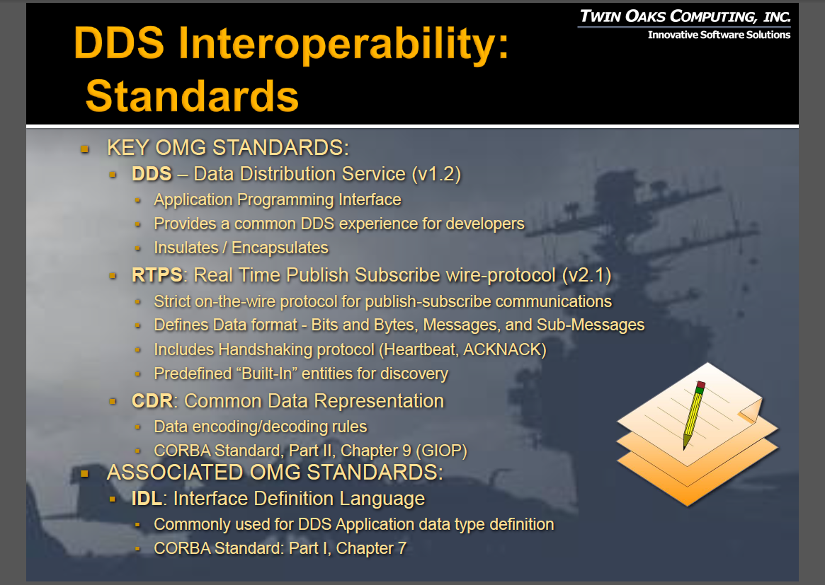

그림 . The difference of DDS and RTPS (출처: http://www.omg.org/news/meetings/GOV-WS/pr/rte-pres/Achieving%20DDS%20Interoperability_v1.7.pdf)

위 자료는 아마도 RTI, PrismTech, Twin Oak Computing 3사가 호환성 테스트 했던 자료로 보이며, 또한 RTPS와 DDS 사양 사이의 차이를 보여준다.