**Initial Results:**

Accuracy was 95% initially.

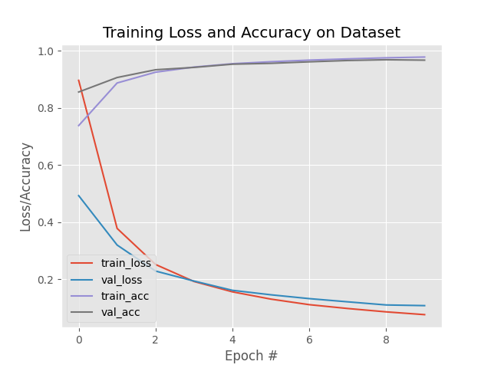

**Initial Learning Rate Parameter:**

I changed this parameter to be 1e-4 and 2e-3.

Results for 1e-4:

Accuracy was reduced to 91% and in the initial runs, loss was much higher.

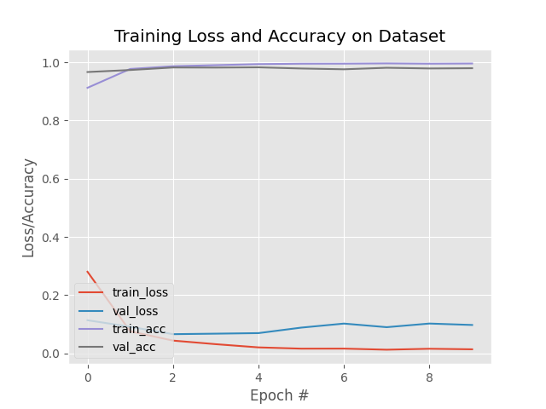

Results for 2e-3:

Accuracy was reduced to 94% but loss was slightly lower initially.

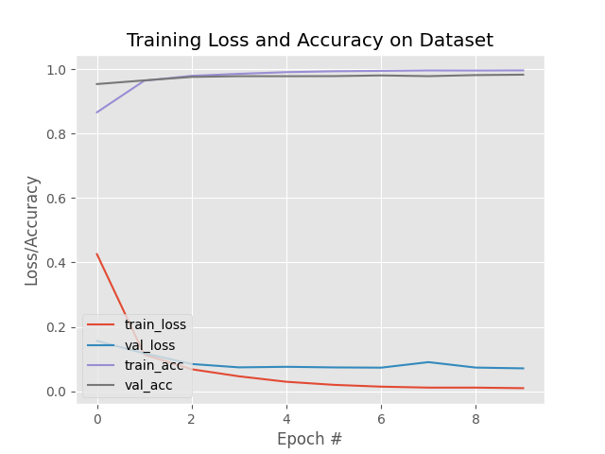**Batch Size Parameter:**

I changed the value to be 128 and 32.

Results for 128:

Accuracy was at 95% with an initial higher loss.

Results for 32:

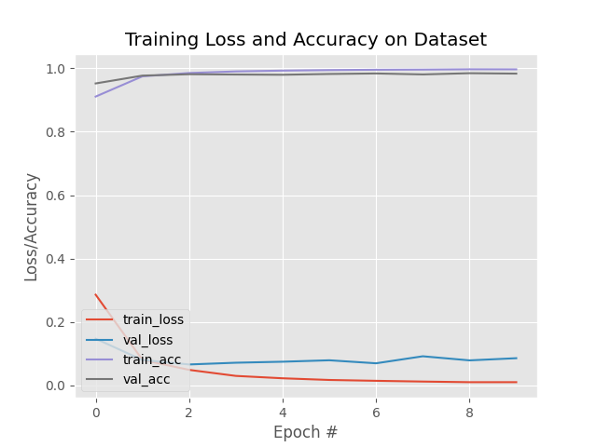Accuracy was at 95% with lower loss.

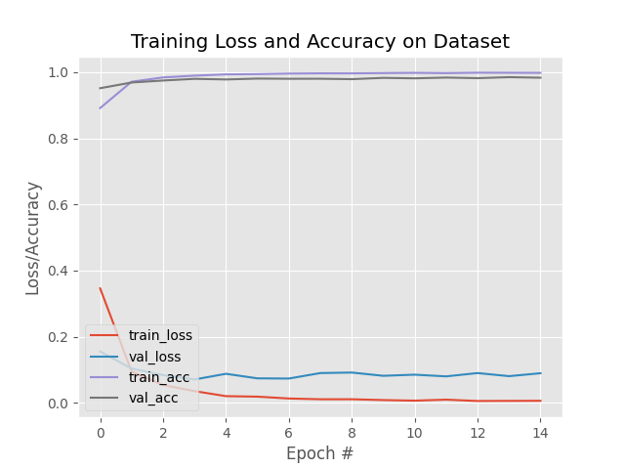**Epochs Parameter:**

I changed the value to be 15 and 5.

Results for 15:

Accuracy was 95% and loss continued to decrease

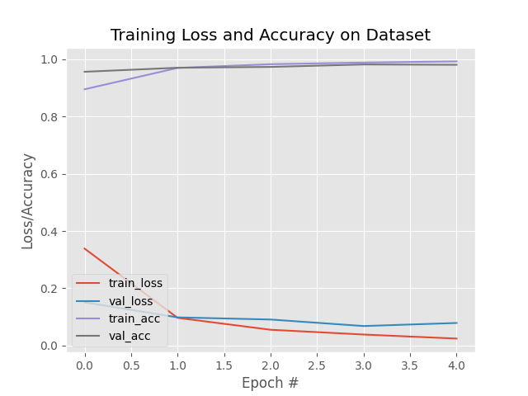Results for 5:

Accuracy decreased to 94% and loss decreased slower.

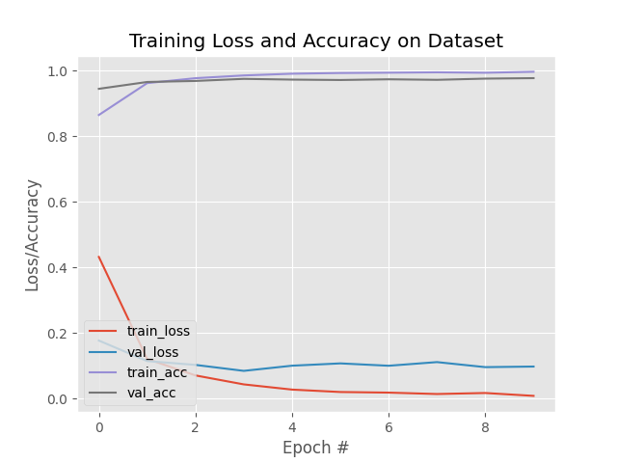**Train Split Parameter:**

I changed the value to be 0.5 and 0.25

Results for 0.5:

Accuracy decreased to 94% and loss initially was higher.

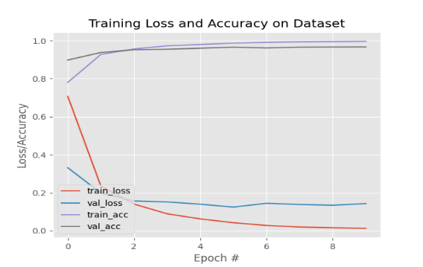Results for 0.25:

Accuracy decreased to 92% and loss was way higher.