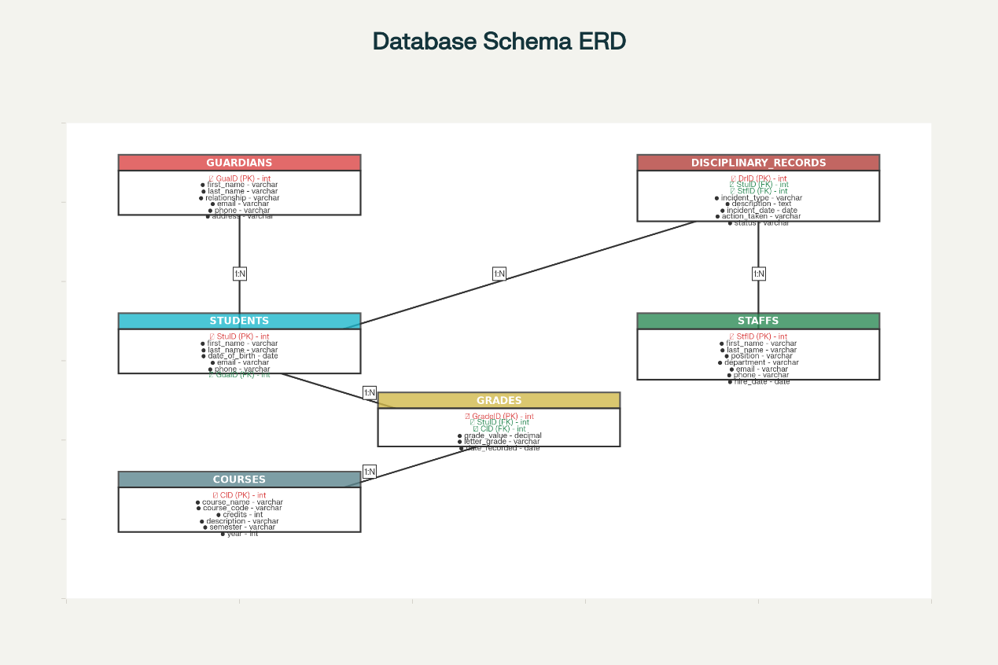

CREATE TABLE students (
StuID INT NOT NULL AUTO_INCREMENT PRIMARY KEY,
last_name VARCHAR(50) NOT NULL,
first_name VARCHAR(50) NOT NULL,
gender CHAR(1) NOT NULL,
Id_No VARCHAR(20) NOT NULL UNIQUE,
address TEXT,
email VARCHAR(100) NOT NULL,
phone CHAR(8) NOT NULL,
enrollment_year YEAR NOT NULL,
GuaID INT,
guardian_relation VARCHAR(50) NOT NULL,
FOREIGN KEY (GuaID) REFERENCES guardians(GuaID) ON DELETE SET NULL ON UPDATE CASCADE
);
StuID | last_  name | First  _name | gender | Id_No | address | email | phone | enrollment_year | GuaID | guardian_relation
100 | Chow | Jeng | M | H234545 | Flat C,/18/F, Hopewell building | Jeng@gmail.com | 23427543 | 2023 | 1000 | mother
101
102

CREATE TABLE guardians (
GuaID INT NOT NULL AUTO_INCREMENT PRIMARY KEY,
last_name VARCHAR(50) NOT NULL,
first_name VARCHAR(50) NOT NULL,
email VARCHAR(100) NOT NULL,
phone VARCHAR(20) NOT NULL
);
GuaID | last_name | first_name | email | phone

CREATE TABLE staffs (
StfID INT NOT NULL AUTO_INCREMENT PRIMARY KEY,
password VARCHAR(255) NOT NULL,
last_name VARCHAR(50) NOT NULL,
first_name VARCHAR(50) NOT NULL,
gender CHAR(1) NOT NULL,
Id_No VARCHAR(20) NOT NULL UNIQUE,
address TEXT,
email VARCHAR(100) NOT NULL,
phone VARCHAR(20) NOT NULL,
department VARCHAR(50) NOT NULL,
role VARCHAR(50) NOT NULL
);
StfID | password | last_  name | first_  name | first_  name | Id_No | address | email | phone | department | role

CREATE TABLE courses (
CID INT NOT NULL AUTO_INCREMENT PRIMARY KEY,
course_name VARCHAR(100) NOT NULL
);
CID | course_name

CREATE TABLE grades (
GradeID INT NOT NULL AUTO_INCREMENT PRIMARY KEY,
StuID INT NOT NULL,
CID INT NOT NULL,
term VARCHAR(10) NOT NULL,
grade VARCHAR(5) NOT NULL,
comments TEXT,
FOREIGN KEY (StuID) REFERENCES students(StuID) ON DELETE RESTRICT ON UPDATE CASCADE,
FOREIGN KEY (CID) REFERENCES courses(CID) ON DELETE RESTRICT ON UPDATE CASCADE
);
GradeID | StuID | CID | term | grade | comments

CREATE TABLE disciplinary_records (
DrID INT NOT NULL AUTO_INCREMENT PRIMARY KEY,
StuID INT NOT NULL,
date DATE NOT NULL,
StfID INT NOT NULL,
descriptions TEXT,
FOREIGN KEY (StuID) REFERENCES students(StuID) ON DELETE RESTRICT ON UPDATE CASCADE,
FOREIGN KEY (StfID) REFERENCES staffs(StfID) ON DELETE RESTRICT ON UPDATE CASCADE
);
DrID | StuID | date | StfID | descriptions

-- GUARDIANS TABLE INSERT INTO guardians (GuaID, last_name, first_name, email, phone) VALUES (1000, 'Chow', 'David', 'davidchow@protonmail.com', '69364231'), (1001, 'Ng', 'David', 'david1975@outlook.com', '62132899'), (1002, 'Wong', 'Margaret', 'wong.margaret@hotmail.com', '61780798'), (1003, 'Lee', 'Linda', 'lindalee@zoho.com', '90145908'), (1004, 'Lau', 'William', 'williamlau@gmail.com', '88361172'), (1005, 'Lau', 'James', 'james_lau@yahoo.com', '66859215'), (1006, 'Yeung', 'David', 'david_yeung@outlook.com', '77751694'), (1007, 'Tang', 'Margaret', 'margaret1915@zoho.com', '65288191'), (1008, 'Lau', 'Linda', 'lau.linda@yandex.com', '72904268'), (1009, 'Chow', 'David', 'david_chow@hotmail.com', '65354748'); -- STUDENTS TABLE INSERT INTO students (StuID, last_name, first_name, gender, Id_No, address, email, phone, enrollment_year, GuaID, guardian_relation) VALUES (100, 'Chow', 'Mia', 'F', 'U974628', 'Apartment 5, 12/F, Central Plaza, Sheung Wan', 'mia_chow@outlook.com', '41831063', 2023, 1000, 'Mother'), (101, 'Ng', 'Jack', 'M', 'R864544', 'Unit 2, 25/F, Exchange Plaza, Admiralty', 'jack.ng@protonmail.com', '41931511', 2024, 1001, 'Father'), (102, 'Wong', 'Noah', 'M', 'H961722', 'Flat C, 18/F, Hopewell Building, Central', 'noah_wong@zoho.com', '62339391', 2024, 1002, 'Mother'), (103, 'Wong', 'Alice', 'M', 'U623481', 'Room 3, 20/F, Landmark Centre, Admiralty', 'alice_wong@hotmail.com', '81586053', 2022, 1002, 'Mother'), (104, 'Lee', 'Chloe', 'F', 'S518801', 'Apartment 5, 12/F, Central Plaza, Sheung Wan', 'chloe_lee@zoho.com', '49436733', 2022, 1003, 'Grandparent'), (105, 'Lau', 'Alice', 'M', 'V542666', 'Flat A, 15/F, Citibank Tower, Central', 'alicelau@gmail.com', '28526544', 2024, 1004, 'Father'), (106, 'Lau', 'Iris', 'M', 'V855731', 'Flat C, 18/F, Hopewell Building, Central', 'iris_lau@mail.com', '92070937', 2023, 1004, 'Aunt'), (107, 'Lau', 'Alice', 'F', 'A857168', 'Apartment 5, 12/F, Central Plaza, Sheung Wan', 'alicelau@protonmail.com', '87187530', 2022, 1005, 'Grandparent'), (108, 'Lau', 'Noah', 'M', 'E492077', 'Unit 2, 25/F, Exchange Plaza, Admiralty', 'noah_lau@outlook.com', '92394227', 2025, 1005, 'Parent'), (109, 'Yeung', 'Grace', 'F', 'H160738', 'Unit 2, 25/F, Exchange Plaza, Admiralty', 'grace_yeung@gmail.com', '96149359', 2021, 1006, 'Parent'), (110, 'Yeung', 'Kate', 'M', 'E791798', 'Room 3, 20/F, Landmark Centre, Admiralty', 'yeung.kate@mail.com', '93793389', 2022, 1006, 'Mother'), (111, 'Tang', 'Chloe', 'F', 'V781446', 'Apartment 5, 12/F, Central Plaza, Sheung Wan', 'chloe_tang@zoho.com', '78800797', 2025, 1007, 'Father'), (112, 'Tang', 'Alice', 'F', 'A716886', 'Flat A, 15/F, Citibank Tower, Central', 'alice.tang@hotmail.com', '50885476', 2025, 1007, 'Guardian'), (113, 'Lau', 'Alice', 'M', 'K174299', 'Flat A, 15/F, Citibank Tower, Central', 'alice.lau@gmail.com', '51944441', 2023, 1008, 'Uncle'), (114, 'Chow', 'Chloe', 'F', 'H922733', 'Room 3, 20/F, Landmark Centre, Admiralty', 'chow.chloe@zoho.com', '74634663', 2022, 1009, 'Parent'); -- STAFFS TABLE INSERT INTO staffs (StfID, password, last_name, first_name, gender, Id_No, address, email, phone, department, role) VALUES (5001, 'hashed_pwd_1', 'Tang', 'Bob', 'F', 'N589710', 'Flat C, 18/F, Hopewell Building, Central', 'bob_tang@school.edu.hk', '91651177', 'Academic Affairs', 'Accountant'), (5002, 'hashed_pwd_2', 'Chan', 'Frank', 'M', 'G662336', 'Room 3, 20/F, Landmark Centre, Admiralty', 'frankchan@school.edu.hk', '92351868', 'Human Resources', 'Teacher'), (5003, 'hashed_pwd_3', 'Ng', 'Elizabeth', 'M', 'O947272', 'Flat A, 15/F, Citibank Tower, Central', 'elizabethng@school.edu.hk', '91642635', 'Academic Affairs', 'Technical Support'), (5004, 'hashed_pwd_4', 'Chan', 'Alice', 'M', 'N609231', 'Room 3, 20/F, Landmark Centre, Admiralty', 'alicechan@school.edu.hk', '93586084', 'Human Resources', 'Administrator'), (5005, 'hashed_pwd_5', 'Tang', 'Catherine', 'F', 'I922157', 'Room 3, 20/F, Landmark Centre, Admiralty', 'catherine.tang@school.edu.hk', '94785687', 'Human Resources', 'Technical Support'), (5006, 'hashed_pwd_6', 'Lee', 'Henry', 'F', 'G161324', 'Flat A, 15/F, Citibank Tower, Central', 'henrylee@school.edu.hk', '99096526', 'Academic Affairs', 'Counselor'), (5007, 'hashed_pwd_7', 'Wong', 'Alice', 'F', 'Q994141', 'Flat A, 15/F, Citibank Tower, Central', 'wong.alice@school.edu.hk', '92641282', 'Academic Affairs', 'Technical Support'), (5008, 'hashed_pwd_8', 'Lee', 'Bob', 'M', 'V346629', 'Room 3, 20/F, Landmark Centre, Admiralty', 'bob.lee@school.edu.hk', '92011363', 'IT Support', 'Teacher'), (5009, 'hashed_pwd_9', 'Chen', 'Jack', 'M', 'N789305', 'Flat A, 15/F, Citibank Tower, Central', 'jack.chen@school.edu.hk', '99482934', 'IT Support', 'Counselor'), (5010, 'hashed_pwd_10', 'Lau', 'Elizabeth', 'M', 'I515011', 'Unit 2, 25/F, Exchange Plaza, Admiralty', 'elizabeth_lau@school.edu.hk', '95033115', 'Human Resources', 'Counselor'); -- COURSES TABLE INSERT INTO courses (CID, course_name) VALUES (2001, 'Mathematics'), (2002, 'English'), (2003, 'Physics'), (2004, 'Chemistry'), (2005, 'Biology'), (2006, 'History'), (2007, 'Geography'), (2008, 'Computer Science'); -- GRADES TABLE INSERT INTO grades (GradeID, StuID, CID, term, grade, comments) VALUES (3001, 100, 2001, '202526S2', 'F', 'Good work, minor areas for improvement'), (3002, 100, 2002, '202425S2', 'D', 'Strong participation in class discussions'), (3003, 100, 2003, '202526S1', 'A-', 'Needs more practice in problem-solving'), (3004, 101, 2005, '202425S2', 'C-', 'Strong participation in class discussions'), (3005, 101, 2001, '202526S1', 'A-', 'Solid understanding of concepts'), (3006, 101, 2005, '202425S1', 'A-', 'Solid understanding of concepts'), (3007, 101, 2005, '202526S1', 'F', 'Needs more practice in problem-solving'), (3008, 102, 2006, '202425S2', 'B-', 'Some difficulty with advanced topics'), (3009, 102, 2005, '202425S1', 'A-', 'Demonstrates good grasp of material'), (3010, 102, 2005, '202425S1', 'A', 'Requires additional tutoring'), (3011, 102, 2003, '202526S1', 'B+', 'Some difficulty with advanced topics'), (3012, 102, 2007, '202425S1', 'A-', 'Good work, minor areas for improvement'), (3013, 103, 2003, '202425S1', 'C+', 'Solid understanding of concepts'), (3014, 103, 2007, '202425S2', 'A', 'Strong participation in class discussions'), (3015, 103, 2006, '202425S1', 'C+', 'Needs more practice in problem-solving'), (3016, 103, 2004, '202425S1', 'C+', 'Demonstrates good grasp of material'), (3017, 103, 2003, '202425S2', 'B+', 'Solid understanding of concepts'), (3018, 104, 2001, '202425S2', 'C+', 'Demonstrates good grasp of material'), (3019, 104, 2004, '202526S1', 'B+', 'Good work, minor areas for improvement'), (3020, 104, 2007, '202425S1', 'C-', 'Needs more practice in problem-solving'), (3021, 104, 2004, '202526S2', 'C+', 'Strong participation in class discussions'), (3022, 105, 2004, '202425S1', 'B', 'Demonstrates good grasp of material'), (3023, 105, 2006, '202526S1', 'A-', 'Strong participation in class discussions'), (3024, 105, 2006, '202526S2', 'D', 'Requires additional tutoring'), (3025, 106, 2002, '202526S1', 'B+', 'Strong participation in class discussions'), (3026, 106, 2001, '202425S1', 'F', 'Demonstrates good grasp of material'), (3027, 106, 2006, '202526S1', 'C', 'Good work, minor areas for improvement'), (3028, 107, 2004, '202526S1', 'A', 'Demonstrates good grasp of material'), (3029, 107, 2001, '202425S2', 'C+', 'Demonstrates good grasp of material'), (3030, 107, 2002, '202526S1', 'F', 'Requires additional tutoring'), (3031, 107, 2002, '202526S1', 'D', 'Strong participation in class discussions'), (3032, 108, 2007, '202526S1', 'C', 'Strong participation in class discussions'), (3033, 108, 2003, '202425S2', 'C', 'Demonstrates good grasp of material'), (3034, 108, 2003, '202526S1', 'C', 'Excellent performance, consistent effort'), (3035, 108, 2005, '202526S1', 'B', 'Demonstrates good grasp of material'), (3036, 108, 2006, '202526S2', 'C-', 'Some difficulty with advanced topics'), (3037, 109, 2004, '202526S2', 'B+', 'Good work, minor areas for improvement'), (3038, 109, 2005, '202526S1', 'A-', 'Needs more practice in problem-solving'), (3039, 109, 2005, '202425S2', 'B', 'Solid understanding of concepts'), (3040, 109, 2001, '202425S1', 'B', 'Some difficulty with advanced topics'), (3041, 109, 2002, '202526S2', 'C', 'Needs more practice in problem-solving'); -- DISCIPLINARY_RECORDS TABLE INSERT INTO disciplinary_records (DrID, StuID, date, StfID, descriptions) VALUES (4001, 100, '2025-06-26', 5007, 'Incomplete homework submission'), (4002, 100, '2025-09-23', 5001, 'Assignment not submitted on time'), (4003, 101, '2025-09-15', 5009, 'Failure to bring required materials'), (4004, 104, '2025-09-26', 5008, 'Use of mobile phone during class'), (4005, 104, '2025-06-09', 5010, 'Violation of school uniform policy'), (4006, 105, '2025-05-27', 5009, 'Late arrival to school - 3 instances'), (4007, 105, '2025-06-12', 5008, 'Minor classroom disruption'), (4008, 106, '2025-07-07', 5005, 'Incomplete homework submission'), (4009, 106, '2025-05-20', 5005, 'Use of mobile phone during class'), (4010, 110, '2025-08-22', 5006, 'Violation of school uniform policy'), (4011, 111, '2025-09-25', 5003, 'Incomplete homework submission');

