PROVISIONAL PATENT APPLICATION
MERLIN ENERGY CONFIGURATION SYSTEM

Applicant: | Robert Christopher
Product: | Merlin Energy — Commercial BESS Quoting & Configuration Platform
Live URL: | https://merlinenergy.net
Filing Date: | March 30, 2026
Document Type: | Provisional Patent Application (35 U.S.C. § 111(b))
Classification: | CONFIDENTIAL — ATTORNEY-CLIENT PRIVILEGED

⚠️ This document is attorney-client privileged and contains trade secret and patent-sensitive information. Do not distribute outside legal counsel.

TITLE OF INVENTION
AUTOMATED COMMERCIAL ENERGY STORAGE SYSTEM CONFIGURATION AND QUOTING PLATFORM WITH FOUR-LAYER PHYSICS SIZING, PROACTIVE BACKGROUND SYNTHESIS, AND SOURCE-TRACEABLE PRICING COMPLIANCE

CROSS-REFERENCE TO RELATED APPLICATIONS
This is an original provisional patent application. No prior provisional applications have been filed for this invention. Applicant intends to file a non-provisional application claiming priority to this provisional within twelve (12) months of this filing date pursuant to 35 U.S.C. § 119(e).

FIELD OF THE INVENTION
The present invention relates to computer-implemented systems for configuring and pricing commercial battery energy storage systems (BESS), and more particularly to automated multi-step configuration platforms that combine geographic intelligence, physics-based facility sizing, machine-learning-assisted industry classification, proactive background computation, and source-traceable financial modeling to generate bankable commercial energy system quotes.

BACKGROUND OF THE INVENTION
Commercial battery energy storage systems represent a rapidly growing segment of the energy market. However, properly sizing a BESS for a commercial facility requires expertise across multiple domains: electrical engineering (demand calculations), solar irradiance analysis, utility rate structures, financial modeling, and equipment pricing intelligence.
Existing solutions suffer from significant deficiencies:
- Manual quoting processes requiring 2–4 weeks and specialized engineering staff
- Single-point sizing that produces one configuration rather than optimized alternatives
- Static pricing databases that do not incorporate real-time market intelligence
- No source attribution — customers cannot verify the basis for quoted numbers
- Separate tools for sizing, pricing, and financial analysis requiring manual integration
- No probabilistic risk modeling for financial performance guarantees
What is needed is a unified automated platform that simultaneously addresses all of these deficiencies while producing bankable, source-traceable quotes suitable for financing and investment decisions.

SUMMARY OF THE INVENTION
The present invention provides a computer-implemented system for automatically generating bankable commercial energy storage system configurations, comprising:
(1) A location-aware geographic intelligence layer that resolves a user-supplied location identifier through a multi-tier fallback chain while simultaneously initiating independent parallel fetches for utility rate data, solar irradiance data, and weather data;
(2) A probabilistic business classification engine that maps a business name to a facility-type category using confidence-weighted keyword matching, eliminates intermediate configuration steps when classification confidence exceeds a threshold, and atomically populates physics constraints in the same transaction;
(3) A four-layer energy system sizing engine that combines geographic, industry, operational, and goal parameters into three distinct optimized configurations;
(4) A proactive synthesis engine that begins computing configurations before the user requests them using a content-addressable cache;
(5) A source-traceable pricing engine where every computed value is linked to a documented external authority with full audit metadata.

BRIEF DESCRIPTION OF THE DRAWINGS
Figure 1: System Architecture — Seven-layer architecture showing the User Interface Layer, Wizard & Orchestration Layer, Quote & Pricing Engine Layer, Intelligence & Data Layer, and External Data Sources with data flow arrows between components.
Figure 2: Wizard Workflow Flowchart — End-to-end user flow from business name entry through ZIP code resolution, industry classification, load profiling, add-on selection, MagicFit optimization, and TrueQuote™-authenticated quote delivery with export options.
Figure 3: Optimization Engine — Three-panel diagram showing the Four-Layer Sizing Engine (Layers 1–4 with solar double-gate formula), MagicFit Three-Tier Optimizer (upsize matrix and content-addressable cache), and TrueQuote™ Compliance stack (source registry, audit metadata, margin policy, and Forbidden UI methods).
Figure 4: User Interface — Five-screen wireframe depicting Steps 0 through 5 of the Merlin Energy wizard, showing business detection, location intel reveal, load profile entry, add-on configuration, and final quote results with export options.

DRAWINGS

Figure 1
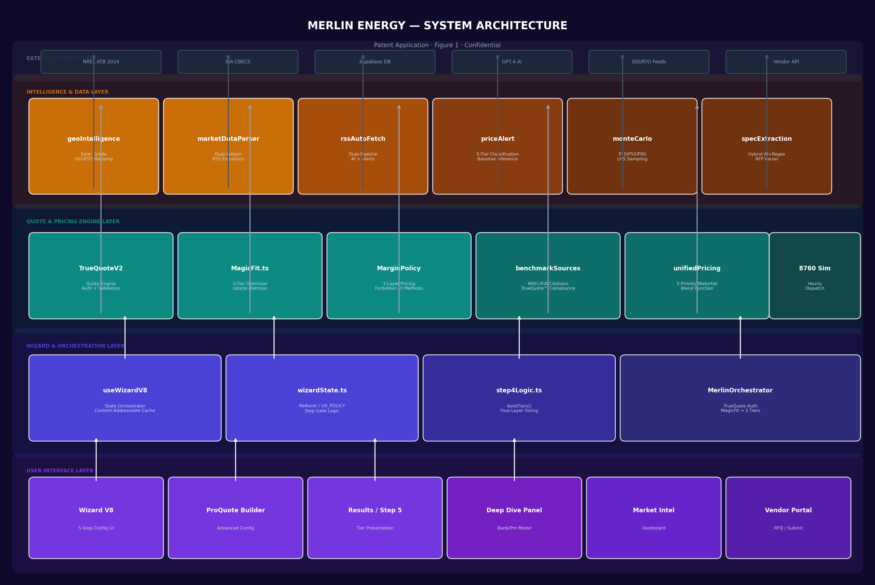
Figure 1 — System Architecture — Seven-layer architecture showing the User Interface Layer,...

Figure 2
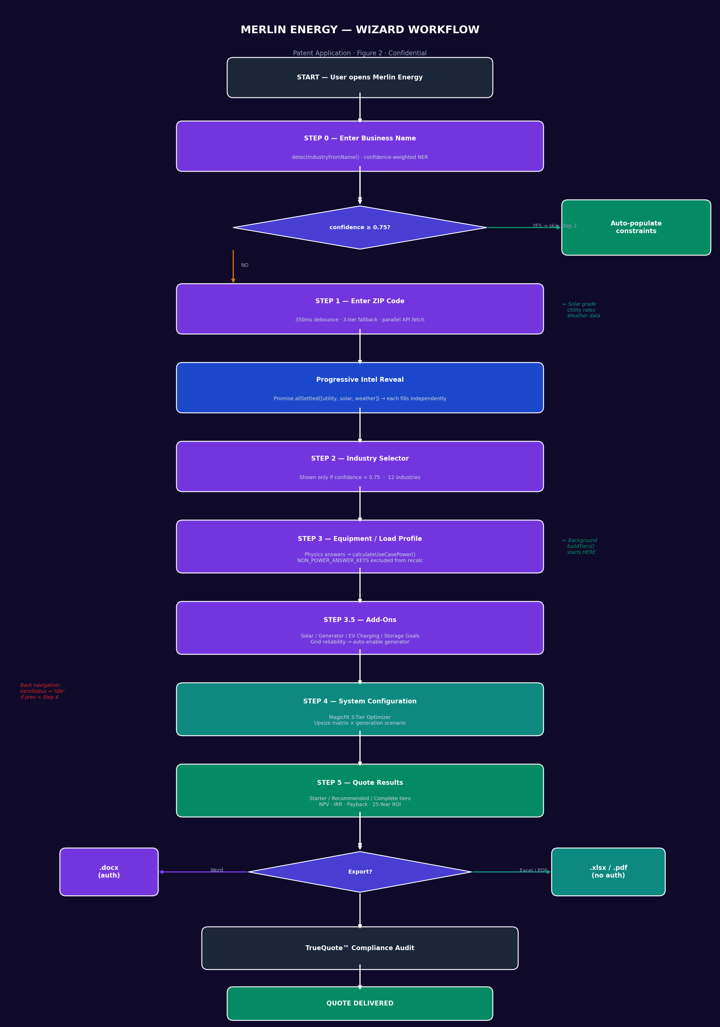
Figure 2 — Wizard Workflow Flowchart — End-to-end user flow from business name entry throug...

Figure 3
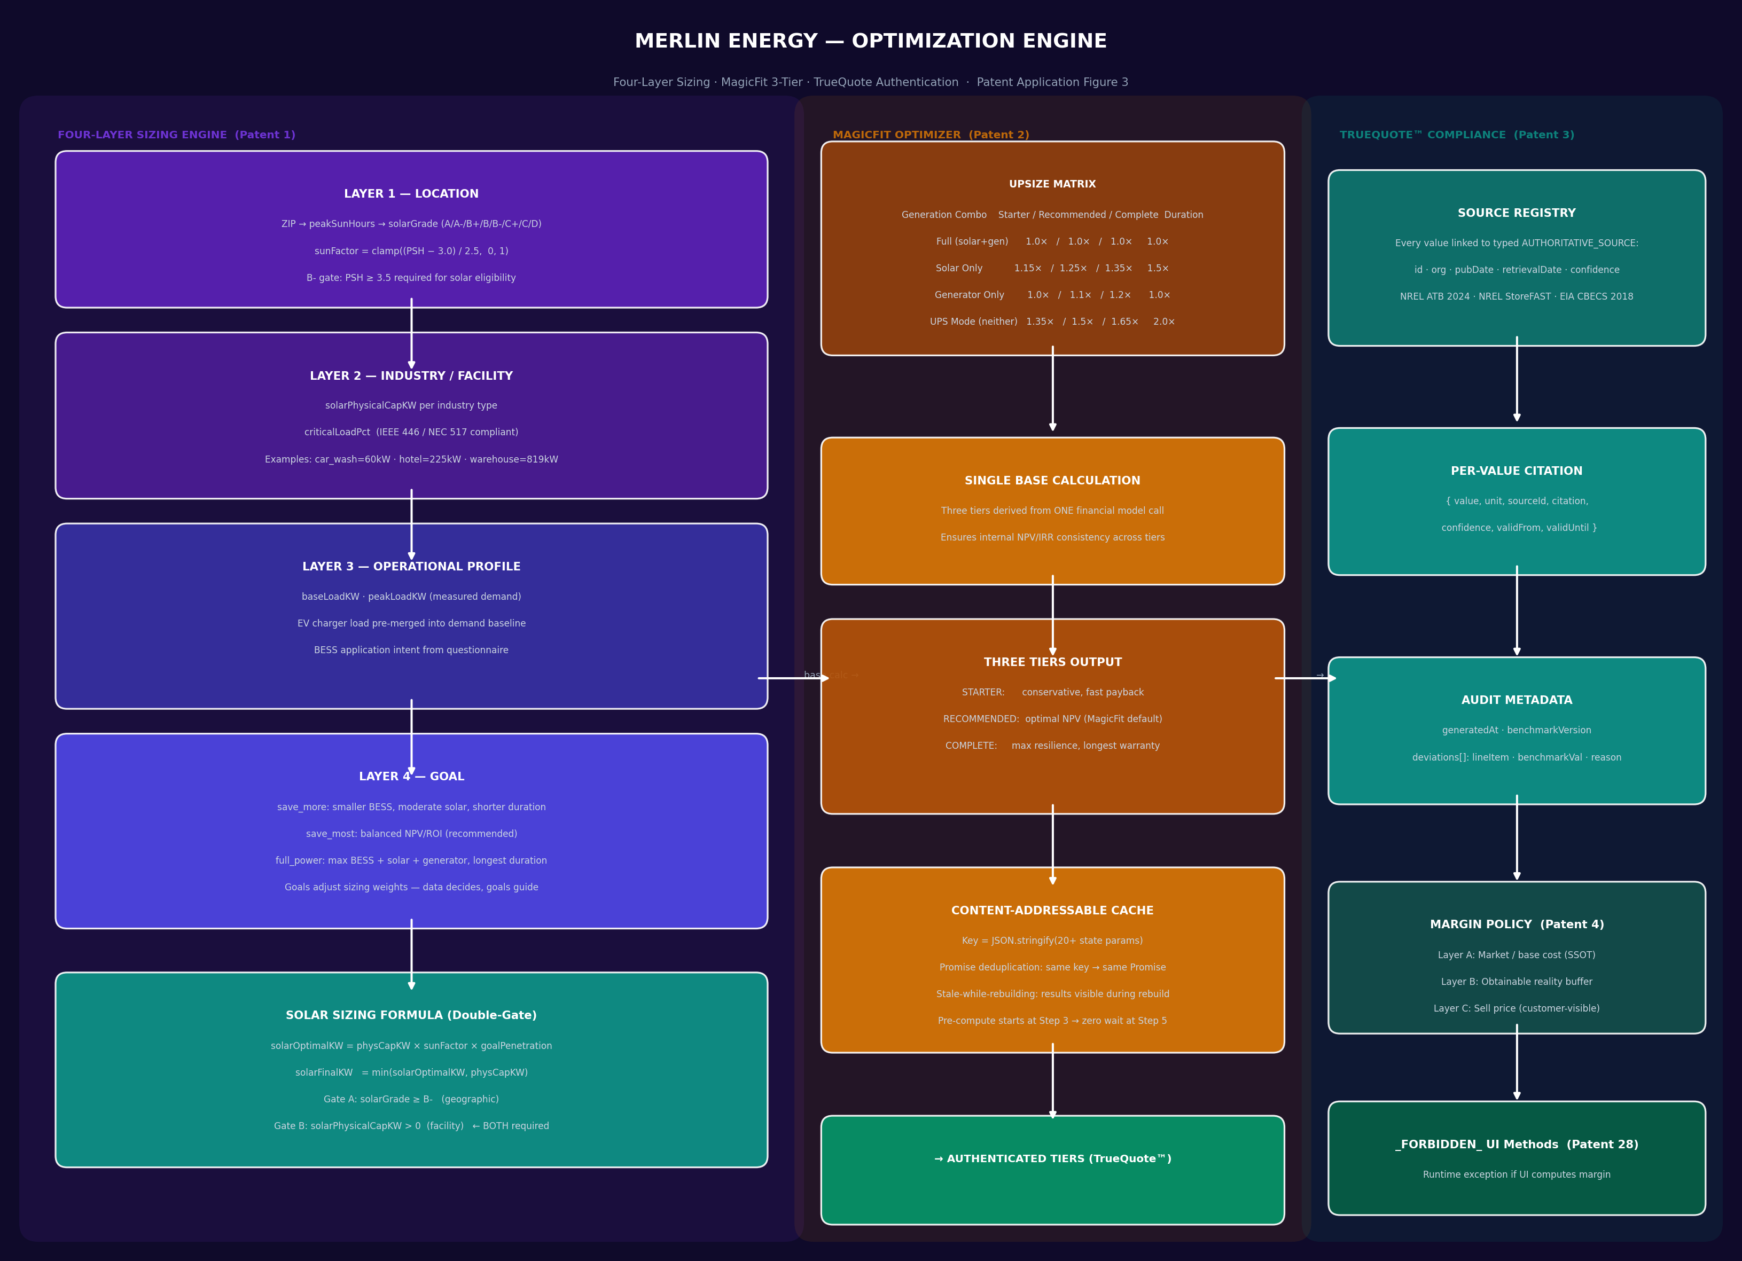
Figure 3 — Optimization Engine — Three-panel diagram showing the Four-Layer Sizing Engine (...

Figure 4
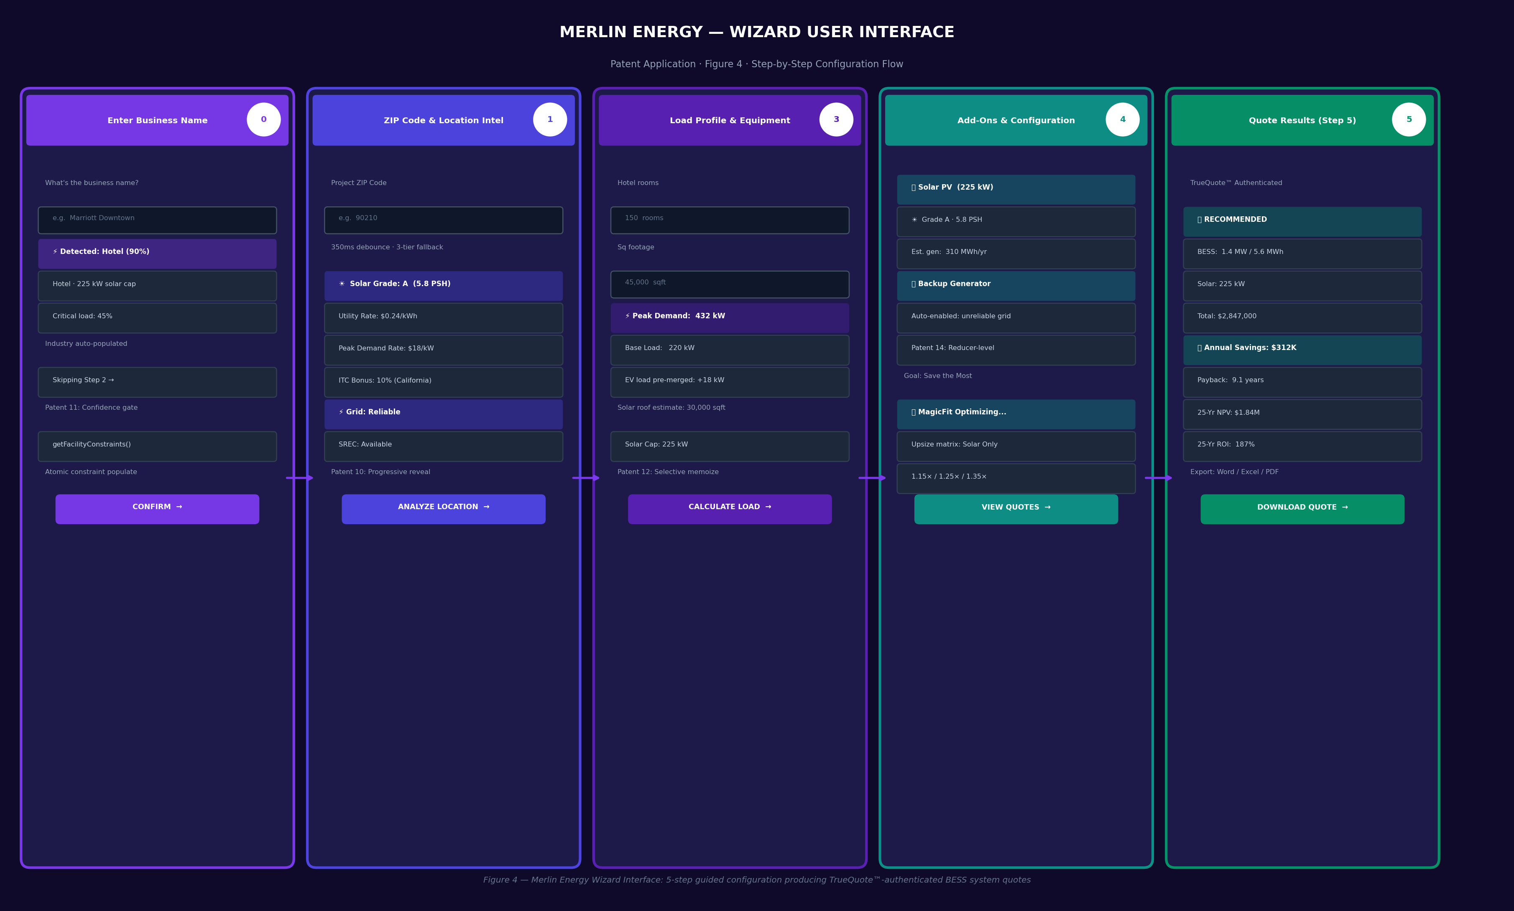
Figure 4 — User Interface — Five-screen wireframe depicting Steps 0 through 5 of the Merlin...

DETAILED DESCRIPTION OF THE PREFERRED EMBODIMENTS

Patent 1 — Four-Layer Energy System Sizing Engine
The sizing engine operates as a four-layer information pyramid where each layer is collected sequentially and each constrains the next. Layer 1 derives a continuous solar viability coefficient: sunFactor = clamp((peakSunHours − 3.0) / 2.5, 0, 1). A letter-grade system (A through D) maps PSH values to solar eligibility; B− (PSH ≥ 3.5) is the minimum viable grade constituting a hard exclusion gate. Layer 2 applies industry-specific physical constraints including maximum solar hosting capacity and critical load percentage per IEEE 446-1995. Layer 3 incorporates measured operational demand with EV charging pre-merged into the baseline. Layer 4 applies goal-weighted penetration adjustments.
Key Source Files:
- src/wizard/v8/step4Logic.ts
- src/wizard/v8/wizardState.ts (isSolarFeasible)
- src/services/useCasePowerCalculations.ts

Patent 2 — MagicFit: Generative Three-Tier Optimizer
MagicFit generates three distinct optimized energy system configurations from a single base calculation. A four-scenario upsize matrix dynamically adjusts BESS capacity based on whether solar and/or generator are included: Full generation (1.0×/1.0×/1.0×), Solar Only (1.15×/1.25×/1.35× with 1.5× duration), Generator Only (1.0×/1.1×/1.2×), and UPS Mode — when neither source is selected — (1.35×/1.5×/1.65× with 2.0× duration). All three tiers derive from a single financial model call ensuring internal NPV/IRR consistency.
Key Source Files:
- src/services/MagicFit.ts
- src/services/TrueQuoteEngineV2.ts
- src/services/MerlinOrchestrator.ts

Patent 3 — Source-Traceable Quote Generation (TrueQuote™)
Every computed value in a customer-facing quote is linked to a documented, version-controlled external authority. A typed AUTHORITATIVE_SOURCES registry contains id, name, organization, type, publicationDate, retrievalDate, vintage, lastVerified, url, and notes for each source. Per-value citations return { value, unit, sourceId, citation, confidence, validFrom, validUntil }. QuoteAuditMetadata includes deviations[] logging any value that differs from the national benchmark with lineItem, benchmarkValue, appliedValue, and reason.
Key Source Files:
- src/services/benchmarkSources.ts
- src/services/marginPolicyEngine.ts
- src/services/unifiedQuoteCalculator.ts

Patent 9 — Proactive Background Synthesis Engine
The system proactively begins computing final quote results at Step 3, two full steps before the results page. A content-addressable cache key (createTierBuildKey) is a deterministic JSON fingerprint derived from 20+ state parameters including location, industry, load measurements, add-on selections, and geographic intelligence values. If the fingerprint matches an in-flight Promise, that Promise is returned without duplication. Stale-while-rebuilding ensures existing results remain visible during background rebuilds.
Key Source Files:
- src/wizard/v8/useWizardV8.ts (createTierBuildKey)
- src/wizard/v8/step4Logic.ts (buildTiers)

Patent 11 — Confidence-Gated Wizard Step Elimination
When business name classification confidence exceeds 0.75, the system simultaneously eliminates Step 2 from navigation AND populates all downstream physics constraints (solarPhysicalCapKW, criticalLoadPct) in a single atomic two-phase dispatch. This prevents the null-state window that would otherwise exist between step elimination and constraint availability — a window that would cause solar to be excluded from all subsequent calculations. The client-side classifier uses confidence-weighted keyword matching with named entity recognition for 30+ industry categories and major brand names.
Key Source Files:
- src/wizard/v8/useWizardV8.ts (detectIndustryFromName)
- src/wizard/v8/wizardState.ts (CONFIRM_BUSINESS reducer)

Patent 28 — Forbidden UI Computation Enforcement
The pricing engine attaches _FORBIDDEN_computeMarginInUI() and _FORBIDDEN_computeNetCostInUI() methods to every MarginRenderEnvelope result object. These methods throw runtime exceptions if called, making it structurally impossible for UI code to compute margin independently. This architectural enforcement guarantees that every sell price reaching the customer interface was produced by the marginPolicyEngine with full audit trail. The _FORBIDDEN_ naming convention also enables static analysis detection.
Key Source Files:
- src/services/marginPolicyEngine.ts (MarginRenderEnvelope)
- src/services/TrueQuoteEngineV2.ts

CLAIMS
What is claimed is:

1. [Independent Claim 1] A computer-implemented system for automatically generating commercial energy storage system configurations, comprising: a processor; a non-transitory computer-readable medium storing instructions that, when executed, cause the processor to: receive a postal code from a user; resolve the postal code through a multi-tier fallback chain comprising an external geocoding service, a local utility rate database, and an identity fallback; simultaneously initiate independent parallel data fetches for solar irradiance data, utility rate data, and weather data; and populate a geographic intelligence profile independently from each fetch result as it completes.
2. [Independent Claim 2] A computer-implemented method for sizing a commercial battery energy storage system, comprising: deriving a solar viability coefficient from a peak sun hours value using a continuous transfer function; applying a letter-grade classification wherein a minimum grade threshold constitutes a hardware exclusion gate preventing solar inclusion in system configurations; applying industry-specific physical capacity constraints; incorporating measured operational demand data; and applying goal-weighted sizing adjustments.
3. [Independent Claim 3] A computer-implemented system for generating optimized energy storage configurations, comprising: a base configuration calculator; a generation scenario detector that identifies which combination of solar generation and backup generation sources are selected; an upsize matrix that applies scenario-specific capacity multipliers to battery storage size and duration, wherein a configuration with neither solar nor backup generation receives a maximum upsize multiplier; and a tier generator that derives three distinct configurations from a single base financial model computation.
4. [Dependent Claim 4] The system of claim 3, wherein the upsize matrix applies a duration multiplier of 2.0 to configurations with neither solar nor backup generation, compensating for the absence of on-site generation through extended storage duration.
5. [Independent Claim 5] A computer-implemented system for enforcing pricing audit integrity, comprising: a pricing engine that computes sell prices with full audit metadata; and a result object returned to a user interface layer comprising embedded methods that throw runtime exceptions when invoked, wherein the embedded methods correspond to margin and net cost computation operations, thereby making independent user-interface-layer pricing computation structurally impossible.
6. [Independent Claim 6] A computer-implemented method for proactive energy system configuration synthesis, comprising: monitoring user configuration state during a multi-step wizard process; computing a deterministic cache key from a plurality of state parameters; initiating a background computation of final system configurations responsive to detecting a trigger step, wherein the trigger step precedes the results step by at least two steps; returning an in-flight computation promise when the cache key matches an existing computation; and displaying previously computed results while a background recomputation proceeds.
7. [Independent Claim 7] A computer-implemented method for business-type-gated wizard navigation, comprising: applying a confidence-weighted keyword classifier to a business name input; comparing a resulting confidence score to a threshold; in response to the confidence score meeting the threshold, in a single atomic transaction: modifying a navigation state to eliminate an intermediate configuration step from the user's path, and populating physics constraint parameters required by subsequent steps.

ABSTRACT
A computer-implemented system and method for automatically generating bankable commercial energy storage system (BESS) configurations. The system comprises a location-aware geographic intelligence layer that resolves postal codes through a multi-tier fallback chain while initiating parallel data fetches; a confidence-weighted business classification engine that eliminates configuration steps and atomically populates physics constraints when classification confidence exceeds a threshold; a four-layer sizing engine combining geographic, industry, operational, and goal parameters into three optimized configurations via a generation-scenario-specific upsize matrix; a proactive background synthesis engine using a content-addressable cache keyed on configuration state to pre-compute results before the user reaches the results step; a source-traceable pricing engine linking every computed value to a documented external authority; and a pricing integrity enforcement mechanism that embeds exception-throwing methods on result objects to make user-interface-layer margin computation structurally impossible. The system produces TrueQuote™-authenticated quotes suitable for commercial energy financing and investment decisions.

INVENTOR DECLARATION
I hereby declare that:
- I am the original inventor of the subject matter claimed in this application.
- I have reviewed and understand the contents of this application.
- I acknowledge my duty to disclose to the USPTO all information known to me to be material to patentability.
- I believe the invention described herein has not been publicly disclosed more than one year prior to this filing date.

Inventor: Robert Christopher
Date: March 30, 2026
Signature: ___________________________

────────────────────────────────────────────────────────────────────────────────
Document generated: March 30, 2026 · Merlin Energy Platform · CONFIDENTIAL — ATTORNEY-CLIENT PRIVILEGED

