**DSCI 5360 – Data Visualization**

**Spring 2020/Final Project**

**A Study of the Distribution of ICU beds across USA**

**Introduction**

In November 2019, an unforeseen outbreak exploded in the Hubei province in China. In spite of its severity, the impact of the outbreak was undermined which gave rise to a faster spread in the region. The early 2020 has taken a different course; the potential of a global threat was assessed, and a global pandemic was waged by the WHO.

In the evolution of the global health crisis, the coordination by various countries to stop the harm was deemed late. The first case was recorded in the USA in January 21, 2020 at Washington. Despite effort by the USA to curb the spread, cases this day surpasses 1,500,000.

This report is intended to dive in a deep study of the trend of COVID 19 rising cases, death toll and more importantly the resources being deployed to manage the situation. This was done by modeling the data and generating meaningful interpretation.

The data is collected from the following datasets <https://raw.githubusercontent.com/nytimes/covid-19-data/master/us-counties.csv>) and <https://docs.google.com/spreadsheets/d/1xAyBFTrlxSsTKQS7IDyr_Ah4JLBYj6_HX6ijKdm4fAY/edit?usp=sharing>

The cases presented are real data collated from 50 states in the United States of America.

**Analysis**

Preparing the database

The Covid 19 data was derived from January 21, 2020 to May 18, 2020 spread across every state in America. The hospital bed allocation dataset which is based on 50% reduction in occupancy was joined with the Covid 19 dataset at the State level in order to produce one data source.

The attributes that were used for this analysis are the Cases, Death, Total ICU (Intensive Care Unit) beds, State and Date (for filtering).

The Maximum value of each measure was applied to get the accurate aggregate from each State at the most recent date (May 18, 2020).

By using the filter by State and Date, the aggregates can be derived respectively.

I applied calculated fields such as Death rate, Color Grading, Ratio of cases to death and Ratio of cases to ICU bed to establish a clearer picture of the reality.

However, there is need to update the dataset for near real-time analysis as the case may be in order to follow recent developments.

Fig. 1 - Interactive Map – Spread

This Visualization shows the spread of Covid19 across all 50 states in America starting from Washington where it was first discovered in New York which by far has the highest number of cases. The duration of Spread spans from Jan 22, 2020 when it was first discovered to May 18, 2020 (date dataset was extracted from source).

Using the filter by date legend control, we can easily tell when each state detected its first case.

Fig. 2 - Trend Cases/Death

Here the line chart shows that Covid19 Cases (blue diversion) and Death (red diversion) has been on a steady increase across the USA since its first discovery at Washington in Jan 22, 2020, although the first Death was recorded in the month of February.

The curve is yet to flatten even as measures are being put in place to contain the spread.

Fig. 3 - Cases by State

This figure represents the distribution of cases across all states in the USA. Here it is evident that New York by far has the highest number of cases which has been on the increase (as shown in Fig 1). New York is followed by Illinois. These two states have over 50,000 cases with New York at 198,114 as at May 18, 2020.

The number of cases per state for each date can be filtered using the date legend control.

Fig. 4 - Death by State

Just like Fig 3, Fig 4 represents the deaths across states in the USA with New York recording the highest number of death followed by Illinois. However, note that death rate was calculated and denoted by the color saturation on the bar chart.

The following calculation was used for death rate: (MAX([Deaths])/MAX([Cases 1]))*100

Following the application of the death rate it can be seen that Michigan has the highest death rate compared to New York which has the highest number of deaths.

Fig. 5 - State & Death Rate

This Fig presents a clear representation of Michigan as the state with the highest death rate followed by New York.

Texas is amongst the states with the lowest death rate.

Fig. 6 - Comparison Cases Vs Death

Here the packed bubbles show the maximum number of cases denoted by size and the maximum number of death denoted by the color saturation.

New York clearly leads followed by Illinois, California, Michigan and Florida progressively.

Recall these numbers are as at May 18, 2020.

Fig, 7 - Comparison Cases Vs Ratio of Cases to Death – Map

The saturation on the map shows the cases while the size of the dot shows the ratio of cases to death calculated as thus: STR(ROUND(MAX([Cases 1])/MAX([Deaths])))+':'+'1'

The ratio of cases to death at Michigan is 9:1 which buttresses the highest death rate shown in the previous fig. This is followed by New York 10:1.

Although Illinois is second with the highest number of death, the death rate is 22:1 but measures have to be put in place as it is at a high risk of increased death rate.

Filter can be applied on the Ratio of Cases to Death legend control to determine each state.

Fig. 8 - ICU Bed Vs State

Despite the increased number of Cases and Death in states like New York, Illinois and Michigan, the distribution of ICU bed appears to be more in California, Texas and Florida as shown on the distribution of the bar chart in Fig 8.

|  |  |
| --- | --- |
| State | ICU Beds |
| California | 8,105 |
| Texas | 7,128 |
| Florida | 6,433 |
| New York | 4,308 |
| Illinois | 3,106 |
| Michigan | 2,604 |

Fig. 9 & 10 - Comparison Cases Vs ICU Bed

On the map (Fig. 10) the ratio of cases to ICU bed was calculated for each state using the formula: STR(ROUND(MAX([Cases 1])/MAX([Total ICU Beds])))+':'+'1'

|  |  |
| --- | --- |
| State | Ratio of Cases to ICU bed |
| Texas | 1:1 |
| Florida | 2:1 |
| California | 5:1 |
| New York | 46:1 |
| Illinois | 21:1 |
| Michigan | 7:1 |

It is clear to note that New York and Illinois are in dire need of ICU bed supplies in order to manage the cases as they keep increasing.

Filter can be applied on the ratio for each State.

Fig. 11 - Cases/Death/ICU Bed

This is a scatter plot that shows New York as an Outlier compared to other states. Comparing Cases Vs Death and Cases Vs Bed, it is worthy to note how the State of New York stands out followed by Florida.

The following calculation was done to distinguish all categories:

IF MAX([Cases 1] > 100000) THEN 'HIGH'

ELSEIF MAX ([Cases 1] >= 50000) THEN 'MED'

ELSE 'LOW'

END

Fig. 12 - Cases/Death/Bed Summary

Summarizes all the numbers discussed on a Tree Map. Cases are shown by the size of each map while ICU bed distribution is denoted by the color saturation.

This is for each State in the USA and as at May 18, 2020.

Fig. 13 – Dashboard – ICU bed & State

The ICU bed/Cases Vs State dashboard (Fig. 12) gives the decision makers an overview of the situation regarding the points buttressed in previous figures discussed above. Without going through the other visualizations, it is obvious that states of New York and Illinois need more ICU beds as quickly as possible.

Fig 14. A Story on ICU bed distribution across USA for Covid 19 Cases

The Story presented in Fig. 14 gives a clear overview of visualizations represented independently.

While some other states need bed supplies as well, New York and Illinois ought to be prioritized.

**Conclusion**

This report is an attempt to review the cases of Covid19 across the USA and compare the readiness level for surge. According to the data acquired and reviewed, it can be shown that New York has the highest number of Covid19 cases while Michigan has the highest death rate. Illinois has the second highest number of cases and death.

“Our goal is to give hospital leaders and policy makers a clear sense of when they will hit capacity, and strategic information on how to prepare for rising numbers of patients with COVID-19 needing care,” - Ashish K. Jha, director of the Harvard Global Health Institute (HGHI) and K.T. Li Professor of Global Health at the Harvard T.H. Chan School of Public Health.

Frequent data analysis in these crucial times provides a pathway to understanding what is needed to get hospitals, the state and the country ready.

From this review, we can deduce that New York and Illinois are critical cases that need immediate attention.

“Pandemics are a time when we need to share information fast, but we also need to be accurate and explain what our estimates mean, especially when they are scary estimates,” - Stefanie Friedhoff, director of content and strategy at HGHI and a veteran journalist.

**Fig. 1 – Interactive Map Spread**

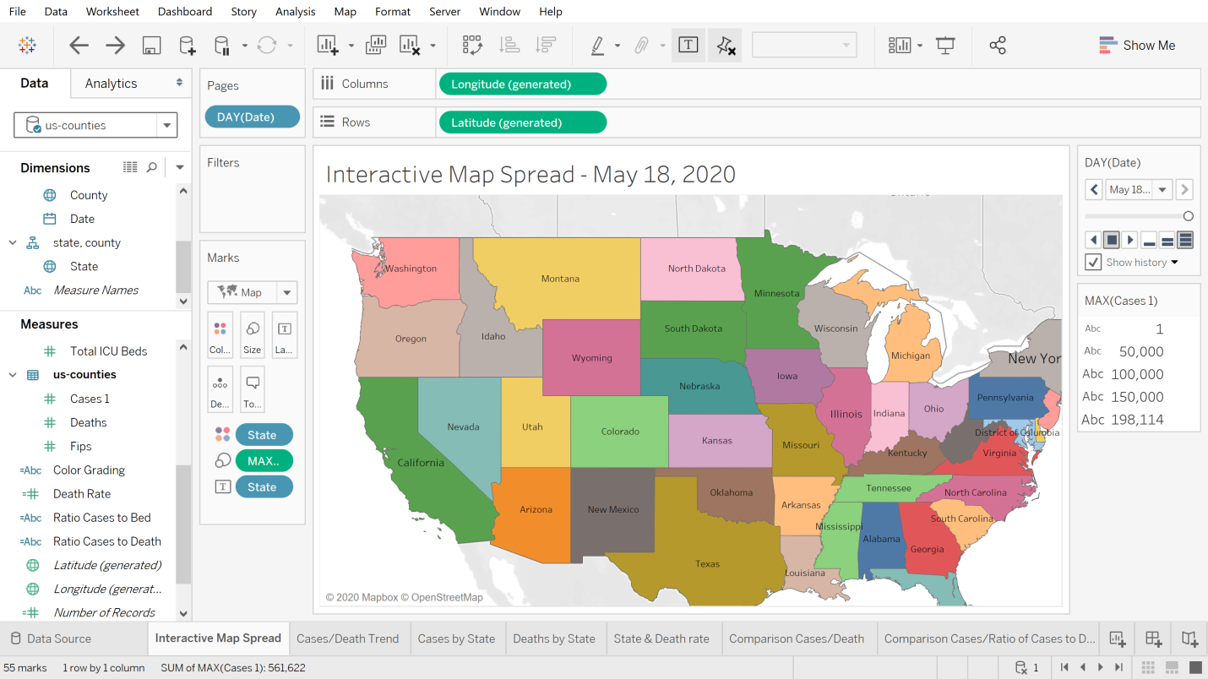

**Fig. 2 - Trend Cases/Death**

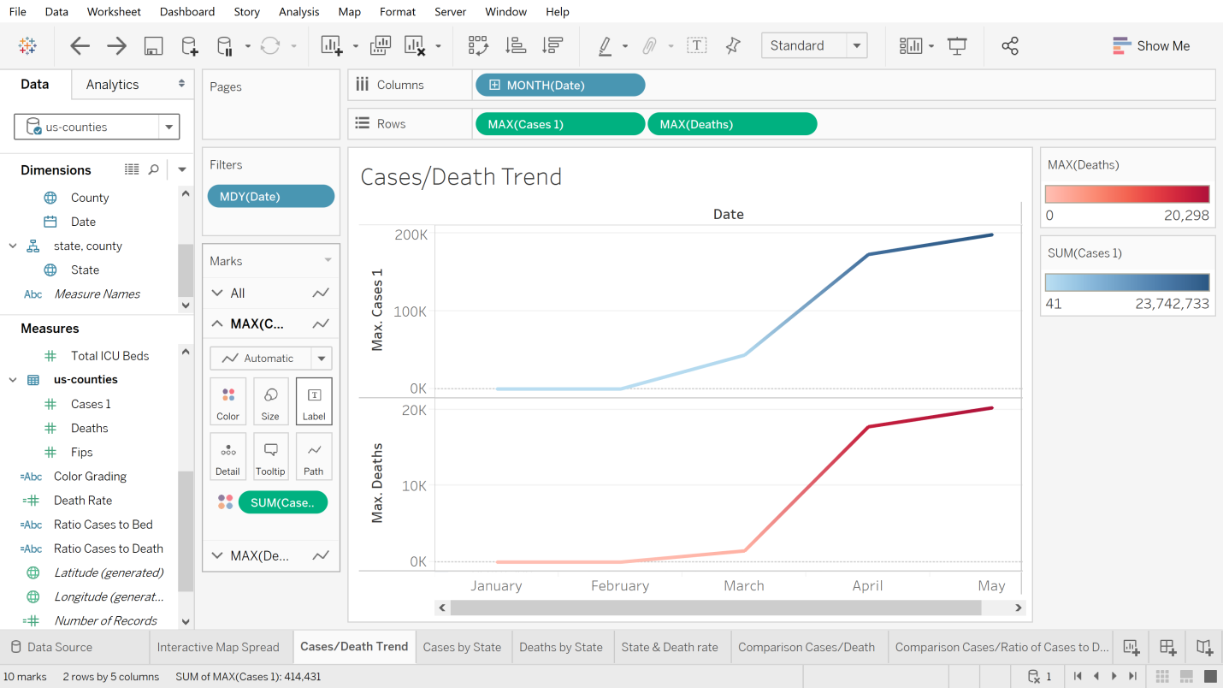

**Fig 3 – Cases by State**

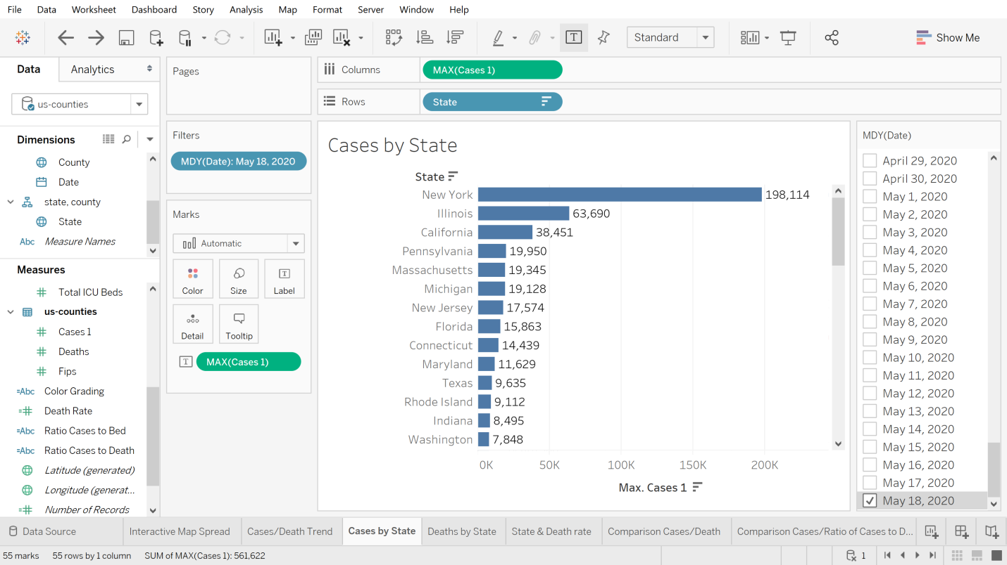

**Fig. 4 – Death by State**

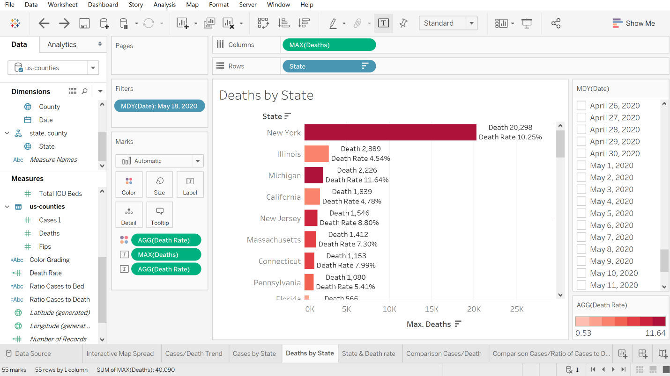

**Fig 5 – State and Death Rate**

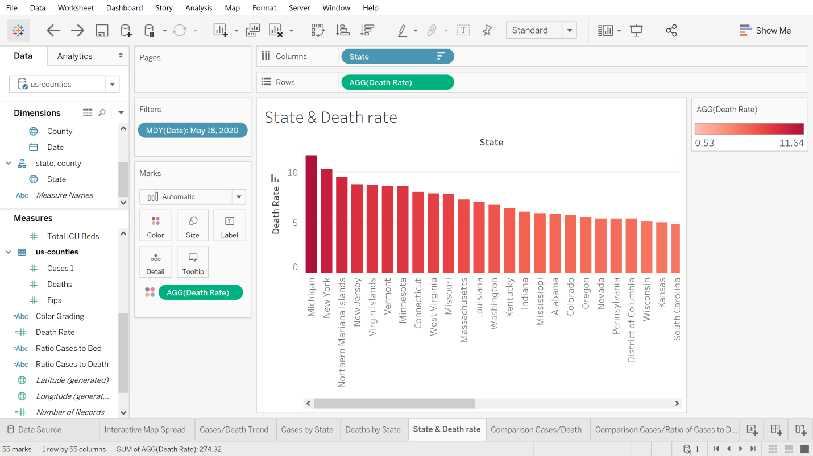

**Fig 6 – Comparison Cases/Death**

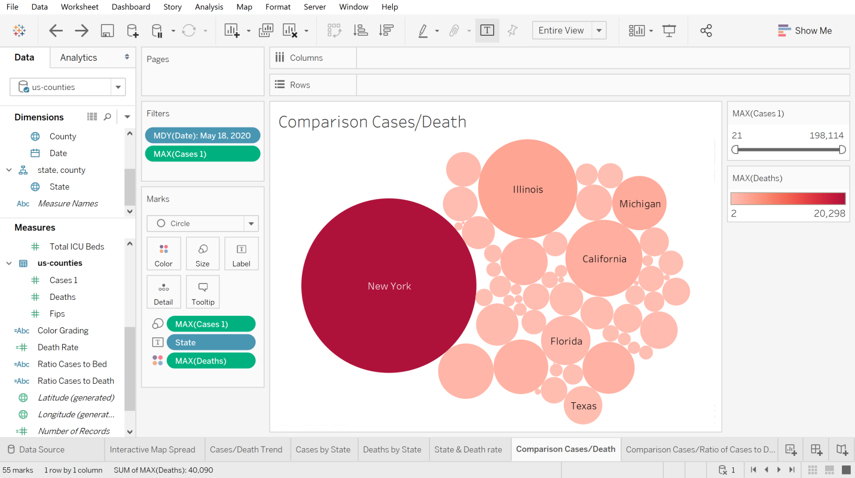

**Fig. 7 - Comparison Cases Vs Ratio of Cases to Death - Map**

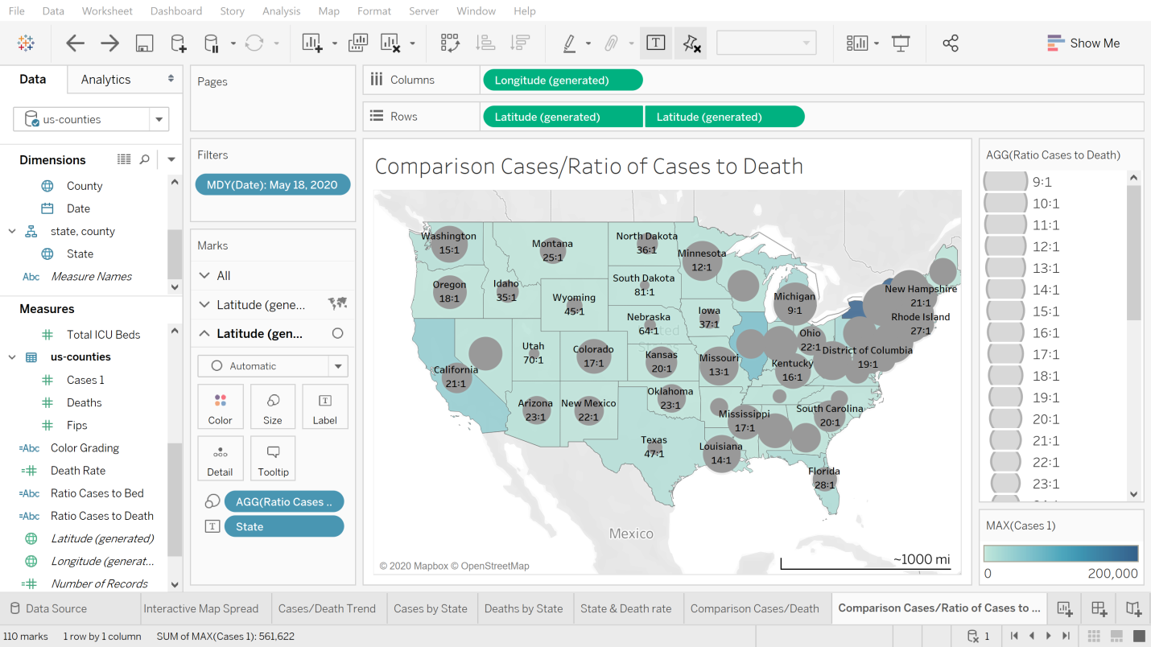

**Fig. 8 - ICU Bed Vs State**

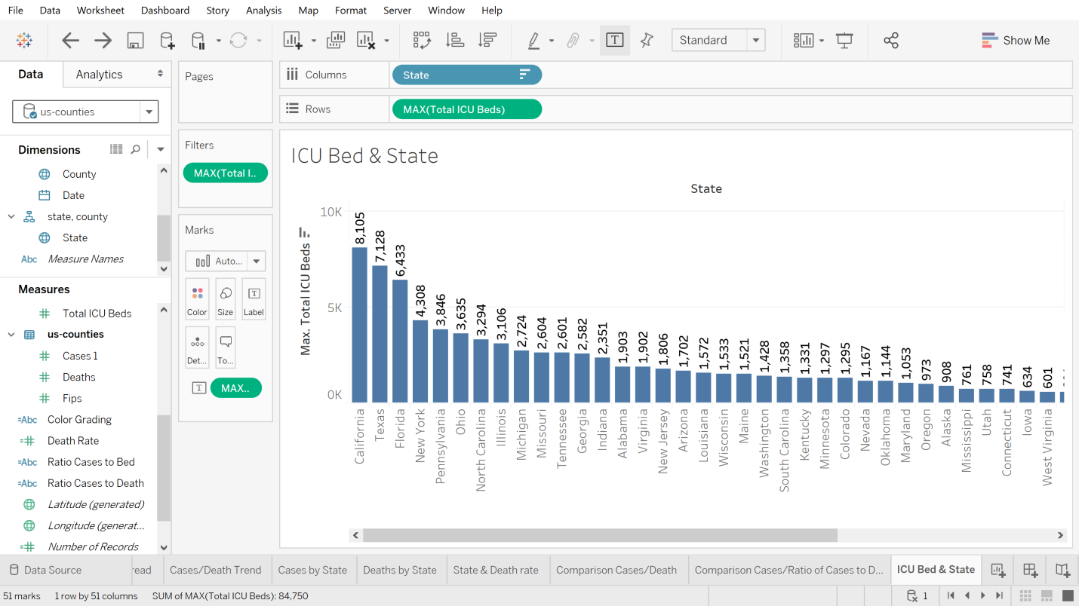

**Fig. 9 Cases & ICU Bed**

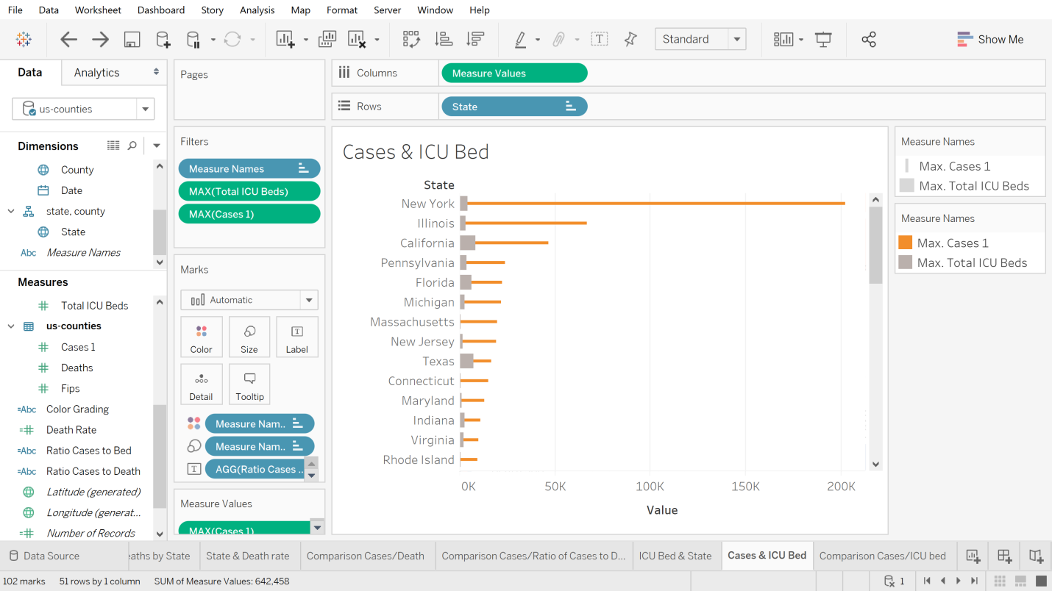

**Fig. 10 – Comparison Cases/ICU Bed - Map**

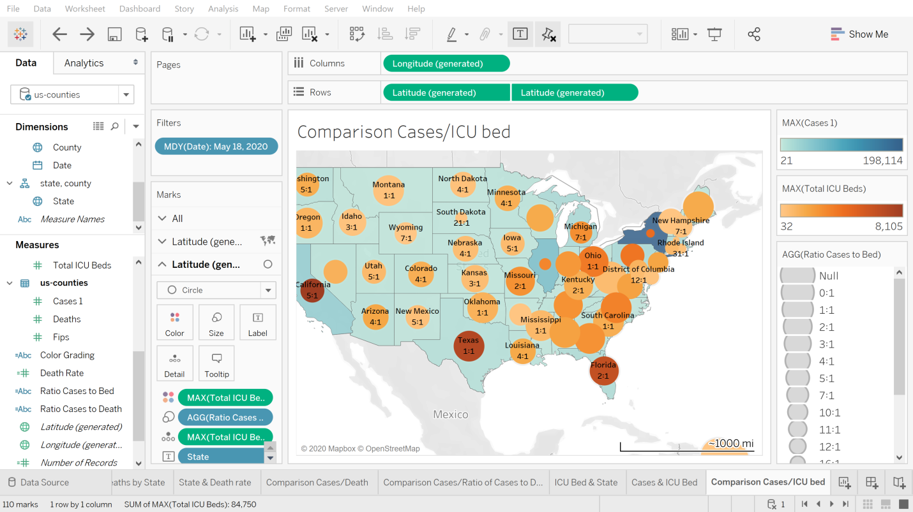

**Fig. 11 Cases/Death/Bed**

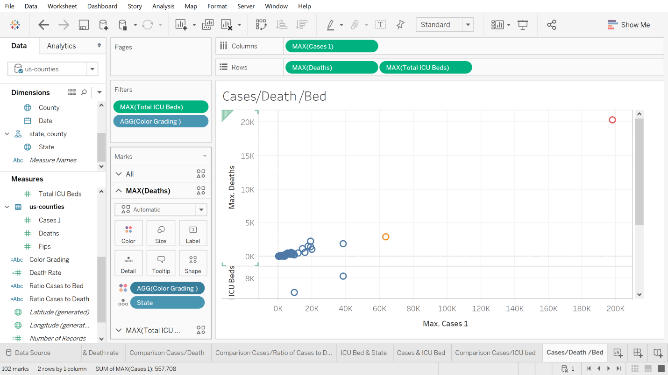

**Fig. 12 – Cases/Death/Bed Summary**

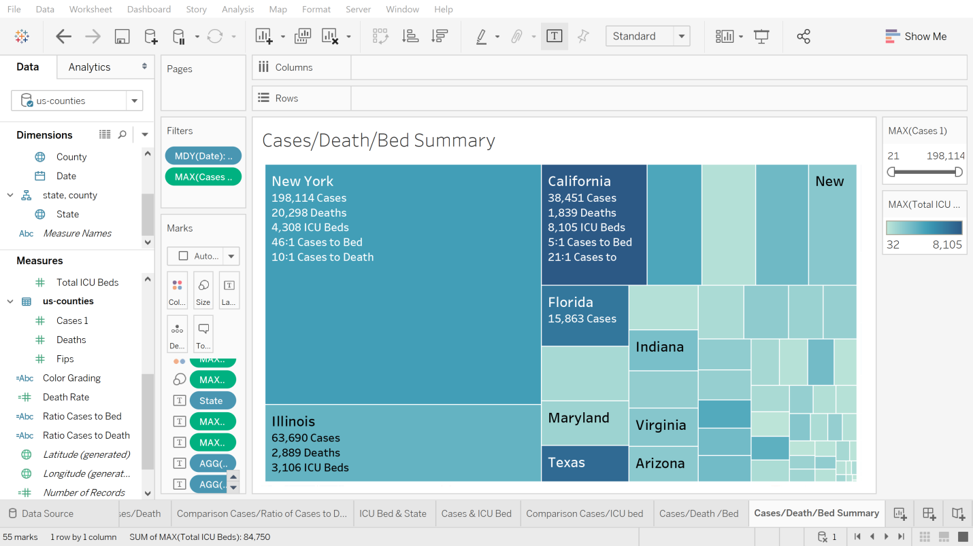

**Fig 13 – Dashboard – ICU Bed & State**

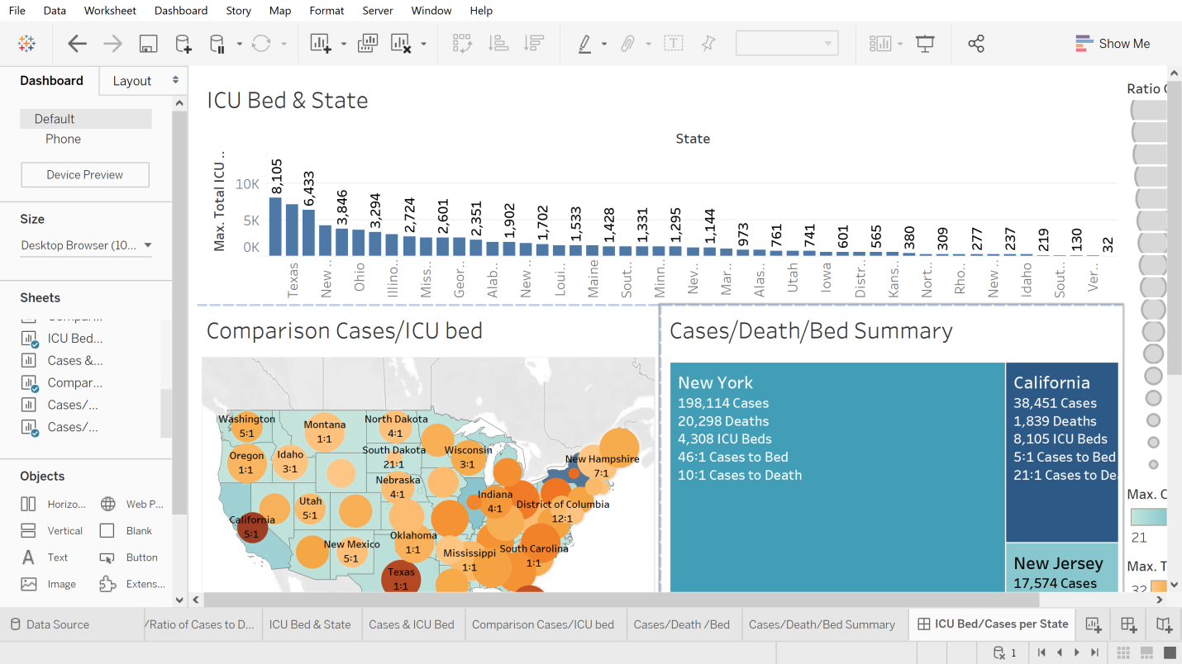

**Fig. 14 – A Story on ICU bed distribution across USA for Covid 19 Cases**

