1. **Setting up a development environment v1.1**

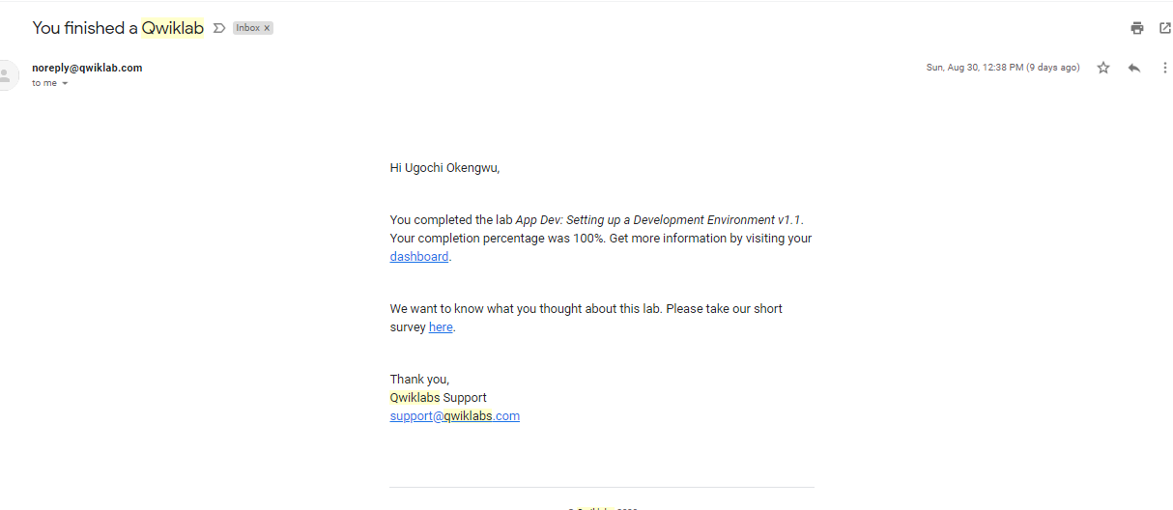

1. **Storing image and video files in cloud storage v1.1**

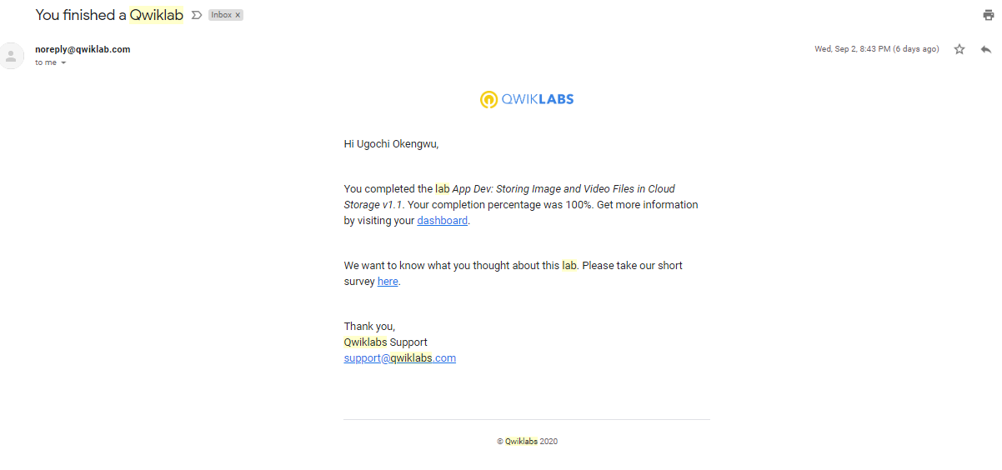

1. **Explore a BigQuery public dataset**

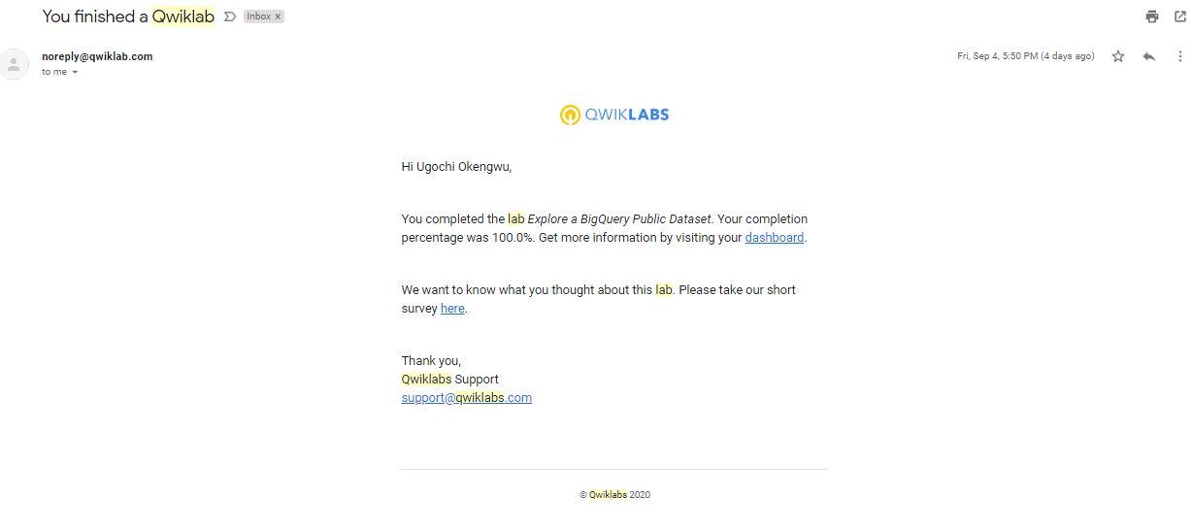

1. **Recommend Products using ML with Cloud SQL and Dataproc**

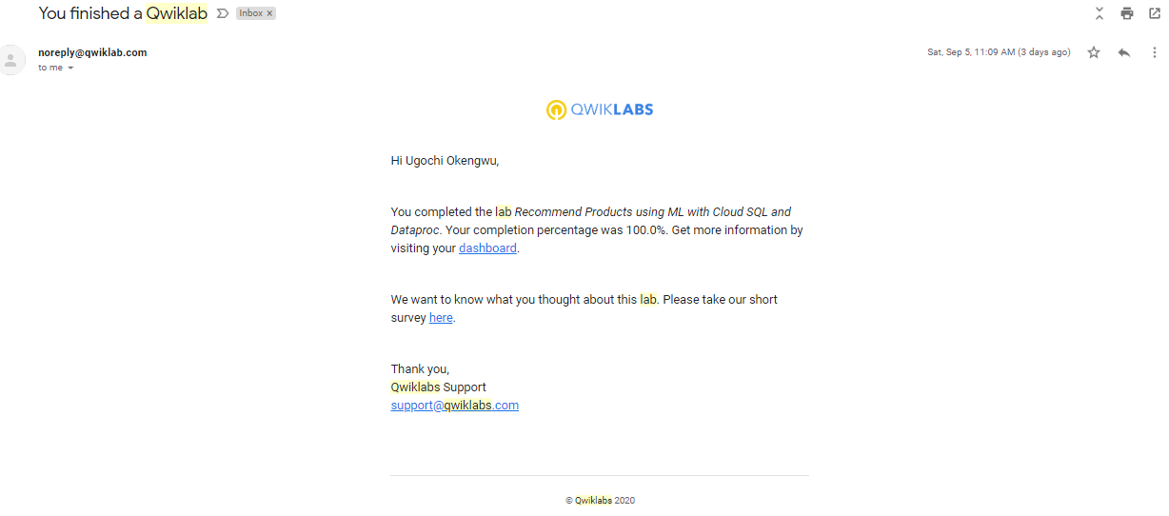

1. **Getting started with Deployment Manager and Cloud Monitoring**

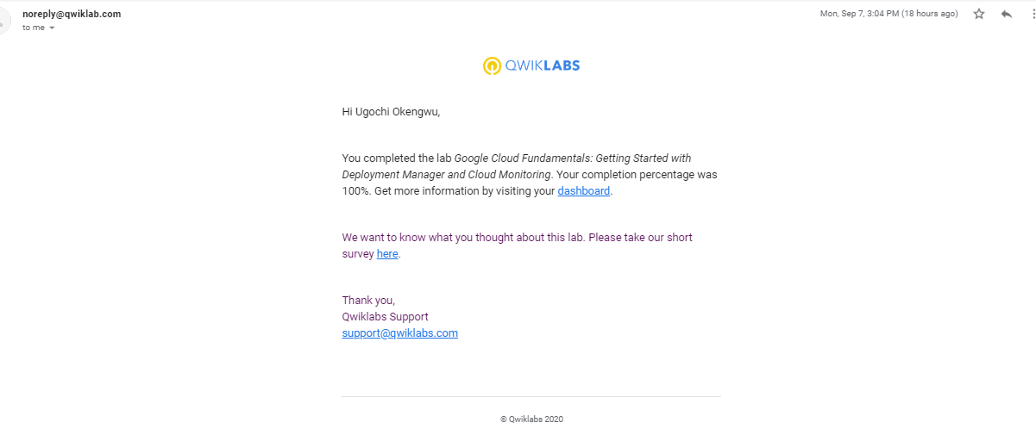

1. **Getting Started with Compute Engine**

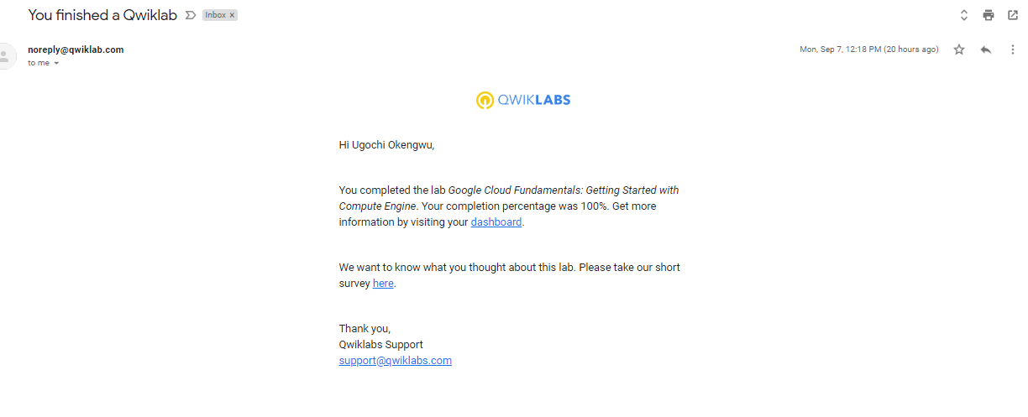

1. **Getting started with Cloud MarketPlace**

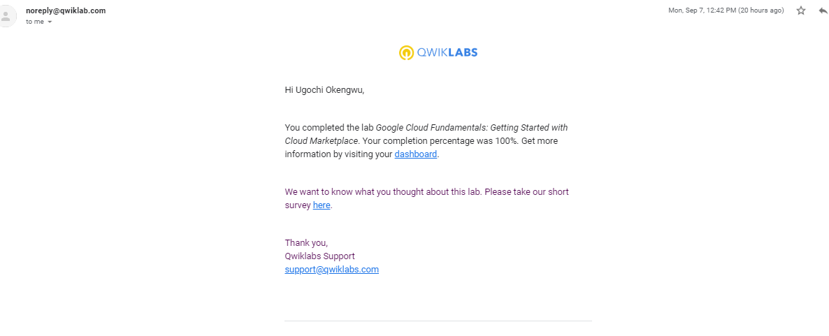

1. **Getting started with Cloud Storage and Cloud SQL**

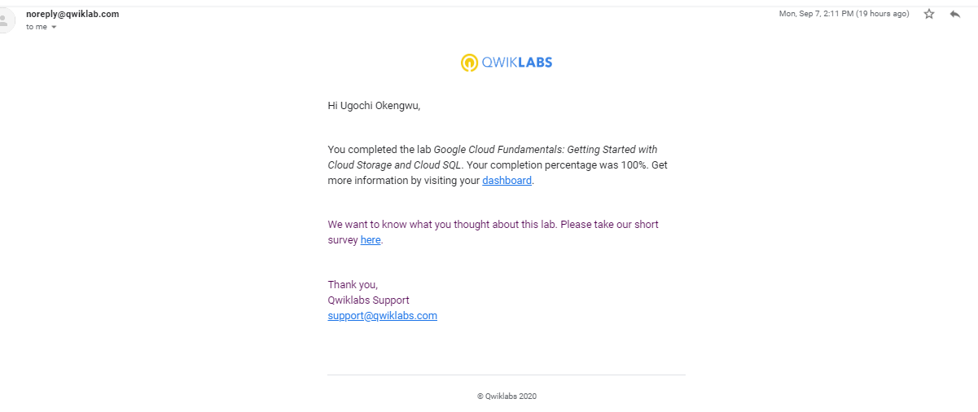

1. **Storing Application Data in Cloud Datastore**

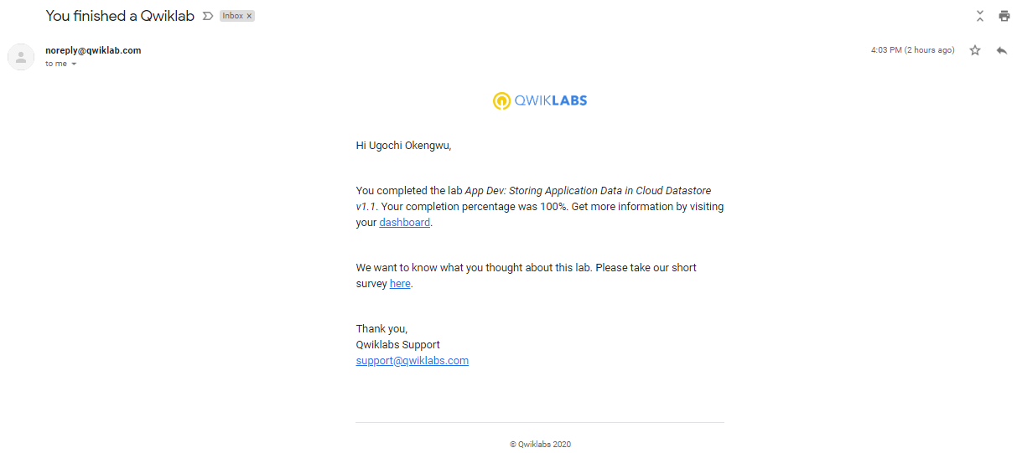

1. **10. Getting started with GKE**
2. . Getting started with GKE

1

ECT=$DEVSHEL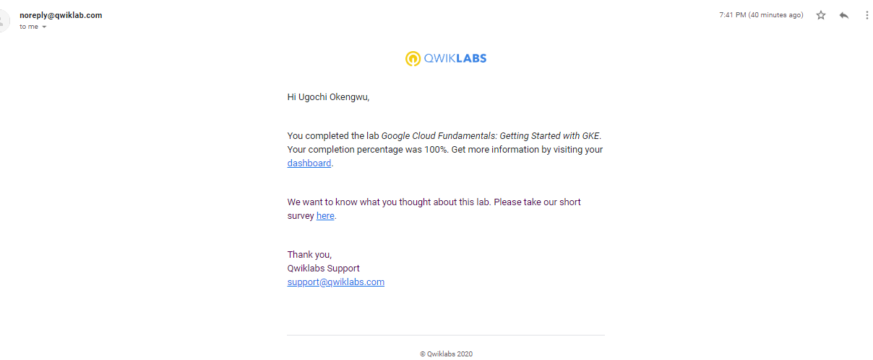

1. 11111**11. Getting started with App Engine**

1111112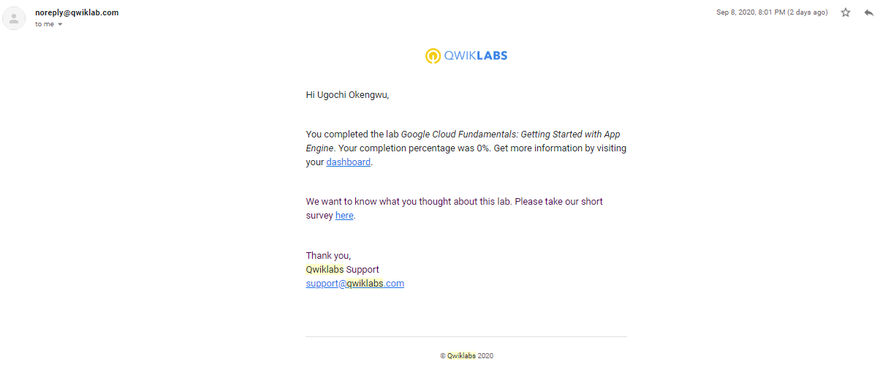

1. **12. Getting Started with BigQuery**

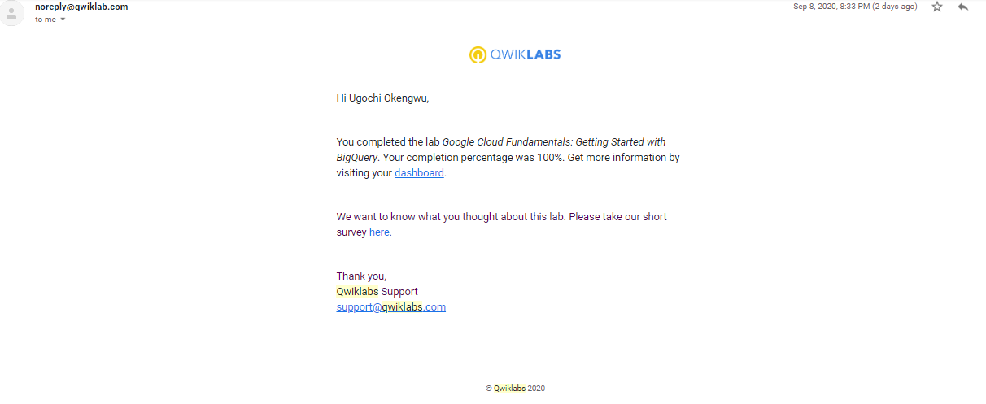

1. **13. Console and Cloud Shell**

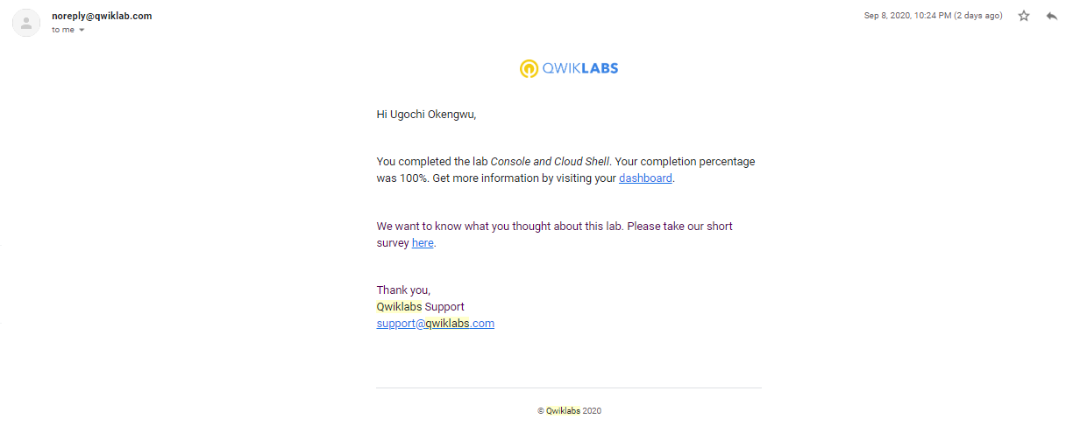

1. **14. Implementing Cloud SQL**

14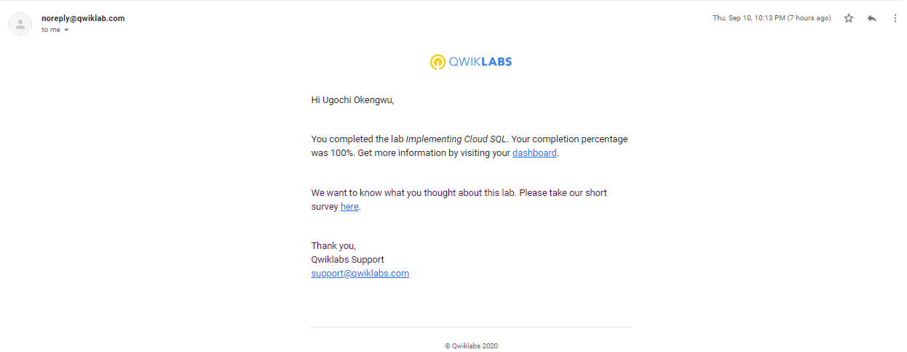

**15. Introduction to container and Docker v1.6**rt10

