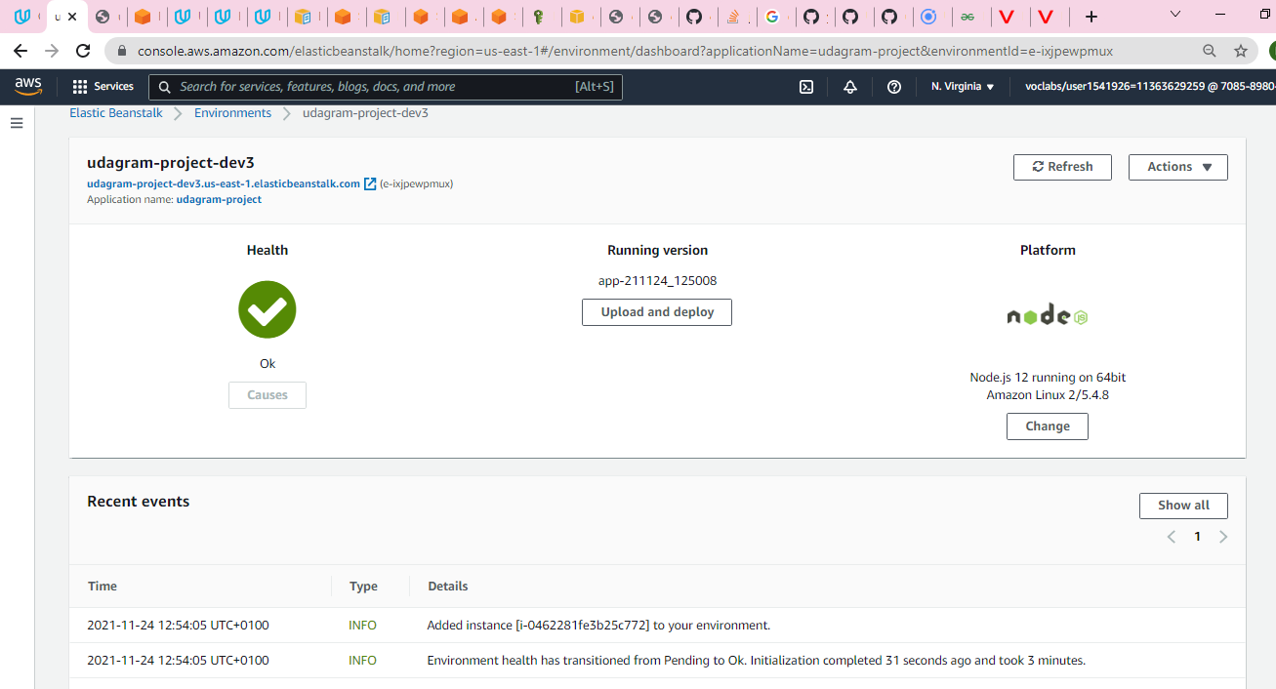

Elastic beanstalk deployment

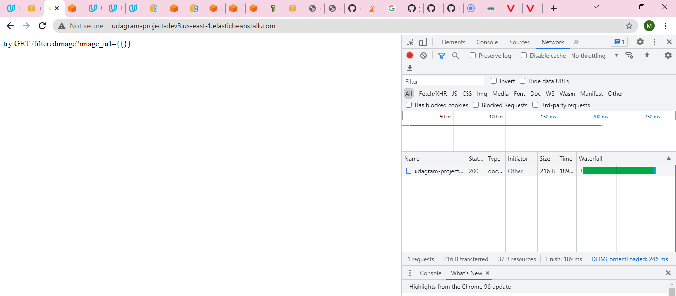

Image filter endpoint

Deployed App link - http://udagram-project-dev3.us-east-1.elasticbeanstalk.com/