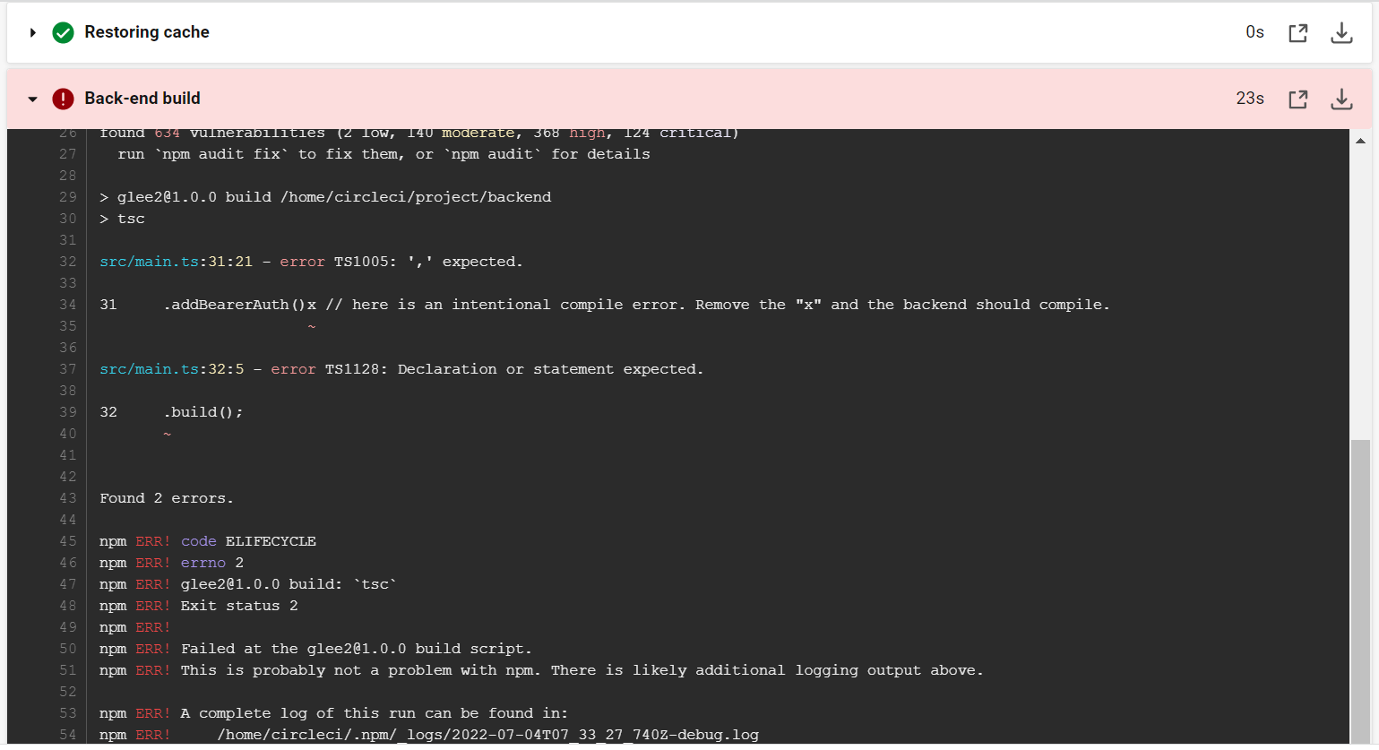

**[SCREENSHOT01]**

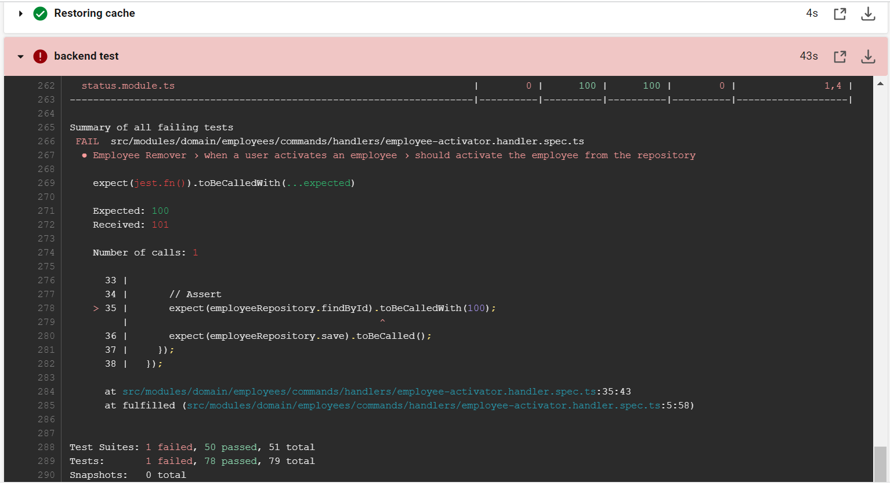**SCREENSHOT02**

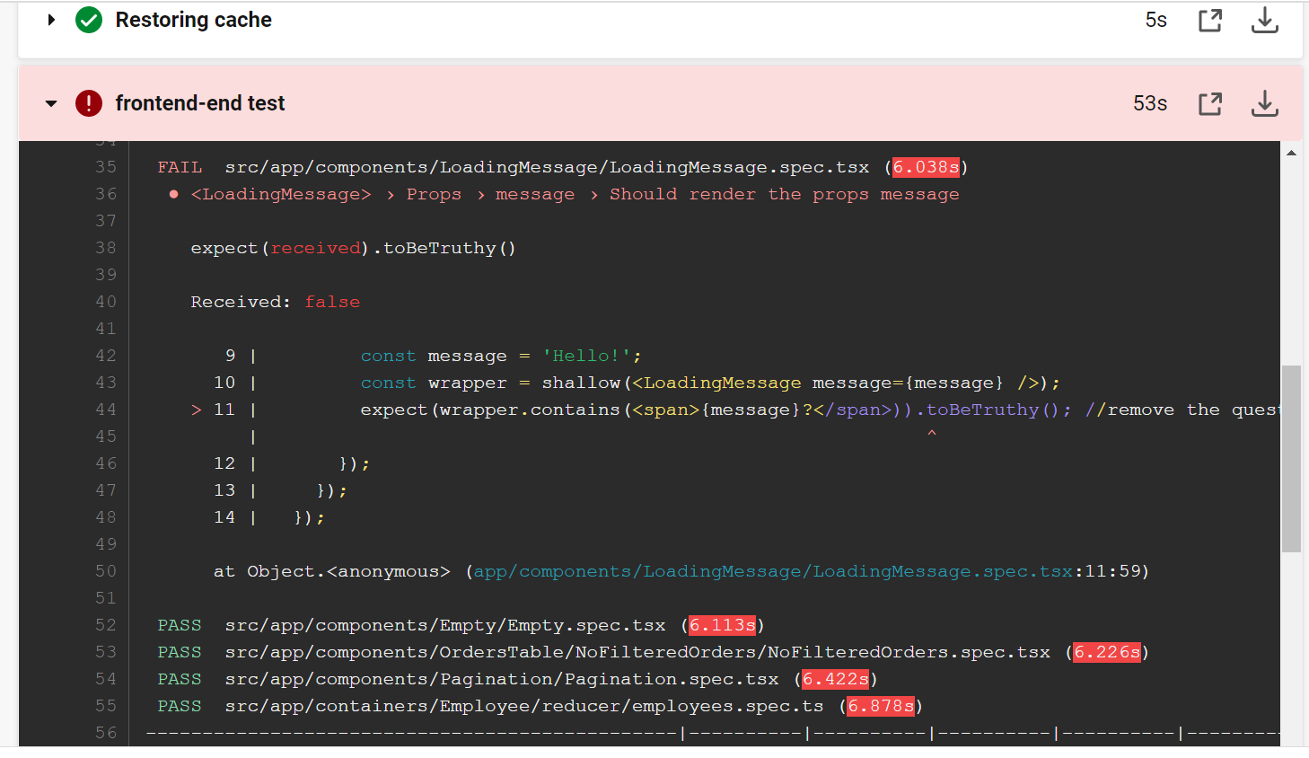

Failed frontend test

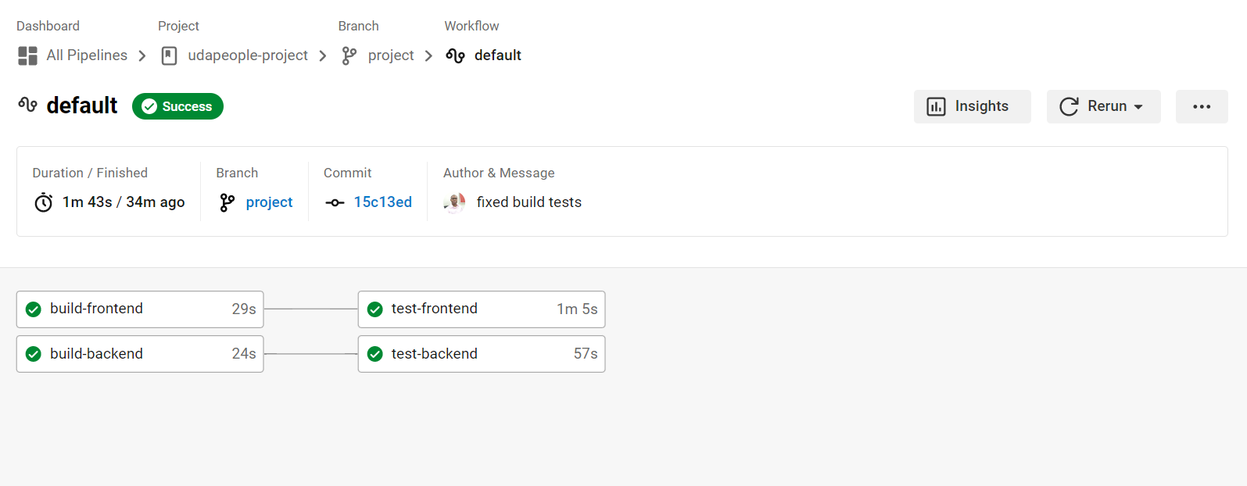

Fixed test errors

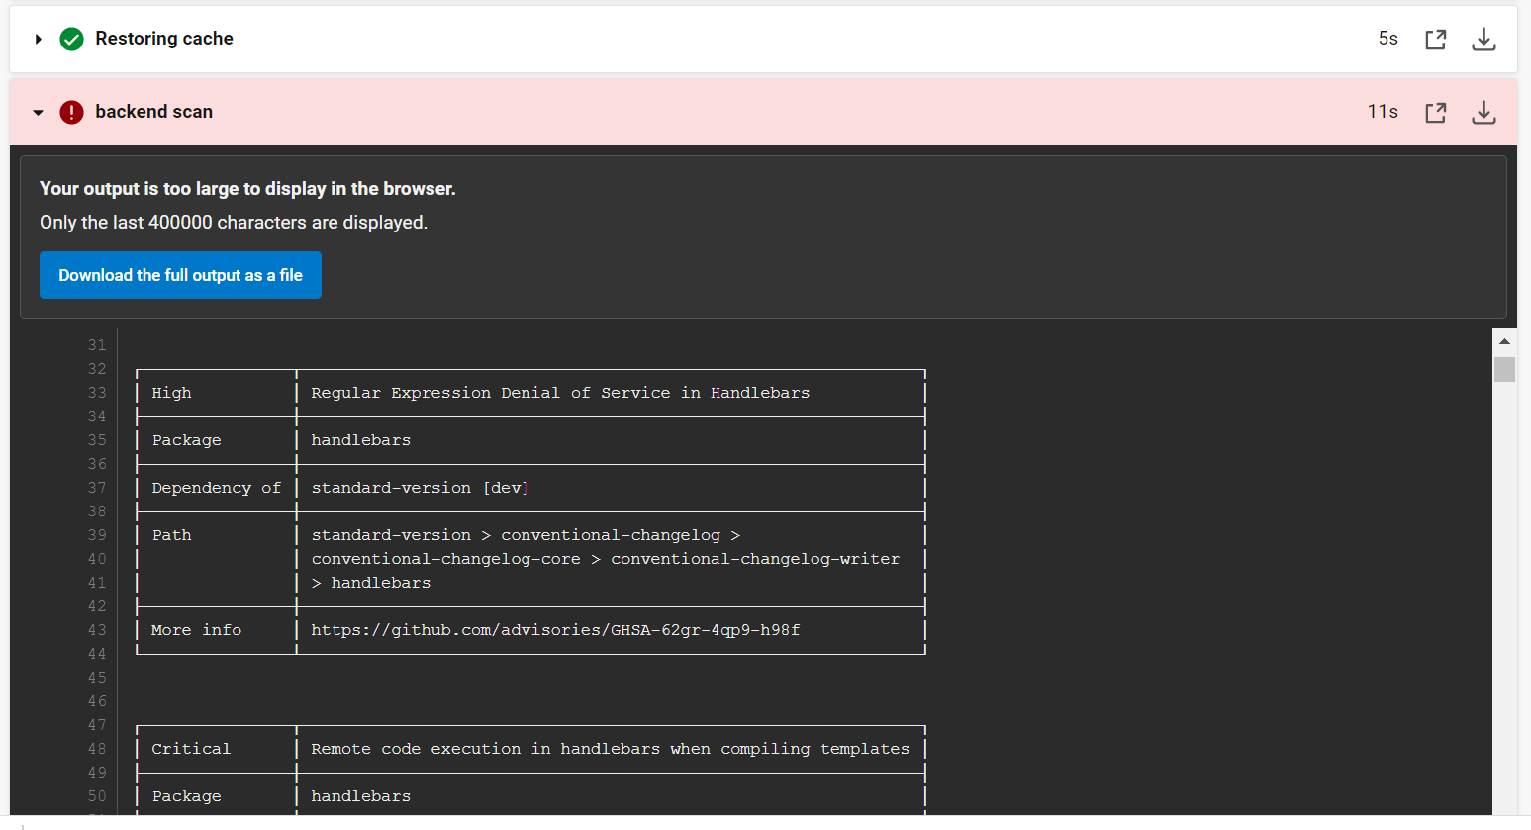

**[SCREENSHOT03]**

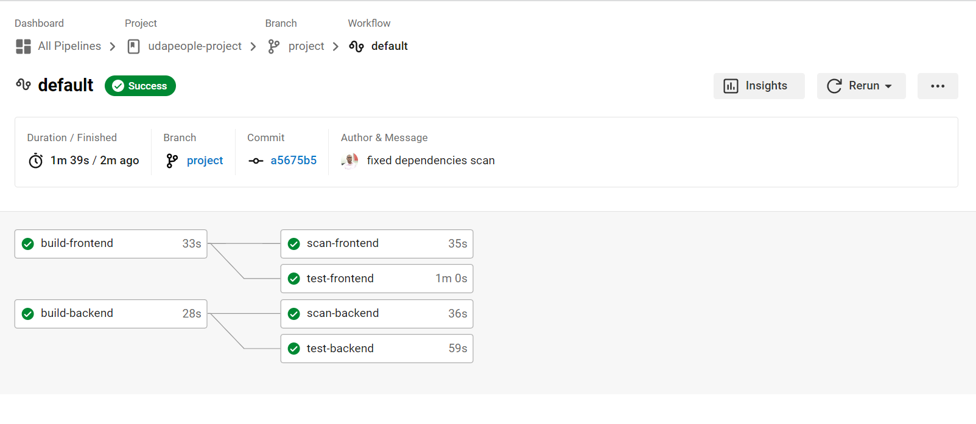

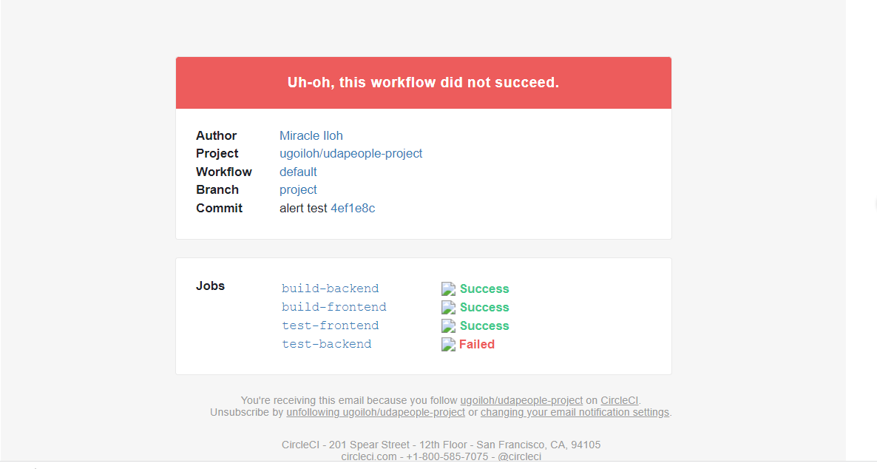

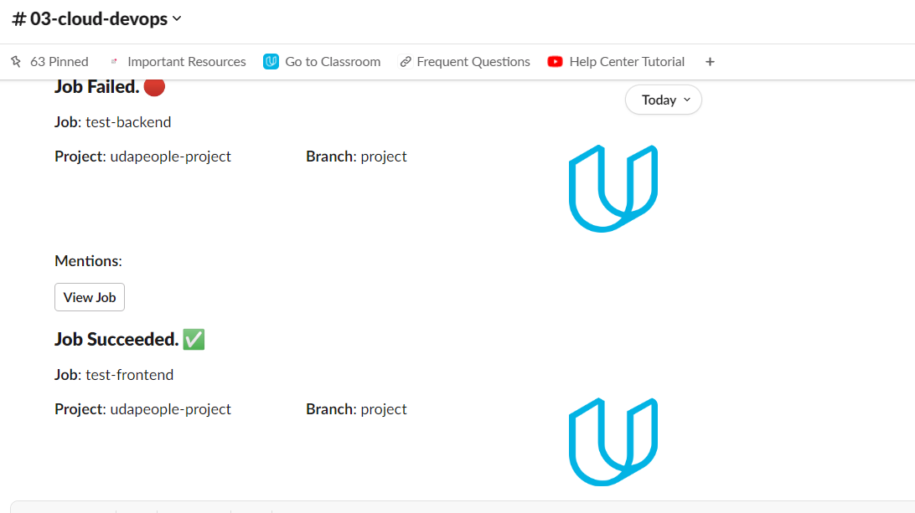

**SCREENSHOT04** Slack and Email notification

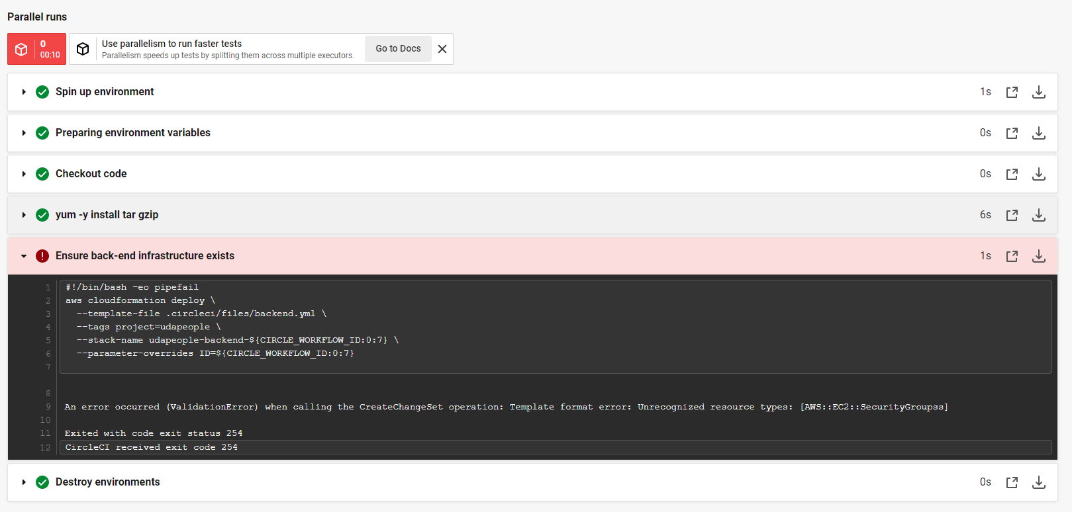

**SCREENSHOT05**

**[URL01] - https://github.com/ugoiloh/udapeople-project**

**[URL02] - http://udapeople-06e538f.s3-website-us-east-1.amazonaws.com/**

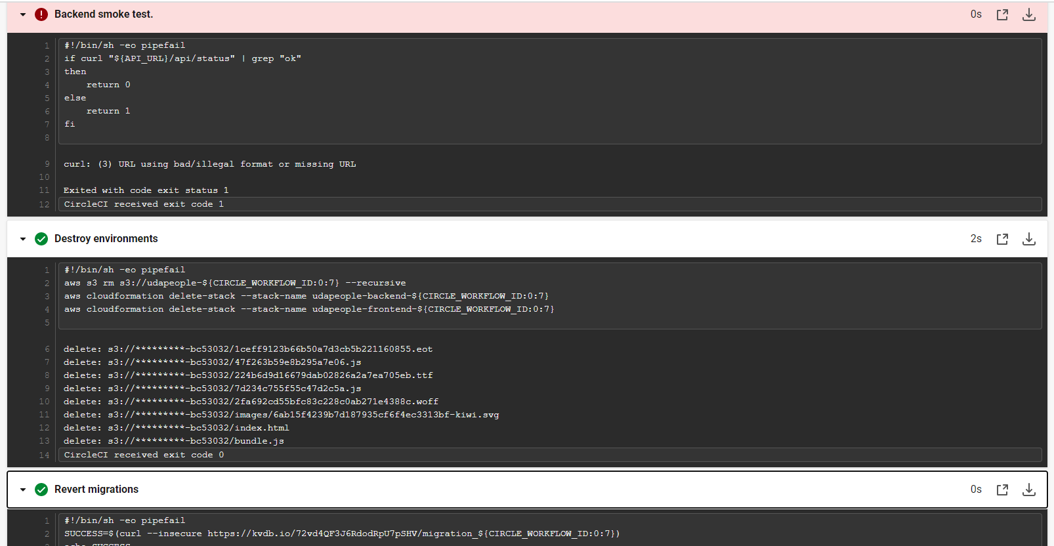

**SCREENSHOT07**

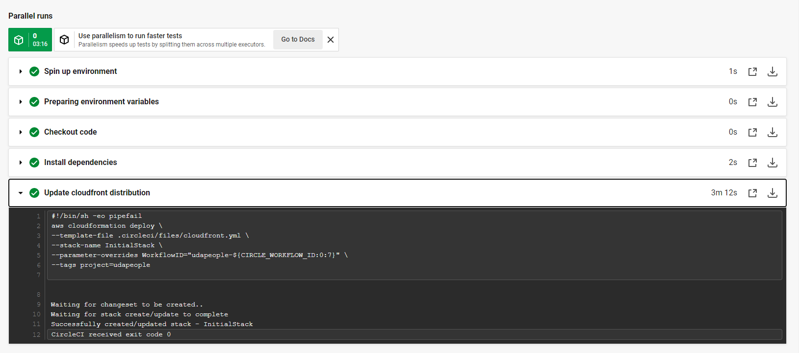

**SCREENSHOT08**

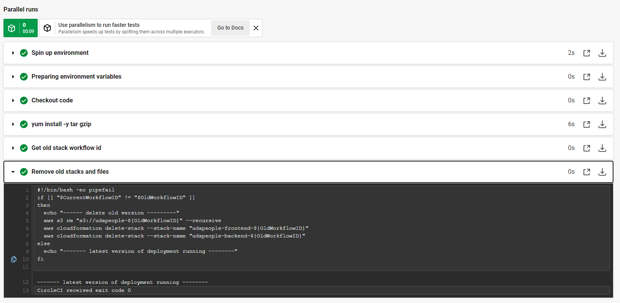

**SCREENSHOT09**

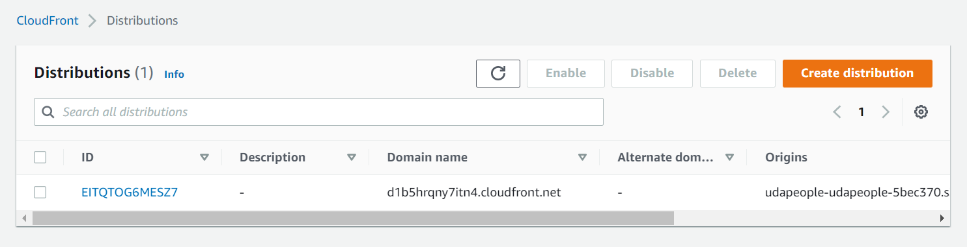

**[URL03_SCREENSHOT]**

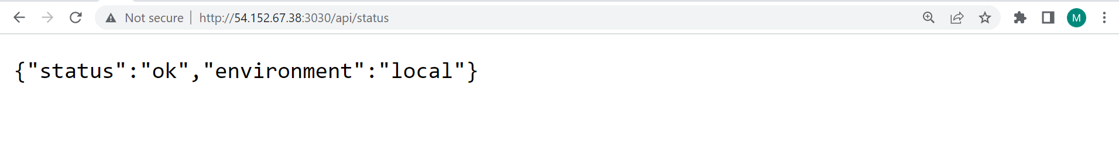

**[URL04_SCREENSHOT]**

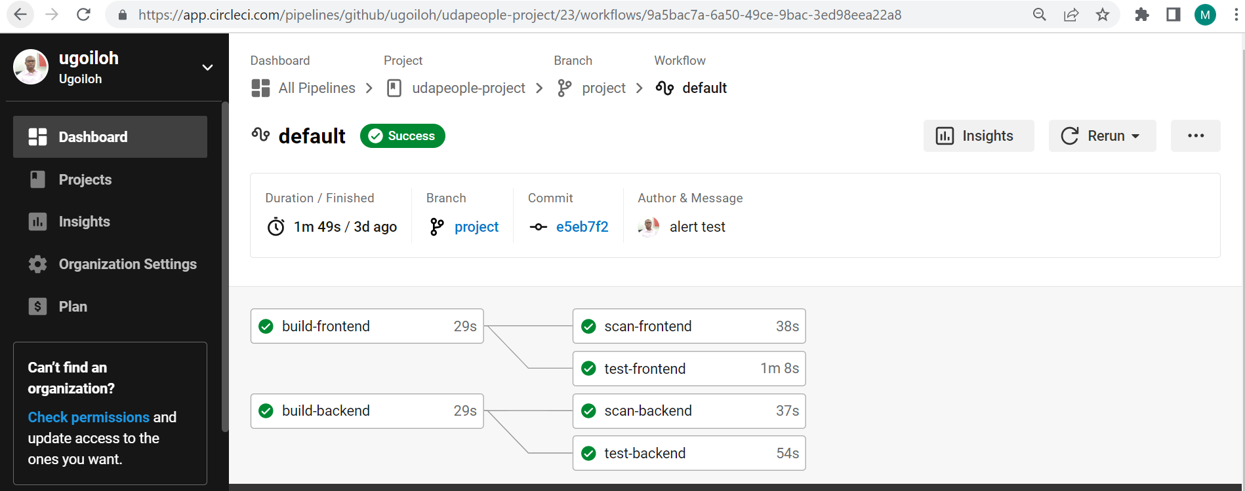

**SCREENSHOT10**

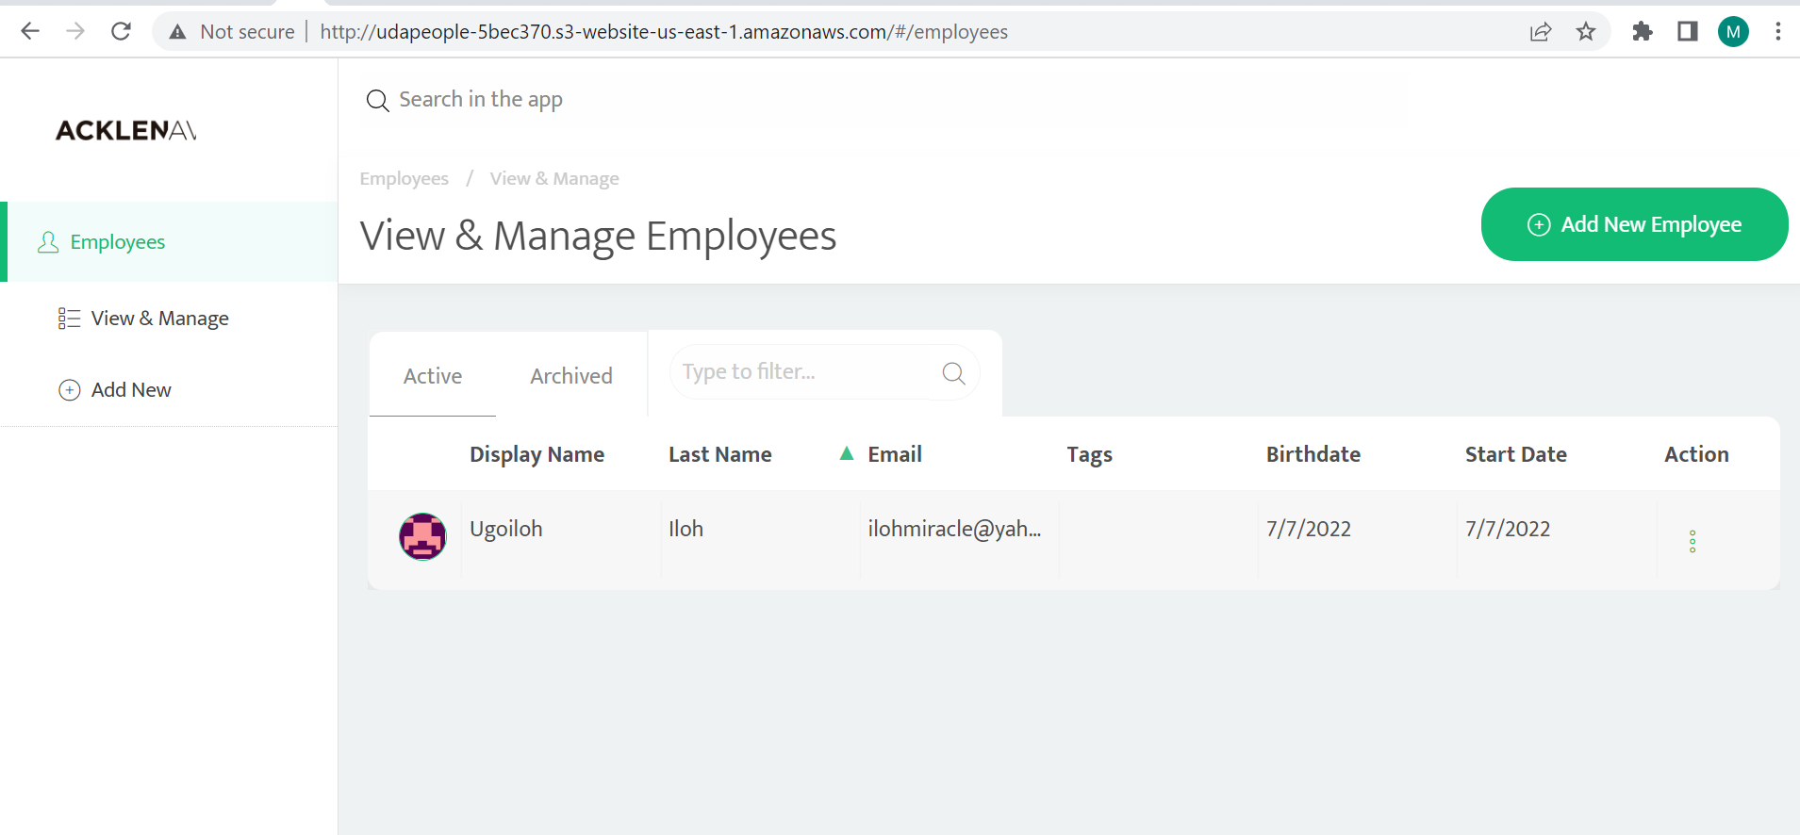

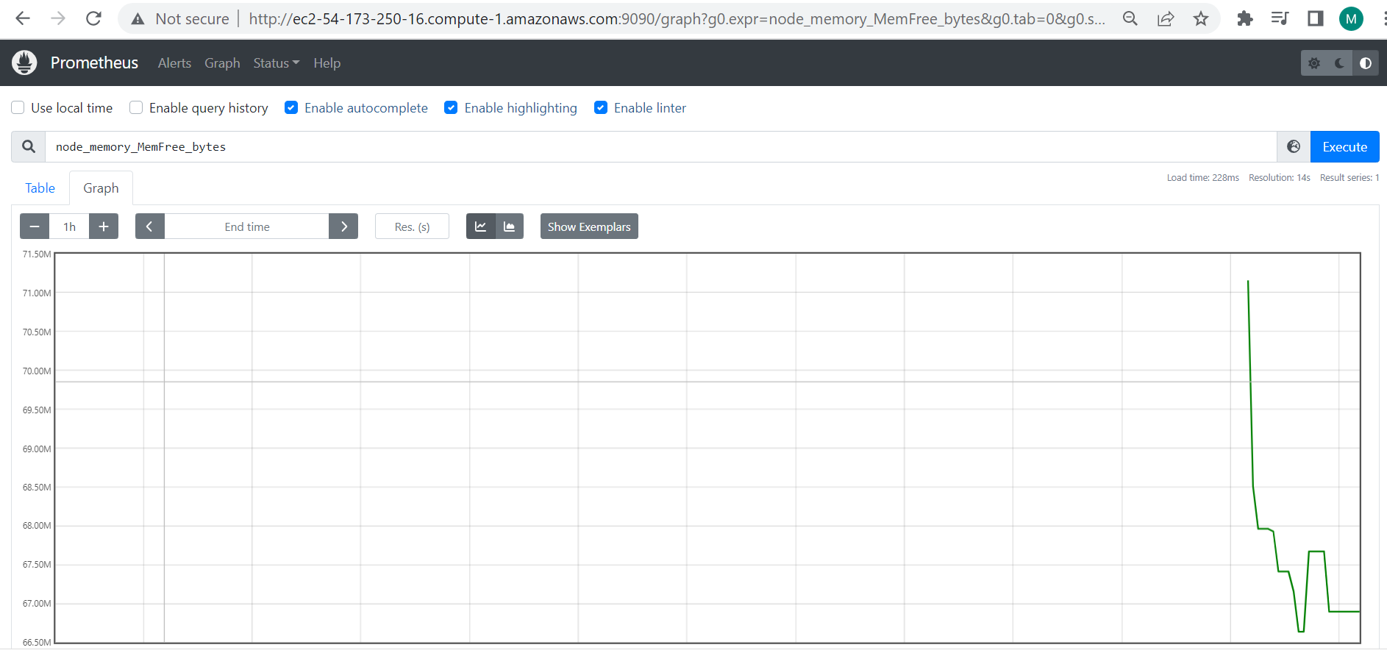

**SCREENSHOT11 - Free memory**

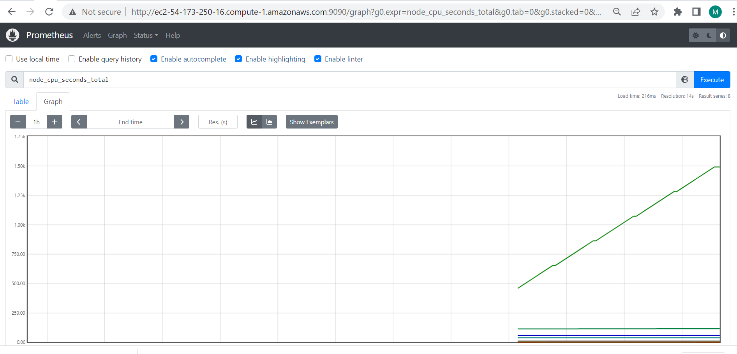

**SCREENSHOT11 - Node CPU usage**

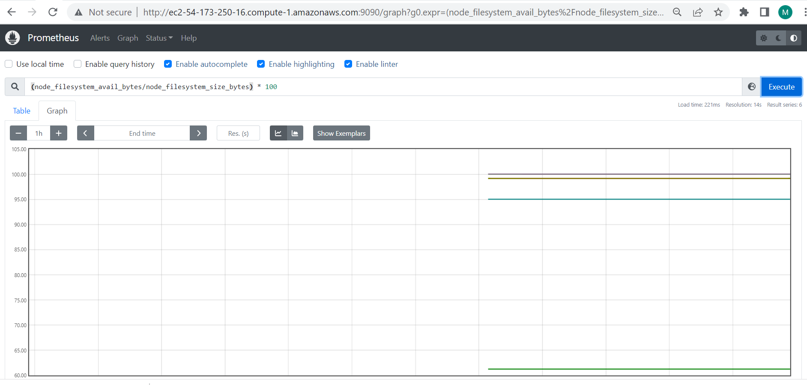

**SCREENSHOT11 - Node disk usage**

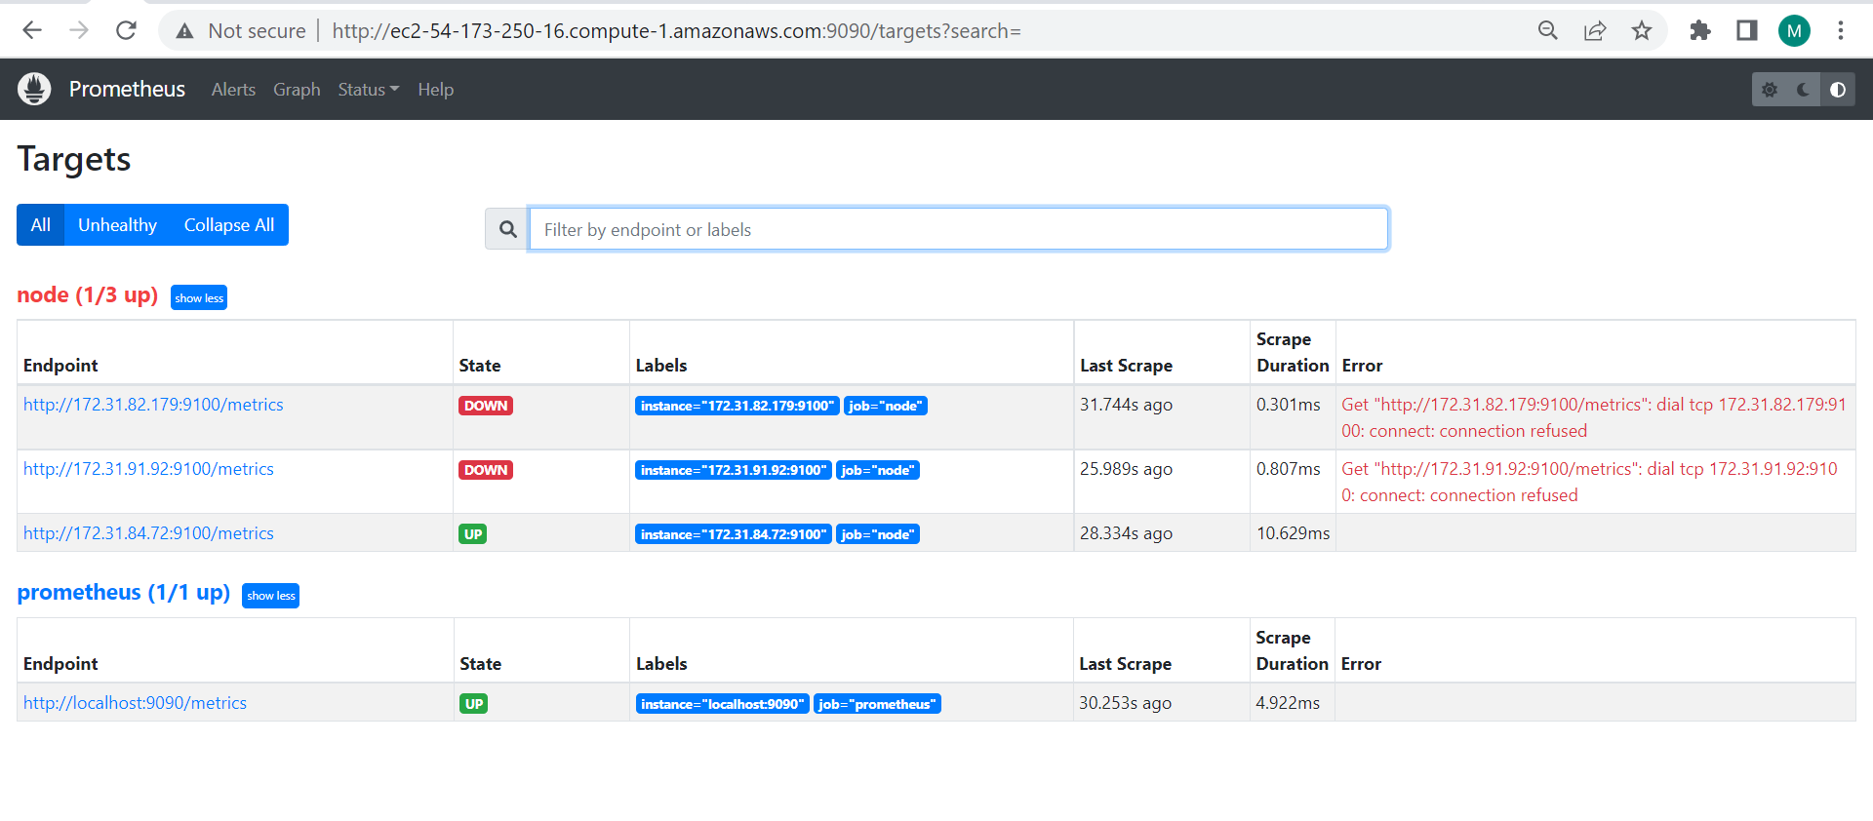

**[URL05_SCREENSHOT]  - Screenshot of Running Prometheus server and Udapeople server (showing State UP)**

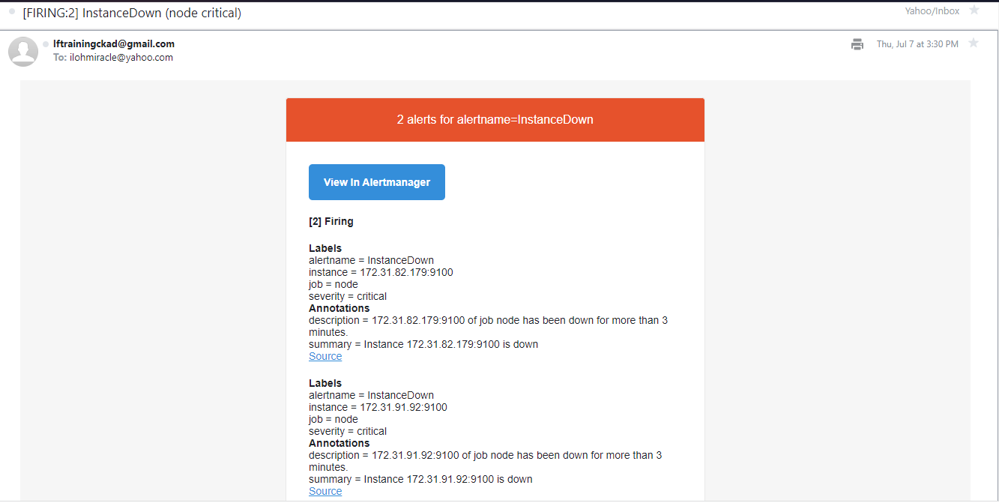

**SCREENSHOT12 - Screenshot of email notification from prometheus**