PAGE 1 • POSITION AND MAGNITUDE
Shine’s best next-quarter bet is to replicate high-value BTP behavior
Confirmed analysis through April 2026 • May excluded because signup coverage is truncated
Across the first three complete calendar months after activation, the highest-revenue 20% of companies generate 70% of revenue. BTP contributes 30% of that value and is the clearest scalable opportunity.

20%  highest-revenue companies | 70.2%  revenue in 3 complete months | 30.3%  high-value revenue from BTP | 95.1%  top-20 accounts Healthy
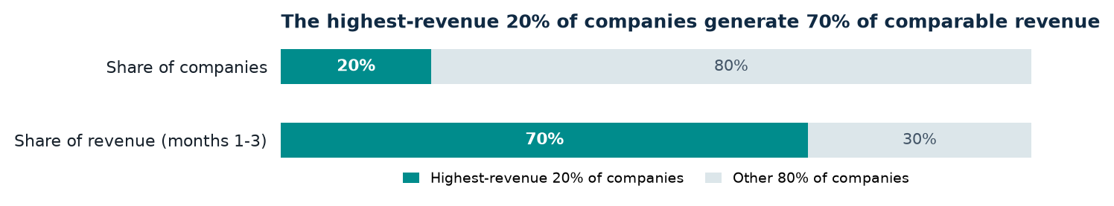
Why this window: revenue is supplied only by calendar month. For a company activated late in month 0, the table cannot separate pre- and post-activation days. We therefore exclude month 0 and compare months 1-3, the first three complete calendar months. An exact 90-day window would require daily revenue.
What the data shows
OPPORTUNITY  BTP is 26.51% of the comparable top 20% and 30.28% of its revenue.  Plus is 2.18× overrepresented; BTP + Plus is 2.44× represented. | RISK  70.7% of April revenue comes from interchange and deposit interest.  The raw top 20% generates ~80% of both streams, creating usage and balance dependence.
Definitions and assumptions
Revenue-active: revenue row in the observation month | Healthy revenue account: Active with an unbroken revenue streak since activation
At-risk: previously Active, then 1–2 missing revenue months | Churned proxy: previously Active, then ≥3 missing months; not confirmed churn
Decision: prioritize a controlled BTP adoption test; protect high-value companies at their first revenue gap. This is a concentrated growth opportunity—not evidence of a broad churn crisis.

PAGE 2 • RANKED DECISIONS
Two initiatives, clearly weighted
Ranked by observable scale, value concentration, health, and actionability
1 | BTP adoption & monetization experiment  Replicate the product behaviors associated with high value; do not assume plan upsell is the lever. | OBSERVABLE MAGNITUDE  1,642 comparable BTP companies; 482 already top 20%, leaving 1,160 outside. BTP contributes €233.6k / 30.28% of top-20 revenue across the first three complete months. | LIMIT  No current plan, product-use, cost, or margin data. Uplift cannot be sized in euros before a causal test.

2 | First-gap protection for high-value companies  Trigger support after the first missing revenue month; keep recovered companies monitored. | OBSERVABLE MAGNITUDE  85 top-20 companies At-risk + 69 Churned proxy. Last-observed monthly revenue exposure: €19.24k. Healthy / recovered pool generates ~€424k in April. | LIMIT  The current eligible risk pool is small and may require a phased rollout or broader pre-defined high-value band.

Why blanket churn is not the lead bet
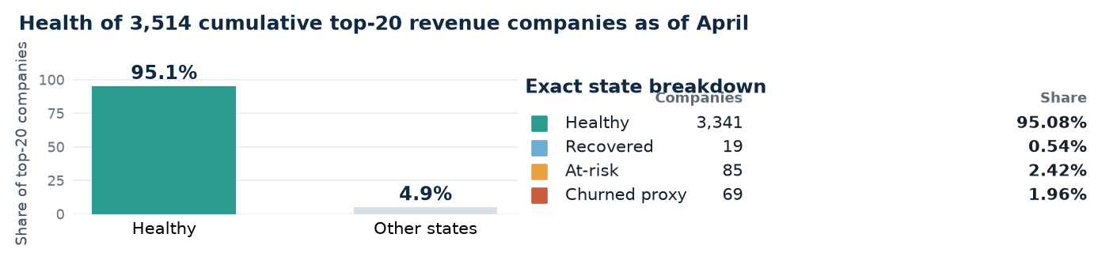
Alternatives considered—and rejected
Alternative | Why attractive | Why it loses now
Acquire more Business | High revenue/company | Small base; 73.3% funnel dropout; weak continuity; no CAC or KYB-reason data.
Broad funnel overhaul | 62.9% 30-day dropout | Cannot distinguish rejection, delay, abandonment, or extraction effects; no channel cost.
Blanket churn campaign | Retention feels urgent | High-value pool is 95.08% Healthy; target the first gap instead.
Immediate plan upsell | Plus/Business correlate with value | Only initial plan exists; current plan and causal plan effect are unknown.
Magnitude: honest bounds
We can size populations and observed revenue, not incremental uplift. The dataset lacks product usage, current plan, treatment cost, margin, CAC, and a causal counterfactual. Rank 1 has the larger addressable pool; Rank 2 protects a smaller currently exposed pool.

PAGE 3 • PROVE AND PRODUCTIONISE
Test the lever before scaling—and make the metrics trustworthy
Association identifies where to test; randomisation establishes whether the lever works
Lead experiment: BTP product adoption
Hypothesis | A single, customer-appropriate product-adoption intervention causes incremental recognised revenue without worsening customer, operational, risk, or fairness outcomes.
Eligibility & design | Freeze eligibility using a pre-period; use revenue-active BTP below a pre-defined high-value threshold; randomise treatment vs business-as-usual; stratify by pre-revenue, cohort age, current plan and usage; analyse intention-to-treat.
Primary metric | Incremental mean total revenue per eligible company over 90 days. Report bootstrap confidence intervals plus median and winsorised sensitivities because revenue is highly skewed.
Success | Scale only if the pre-registered interval supports positive uplift above fully loaded treatment cost, with no material guardrail deterioration. Power the test after final eligibility, cost and variance are known.
Guardrails | Closures, complaints, support contacts, fraud/AML/risk outcomes, fairness, operational failures, and negative-fee adjustments.
Validate first
1 Completeness  Confirm missing row = zero; reconcile to Finance; keep May out until signup coverage is explained. | 2 Business meaning  Validate activation, closure, cancellation, revenue recognition, current plan and persona history. | 3 KYB & privacy  Confirm permitted persona use; minimise data; suppress small cells; never use this for adverse eligibility decisions.
Trusted production engine
Raw  snapshots | → | Typed  company-month fact | → | Versioned  metric marts | → | Governed  semantic layer
Automated tests: unique company-month key; referential integrity; component-to-total and Finance reconciliation; freshness/completeness; date ordering; state-transition invariants; fixed cohort denominators; late-arriving-data/backfill controls.
Ownership: Finance—revenue; Product/Growth—lever and thresholds; Data—models/tests/lineage; Risk/Compliance/Privacy—KYB use; Operations/CRM—execution. Refresh after monthly close and version every definition change.
SQL appendix: sql/revenue_concentration_analysis.sql • sql/presentation_kpis.sql • sql/kpi_deep_dive.sql
Not concluded: true churn, forecast LTV, causal plan effect, CAC/payback, profitability, or complete May performance.

