PAGE 1 • RAW-DATA BIG PICTURE
BTP leads the full confirmed revenue view; Start leads plan scale
Base tables only • Cumulative through April 2026 • May excluded from headlines
€2.35m  confirmed revenue through April | 17,568  companies with confirmed revenue | 25.4%  confirmed revenue from BTP | 44.5%  confirmed revenue from Start
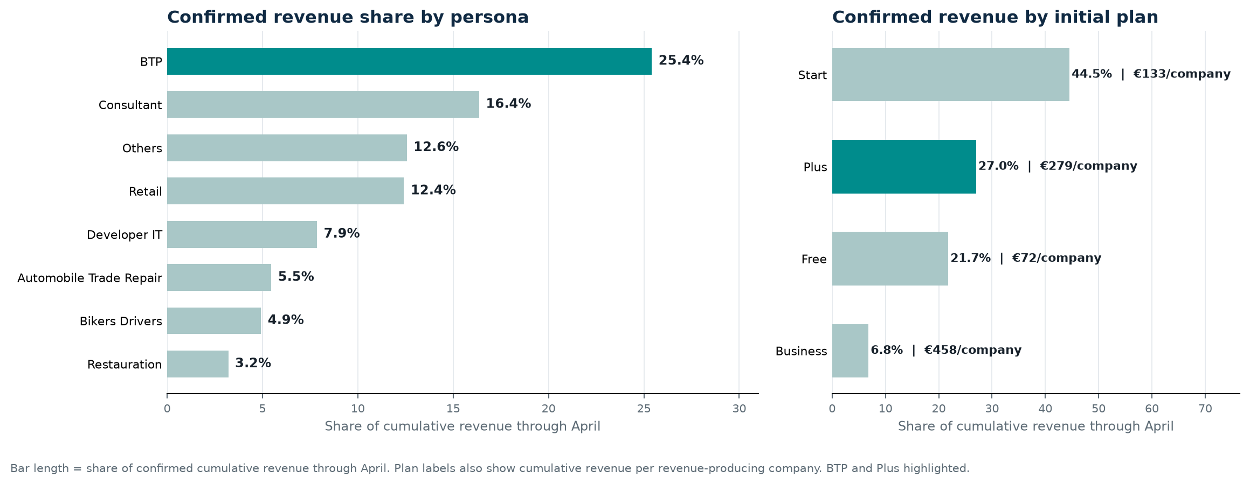
What I conclude
BTP  Largest confirmed persona at 25.42%; April independently shows 24.06%, so the result is not driven by one view. | Start vs Plus  Start supplies 44.49% through scale; Plus supplies 26.98% at €279.26 cumulative revenue per revenue company. | Current economics  In April, interchange is 42.0% and deposit interest 28.7% of revenue; subscriptions alone are 21.0%.
Core query pattern
SELECT c.persona, SUM(r.total_revenue),
100 * SUM(r.total_revenue) / SUM(SUM(r.total_revenue)) OVER ()
FROM companies c JOIN revenue_with_total r USING (company_profile_id)
WHERE r.revenue_month <= DATE '2026-04-01' GROUP BY c.persona;

PAGE 2 • RANKED ACTIONS
Use simple evidence to choose where to test—not to claim causality
Two initiatives, clearly weighted
1 | BTP-fit activation test  Test one relevant workflow—such as invoicing, collection, expense control, or cash-flow alerts—against business-as-usual. | Raw evidence  BTP is 24.06% of April revenue and 25.42% of cumulative confirmed revenue. | Important limit  Raw revenue cannot show product use, CAC, margin, current plan, or whether existing BTP marketing created the result.

2 | Revenue-decline diagnosis  Use the decline as a diagnostic trigger and investigate the first missing-revenue month; monitor recoveries separately. | Raw evidence  1,543 of 13,189 March-April active companies (11.70%) fell ≥30% and €10; 424 had a first April gap. | Important limit  Two months are noisy. This is not churn, forecast loss, or proof that outreach will recover revenue.

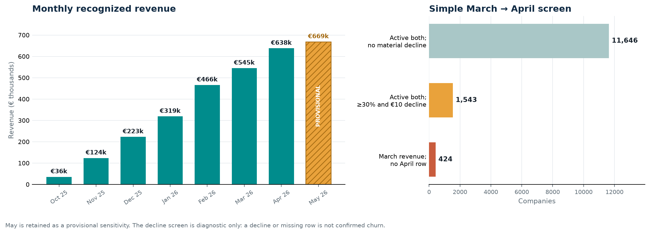
Alternatives considered
Alternative | Why it is not the lead
Acquire Business | High revenue/company, but only 262 April revenue companies and 6.79% of April revenue.
Immediate plan upsell | Initial plan is not current plan and correlation is not a causal effect.
Blanket churn campaign | A decline, revenue gap, or company closure does not prove customer churn.
Headline May | May revenue is retained as sensitivity, but signup coverage is incomplete.

PAGE 3 • TRANSPARENCY AND PROOF
Start simple; use advanced SQL to test whether the story survives
Raw numbers remain the entry point—the model is the validation layer
What each layer answers
Question | Simple view | Advanced check | Where
Largest persona | April and cumulative GROUP BY | Equal-tenure first 3 complete months | sql/revenue_concentration_analysis.sql
Revenue concentration | Not used to pick the segment | Top-10/top-20 and Pareto sensitivities | sql/revenue_concentration_analysis.sql
Account health | March-to-April decline | Trailing median + continuity states | sql/presentation_kpis.sql
Inactivity | Missing revenue row | Return curve and lifecycle states | sql/kpi_deep_dive.sql
Cohorts | Not answered | Equal-age cohort transitions | sql/cohort_state_analysis.sql
Loyalty | Not answered | Streak persistence and restart | sql/streak_analysis.sql
The useful triangulation
24.06%  BTP share in April  simple current snapshot | 25.42%  BTP share through April  simple cumulative view | 26.74%  BTP equal-tenure share  advanced confirmation
Lead experiment and validation
- Randomise eligible BTP companies to one defined workflow versus business-as-usual; do not target on persona alone.
- Measure incremental recognized revenue over 90 days, feature adoption, and account-health guardrails.
- Validate missing-row meaning, current plan, product use, channel/CAC, margin, BTP definition, and permitted KYB use.
Simple SQL appendix: sql/simple_raw_memo_queries.sql
Advanced SQL: revenue_concentration_analysis.sql • presentation_kpis.sql • cohort_state_analysis.sql • streak_analysis.sql • kpi_deep_dive.sql
External context: docs/research/SHINE_MARKET_RESEARCH_AND_STRATEGY.md

