PAGE 1 • POSITION AND MAGNITUDE
BTP is the strongest demonstrated vertical—not unlimited market headroom
Confirmed analysis through April 2026 • May excluded because signup coverage is truncated
Across all 9,088 comparable companies, BTP contributes 26.74% of revenue and Plus generates 2.02× average revenue/company. External evidence supports BTP product fit, but sector and product constraints require a bounded causal test before scaling.

9,088  companies in comparable base | 44.6%  all comparable revenue from Start | 26.7%  all comparable revenue from BTP | 70.2%  generated by top 20% — secondary
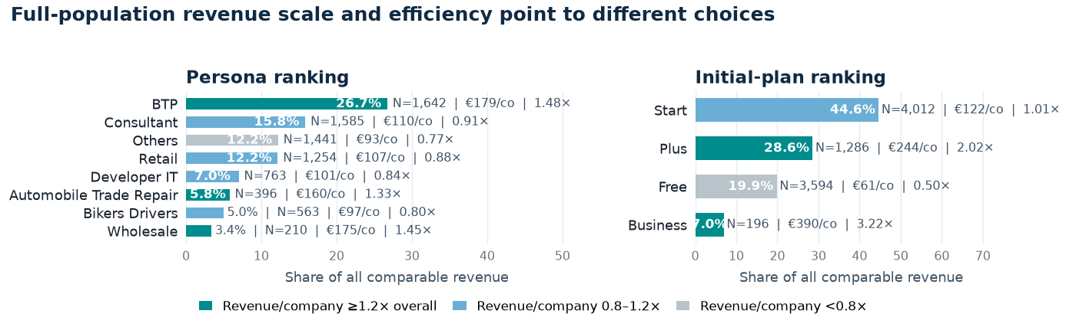
Why this window: revenue is supplied only by calendar month. For a company activated late in month 0, the table cannot separate pre- and post-activation days. We therefore exclude month 0 and compare months 1-3, the first three complete calendar months. An exact 90-day window would require daily revenue.
What the data shows
OPPORTUNITY  BTP leads demonstrated persona scale and efficiency: 26.74% of revenue and 1.48× average revenue/company.  France has a large artisan BTP base; Shine already offers a dedicated BTP workflow. | RISK  BTP activity contracted in 2025; Shine cannot directly offer overdrafts and advanced BTP invoicing is only partly supported.  Business reaches 3.22× average revenue/company but contributes only 6.95% (N=196); it is not the lead bet.
How to read the ranking
Bar length: share of revenue across the complete 9,088-company base | Bar color: average revenue/company versus overall; teal means at least 1.2×
N: eligible companies with three complete post-activation months | No composite score: leadership can see the scale-efficiency trade-off directly
Decision: prioritize a controlled BTP-fit activation test, with Plus as the strongest initial-plan signal. Scale only on incremental contribution; treat 70/20 as secondary concentration context.

PAGE 2 • RANKED DECISIONS
Two initiatives, clearly weighted
Ranked by observable scale, value concentration, health, and actionability
1 | BTP-fit activation & monetization experiment  Test a vertical workflow with suitable tradespeople and small crews; do not assume broad BTP acquisition or plan upsell is the lever. | OBSERVABLE MAGNITUDE  BTP contributes 26.74% of all comparable revenue (N=1,642; €178.85/company; 1.48× overall). In the mature BTP base, 71.07% are Healthy and 15.55% Watch. | LIMIT  Existing BTP targeting, sector contraction, financing needs, and product limits cap extrapolation. No CAC, margin, current-plan, or product-use data.

2 | Revenue-decline & first-gap protection  Trigger diagnosis at a material revenue decline and support after the first missing month; monitor recoveries. | OBSERVABLE MAGNITUDE  493 high-value accounts are Watch, with a €41.0k observed baseline-to-April gap. In the mature base, Business is only 46.15% Healthy and 43.36% inactive—but N=143. | LIMIT  The decline threshold is an analytical assumption, not causal loss. Product usage is missing, so diagnose the driver before outreach.

External pressure test: large artisan base and a dedicated Shine offer support fit; BTP contraction, no direct overdraft, and advanced invoicing limits narrow the ideal customer. INSEE • Shine BTP • CAPEB • Product limits
Health by segment: activated by Dec 2025 (N=6,337)
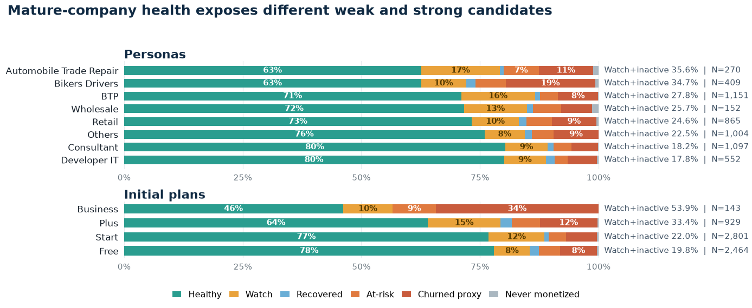
Alternatives considered—and rejected
Alternative | Why attractive | Why it loses now
Acquire more Business | High revenue/company | Small base; 73.3% funnel dropout; weak continuity; no CAC or KYB-reason data.
Broad funnel overhaul | 62.9% 30-day dropout | Cannot distinguish rejection, delay, abandonment, or extraction effects; no channel cost.
Blanket churn campaign | Retention feels urgent | A decline is not churn; target the 493 Watch and 154 inactive accounts with distinct treatments.
Immediate plan upsell | Plus/Business correlate with value | Only initial plan exists; current plan and causal plan effect are unknown.
Magnitude limit: populations and observed revenue can be sized; uplift, margin, CAC and causal impact cannot.

PAGE 3 • PROVE AND PRODUCTIONISE
Test the lever before scaling—and make the metrics trustworthy
Association identifies where to test; randomisation establishes whether the lever works
Lead experiment: BTP-fit workflow activation
Hypothesis | A BTP-specific workflow around e-invoicing, collection, expense control, cash-flow signals, or relevant partner services causes incremental recognised revenue without worsening guardrails.
Eligibility & design | Use product need—not persona alone—to identify suitable tradespeople and small crews; freeze eligibility in a pre-period; randomise treatment vs business-as-usual; stratify by pre-revenue, cohort age, current plan and usage; analyse intention-to-treat.
Primary metric | Incremental mean total revenue per eligible company over 90 days. Report bootstrap confidence intervals plus median and winsorised sensitivities because revenue is highly skewed.
Success | Scale within BTP only if the pre-registered interval supports uplift above fully loaded treatment cost with no guardrail deterioration. Test transferability separately before expanding to other personas.
Guardrails | Closures, complaints, support contacts, fraud/AML/risk outcomes, fairness, operational failures, and negative-fee adjustments.
Validate first
1 Completeness  Confirm missing row = zero; reconcile to Finance; keep May out until signup coverage is explained. | 2 Selection & meaning  Validate BTP definition, acquisition channel/spend, CAC, approval, current plan, persona history and product use. | 3 KYB & privacy  Confirm permitted persona use; minimise data; suppress small cells; never use this for adverse eligibility decisions.
Trusted production engine
Raw  snapshots | → | Typed  company-month fact | → | Versioned  metric marts | → | Governed  semantic layer
Automated tests: unique company-month key; referential integrity; component-to-total and Finance reconciliation; freshness/completeness; date ordering; state-transition invariants; fixed cohort denominators; late-arriving-data/backfill controls.
Ownership: Finance—revenue; Product/Growth—lever and thresholds; Data—models/tests/lineage; Risk/Compliance/Privacy—KYB use; Operations/CRM—execution. Refresh after monthly close and version every definition change.
SQL appendix: sql/revenue_concentration_analysis.sql • sql/presentation_kpis.sql • sql/account_health_playground.sql
Not concluded: true churn, forecast LTV, causal plan effect, CAC/payback, profitability, or complete May performance.
External sources: Shine pricing • Overdraft policy • E-invoice reform • full research note: docs/research/SHINE_MARKET_RESEARCH_AND_STRATEGY.md

