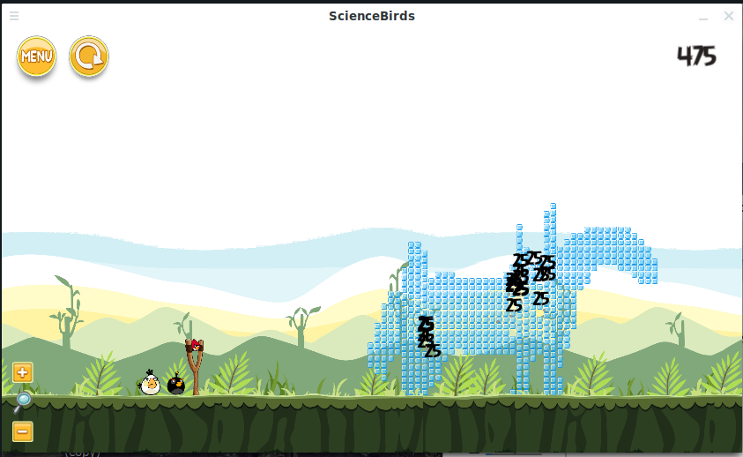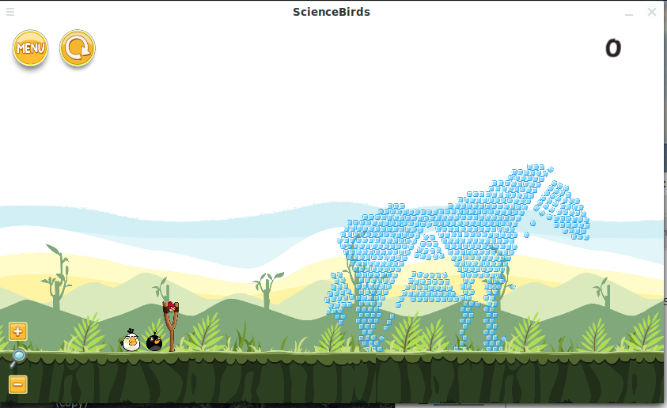Comparison:



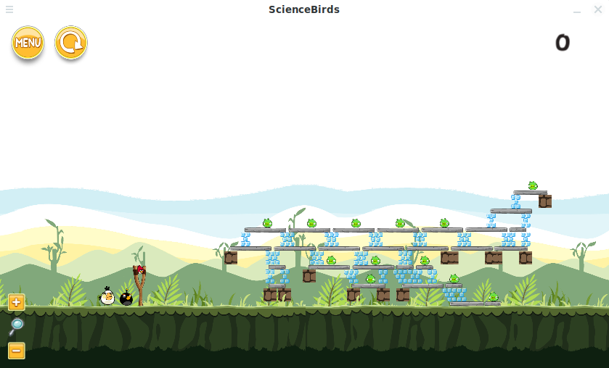

**3. Experiment**

In experiment, we made a number of tests to find out the object, clear rate, and stability of our structure in four different difficulty settings. First, we want to understand what factor impact the number of object in the structure.

In Figure 3, we found that the number of object have a positive relationship with the difficulty. Deeply, in Figure 4 we found that the player needs to kill average about 3 pigs in the lowest difficulty, 9.5 in mid, 21 in hard, and 42.58 in very hard. Therefore, we set the player can have three red birds in low level, which we expect players can kill one pig per shot. We place an additional black bird(boom bird) in mid level for player to denoting the TNT(average 1.5), another one additional black bird in hard level, and one more white bird in very hard.

