TITLE (TNR, 14, BOLD, CENTER, SINGLE SPACING, UPPERCASE)

Author’s Name^{1*}, Author’s Name² and Author’s Name³
(TNR, 12, Centre, Capitalized Each Word, Full Name)
¹Affiliation Author1
²Affiliation Author 2
³Affiliation Author 3

*Email (corresponding author)

Abstract

The abstract should be written in Times New Roman, 10 font size, single line spacing, and justified. Summarize the introduction, problem statement, objective, methods, findings, and conclusions in this section. The length of the abstract should not be more than 200 words.

Keywords: maximum 5 words that are written with 10 font size and separated with semi-colon.

1. INTRODUCTION (Title Times New Roman, 12 font size, bold)
The introduction of the extended abstract should contain the problem statement, the aim/objective and scope of the project. Extended abstract of the full paper shall be written with Times New Roman font, single line spacing and 12 font size. Extended abstracts should not exceed 4 pages including the references and pages should not be numbered.
Current literature regarding the work subject should be examined, and the differences of the said work from the past, similar works should be presented clearly in the introduction section.

2. MATERIALS AND METHODS (1st level)
All materials and methods that have been used in the work must be stated clearly and subtitles should be used when necessary.

Subtitle (2nd level)
First level title (2.) should be written left aligned, all caps and bold. Second and 3rd level subtitles (2.1, 2.1.1) should be written left aligned, bold and with title case. A blank line should be placed between the paragraphs and there should not be any paragraph indentation.

2.1.1 Subtitle (3rd level)
First level title (2.) should be written left aligned, all caps and bold. Second and 3rd level subtitles (2.1, 2.1.1) should be written left aligned, bold and with title case. A blank line should be placed between the paragraphs and there should not be any paragraph indentation.

3. RESULTS AND DISCUSSION

Subtitle
The figure, table, or image should be numbered and captioned with font size of 10 and with upper case initial letters. References (if any) of the figure, table, or image should be presented at the bottom of the visuals in the form of author surname and publication date (italic).

2nd week | 3rd week

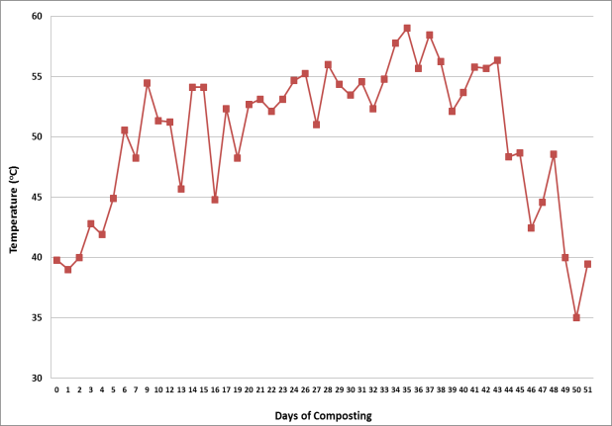
Figure 3. Figure Header

4th week 5th week
6th week 7th week 8th week
1st week

Subtitle

Factor | Unit | Low | High
Final temperatures | °C | 200 | 600
Heating rate | °C/min | 1 | 10
Holding time | Min | 0 | 60
N2 flow rate | L/min | 0.2 | 1.0
Condensing temperature | °C | 0 | 10
Table 3. Table Header
Reference: author surname and publication date (eg: George, 2009)

4. CONCLUSION
Please conclude your work incorporating your most important finding as well as future works (3-4 lines).

ACKNOWLEDGEMENT
Please acknowledge your research grant, organization, scholarship (where relevant)

REFERENCES
(APA 7th Edition, Single Spacing)
(Minimum references 15 (70% from published work)
Grady, J. S., Her, M., Moreno, G., Perez, C., & Yelinek, J. (2019). Emotions in storybooks: A comparison of storybooks that represent ethnic and racial groups in the United States. Psychology of Popular Media Culture, 8(3), 207 217. https://doi.org/10.1037/ppm0000185.

Note:
Please include the following sections as possible in your paper, as relevant.
- Description of your innovation / product development / design / process.
- What is the context or background of the innovation / product development / design / process?
- Novelty & Originality: Clearly describe the unique features, intellectual property (patents/copyrights), and what makes it stand out.
- Commercialization Potential: Any advantages of your innovation / product development / design / process towards education and community/ how the innovation creates economic or social value.
- Any commercial value in terms of marketability or profitability of your innovation / product development / design / process if any.

