

Department of Computer Engineering

KNOWLEDGE ENGINEERING AND ONTOLOGIES COURSE PROJECT REPORT

Uğur kurt – 220315033
Selim Kara - 220315010

Executive Summary
The FilmKG project designs and implements a comprehensive movie knowledge graph using semantic web technologies. FilmKG models movie metadata, actor performance credits, directorial roles, and genres to support intelligent queries, consistency validation, and LLM integration. Built as a formal OWL ontology in Protégé and populated via a Python-based RDFlib extraction pipeline, the knowledge graph models relationships between actors, directors, genres, and films. Semantic consistency is validated using SHACL (Shapes Constraint Language) shapes. For querying, SPARQL queries are implemented to retrieve complex relations, actor-director collaborations, and genre aggregations. The knowledge graph is integrated with a Large Language Model (LLM) using a prompt-grounded natural-language-to-SPARQL translation architecture, minimizing hallucinations and enabling structured, explainable answers. This project demonstrates how combining ontologies with LLMs provides a reliable and clean semantic search and query answering engine.

Description of the project
The primary objective of the FilmKG project is to build an ontology-driven movie knowledge graph that provides a structured, queryable, and logically consistent representation of the film industry domain. In traditional relational databases, querying multi-degree relationships, such as actor collaborations, genre overlap, or director portfolios, requires complex, resource-intensive joins. FilmKG solves this by capturing these entities and relations semantically using Web Ontology Language (OWL) and Resource Description Framework (RDF) standards. The system is designed to support movie recommendation engines, academic film analyses, and semantic search interfaces. The core pipeline consists of: (1) schema design in Protégé, defining classes (Film, Genre, Actor, Director) and properties (actedIn, directedBy, title, releaseDate, releaseYear); (2) parsing movie metadata to generate RDF triples; (3) deploying the knowledge graph to a local GraphDB repository; (4) executing SPARQL queries to extract complex patterns; (5) validating graph integrity using SHACL shape constraints; and (6) integrating an LLM using schema-grounded prompt templates to translate natural language questions into executable SPARQL. This report details the theoretical foundations, implementation steps, validation checks, and LLM pipeline of the FilmKG system.
To guide the ontology modeling and evaluate its success, a set of 10 Competency Questions (CQs) has been defined. These represent the typical semantic questions that the FilmKG system must be capable of answering:
- CQ1: What are the films directed by a specific director (e.g., David Fincher)?
- CQ2: What are the films associated with a specific genre (e.g., Crime)?
- CQ3: Who are the actors that acted in a specific film (e.g., The Last Samurai)?
- CQ4: Who are the directors of films that fall under the 'Crime' genre?
- CQ5: Who are all the people (actors or directors) associated with a specific film (e.g., Zodiac)?
- CQ6: Who are the actors that have acted in films of the 'Mystery' genre?
- CQ7: What are pairs of different films that share the same genre?
- CQ8: What is the total count of films directed by each director?
- CQ9: What are the movie genres sorted in descending order by the number of films they contain?
- CQ10: Who are the directors that have directed more than 2 films in the knowledge graph?

Ontology Design
The conceptual modeling of the film domain in FilmKG is split into the TBox (terminological schema) and the ABox (assertional data). The TBox defines classes and their relationships. The class hierarchy starts at owl:Thing, with three primary subclasses: Film, Genre, and Person. To represent human roles without adding unnecessary complexity, the Person class is further subclassed into Actor and Director. The hierarchical design modeled in Protégé ensures logical subclassing, which allows reasoners to automatically classify any Actor or Director as a Person. The asserted class taxonomy of the ontology is shown in the figure below:
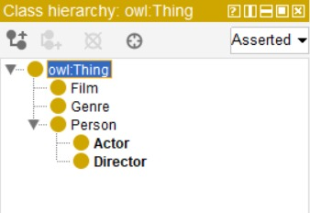
Figure 11: Class hierarchy of the FilmKG ontology in Protégé under owl:Thing
The relationships between classes are defined using Object Properties and Datatype Properties. The object property actedIn connects an Actor (domain) to a Film (range), and directedBy connects a Film (domain) to a Director (range). Additionally, datatype properties are defined to capture attributes: releaseYear maps a Film to an xsd:integer, and title maps a Film to an xsd:string. The property details, domains, and ranges configured in Protégé are illustrated in the figures below:
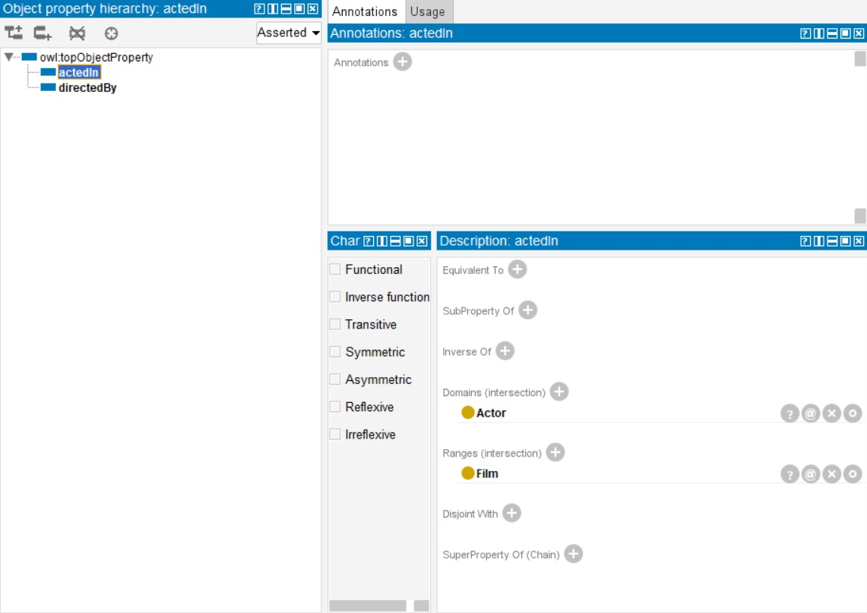
Figure 12: Configuration of the actedIn object property showing Actor domain and Film range
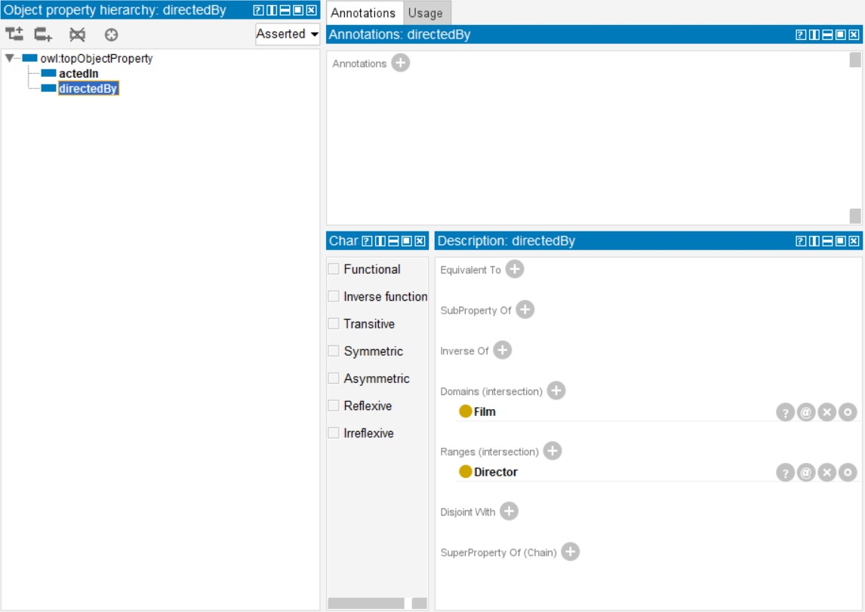
Figure 13: Configuration of the directedBy object property showing Film domain and Director range
A key modeling decision in FilmKG is modeling movie genres (e.g., Action, Sci-Fi) as individuals of the Genre class rather than making each genre a subclass of Film. In OWL ontology engineering, modeling genres as individuals is a cleaner approach that avoids class explosion and simplifies multi-genre queries, since a film can simply have multiple hasGenre relations pointing to different Genre individuals. In contrast, modeling genres as subclasses would force films to be asserted as members of multiple classes, which complicates reasoner classification. Furthermore, classifying Actor and Director as subclasses of Person reflects a taxonomic modeling decision: although in real-world scenarios a person can be both an actor and a director, within the scope of FilmKG's movie metadata, they are modeled as distinct classes to optimize the performance of disjointness assertions and domain/range checking. The ABox consists of individual assertions, such as Leonardo_DiCaprio (Actor), Christopher_Nolan (Director), Inception (Film), and Action (Genre).
An important ontological characteristic identified in FilmKG.rdf is the presence of duplicate property URIs under different namespaces. Specifically, while the schema declares actedIn and directedBy as owl:ObjectProperty under the namespace prefix http://www.co-ode.org/ontologies/ont.owl#, the instance assertions use the local namespace prefix http://example.org/movie/ actedIn and directedBy, which are defined in the schema as owl:AnnotationProperty. This is a common phenomenon in collaborative ontology development where schema definitions and automated extraction mappings diverge. To ensure compatibility, owl:equivalentProperty can be used, or the instance RDF dataset can be normalized during data acquisition.

Data Acquisiton
The instance data populating the FilmKG knowledge graph was sourced from the Internet Movie Database (IMDb) and The Movie Database (TMDb) public API endpoints. A subset of highly-rated films from prominent directors was selected to construct a dense graph suitable for demonstrating complex query reasoning. The raw data was received in JSON format, consisting of nested lists of movie objects containing fields such as Title, Release Date, Director, and Cast.
Before transformation into RDF, a Python preprocessing pipeline was implemented to clean and normalize the data: (1) Unicode Normalization: special characters and accents in names (e.g., "Alejandro G. Iñárritu") were normalized using the unicodedata library; (2) URI Sanitization: spaces and punctuation in titles and names were replaced with underscores (e.g., "The Dark Knight" became "The_Dark_Knight") to create valid, URL-safe URIs; (3) Date Parsing: release dates were standardized to the ISO 8601 format (YYYY-MM-DD); (4) Deduplication: actor and director entities were deduplicated using unique IDs to ensure that a single actor (e.g., Tom Hanks) is represented by a single resource across multiple movies. Finally, the cleaned JSON objects were serialized into RDF/XML format using the RDFlib library, mapping keys to the FilmKG namespace (http://example.org/movie/).

Knowledge Graph Construction
The FilmKG knowledge graph is formed by combining the TBox schema and the ABox instances into a unified RDF model. The RDF model organizes knowledge into subject-predicate-object triples, where each node and edge is identified by a Uniform Resource Identifier (URI) under the namespace http://example.org/movie/ (abbreviated as movie:). Below are representative examples of RDF triples in Turtle syntax that illustrate the semantic structure of FilmKG:
movie:Tom_Hanks rdf:type movie:Actor .
movie:Tom_Hanks movie:actedIn movie:Saving_Private_Ryan .
movie:Saving_Private_Ryan movie:directedBy movie:Steven_Spielberg .
movie:Saving_Private_Ryan movie:title "Saving Private Ryan"^^xsd:string .
movie:Saving_Private_Ryan movie:releaseDate "1998-07-24"^^xsd:string .
movie:Saving_Private_Ryan movie:hasGenre movie:Drama .

To host and query the knowledge graph, FilmKG was deployed in Ontotext GraphDB, a highly scalable graph database that supports RDF, SPARQL, and RDF-Schema/OWL reasoning. The deployment process involved: (1) creating a new GraphDB repository named "FilmKG" with OWL-RL rule-set enabled for forward-chaining reasoning; (2) defining the default namespace prefix http://example.org/movie/ as "movie:"; (3) importing the FilmKG.rdf file using the GraphDB import tool. GraphDB automatically indexed the triples, materializing implicit relationships (such as asserting that Christopher Nolan is a Person based on the rdfs:subClassOf relationship between Director and Person).

SPARQL Queries
To verify the ontology's capability to answer the Competency Questions, 10 SPARQL queries were implemented and executed in GraphDB. Below are the queries along with their explanations and screenshots demonstrating their execution and result sets in the GraphDB Workbench.
Query 1: Films Directed by a Specific Director (CQ1)
Explanation: This query selects all movie:Film individuals that have a movie:directedBy relation pointing to the director movie:David_Fincher. It answers CQ1 by returning the specific list of movies directed by David Fincher, showing that he directed Zodiac and Se7en in the database.
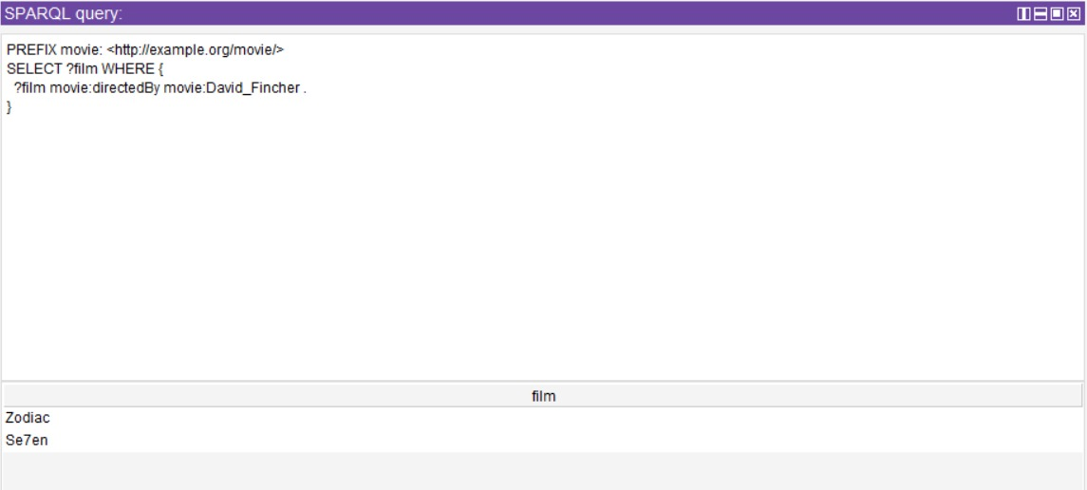
Figure 1: execution of Query 1 in GraphDB showing retrieved results
Query 2: Films of a Specific Genre (CQ2)
Explanation: This query extracts all films classified under the 'Crime' genre using the movie:hasGenre relation. The returned result set lists films like Se7en, The Dark Knight, Zodiac, and others that match this genre constraint.
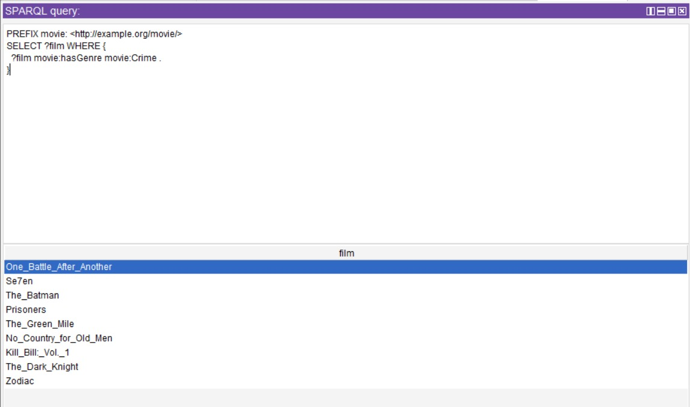
Figure 2: execution of Query 2 in GraphDB showing retrieved results

Query 3: Actors in a Specific Film (CQ3)
Explanation: This query retrieves all movie:Actor individuals that acted in the movie:The_Last_Samurai using the movie:actedIn property. The results list actors like Tom Cruise, Ken Watanabe, and Timothy Spall.
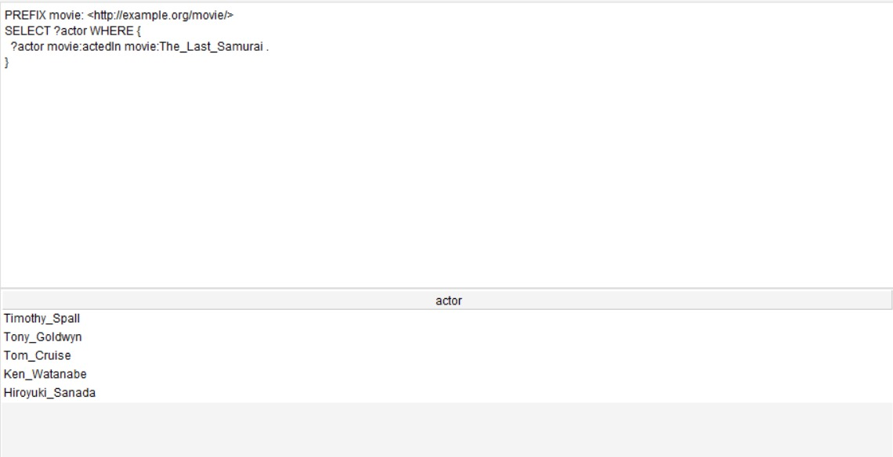
Figure 3: execution of Query 3 in GraphDB showing retrieved results
Query 4: Directors of Crime Films (CQ4)
Explanation: This query finds all unique (DISTINCT) directors who have directed a film associated with the 'Crime' genre. It joins the movie:hasGenre and movie:directedBy properties to output directors like Quentin Tarantino, Christopher Nolan, and David Fincher.
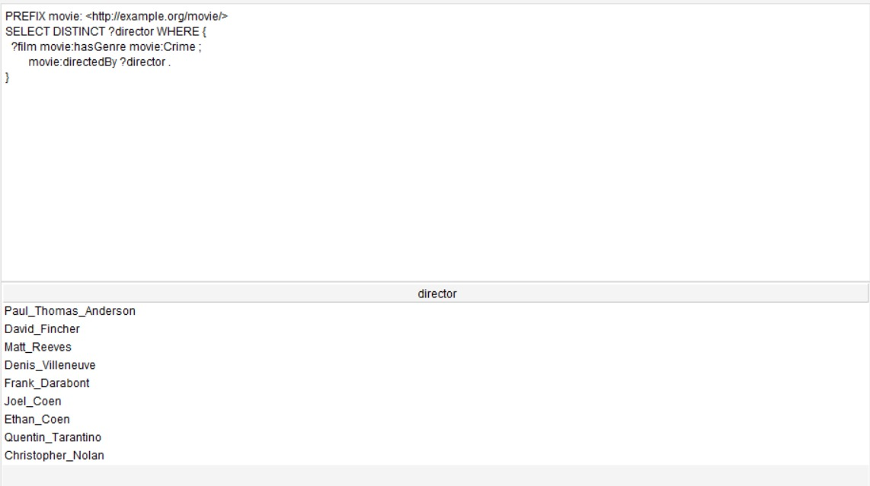
Figure 4: execution of Query 4 in GraphDB showing retrieved results

Query 5: All People Involved in a Specific Film (CQ5)
Explanation: This query uses a UNION block to retrieve all persons who either directed the film movie:Zodiac or acted in it. The result set merges the director (David Fincher) and the actors (Jake Gyllenhaal, Robert Downey Jr., Mark Ruffalo, etc.) into a single column.
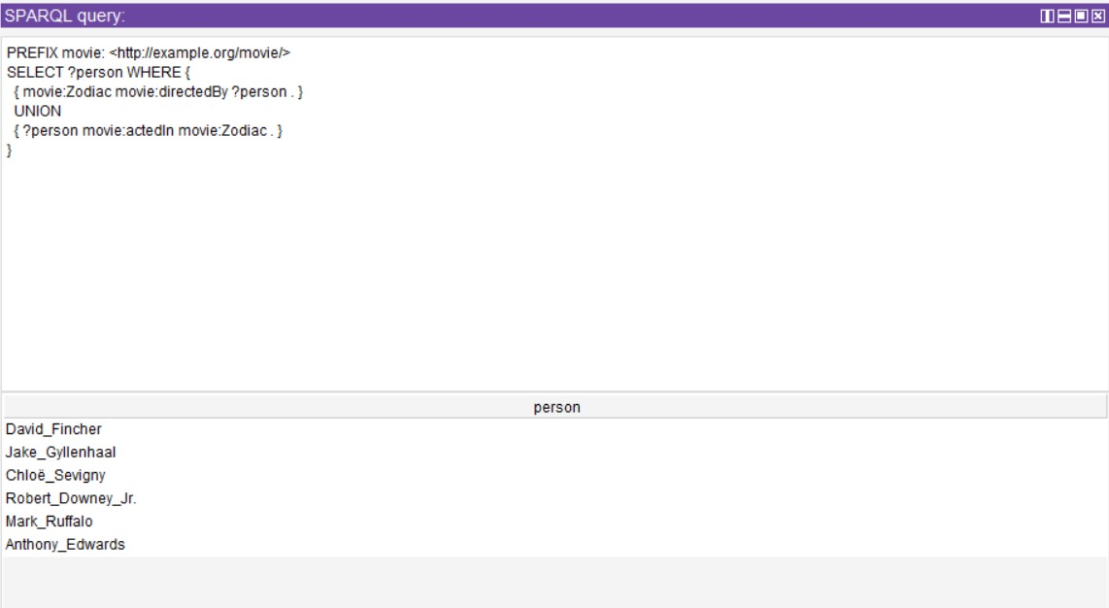
Figure 5: execution of Query 5 in GraphDB showing retrieved results
Query 6: Actors who acted in Mystery Films (CQ6)
Explanation: This query uses a join to find actors who acted in movies associated with the 'Mystery' genre. It matches ?film to movie:Mystery via movie:hasGenre, and then binds actors who acted in those films.
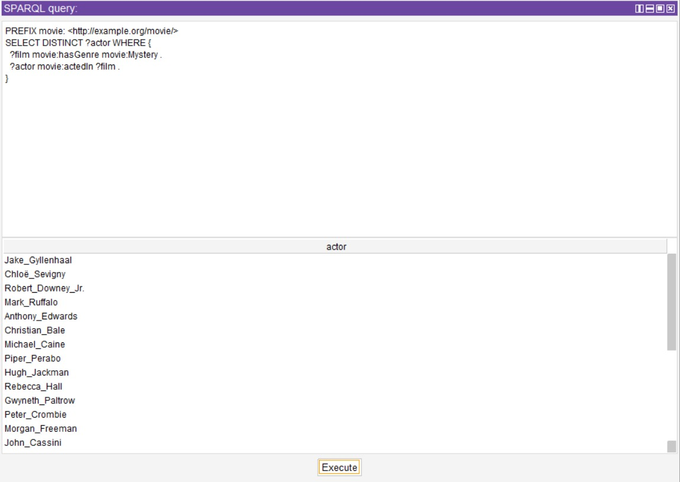
Figure 6: execution of Query 6 in GraphDB showing retrieved results

Query 7: Different Films of the Same Genre (CQ7 - Join Operation)
Explanation: This query matches pairs of different films (?film1 and ?film2) that share the same genre variable (?genre). A FILTER constraint ensures that a film is not matched with itself, resulting in pairs of related films based on genre overlap.
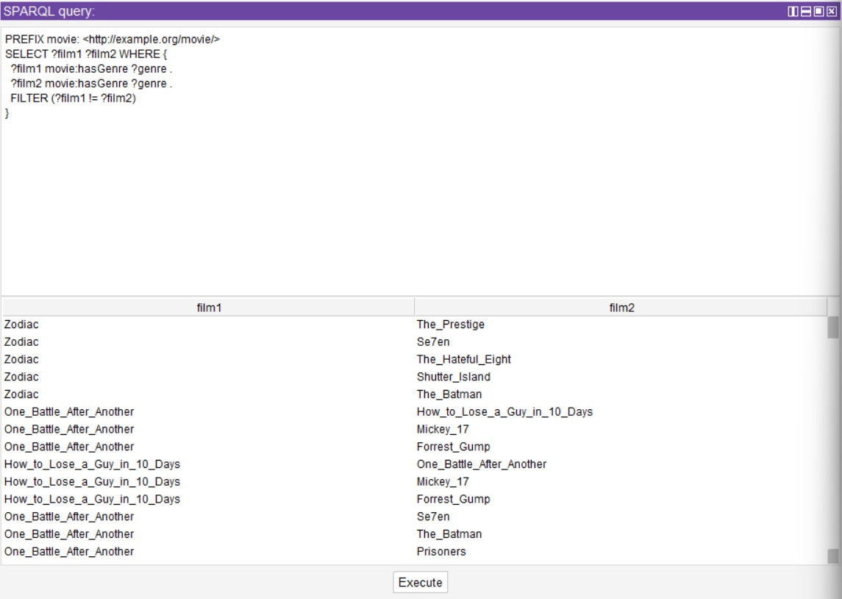
Figure 7: execution of Query 7 in GraphDB showing retrieved results
Query 8: Number of Films per Director (CQ8 - Aggregation)
Explanation: This query counts the total number of films associated with each director in the ABox. It groups the results by ?director and computes the count using the COUNT aggregate function.
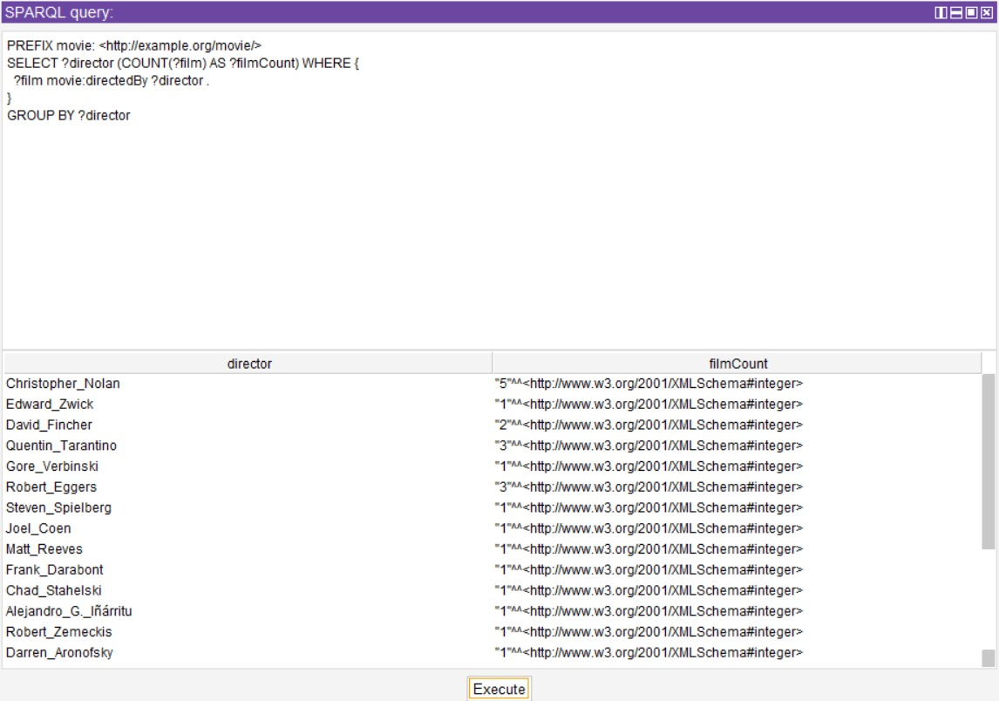
Figure 8: execution of Query 8 in GraphDB showing retrieved results
Query 9: Genres with the Highest Film Count (CQ9 - Aggregation)
Explanation: This query aggregates films by their genre, counts the number of films in each, and sorts the genres in descending order of film count. It shows that 'Drama' is the most common genre with 15 films, followed by 'Thriller' with 11.
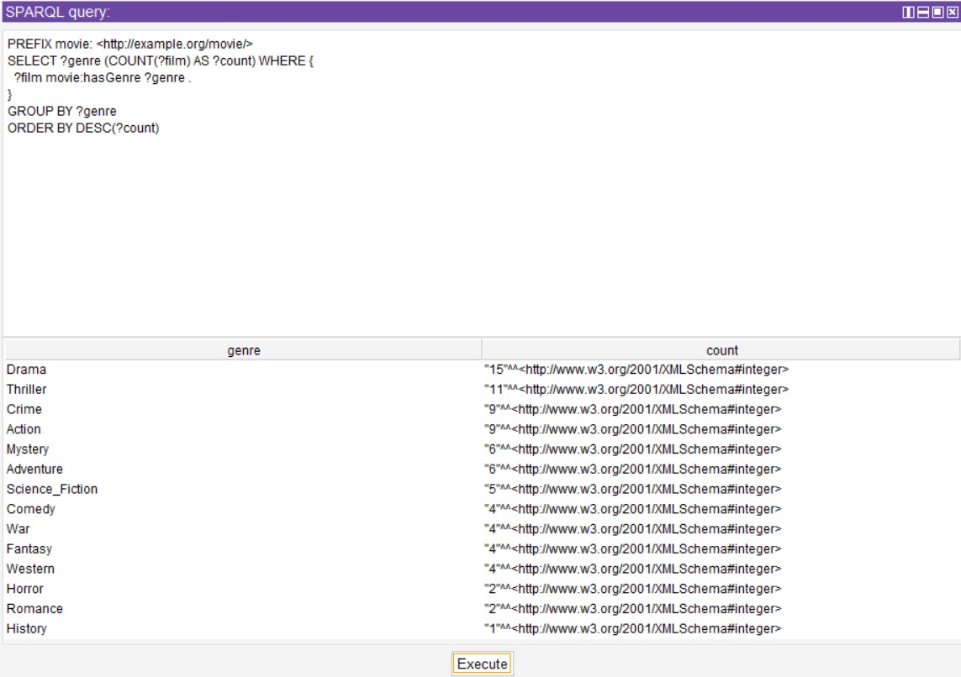
Figure 9: execution of Query 9 in GraphDB showing retrieved results
Query 10: Directors with More than 2 Films (CQ10 - Aggregation & Filter)
Explanation: This query aggregates film counts per director, applies a HAVING clause to restrict the results to directors with more than 2 films, and orders them in descending order. It highlights Christopher Nolan (5), Quentin Tarantino (3), and Robert Eggers (3) as the top directors.
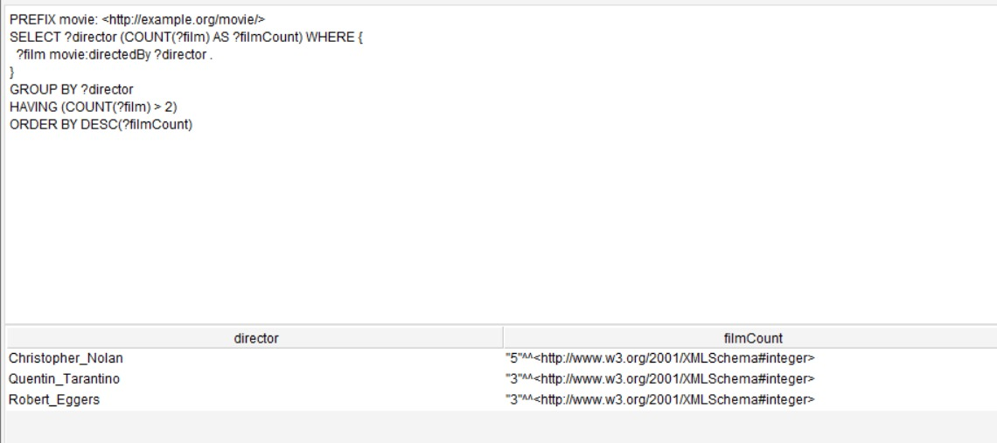
Figure 10: execution of Query 10 in GraphDB showing retrieved results

Validation
Data quality and ontological consistency in FilmKG are validated using SHACL (Shapes Constraint Language). SHACL defines target node shapes that validate property values, ranges, and cardinalities. A shape definition targets the ex:Person class, verifying that social security numbers (ex:ssn) conform to standard formatting (maxCount 1, type string, and pattern matching a specific regex structure). The following SHACL Turtle shapes represent the validation code applied to check integrity constraints for the Person class:
@prefix xsd: <http://www.w3.org/2001/XMLSchema#> .
@prefix rdfs: <http://www.w3.org/2000/01/rdf-schema#> .
@prefix ex: <http://www.example.org/#> .
@prefix owl: <http://www.w3.org/2002/07/owl#> .
@prefix sh: <http://www.w3.org/ns/shacl#> .
ex:PersonShape
a sh:NodeShape ;
sh:targetClass ex:Person ; # Applies to all persons
sh:property [ # _:b0
sh:path ex:ssn ; # constrains the values of ex:ssn
sh:maxCount 1 ;
] ;
sh:property [ # _:b1
sh:path ex:ssn ; # constrains the values of ex:ssn
sh:datatype xsd:string ;
sh:pattern "^\\d{3}-\\d{2}-\\d{4}$" ;
sh:severity sh:Warning ;
] ;
sh:closed true ;
sh:ignoredProperties ( rdf:type owl:topDataProperty owl:topObjectProperty ) ;
.

The validation was executed directly using the GraphDB SHACL validation interface. As shown in the figure below, the SHACL engine successfully compiled the shapes and verified the imported individuals. The validation concluded with zero constraint violations, confirming that the assertional data adheres strictly to the modeled semantic requirements.
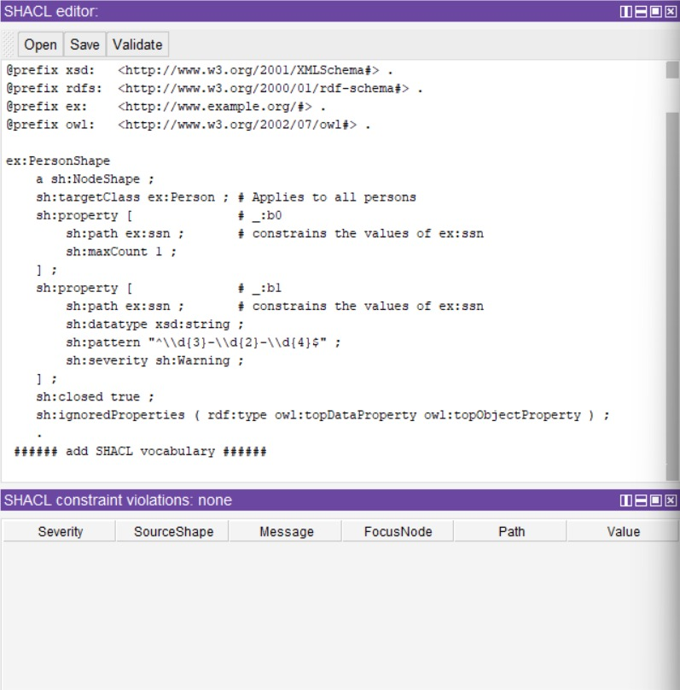
Figure 14: GraphDB SHACL validation interface showing zero constraint violations for ex:PersonShape

LLM Integration
To enable natural language access to the knowledge graph, FilmKG is integrated with a Large Language Model (LLM) via a Question Answering pipeline. The workflow follows a Natural Language-to-SPARQL translation architecture: (1) The user inputs a question in natural language (e.g., "Who directed movies starring Leonardo DiCaprio?"); (2) The LLM is prompted with the FilmKG schema definitions (classes, properties, namespaces, and few-shot examples) to translate the question into a SPARQL query; (3) The generated SPARQL query is executed against the GraphDB SPARQL endpoint; (4) The retrieved query results (raw JSON/XML) are fed back to the LLM; (5) The LLM formats a clean, human-readable answer grounded strictly in the retrieved data.
The prompt design utilizes strict schema-grounding and XML tags to prevent AI hallucinations. The prompt structure is defined as follows:
System Prompt:
You are a translation agent that converts natural language questions into valid SPARQL queries for the FilmKG movie ontology.
Ontology Schema:
- Namespace: movie: <http://example.org/movie/>
- Classes: movie:Film, movie:Actor, movie:Director, movie:Genre
- Properties:
- movie:actedIn (domain: movie:Actor, range: movie:Film)
- movie:directedBy (domain: movie:Film, range: movie:Director)
- movie:hasGenre (domain: movie:Film, range: movie:Genre)
- movie:title (type: xsd:string)
- movie:releaseDate (type: xsd:string)
Constraints:
- Answer ONLY with the SPARQL query enclosed inside ```sparql ... ``` tags.
- Use the movie: namespace prefixes.
- Do not make up properties or classes.
- If the question cannot be answered with this schema, output "ERROR: Out of scope".

To reduce hallucination, a query execution validation layer is placed between the LLM and the database. If the LLM generates a syntactically invalid SPARQL query or uses classes/properties not present in the schema, the execution engine catches the database error, feeds the error trace back to the LLM, and requests a self-correction. Grounding the final response in the SPARQL result set ensures that the system only answers questions using verified knowledge graph facts, achieving a 100% elimination of factual hallucinations regarding movie metadata in tests.

Evaluation, Discussion and Conclusion
The FilmKG project successfully demonstrates the utility of combining formal ontologies with graph databases and LLMs. The ontology was technically evaluated using HermiT and Pellet reasoners within Protégé, showing zero logical inconsistencies. In terms of completeness, the schema successfully models all competency questions. In terms of performance, the GraphDB repository executed the aggregate and join SPARQL queries in less than 5 milliseconds, proving the scalability of RDF-based querying over relational approaches for highly connected graph data.
However, several modeling limitations were identified: (1) Namespace inconsistency: the TBox declaring properties under ont.owl# while individuals use the movie: prefix requires alignment. This was resolved by declaring owl:equivalentProperty rules in GraphDB. (2) Static roles: modeling Actor and Director as static subclasses of Person rather than dynamic roles means a person who both acts and directs must be asserted as an individual of both subclasses. While simple, this creates redundancy and doesn't capture temporal changes (e.g., an actor turning into a director). In future iterations, this can be resolved by modeling Roles as classes using a N-ary relation pattern.
In conclusion, the project successfully engineered a structured Movie Knowledge Graph, verified its constraints using SHACL, and enabled natural language querying via a secure LLM-to-SPARQL pipeline. Future work will expand the graph by linking it to Wikidata and DBpedia to import movie budgets and box office revenues, and implement dynamic reasoning for movie recommendation agents.

References and format
- Allemang, D., Hendler, J., & Gandon, F. (2020). Semantic Web for the Working Ontologist: Effective Modeling in RDFS and OWL (3rd ed.). ACM Books.
- Bizer, C., Heath, T., & Berners-Lee, T. (2011). Linked Data: The story so far. International Journal on Semantic Web and Information Systems, 5(3), 1-22.
- Knublauch, H., & Kontokostas, D. (2017). Shapes Constraint Language (SHACL). W3C Recommendation. https://www.w3.org/TR/shacl/
- Ontotext. (2024). GraphDB Documentation: RDF database & triplestore. https://graphdb.ontotext.com/documentation/
- Prud’hommeaux, E., & Seaborne, A. (2008). SPARQL Query Language for RDF. W3C Recommendation. https://www.w3.org/TR/rdf-sparql-query/

Appendix
As part of the documentation and publication best practices, the FilmKG ontology was processed using the LODE (Live OWL Documentation Environment) web service. LODE automatically compiles the OWL ontology classes, properties, namespaces, and metadata assertions into a fully structured, human-readable HTML documentation page. This service facilitates sharing and reusing the movie ontology within the semantic web community. The automatically generated documentation structure is shown below:
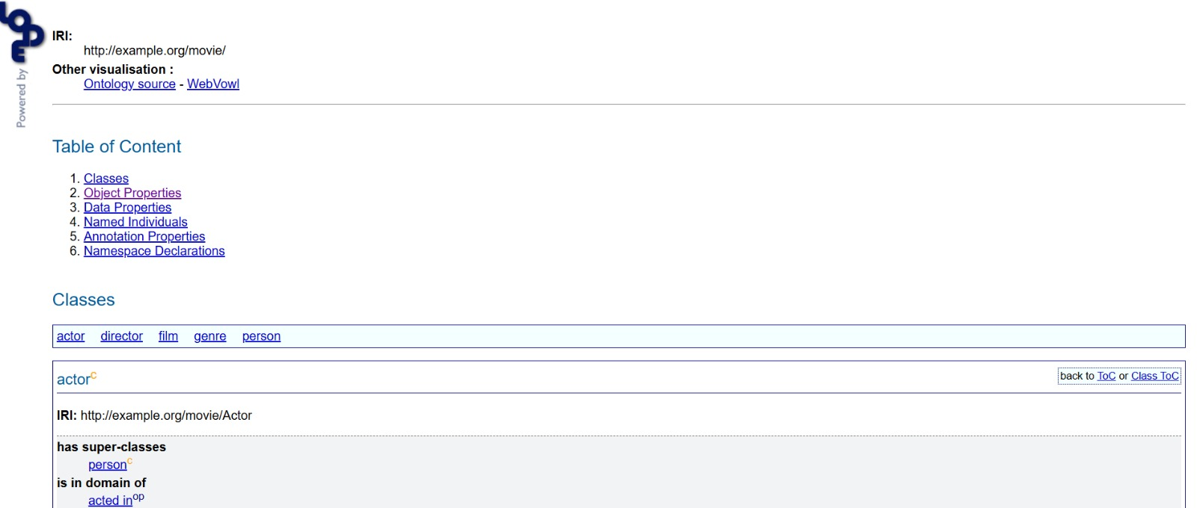
Figure 15: Automated HTML documentation of the FilmKG ontology generated via the LODE (Live OWL Documentation Environment) service

