Weak Prompt: Explain regression

Improved Prompt:
Explain regression in simple terms for a beginner. Include a real-life example and explain when it is used in data analysis.
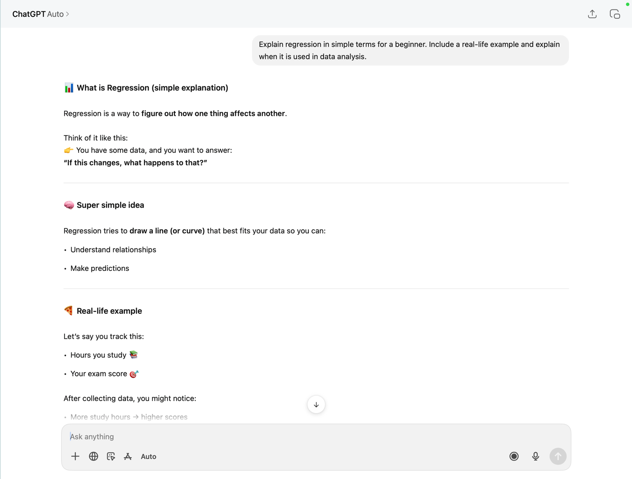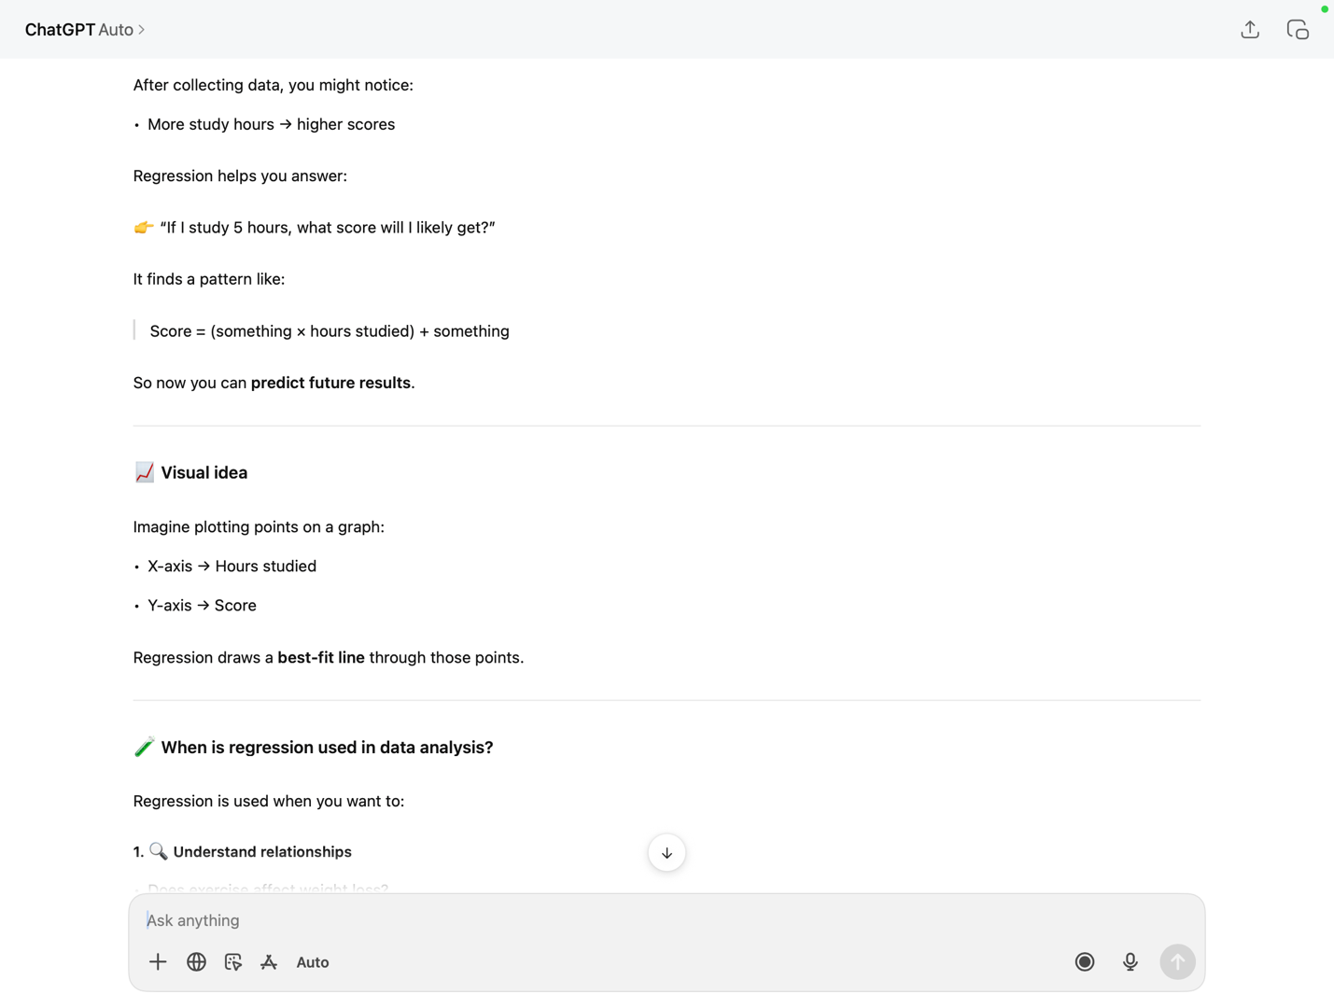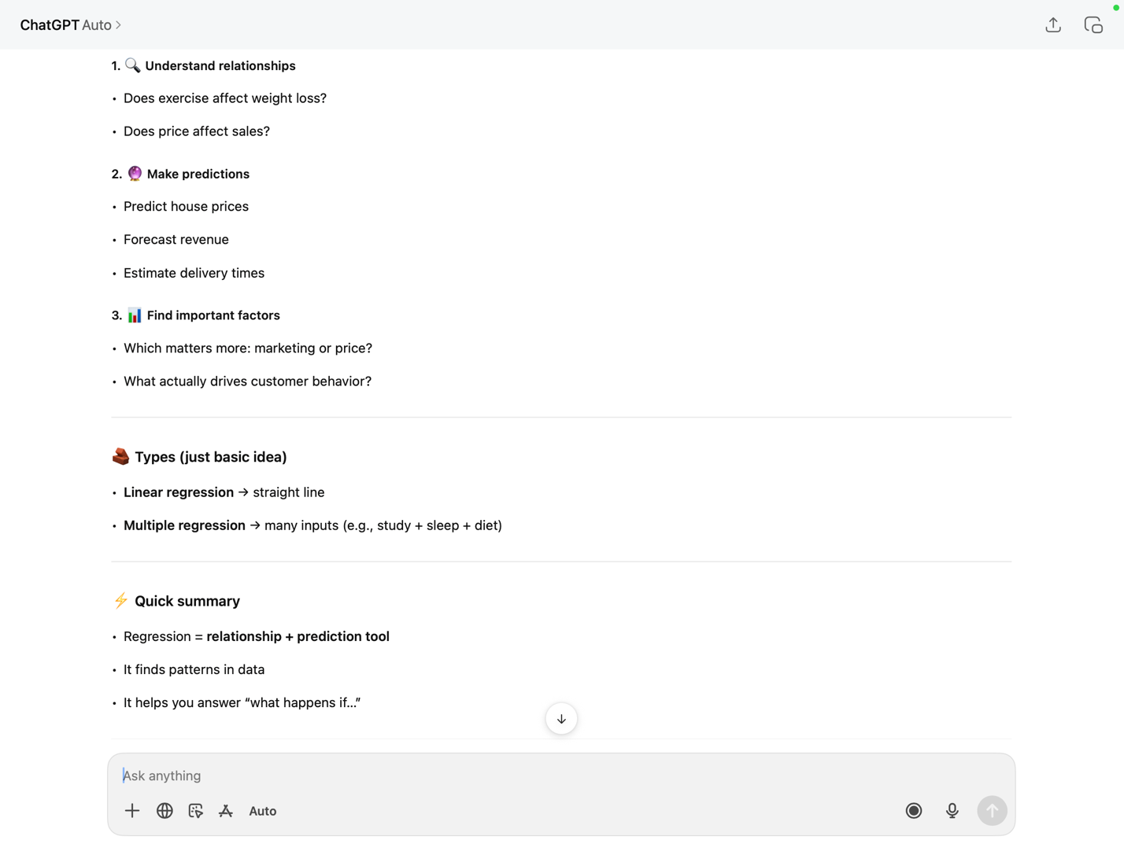

Why this is stronger:
This prompt is more specific and asks for a simple explanation, a real-life example, and context, which makes the response more useful and easier to understand.

Weak Prompt: Help me understand SQL

Improved Prompt:
Explain SQL for a beginner with a simple example. Show how to use SELECT and WHERE in a basic query.

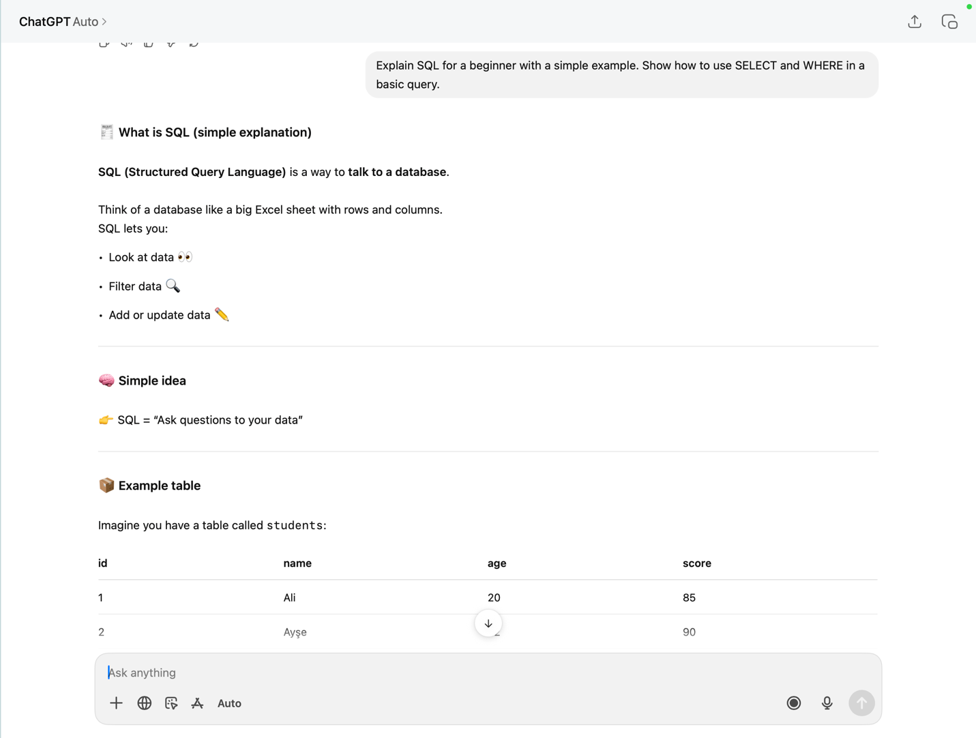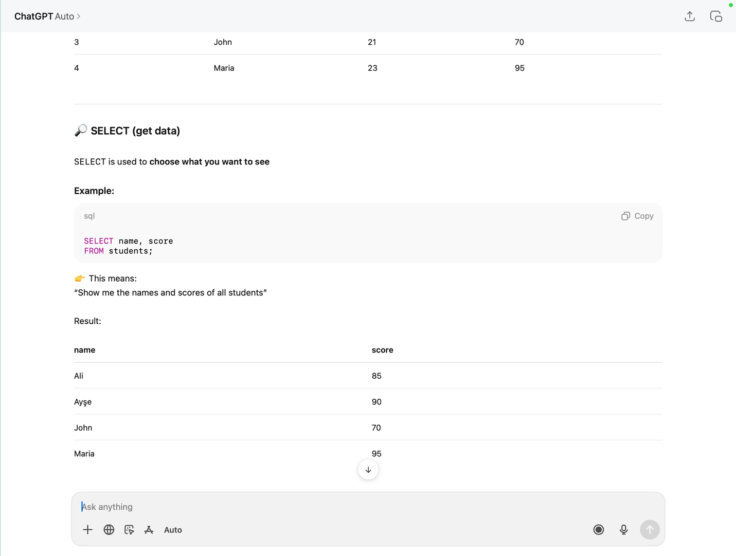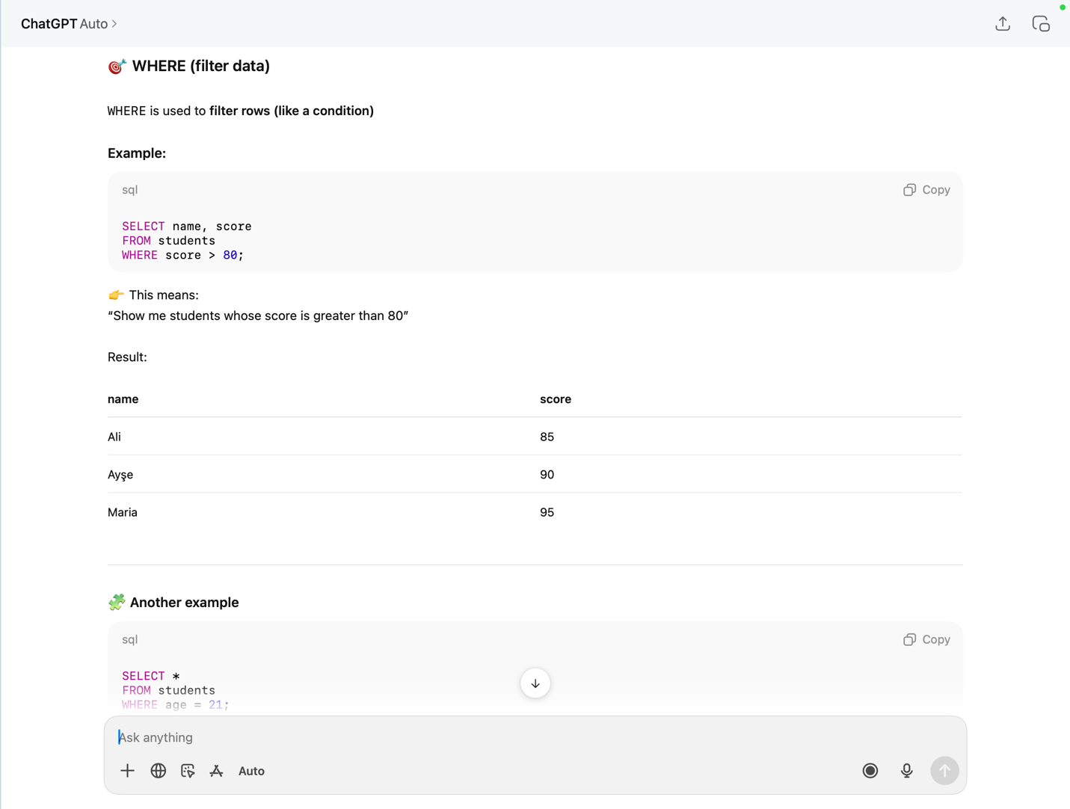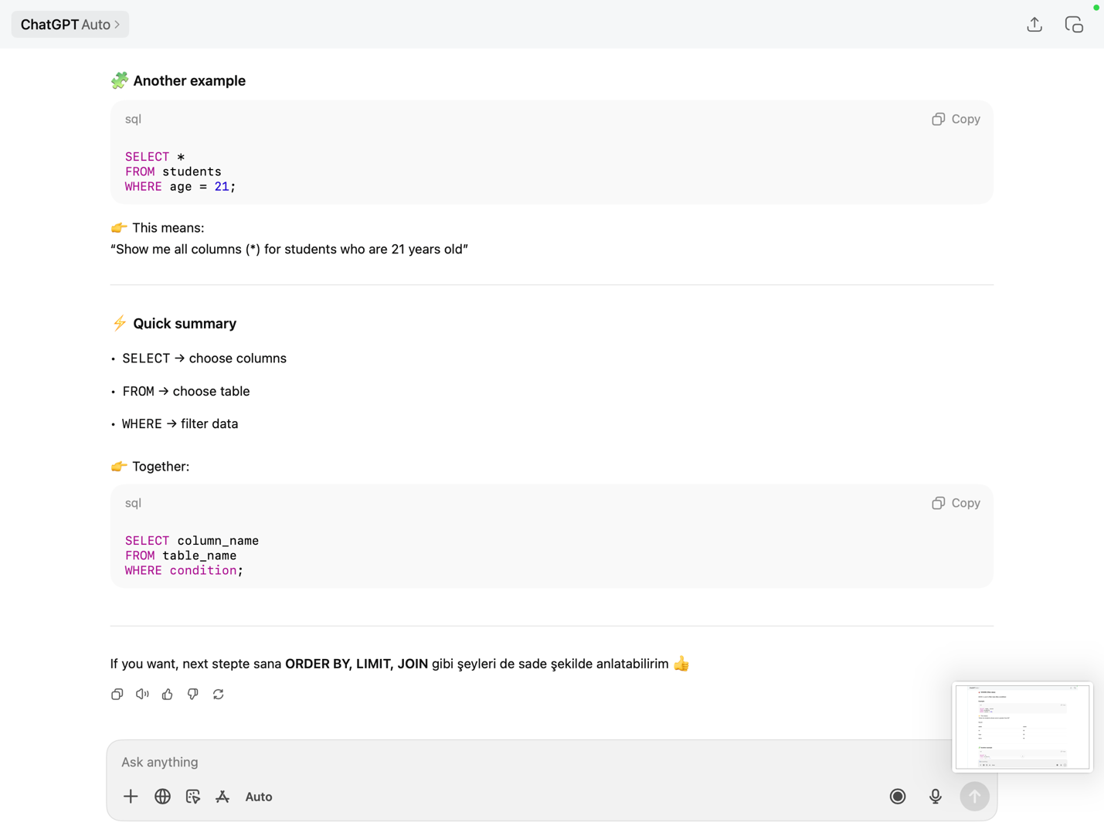

Why this is stronger:
This prompt clearly defines the level (beginner) and asks for specific examples, which helps generate a more focused and practical response.

Weak Prompt: Create a dataset

Improved Prompt:
Create a dataset with 10 rows showing product name, price, and category. Format it as a table.

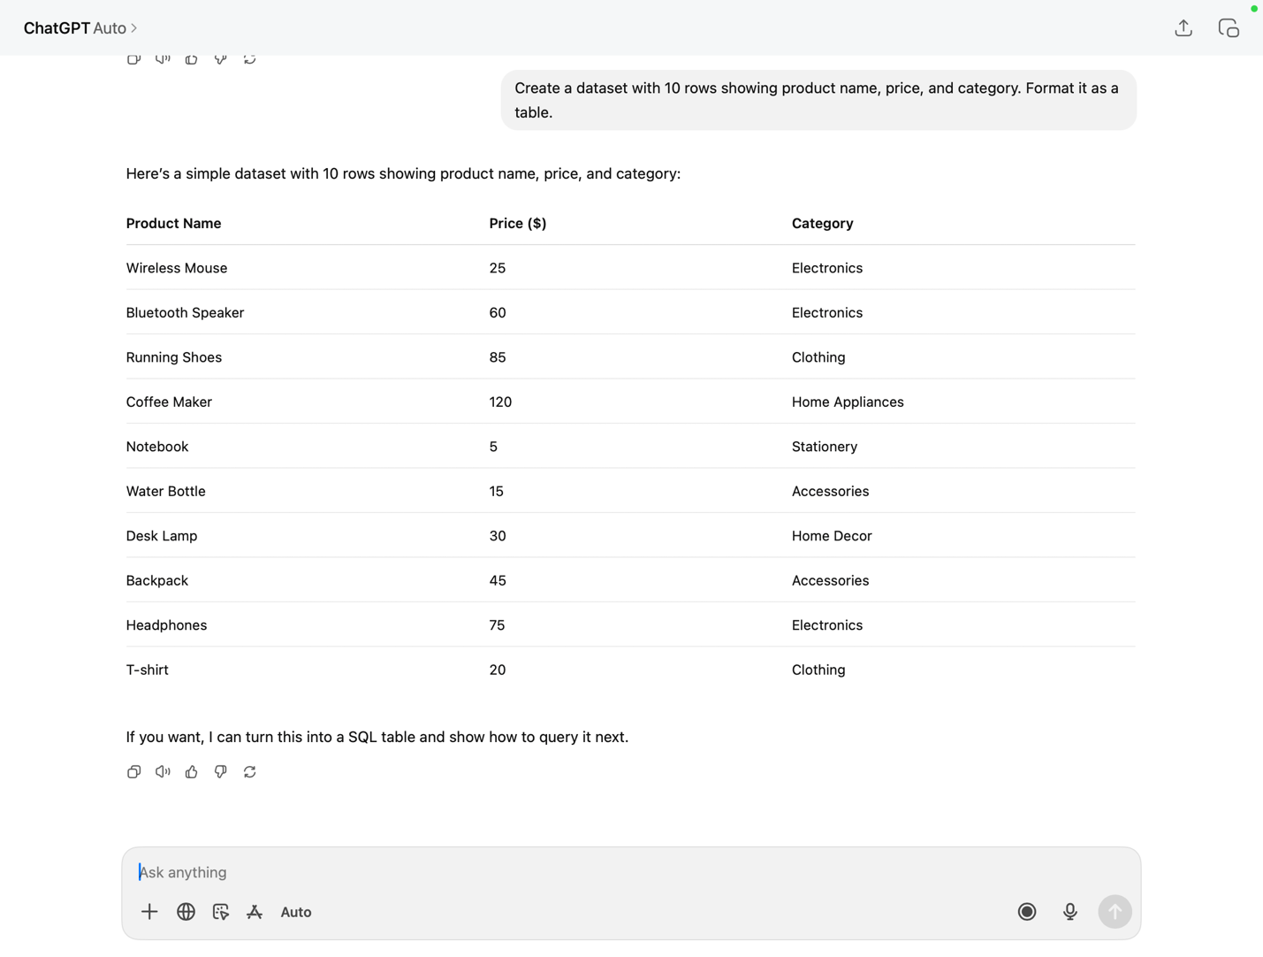

Why this is stronger:
This prompt is specific about the number of rows, the columns, and the format, which results in a structured and usable output.

