Uğur AKYOL
Feel free to send an email to ugur-akyoll@hotmail.com if you have any inquiries.

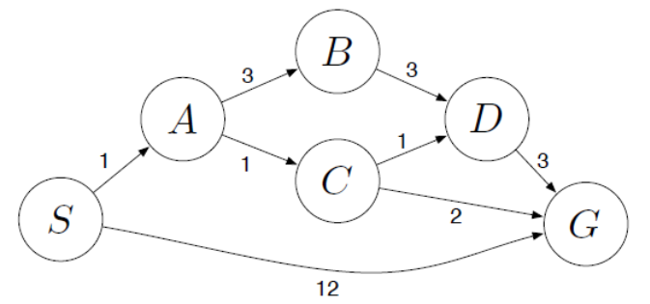
Use the following map as sample and place it in your tree:

