

**Modeling and Discrete Simulation**

**Homework#3**

Uğur Alp Yavuz – 150115054

Taylan Rojen Döğer-150117055

* **Performance Metrics**
* **Security Guard Service Count:** Number of jobs that the security guard has completed.
* **Waiting time for Security Guard:** The time the passenger spends until the security guard is available.
* **Average number of passenger waiting for Security Guard:** The number of passengers in the queue when the security guard is busy.
* **Service time for Security Guard:** The time it takes for a security guard to complete a job for a passenger.
* **Counter Attendant Service Count:** Number of jobs that the counter attendant has completed.
* **Waiting time for Counter Attendant:** The time the passenger spends until the counter attendant is available.
* **Average number of passenger waiting for Counter Attendant:** The number of passengers in the queue when the counter attendant is busy.
* **Service time for Counter Attendant:** The time it takes for a counter attendant to complete a job for a passenger.
* **Last attendant Service Count:** Number of jobs that the last attendant has completed.
* **Waiting time for Last Attendant:** The time the passenger spends until the last attendant is available.
* **Average number of passenger waiting for Last Attendant:** The number of passengers in the queue when the last attendant is busy.
* **Service time for Last Attendant:** The time it takes for a last attendant to complete a job for a passenger.
* **Average Service Time:** Average time spent of attendants doing their job
* **Average Waiting Time:** Average waiting time for security guard, counter attendant and last attendant.
* **Average System Time:** The average elapsed time from the arrival of the airport to the arrival of the passenger on the plane.
* **Busy Signal Count:** If the employee is busy, the passenger will be added queue.
* **System Components**
* **Passengers**: Customers that traveling from one place to another.
* **Security Guards**: They are the first to meet the passengers inside the airport. After the necessary checks are made, the passengers are taken into the airport.
* **Counter Attendant:** Counter is a section reserved for passengers to complete their check-in procedures at airports. Inside the airport, there are counter areas of airline companies. Here you can do luggage delivery and check-in. An attendant will assist you with the counter check-in and baggage procedures.
* **Last Attendant:** After the check-in process, it will be clear from which door you will enter the plane. The staff at this gate will send you to the plane when the time comes, after seeing your flight card and ID.
* **Objectives**
* Find out the optimum service rate.
* Find out the optimum the number of servers.
* Find out best model.

So that the average cost of being in queuing system and the cost of service are minimised.

* **Conceptual Model**

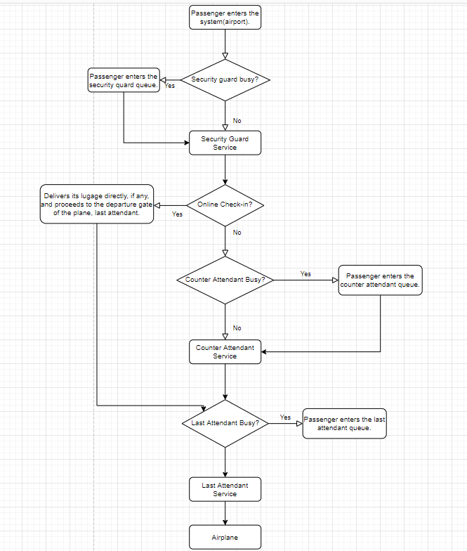  
Alternative model that we didn’t prefer:

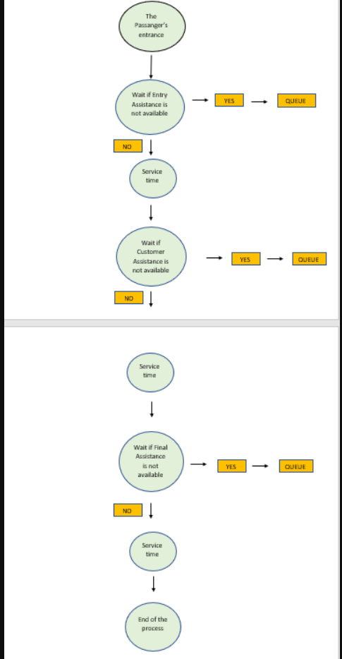

* 2D view of the model

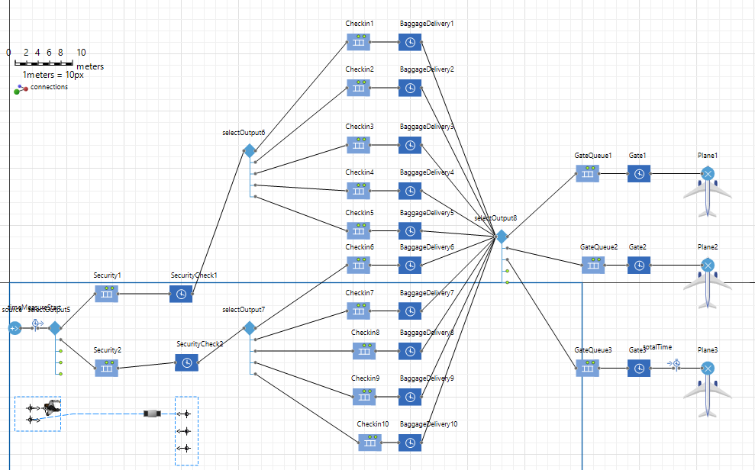

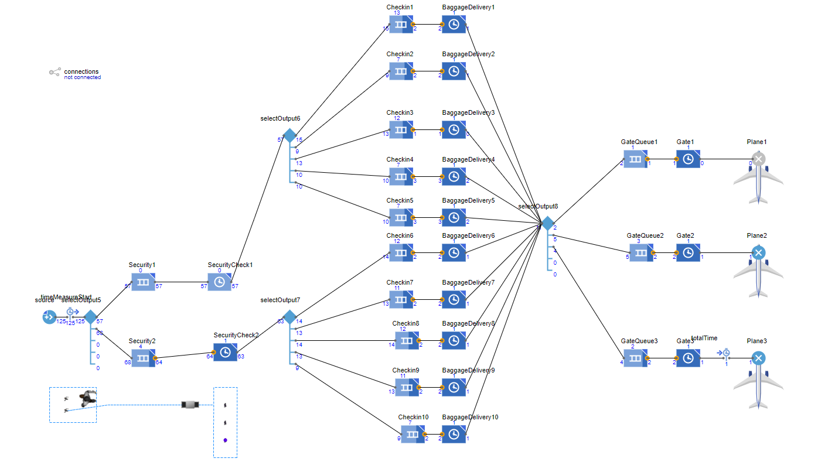

* 3D view of the model

We haven’t completed it yet, we’ll in future iterations.

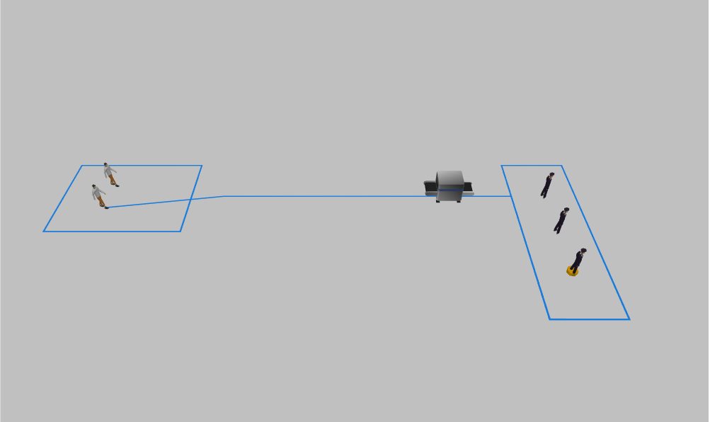

* Graphs:

Total amount of spent time by a passanger in system.

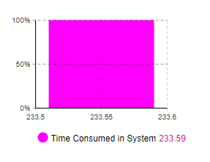

SecurityCheck2 Queue length at a spesific time.

