**SocialGoal v1.0.0 Release Notes**

This Document describes the release of SocialGoal v1.0.0

**How to build**

1. Clone the source code from GitHub and open the solution in Visual Studio 2013.
2. Build the solution. It will automatically restore NuGet and will install NuGet packages.

Note: The source code is excluded NuGet packages in the source control.

**Introduction**

SocialGoal is a social networking web app for socializing your goals and strategies with people. People can create goals and can be shared across the network of SocialGoal users. Goals can have start date, end date, metrics and target. People can update their goals and others can see those updates and can comment on each updates. People can support any public goal.

Groups can be created within SocialGoal so that it is very easy to build goals for a team. Group goals can be assigned to any of the group members. Groups can have focus and group goal can be created with a particular focus also.

**Features of SocialGoal**

* User should Register to start using SocialGoal application
* Creating Goals –

User can set goals in two types

1. Individual goals
2. Goals for a group in which the user is a member.

Edit & Delete Functionality is provided for each goal.

* Update Status-

Updates can be given for users own goal with or without status.

* Comment on an Update-

Any user can comment on an update of a public goal created by any user.

* Searching & Supporting a Goal-

User can search all the public goals in the search box provided and can support them. The user can follow a goal.

* Creating Group & Inviting Users –

User can create a group and can invite others to join the group

Invitation can send in two ways-

1. Can invite an existing user by searching with a user name.

Those invitations will send to user’s my invitation list and from there user can accept the invitation

1. Can invite a new user by sending an email

That invitation will send to the inbox of the recipient’s mailid and from there can join to the social goal and accept the invitation

* Following Group-

Once the User accepts the invitation to a group, then goals can be created for that group. He can invite other users and can create a focus for the group.

* Creating Focus For a Group-

The group can have a focus and the creation of goals is completely dependent on that focus

* Report for a Goal-

User can see the report of a goal based on update date and target date. Report will be generated for updates having status.

* Notifications –

User can see the notifications of the goal & group which is public.

* User Profile Creation-

User can create a profile and can edit the profile.

**Screen Shots**

1) Login Page

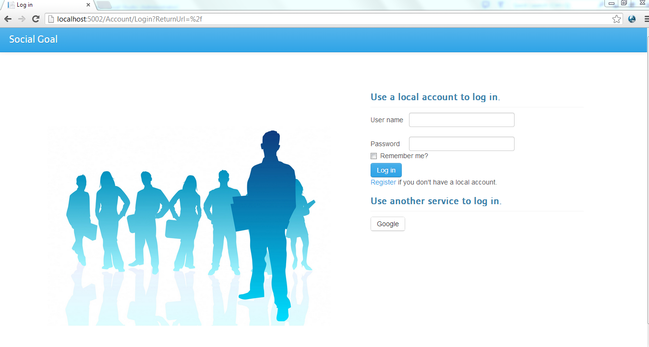

2) Home Page

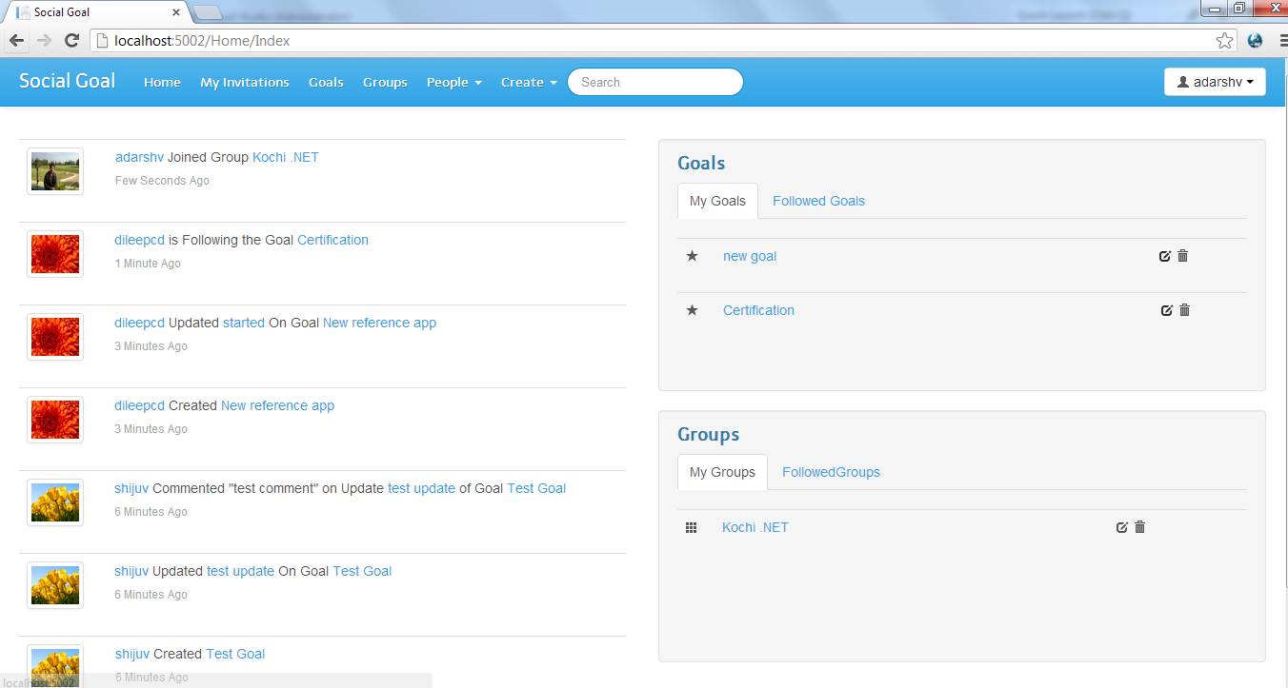

3) Goal Page

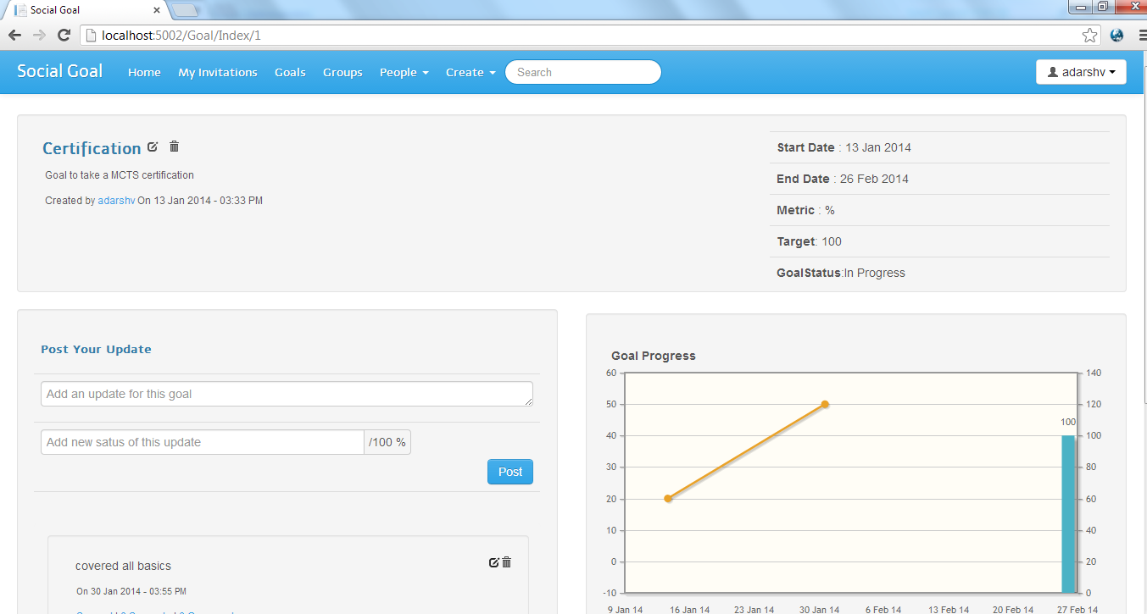

4)Update page of Goal

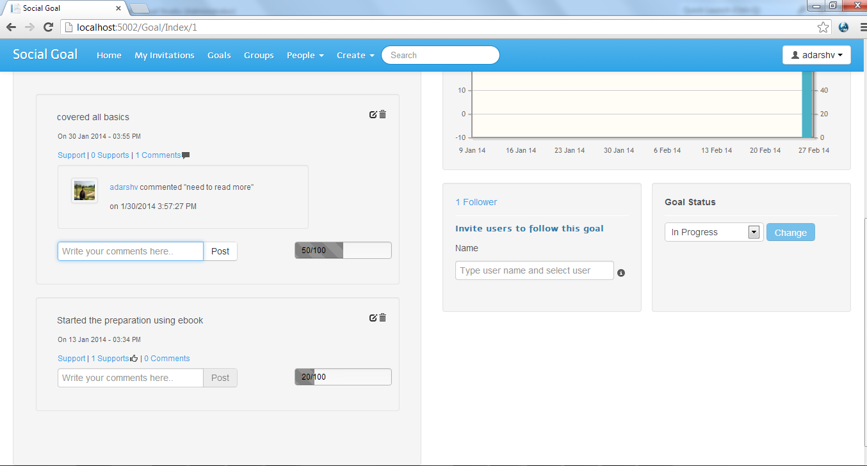

5) Group Page

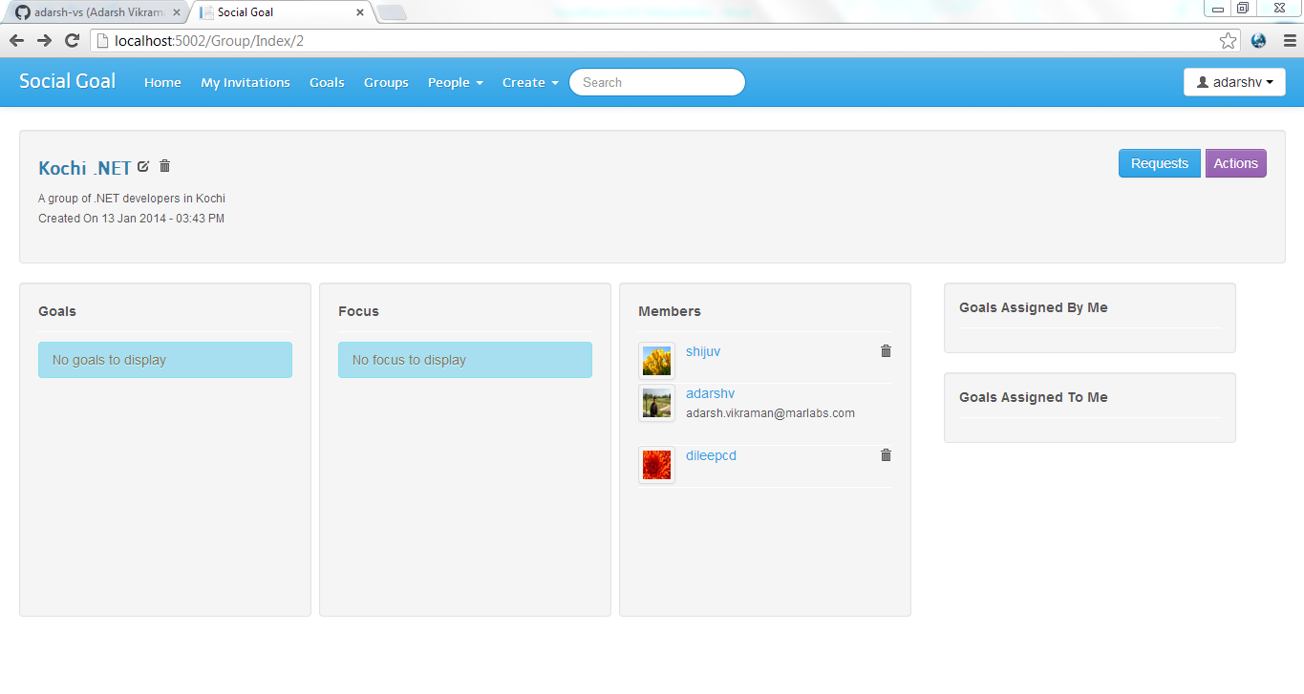

6) User profile

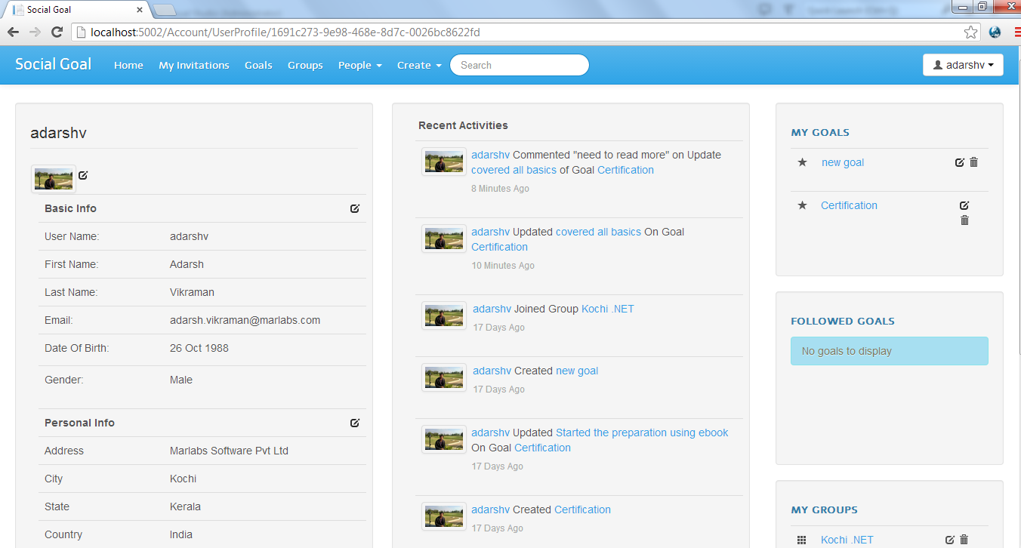

**Known Issues**

* This is not a completed version.

**Technologies/Frameworks**

* **Persistence/ORM** – EF 6 Code First
* **Data Migration** - EF Code First Migrations
* **Database** – SQL Server
* **Server-Side** – ASP.NET
* **Web Framework** – ASP.NET MVC 5
* **Authentication**- ASP.NET Identity
* **Data Mappers** – AutoMapper
* **IoC** - Autofac
* **Client-Side Frameworks** – jQuery, Twitter Bootstrap