Project Development Process and Individual Contribution Statement
Table 1. Submission metadata.
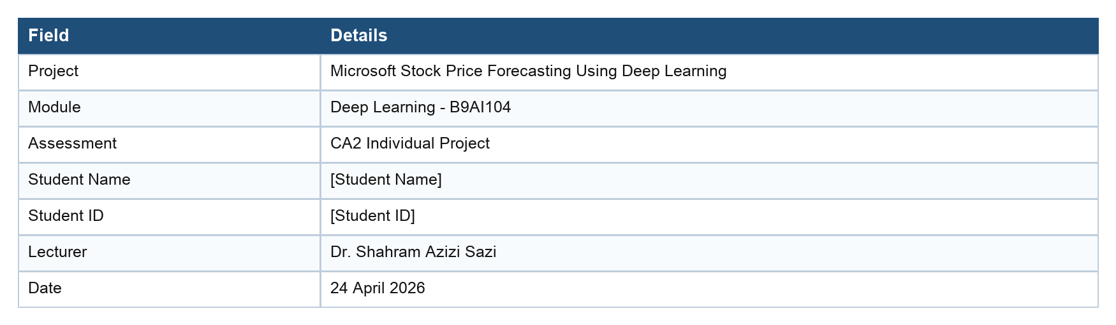

1. Project Timeline
Table 2. Project timeline and estimated time spent.
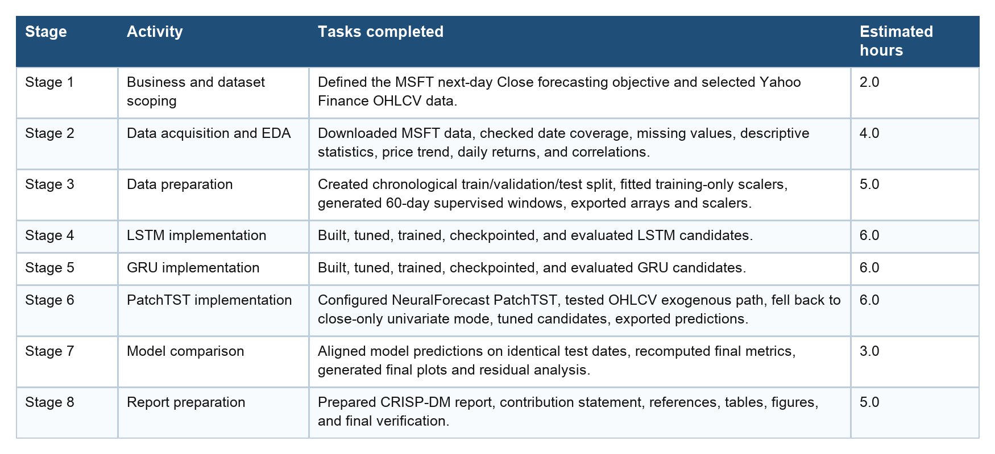

2. Individual Tasks Completed
- Defined the forecasting objective: predict the next trading day's Microsoft adjusted Close from historical daily market data.
- Downloaded and validated MSFT OHLCV data through yfinance.
- Prepared chronological train, validation, and test splits while preserving time order.
- Fitted MinMax scalers only on the training period and saved scalers for inverse transformation.
- Generated 60-day windows with next-day Close targets and saved NumPy arrays for later notebooks.
- Implemented LSTM and GRU PyTorch models with tuning, early stopping, learning-rate scheduling, gradient clipping, and saved checkpoints.
- Implemented PatchTST through NeuralForecast, documented the close-only fallback, tuned configurations, and exported validation/test forecasts.
- Created final aligned metrics and plots comparing Naive, LSTM, GRU, and PatchTST on the same 616 test dates.
- Prepared the final CA2 report and this individual contribution statement.

3. Tools Used
Table 3. Tools and purpose.
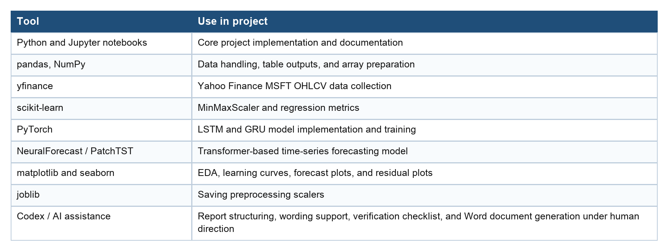

4. Evidence of Individual Contribution
Table 4. Evidence of work completed.
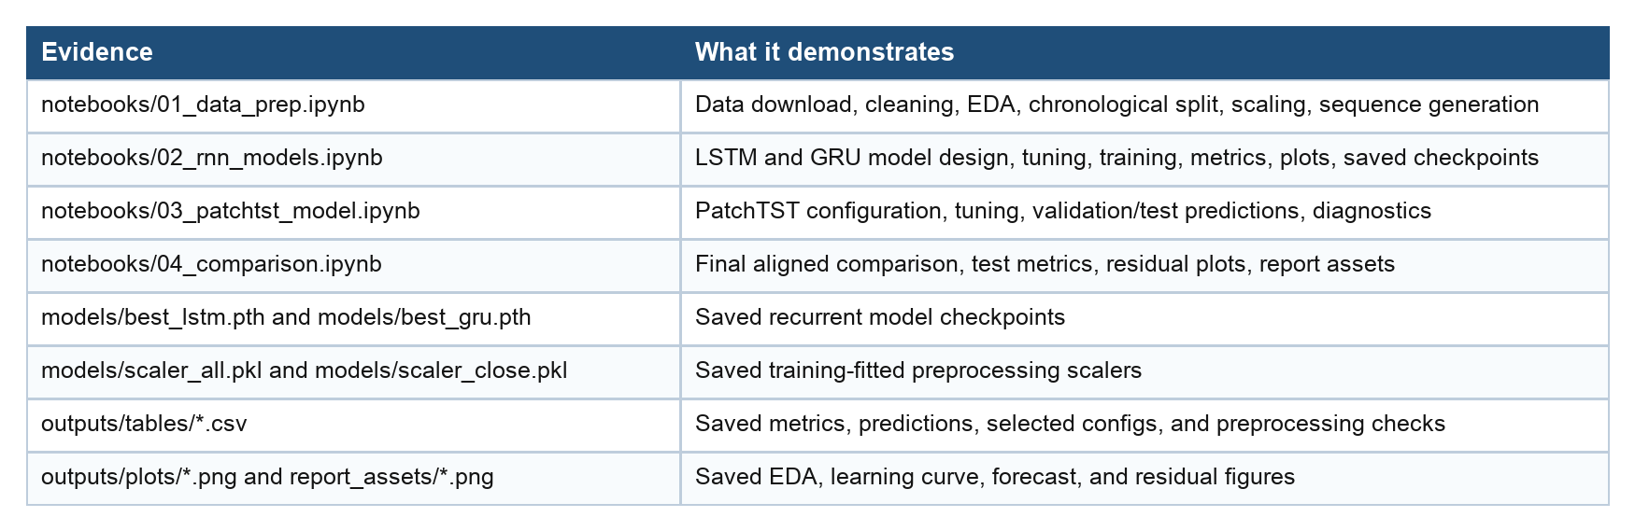

5. Reflection on Development Process
The project followed a staged workflow. The first priority was to make the dataset reliable and reproducible, because any modelling result would be weak if the time split, target alignment, or scaling introduced leakage. Creating saved arrays and date mappings made the later modelling notebooks easier to verify.
The recurrent modelling stage showed that validation performance alone was not enough to guarantee final test performance. The GRU generalised better than the LSTM, but both recurrent models struggled on the later test period where price levels moved outside the training-fitted scaling range. This was a useful lesson in the non-stationarity of financial time series.
The PatchTST stage also required practical adaptation. The intended OHLCV historical-exogenous setup was attempted, but the implementation path did not support those inputs, so the final PatchTST model used close-only univariate input. Recording that limitation made the comparison more transparent.
The final comparison reinforced the need for a naive baseline. PatchTST was strong, but the last-close baseline was slightly better on RMSE. This means the final report must avoid overstating deep learning performance and should explain that close price persistence is a difficult benchmark.

6. AI-Assisted Workflow Statement
AI assistance was used as a support tool for structuring the report, improving clarity, converting verified notebook outputs into a Word report, and checking that the CRISP-DM sections and CA2 marking criteria were covered. The project code, notebooks, saved outputs, metrics, plots, and interpretation remained grounded in the student's project files. AI assistance was not used to invent model results, and all numerical findings in the report are taken from the notebooks and saved output files.
Any final submission should be reviewed by the student before Moodle upload to ensure it accurately reflects their own work, complies with DBS generative AI guidance, and includes any additional lecturer-required declaration if applicable.

7. Declaration
I confirm that this project was completed as an individual CA2 project. The notebooks, outputs, and report materials listed above represent the work undertaken for the Microsoft stock forecasting task. Student signature: ____________________________ Date: ____________________

