Microsoft Stock Price Forecasting Using Deep Learning
CRISP-DM Aligned CA2 Report

Cover page metadata.
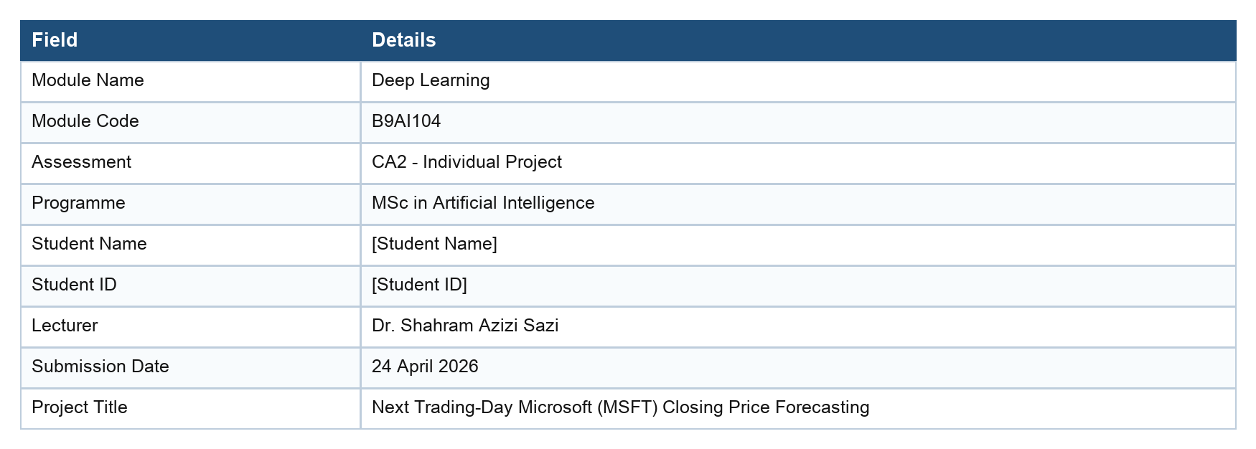

Important scope note
This coursework project is educational and analytical. It is not investment advice, trading advice, or a recommendation to buy, sell, or hold Microsoft securities.

Executive Summary
This report presents a CRISP-DM aligned deep learning project for forecasting the next trading day's Microsoft Corporation (MSFT) adjusted closing price. The dataset was downloaded from Yahoo Finance through yfinance and contains daily Open, High, Low, Close, and Volume observations from 2010-01-04 to 2026-04-23. The modelling task is a supervised one-step-ahead time-series problem: use the previous 60 trading days to predict the next adjusted Close value.
Three deep learning model families were implemented and compared: LSTM, GRU, and PatchTST. A naive last-close baseline was also included because next-day price-level forecasting often rewards persistence and can make complex models appear strong unless they are compared against a simple temporal benchmark. The final aligned test set contains 616 trading dates from 2023-11-07 to 2026-04-23.
The main empirical finding is deliberately reported without overstating predictive power. The naive baseline achieved the lowest test RMSE at 6.2935. PatchTST was the strongest deep learning model and was very close to the baseline with RMSE 6.3617 and MAE 4.5088. GRU and LSTM performed substantially worse on the later test period, with RMSE 34.5774 and 92.5008 respectively, indicating sensitivity to non-stationarity and scale shift. Directional accuracy for the deep learning models was below 50%, so none of the models should be interpreted as a deployable trading signal.
The project therefore met the educational objective of implementing, validating, and comparing deep learning forecasting models, while also showing a realistic limitation: for one-step-ahead stock price level prediction, a simple last-observation baseline can be extremely difficult to beat.
Table 1. Explicit CA2 marking criteria coverage.
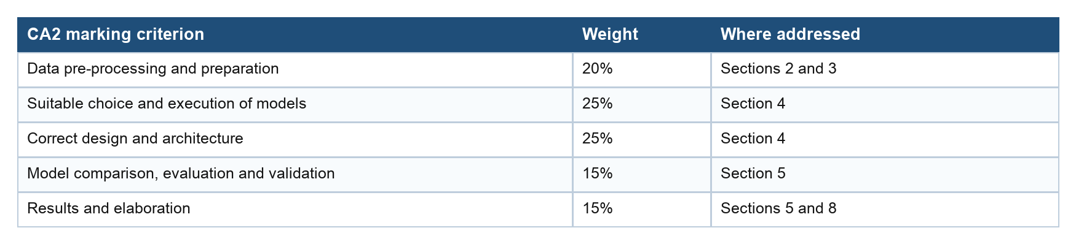

1. Business Understanding
Stock price forecasting is a relevant time-series problem because investors, analysts, and risk managers continually assess how new information changes expected future prices. A listed equity price is observed sequentially, is affected by previous market behaviour, and changes under uncertainty. This makes stock forecasting a natural sequence-modelling problem, but also a difficult one because prices respond to public information, expectations, liquidity, macroeconomic conditions, earnings news, and investor sentiment.
Microsoft is a suitable case study because it is one of the most visible large-cap technology companies and its share price reflects investor expectations about cloud computing, artificial intelligence, enterprise productivity software, gaming, and personal computing. Microsoft reports through the Productivity and Business Processes, Intelligent Cloud, and More Personal Computing segments. Its 2025 Annual Report states that Microsoft Cloud revenue reached $168.9 billion in fiscal 2025, compared with $137.7 billion in fiscal 2024 and $111.6 billion in fiscal 2023 (Microsoft, 2025a). The same annual report notes that Azure surpassed $75 billion in annual revenue and grew 34 percent, indicating why Azure and AI infrastructure are central to investor attention.
The current business context also supports the case-study choice. Microsoft reported fiscal Q2 2026 revenue of $81.3 billion, up 17 percent year on year, and Microsoft Cloud revenue of $51.5 billion, up 26 percent. The release also reported Azure and other cloud services revenue growth of 39 percent, or 38 percent in constant currency, and shareholder returns of $12.7 billion during the quarter (Microsoft, 2026). These figures show that Microsoft remains financially material, growth oriented, and highly watched by investors.
Next-day closing price forecasting has practical analytical value because the close is a standard reference point for daily returns, portfolio valuation, risk reporting, and backtesting. A one-day horizon is also appropriate for coursework because it keeps the modelling target clear and allows LSTM, GRU, and transformer-based architectures to be compared on the same supervised forecasting interface. However, this report treats the output as an analytical forecast only. It is not financial advice and does not claim that the model is sufficient for live trading.
From a CRISP-DM perspective, the business question is not simply whether a neural network can produce a line that visually follows MSFT. The useful analytical question is whether the model produces out-of-sample forecasts that are better than a simple benchmark after preserving the order of time. This distinction matters in finance because an apparently accurate price-level forecast can be driven by persistence: today's close and tomorrow's close are usually similar. The project therefore defines success through transparent validation, direct comparison with a naive last-close baseline, and careful interpretation of error metrics rather than through visual fit alone.
The business context also motivates the choice of MSFT rather than a thinly traded or obscure asset. Microsoft is liquid, highly covered by analysts, and strongly connected to current themes in enterprise cloud, AI infrastructure, Microsoft 365 productivity software, and Azure demand. That makes it relevant to investors but also difficult to forecast because new information is rapidly incorporated into prices. This is useful for a deep learning coursework project: it creates a realistic forecasting challenge where model discipline, validation, and limitations are as important as architecture selection.
Business objective
Predict the next trading day's Microsoft adjusted closing price using historical daily OHLCV data, then compare recurrent deep learning models with a PatchTST transformer-based approach and a naive last-close baseline.

2. Data Understanding
The dataset was collected from Yahoo Finance using the Python yfinance package. Yahoo Finance provides the MSFT historical price table with Date, Open, High, Low, Close, and Volume fields, while yfinance provides a Python interface for downloading financial and market data from Yahoo (Yahoo Finance, 2026; yfinance, 2026). In the notebooks, yfinance was called with ticker MSFT, start date 2010-01-01, and exclusive end date 2026-04-24 to include the final trading date 2026-04-23.
Table 2. Dataset overview from Notebook 01.
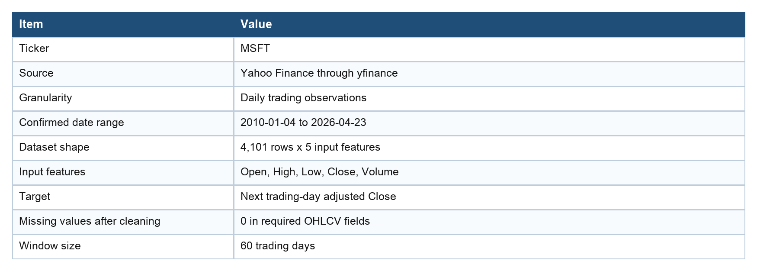

Initial inspection confirmed that the downloaded data was complete for the required OHLCV fields after cleaning. Descriptive statistics and plots showed a strong long-term price trend, changing volatility, and highly correlated price fields. Daily returns had a mean of approximately 0.0836 percent and standard deviation of approximately 1.6167 percent over the full period, with large positive and negative daily moves. This supports a chronological validation design because random shuffling across dates would leak future market regimes into training.
The OHLCV variables have different meanings in the forecasting design. Open, High, Low, and Close describe the daily price range and final adjusted price, while Volume provides a measure of trading activity. Because the notebook used yfinance with auto_adjust=True, the Close field is treated as the adjusted Close used for the forecasting target. This keeps the historical series more consistent across corporate actions such as dividends and stock splits, which is important when modelling a long date range.
The EDA also shows why the task is non-stationary. Microsoft traded at much lower price levels in the early part of the sample than in the validation and test periods. A model trained mainly on earlier, lower price levels has to extrapolate to later, higher price regimes. This does not make the dataset invalid, but it means that test-period errors should be interpreted as genuine generalisation difficulty rather than merely training noise.
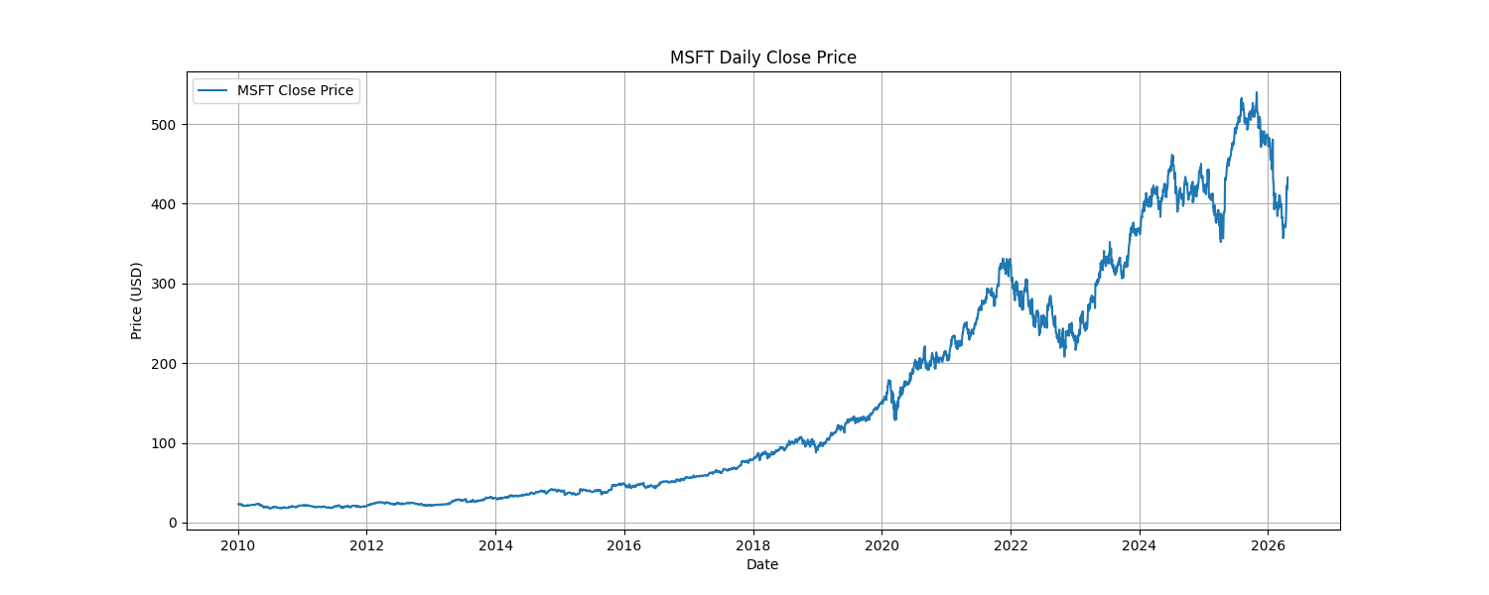
Figure 1. MSFT adjusted Close overview used for data understanding.

Temporal order matters because the task simulates forecasting from historical data into the future. The model must be trained on past observations and evaluated on later observations. If validation or test dates were mixed into training, the model could benefit from future price levels or volatility regimes, giving an unrealistic estimate of performance.

3. Data Preparation
CA2 criterion addressed: Data pre-processing and preparation (20%)
This section documents cleaning, feature selection, temporal splitting, scaling, window creation, target alignment, and leakage checks.
The raw Yahoo Finance download was standardised to the five required input features: Open, High, Low, Close, and Volume. The rows were sorted by date, indexed chronologically, checked for duplicates, and cleaned by removing rows with missing values in the required fields. The notebooks retained temporal ordering throughout all split and sequence generation steps.
Table 3. Chronological train-validation-test split.
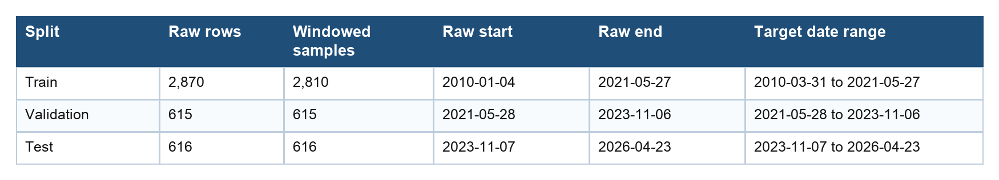

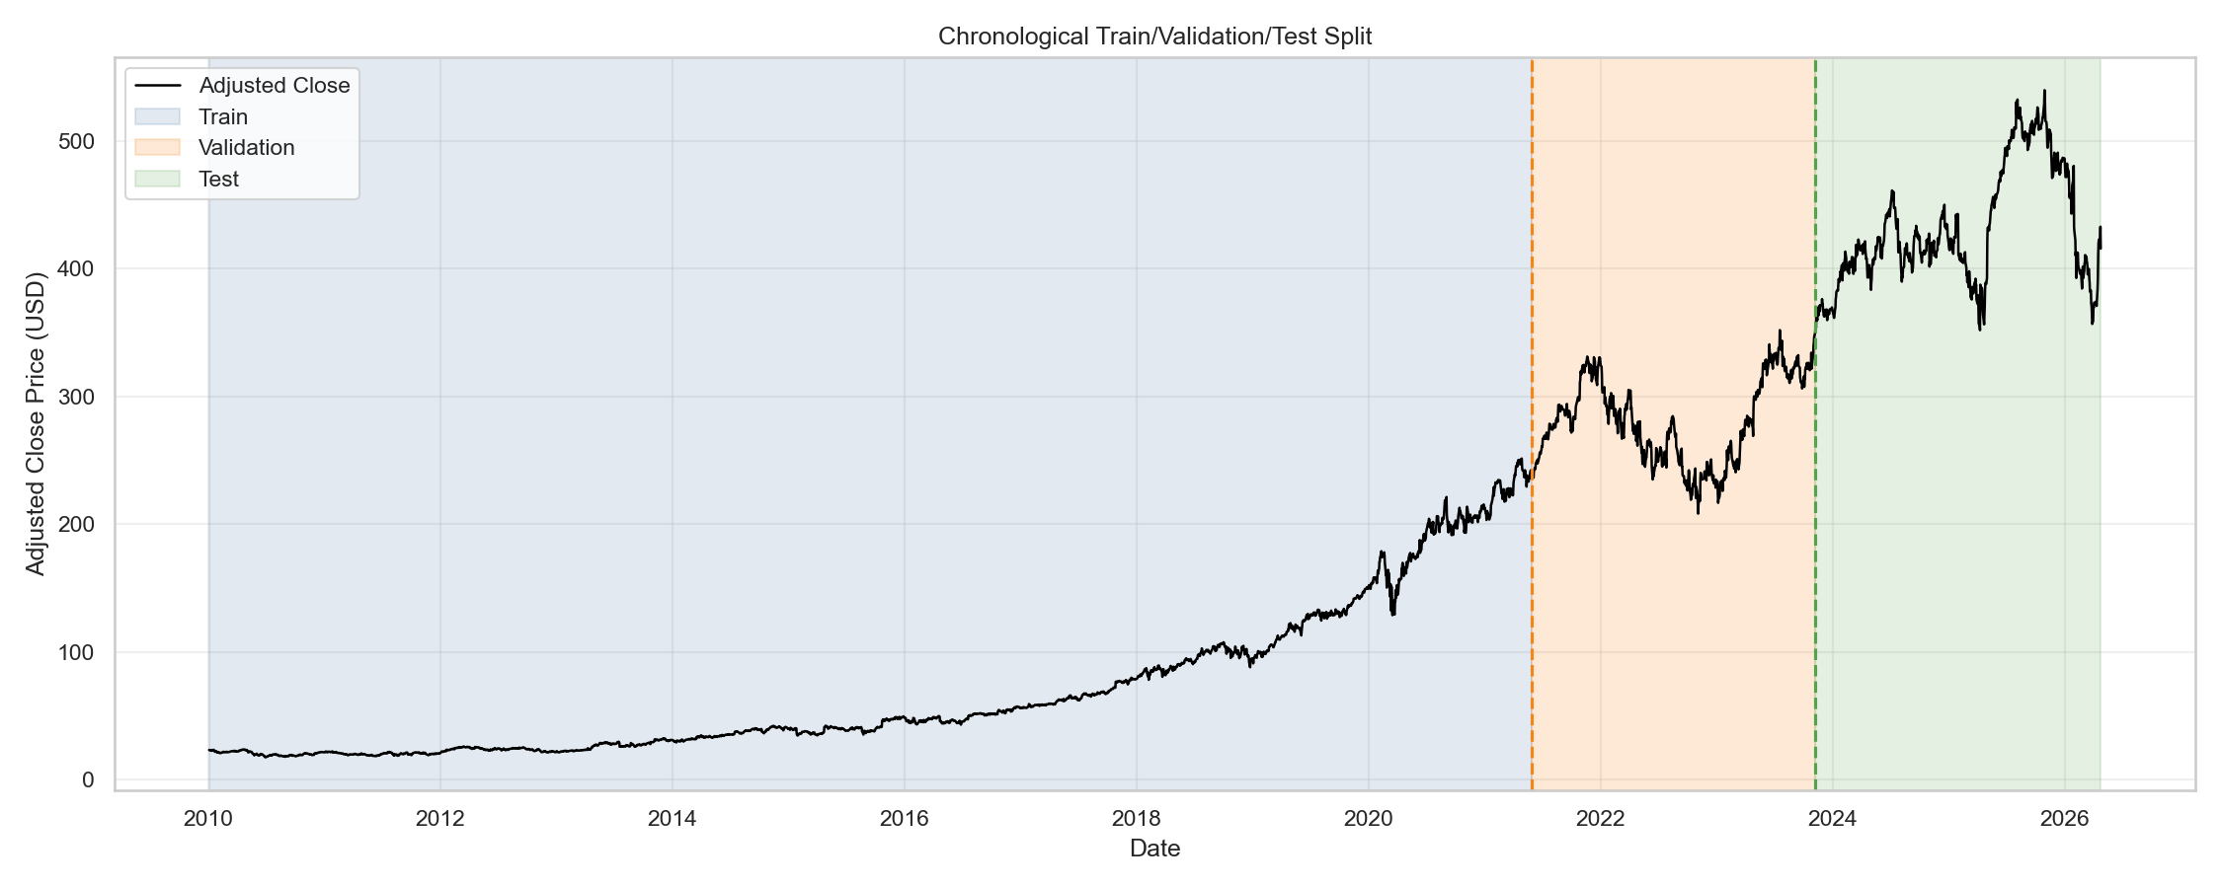
Figure 2. Chronological train, validation, and test split.

The split was 70 percent training, 15 percent validation, and 15 percent test. No random row-level split was used. A MinMaxScaler was fitted on the training split only, then reused to transform validation and test observations. A separate Close scaler was fitted on the training Close column so predictions could be inverse-transformed to dollar-space metrics. This is a key leakage prevention step because the validation and test price ranges were not allowed to influence scaling parameters.
The validation set had a specific role: it was used to choose model configurations and decide when training should stop. The test set had a separate role: it was held out for final comparison only. This separation follows good forecasting practice because repeated tuning on the test period would make the final test estimate optimistic. In the notebooks, the final aligned comparison was recomputed after all models had produced their own prediction files, so every model was evaluated on the same 616 target dates.
The scaled range check is particularly important. Validation and test values outside the [0, 1] training range are not evidence of leakage; they are expected when future MSFT prices exceed the training-period maximum. This check instead documents a real modelling challenge: the later market regime sits partly outside the scale learned from the training period. Direct price-level models can struggle in this situation because the neural network must extrapolate beyond the target distribution it saw during training.
Table 4. Scaled range check showing later-period scale shift.
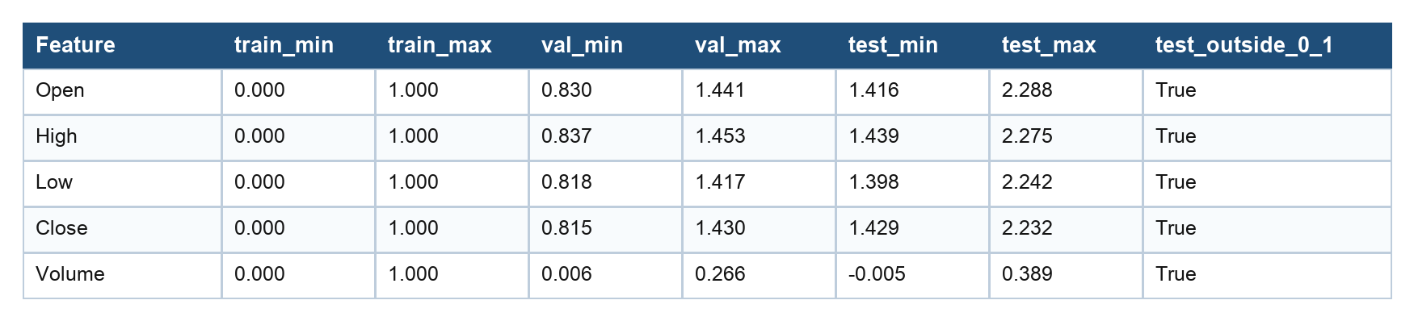

Each supervised sample uses a 60-day input window with shape (60, 5). The target is the scaled adjusted Close on the next trading day after the final date in the input window. Notebook checks confirmed that X arrays are three-dimensional, y arrays are one-dimensional, sample counts match, chronological order is preserved, no NaNs remain, and saved target dates align with the target Close values.
The 60-day window was selected as a practical compromise. It gives the models roughly three months of recent trading history, enough to observe short-term trend and volatility behaviour, while keeping the input sequence small enough for coursework runtime. The target alignment is one-step ahead rather than multi-step, so each row asks a clear question: given the previous 60 trading days, what is the adjusted Close on the next trading day?
Table 5. Exported preprocessing artifacts.
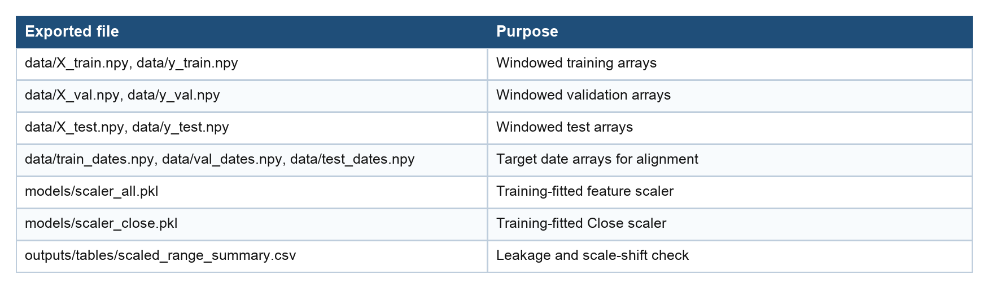

4. Modelling
CA2 criteria addressed: Suitable choice and execution of models (25%) and Correct design and architecture (25%)
This section explains why LSTM, GRU, and PatchTST are suitable sequence models, how they were configured, and how they were trained. A vanilla RNN is discussed only as background theory and was not implemented as a separate model.

4.1 Model Architecture Background
Recurrent neural networks process ordered data by maintaining a hidden state that is updated as each time step is read. This makes RNN-family models suitable for sequences such as financial time series. A limitation of simple RNNs is that gradients can vanish or explode during backpropagation through time, making long-range dependency learning difficult. LSTM and GRU models address this problem with gating mechanisms that control information flow through the hidden state.
LSTM networks use input, forget, and output gates around a memory cell. The memory cell lets useful information persist while gates decide what to add, remove, and expose to the output. This architecture was introduced to address long-term dependency learning (Hochreiter and Schmidhuber, 1997). In this project, the LSTM is a many-to-one forecaster: 60 days of OHLCV features are mapped to one next-day Close forecast.
GRU networks simplify the gated recurrent design by using update and reset gates, reducing the number of gates compared with LSTM while retaining an explicit mechanism for remembering or replacing hidden-state information. The GRU architecture is associated with Cho et al. (2014). In this project, the GRU uses the same supervised input-output interface as the LSTM, allowing a fair recurrent-model comparison.
PatchTST is a transformer-based time-series architecture. Instead of treating each individual time step as a token, it segments the time series into temporal patches and feeds these patches to a transformer encoder. Patching can retain local temporal structure and reduce attention cost for longer look-back windows (Nie et al., 2023). In this project, PatchTST was configured with a 60-step input and a one-step forecasting horizon.
The mathematical intuition behind all three model families is sequence representation learning. LSTM and GRU recursively update a hidden representation as each day in the 60-day window is processed. Their gates learn how much of the previous hidden state should be retained and how much new information should be added. PatchTST instead creates patch tokens from the look-back window and lets self-attention learn relationships among those patches. The architectures differ, but each attempts to transform recent historical observations into a compact representation useful for next-day regression.
The output layer in the recurrent models produces a single continuous value: the scaled next-day Close. During evaluation, this scaled forecast is inverse-transformed to dollar space before MAE, MSE, RMSE, MAPE, and R2 are calculated. This is important because dollar-space errors are easier to interpret and because model selection should reflect practical forecast error rather than only scaled training loss.

4.2 Implemented Model Designs
Table 6. Final selected model designs.
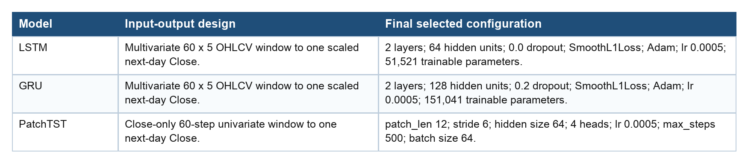

For LSTM and GRU, training used batch size 64, a maximum of 80 epochs, Adam optimisation with weight decay 1e-5, ReduceLROnPlateau, gradient clipping at max norm 1.0, and early stopping with patience 10. Training batches were shuffled within the already-defined training split, while validation and test loaders were not shuffled so predictions remained date-aligned. Candidate models were selected using validation performance, and the test set was reserved for final evaluation.
The RNN tuning grid compared hidden size, number of layers, dropout, learning rate, and loss function. The selected LSTM was candidate C with 64 hidden units, two layers, no dropout, learning rate 0.0005, and SmoothL1Loss. The selected GRU was candidate F with 128 hidden units, two layers, 0.2 dropout, learning rate 0.0005, and SmoothL1Loss.
SmoothL1Loss was selected for both final recurrent models because it is less sensitive to occasional large errors than pure MSE while still behaving like a squared loss near zero. This is reasonable for stock data because sharp price movements can create large residuals. Dropout and weight decay were included as regularisation tools, while early stopping used validation loss to reduce the risk of continuing training after generalisation stopped improving.
PatchTST was first attempted with OHLCV historical exogenous variables, but the NeuralForecast PatchTST path used in the notebook did not support historical exogenous variables in that configuration. The workflow therefore fell back to a close-only univariate PatchTST model. This limitation is reported directly because it affects model comparability: LSTM and GRU used all five OHLCV inputs, while PatchTST used only the adjusted Close history.
Table 7. Selected PatchTST configuration from Notebook 03.
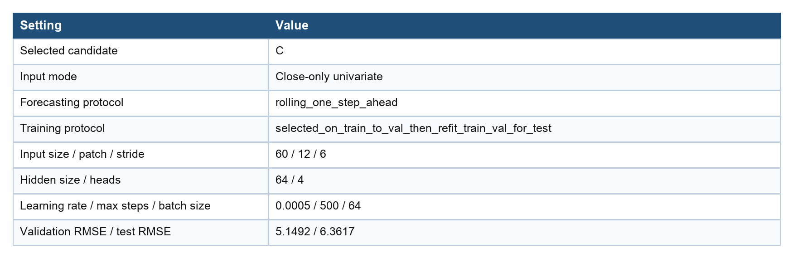

The main modelling assumption is that recent daily price and volume patterns contain information useful for forecasting the next adjusted Close. This is plausible for sequence modelling but limited for financial markets because unobserved news, earnings surprises, interest-rate expectations, broader market risk appetite, and investor sentiment can dominate short-term price movement.

5. Evaluation
CA2 criteria addressed: Model comparison, evaluation and validation (15%) and Results and elaboration (15%)
This section compares all models on aligned validation and test outputs, explains the results in plain English, and discusses error behaviour.
Table 8. Final aligned test-set comparison from Notebook 04.
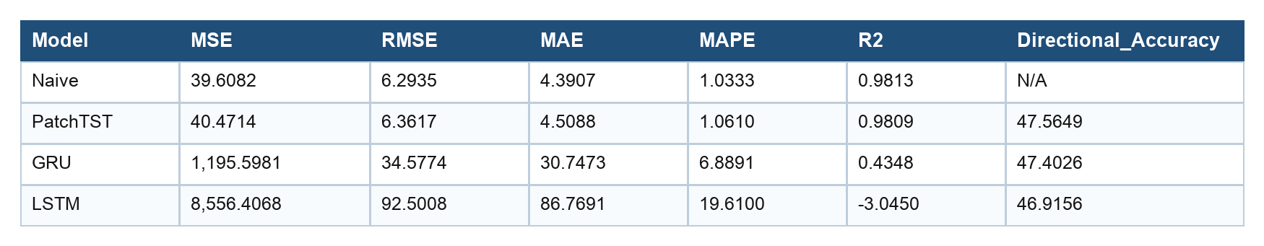

The final comparison shows that the naive baseline was the best model by RMSE, MAE, MAPE, and R2 on the aligned test period. This is an important result, not a failure to hide. For one-step-ahead price-level forecasting, the previous close is a very strong predictor because the next close often differs by only a small daily movement. A deep learning model must therefore improve on a very competitive persistence baseline.
The metrics capture different aspects of performance. MAE measures the average absolute dollar error and is easy to explain in practical terms. MSE and RMSE penalise larger errors more strongly, which is useful when large misses are especially undesirable. MAPE expresses the error relative to the actual price level, while R2 compares the forecasts with a mean-based reference. Directional accuracy asks a different question: whether the model predicted the sign of the daily move relative to the previous close.
PatchTST was the best deep learning model. Its test RMSE of 6.3617 was only slightly worse than the naive RMSE of 6.2935, and its MAE of 4.5088 was close to the naive MAE of 4.3907. This suggests that the transformer-style patch representation tracked the price level well, although it did not reliably add incremental value beyond the last-close baseline.
GRU and LSTM struggled on the test period. GRU had much better test performance than LSTM, but its RMSE of 34.5774 was still far above the naive and PatchTST models. LSTM had RMSE 92.5008 and negative R2, indicating poor generalisation into the later market regime. The scaled range table helps explain this behaviour: validation and test prices moved outside the training-fitted [0, 1] range, creating a scale-shift problem for direct price-level prediction.
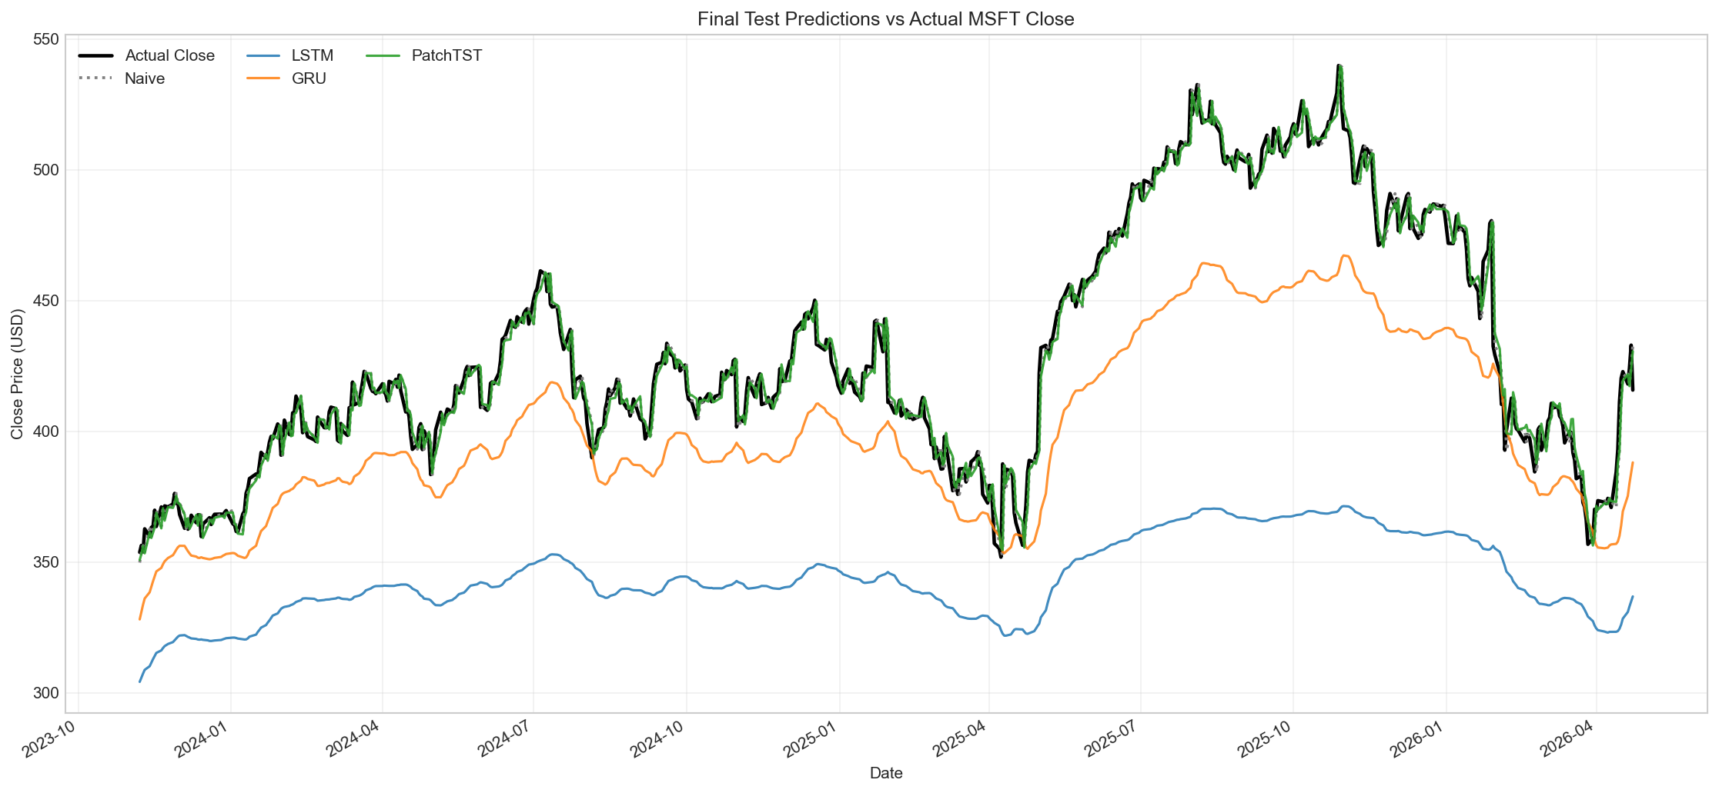
Figure 3. Final aligned forecast-vs-actual comparison for all models.

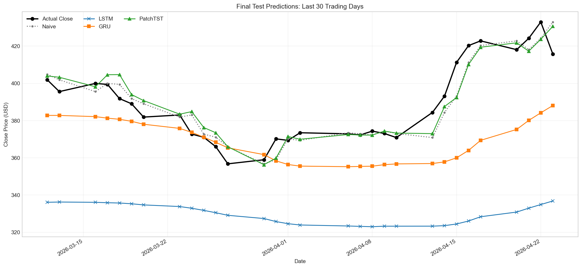
Figure 4. Last 30 trading days forecast comparison.

5.1 Learning Curves and Overfitting
The recurrent-model learning curves show rapid training loss reduction and validation-based early stopping. The gap between validation and final test performance indicates that validation success did not fully transfer to the later test period. This pattern is consistent with non-stationarity in equity data and with the difficulty of predicting price levels across a period where Microsoft traded at higher scaled values than the training range.
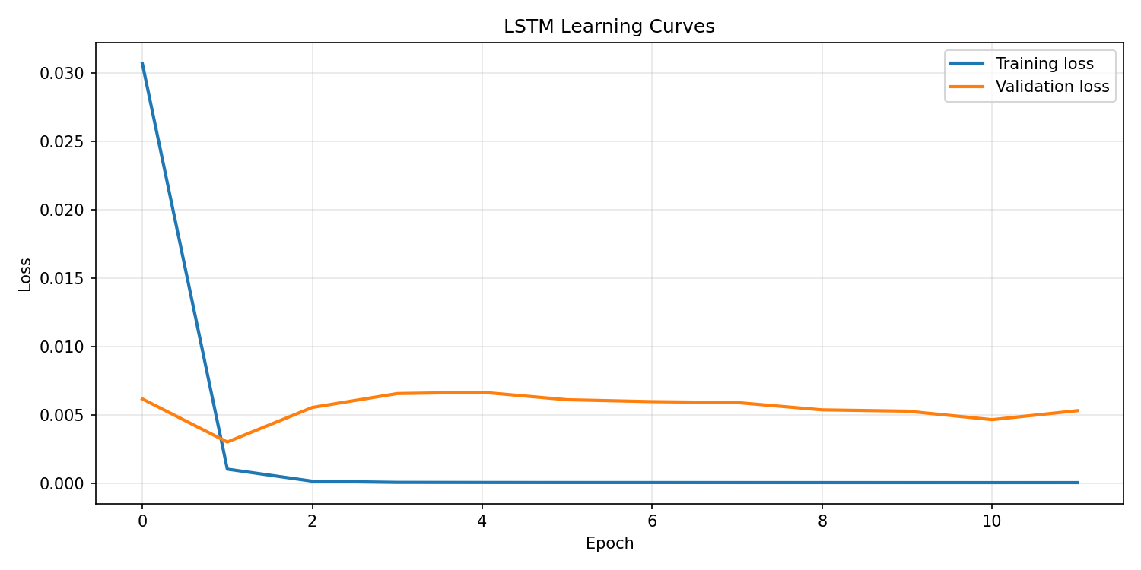
Figure 5. LSTM training and validation learning curves.

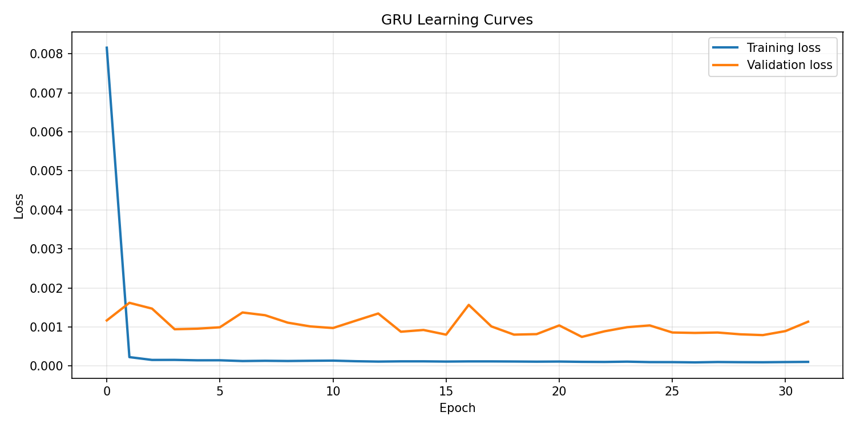
Figure 6. GRU training and validation learning curves.

5.2 PatchTST Diagnostics and Residual Analysis
PatchTST tracked the test price level much more closely than the recurrent models, but the residuals and directional accuracy show that close price tracking is not the same as a reliable trading signal. PatchTST directional accuracy was 47.56 percent, while GRU and LSTM were 47.40 percent and 46.92 percent respectively. These values are below 50 percent, so the models were not reliable at predicting whether the next close would rise or fall relative to the previous close.
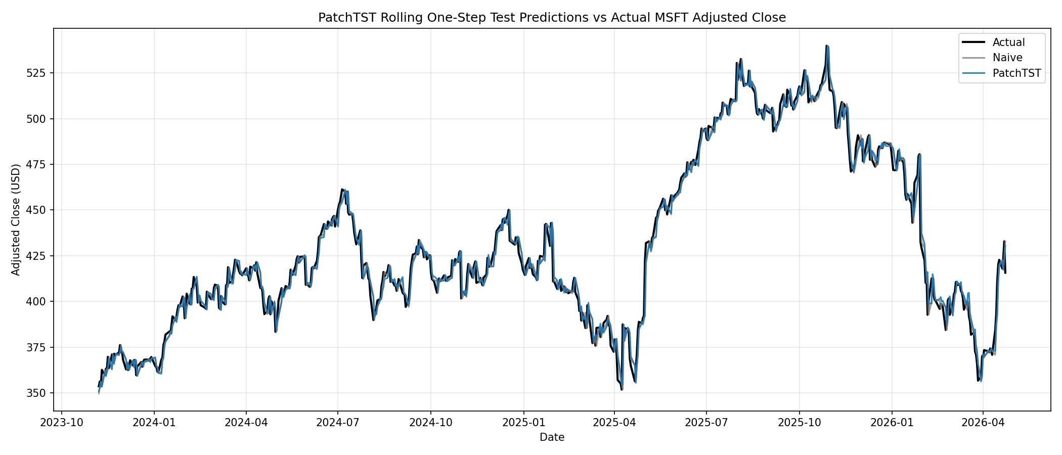
Figure 7. PatchTST test predictions against actual and naive baseline.

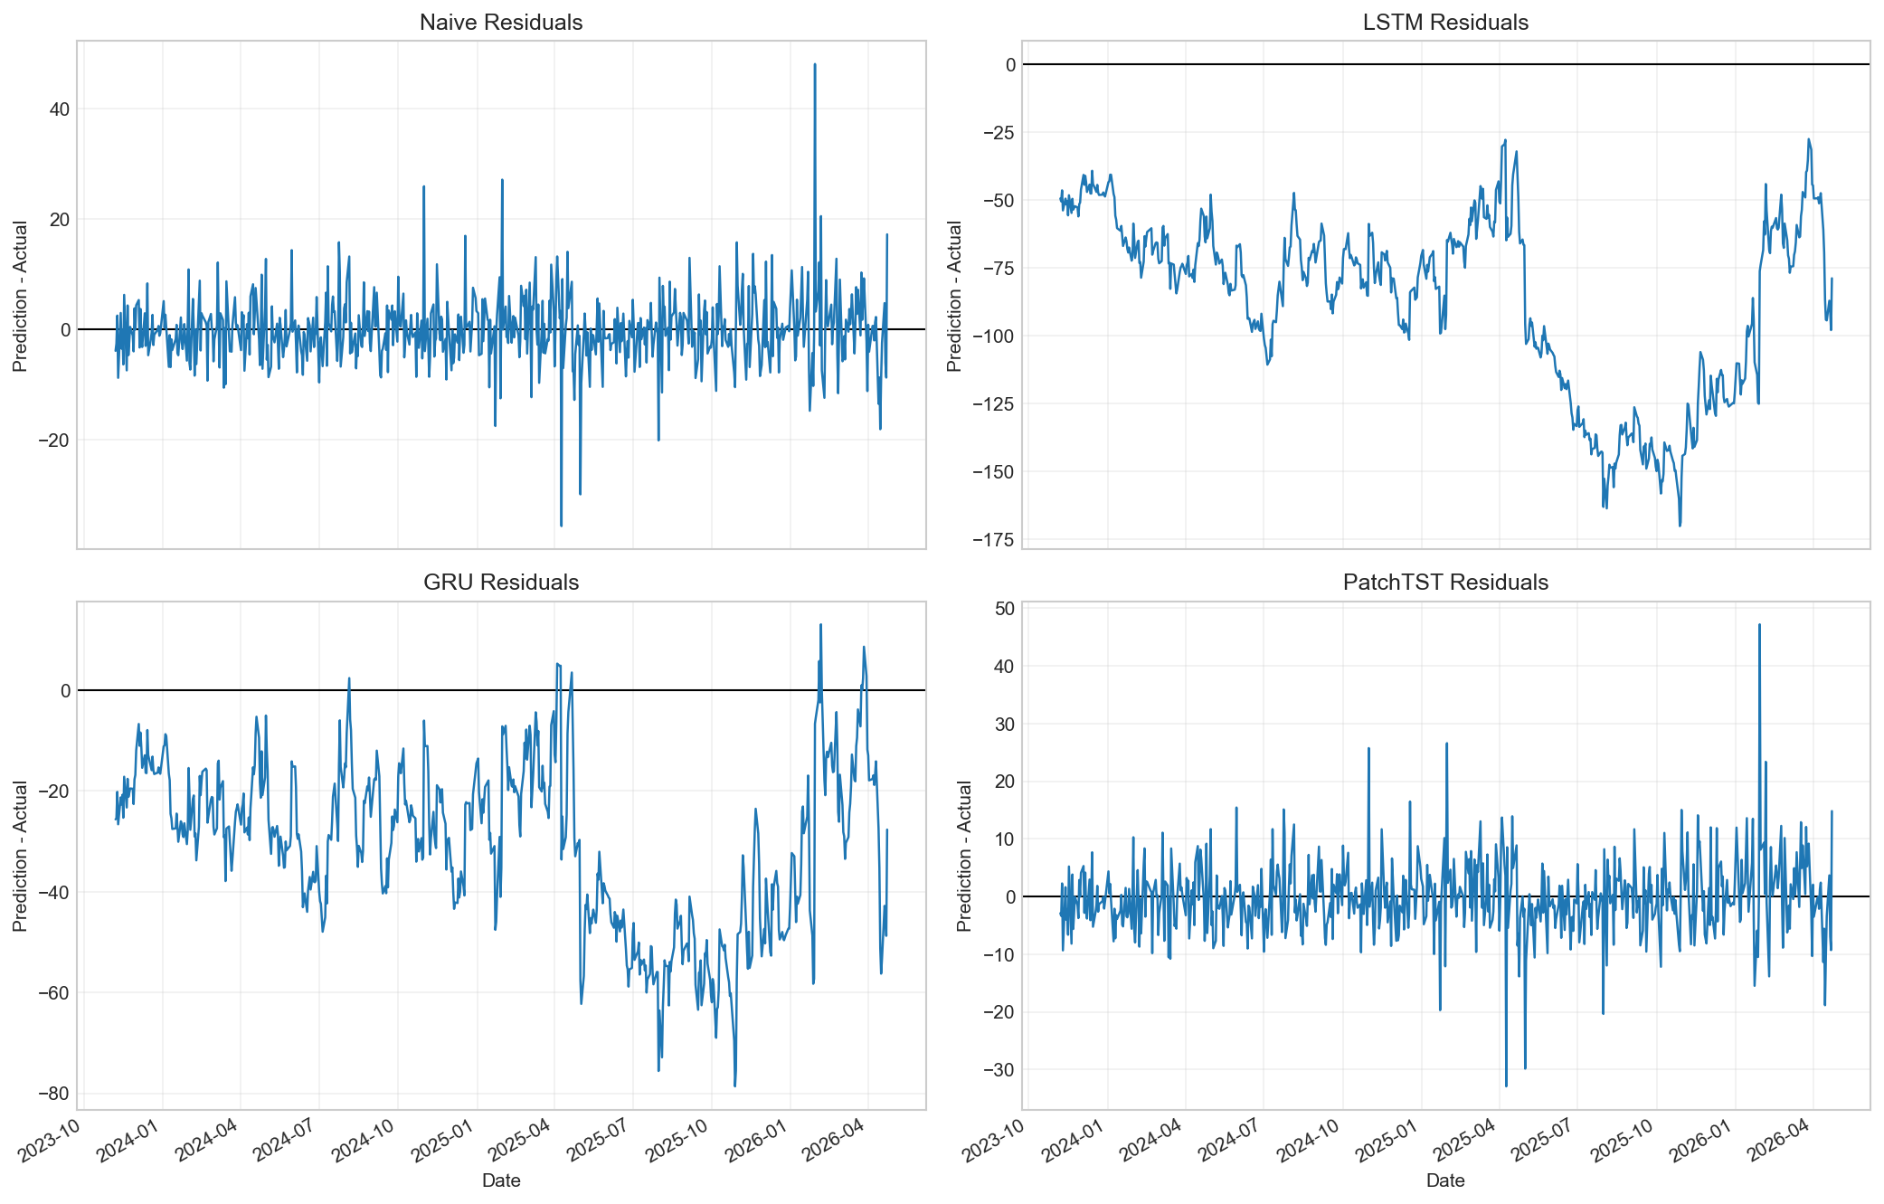
Figure 8. Residual comparison across final aligned models.

Overall, the validation design was appropriate because it separated model selection from final testing and preserved chronological order. The results also show why a naive baseline is essential in stock forecasting. Without it, PatchTST could appear highly successful because its R2 was high, but the baseline reveals that most of that performance comes from persistence in the price level.
A further interpretation is that the best-performing deep learning model was successful at level tracking but not at directional prediction. For a coursework forecasting task, level tracking is a valid regression objective. For a real trading task, however, level tracking alone would not be enough because profit depends on direction, magnitude, timing, transaction costs, and risk management. This distinction is why the report treats the results as analytical evidence rather than as a trading recommendation.

6. Deployment / Practical Use
For coursework, deployment is treated conceptually rather than as a live trading system. The notebooks and saved outputs could support a simple dashboard that displays the latest data window, model forecasts, historical actual-vs-predicted plots, residuals, and metric tables. The saved model files and scalers make it possible to reload the trained LSTM and GRU models, while the exported CSVs support reproducible comparison and reporting.
A minimal decision-support prototype would need a repeatable data pipeline. The pipeline would download the latest MSFT data, check that the newest trading session is complete, apply the same feature order and training-fitted scalers, create the most recent 60-day window, generate forecasts, and store predictions with the date and model version. The dashboard should show the naive baseline beside any deep learning forecast so users can see whether model complexity is adding value.
The model should not be used directly for trading. A production decision-support prototype would need live-data validation, robust retraining schedules, drift detection, walk-forward testing, transaction-cost modelling, slippage assumptions, risk limits, and monitoring of forecast error. It would also need controls for corporate actions, data outages, missing market sessions, and changes in Yahoo Finance data availability.
Reproducibility is supported by the notebook execution order: Notebook 01 prepares data and scalers, Notebook 02 trains LSTM and GRU models, Notebook 03 trains PatchTST, and Notebook 04 aligns predictions and creates final comparison assets. The project also saves model checkpoints, processed arrays, prediction CSVs, metrics CSVs, plots, and report assets. Random seeds were set in the recurrent modelling workflow to improve repeatability.

7. Limitations, Ethics, and Future Work
Stock markets are noisy and affected by external events that are not present in OHLCV data. Earnings announcements, regulatory news, product launches, AI infrastructure spending, interest-rate expectations, macroeconomic releases, geopolitical risk, and investor sentiment can all move MSFT in ways that a price-only or OHLCV-only model cannot anticipate.
The project predicts the price level rather than returns or direction. Price-level forecasting can produce high R2 values because adjacent daily prices are close, but that does not necessarily imply economic value. A trading system would usually need to predict returns, direction, risk-adjusted expected value, or probability distributions, and then account for transaction costs and risk constraints.
Another limitation is that the project uses a single equity. A model that works on MSFT may not generalise to other technology stocks, defensive sectors, financial stocks, or index-level instruments. A stronger empirical design would evaluate the same modelling approach across several assets and market regimes. It would also report performance stability over rolling windows, not only one fixed test period.
The ethical risk is overclaiming predictive ability. A polished forecast chart can make a model appear more useful than it is, especially when the target is a highly persistent price level. This report therefore reports the naive baseline, directional accuracy, and limitations plainly. The project is educational and analytical only and is not financial advice.
Future work should add sentiment and news features, earnings-event indicators, macroeconomic variables, market index features, interest rates, and volatility indicators. Methodologically, the project could be extended with rolling walk-forward validation, return or residual forecasting, probabilistic prediction intervals, stronger transformer baselines, longer hyperparameter tuning, and evaluation across multiple stocks rather than a single MSFT case study.

8. Conclusion
This project built a complete CRISP-DM aligned deep learning workflow for next trading-day Microsoft adjusted Close forecasting. The work included data collection from Yahoo Finance through yfinance, chronological preprocessing, leakage-aware scaling, 60-day sequence generation, LSTM and GRU recurrent models, a PatchTST transformer-based model, and a final aligned comparison against a naive last-close baseline.
The original objective was achieved in an educational sense: three suitable deep learning architectures were implemented, tuned, evaluated, and compared using consistent metrics. The best overall test performer was the naive baseline with RMSE 6.2935. The best deep learning model was PatchTST with RMSE 6.3617, very close to the baseline. GRU outperformed LSTM among the recurrent models, but both recurrent models performed poorly on the later test period compared with the baseline.
The comparison shows that transformer-style patching can be competitive for one-step price-level tracking, while recurrent models can suffer when the test period shifts outside the training price scale. The main lesson is that deep learning model complexity does not guarantee better stock forecasts. Careful validation, strong baselines, honest limitations, and domain-aware interpretation are essential.

9. Bibliography
Cho, K., van Merrienboer, B., Gulcehre, C., Bahdanau, D., Bougares, F., Schwenk, H. and Bengio, Y. (2014) 'Learning Phrase Representations using RNN Encoder-Decoder for Statistical Machine Translation', Proceedings of EMNLP 2014, pp. 1724-1734. Available at: https://aclanthology.org/D14-1179/.
Hochreiter, S. and Schmidhuber, J. (1997) 'Long Short-Term Memory', Neural Computation, 9(8), pp. 1735-1780. Available at: https://direct.mit.edu/neco/article/9/8/1735/6109/Long-Short-Term-Memory.
Microsoft (2025a) Microsoft Annual Report 2025. Available at: https://www.microsoft.com/investor/reports/ar25/.
Microsoft (2025b) Form 10-K for fiscal year ended 30 June 2025. U.S. Securities and Exchange Commission. Available at: https://www.sec.gov/Archives/edgar/data/789019/000095017025100235/msft-20250630.htm.
Microsoft (2026) 'Microsoft Cloud and AI Strength Drives Second Quarter Results', Microsoft Investor Relations, 28 January. Available at: https://www.microsoft.com/en-us/Investor/earnings/FY-2026-Q2/press-release-webcast.
Nie, Y., Nguyen, N.H., Sinthong, P. and Kalagnanam, J. (2023) 'A Time Series is Worth 64 Words: Long-term Forecasting with Transformers'. Available at: https://arxiv.org/abs/2211.14730.
Sazi, S.A. (2026a) Sequential Data and Recurrent Models. Deep Learning module lecture material, Dublin Business School, unpublished Moodle resource.
Sazi, S.A. (2026b) Simple RNN Tutorial. Deep Learning module lecture material, Dublin Business School, unpublished Moodle resource.
Yahoo Finance (2026) Microsoft Corporation (MSFT) Historical Prices. Available at: https://ca.finance.yahoo.com/quote/MSFT/history/.
yfinance (2026) yfinance Python package. Available at: https://pypi.org/project/yfinance/.

