**Test Scenario 1:**Check the Search Functionality (Basic Search)

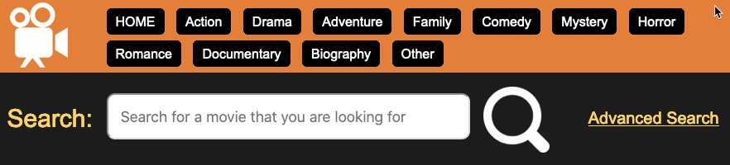

**Test Cases:**

1. Check system behavior when input field is left blank and search button entered.
2. Check system behavior when title entered.

|  |  |  |
| --- | --- | --- |
| **No** | **Test Scenario Description** | **Test Cases** |
| 1 | Check the Search Functionality (Basic Search) | 1-Check system behavior when input field is left blank and search button entered.  2-Check system behavior when title entered. |
| 2 | Add a New Movie | 1-Check system behavior when all input fields are left blank and ADD button entered.  1-Check system behavior when all input fields are entered, go to advanced search, search by title and confirm movie exist |

cc