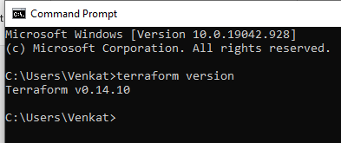

Change the access_key and Secret_key.

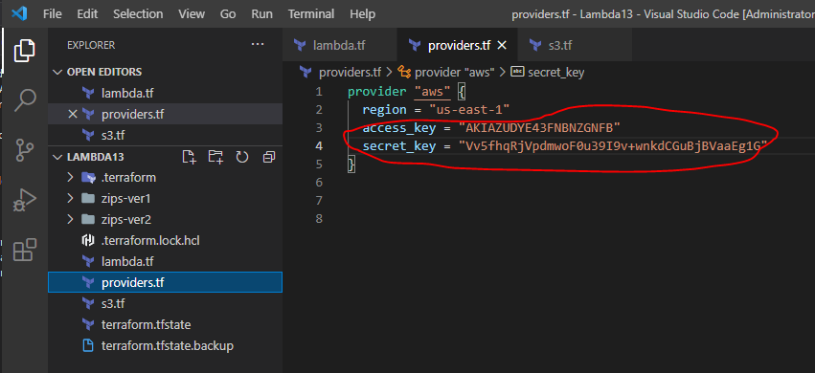

Then being on the directory where the scripts are execute.

Terraform init

Terraform plan

Terraform deploy

Once the infra is created.

Got to Lambda functions in

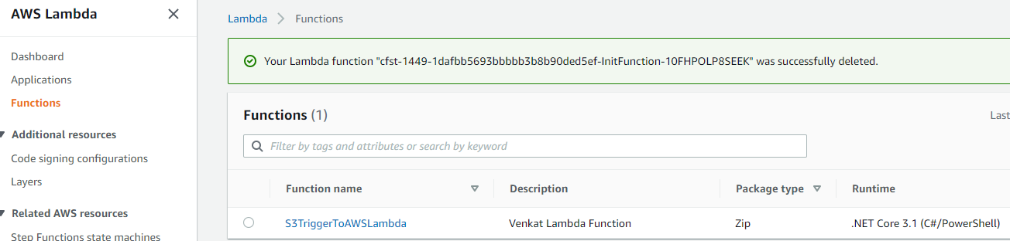

Select the trigger and then add trigger by clicking on add trigger.

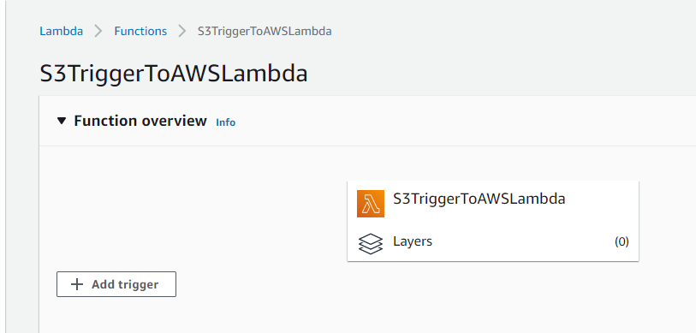

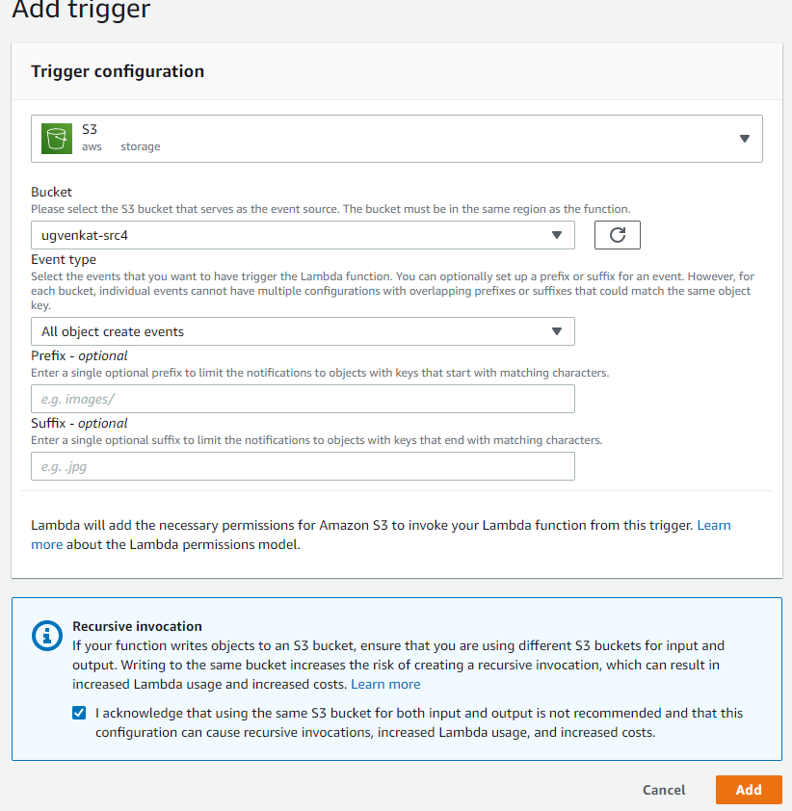

**fyi: If I have time, I would have automated this step in Terraform. **

