**A Bull Put Spread is a bullish options strategy (at support levels) designed to profit when the stock stays above the higher strike price**

**A Bull Put Spread involves two put options with the same expiration date:**

1. **Sell a higher strike put (short put) => Sell 175 put. This generates income (premium).**
2. **Buy a lower strike put (long put) => Buy 165 put This limits the potential loss (provides protection).**

**Bull Put Spread / Put Credit Spread / Credit put Spread / Short Put Spread / Short Put Vertical (Price at Support, Slight Bullish)**

<https://www.tastylive.com/concepts-strategies/bull-put-spread> [**https://www.youtube.com/watch?v=j4VddcIlDkQ**](https://www.youtube.com/watch?v=j4VddcIlDkQ)

**Stock**: XYZ is trading at $50.

**Strategy**: Sell a $48 strike put for $2.50 and buy a $45 strike put for $1.00.

* **Net Credit**: $2.50 - $1.00 = $1.50 ($150 per contract).
* **Maximum loss**: Difference in strike prices ($48 - $45 = $3) - Net Credit ($1.50) = $1.50 ($150 per contract).
* **Maximum Profit**: The net credit received ($1.50 or $150 per contract).

**Scenarios**:

* **If stock stays above $48**: Both puts expire worthless. You keep the net credit = $150 profit.
* **If stock falls below $45**: Both puts are exercised. Loss = $150 (maximum risk).

**Important Considerations**

1. **Time Decay**: This strategy benefits from time decay because you receive a premium upfront. The options lose value over time, especially the short call, which helps increase profit as expiration approaches.
2. **Implied Volatility**: High implied volatility can increase premiums, which may result in a higher net credit at the start. However, if volatility drops, it can make it easier for the options to expire worthless, benefitting the trade.

**How It Works:**

* **Slightly Bullish Outlook:** If you expect the stock price to stay above a certain level but don’t anticipate a big move upward, this strategy works well. Example: If a stock is trading at $100, you might sell a $95 put and buy a $90 put.

**Why "Play the Opposite Side"?**

* **Selling puts** means **you're betting the stock won’t fall significantly.**
* You sell the higher-strike put (closer to the current price) because it has a higher premium, and buy the lower-strike put for protection, limiting potential losses.

**Profit and Loss:**

* Maximum Profit: Premium collected when the stock stays above the higher strike price (all options expire worthless).
* Maximum Loss: The difference between the strike prices minus the premium collected, if the stock price falls below the lower strike.

**Ideal Scenarios for Bull Put Spreads:**

* You expect the stock to stay flat or rise slightly.
* Example: A stock trading at $100; you sell a $95 put, buy a $90 put, and collect premium if the stock remains above $95.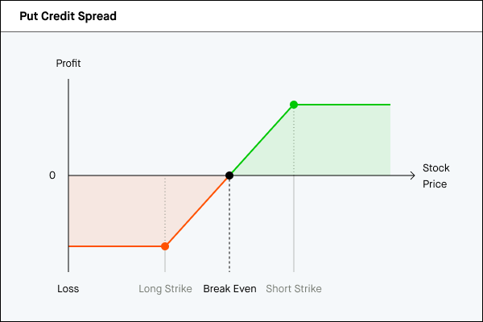

**Bear Call Spread is a bearish options strategy (used at resistance) designed to profit from a stock staying below the lower strike price**

**A Bear Call Spread involves two call options with the same expiration date:**

* Sell a lower-strike call (short call) example **Sell 175 You sell a call closer to the stock price, which generates a premium**
* Buy a higher-strike call (long call) example **Buy 185 You buy a call further from the stock price to limit your potential loss**

**Bear Call Spread / Call Credit Spread / Short Call Spread / Credit Call Spread /**

<https://www.tastylive.com/concepts-strategies/bear-call-spread> <https://www.youtube.com/watch?v=iATEuiE42uY>

**Stock**: XYZ is trading at $50.

**Strategy**: Sell a $52 strike call for $2.00 and buy a $55 strike call for $1.00.

* **Net Credit**: $2.00 - $1.00 = $1.00 ($100 per contract).
* **Maximum Risk**: Difference in strike prices ($55 - $52 = $3) - Net Credit ($1.00) = $2.00 ($200 per contract).
* **Maximum Profit**: The net credit received ($1.00 or $100 per contract).

**Scenarios**:

* **If stock stays below $52**: Both calls expire worthless. You keep the net credit = $100 profit.
* **If stock rises above $55**: Both calls are exercised. Loss = $200 (maximum risk).

**Important Considerations**

1. **Time Decay**: This strategy benefits from time decay because you receive a premium upfront. The options lose value over time, especially the short call, which helps increase profit as expiration approaches.
2. **Implied Volatility**: High implied volatility can increase premiums, which may result in a higher net credit at the start. However, if volatility drops, it can make it easier for the options to expire worthless, benefitting the trade.

-------------------------------------------------------------------------------------------------------------------------------------------------------------------------------------

**How It Works:** Slightly Bearish Outlook:

If you expect the stock price to stay below a certain level but don’t anticipate a sharp drop, this strategy works well.

Example: If a stock is trading at $100, you might sell a $105 call and buy a $110 call.

**Why "Play the Opposite Side"? Selling** **calls** means **you're betting the stock won’t rise significantly**.

You sell the lower-strike call (closer to the current price) because it has a higher premium, and buy the higher-strike call for protection, capping potential losses.

**Maximum Profit:** Premium collected when the stock stays below the lower strike price (all options expire worthless).

**Maximum Loss:** The difference between the strike prices minus the premium collected, if the stock price rises above the higher strike.

**Ideal Scenarios for Bear Call Spreads:** You expect the stock to stay flat or fall slightly.

**Example:** A stock trading at $100; you sell a $105 call, buy a $110 call, and collect premium if the stock remains below $105.

**Why Play "Opposite Sides"?** The idea of "playing the opposite side" refers to aligning your strategy with a probable lack of significant movement in the stock. In both cases, you collect premium based on the assumption that the stock won't breach your short option strike:

