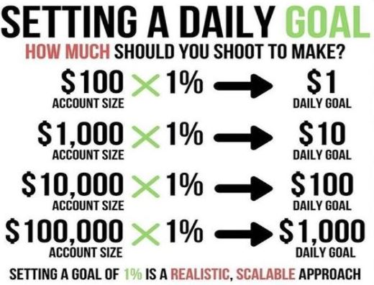

**Support**

**Overview**:  
Support is a price level where a stock or asset tends to find buying interest or demand strong enough to prevent it from declining further. It often acts as a “floor,” keeping the price from falling below that level. When the price reaches support, traders watch to see if it will hold and create a buying opportunity or if the price will break below, potentially signaling a continuation of a downtrend.

**How Support Works**:

* **Buyers Step In**: At support levels, demand typically outweighs supply, causing buyers to step in and prevent further declines.
* **Psychological Levels**: Support can occur at round numbers (e.g., $100), historical price lows, or levels with high trading volume, where market participants are psychologically conditioned to buy.
* **Multiple Tests**: The more times a price tests a support level without breaking below it, the stronger the support is considered to be.

**Types of Support**:

1. **Horizontal Support**: Formed at a constant price level, acting as a consistent "floor."
2. **Dynamic Support**: Often a moving average (e.g., 50-day or 200-day EMA) that adjusts with the trend.
3. **Trendline Support**: Upward-sloping lines that connect higher lows in an uptrend, providing a level of support within the trend.

**Using Support in Trading**:

* **Entry Point**: Traders often buy at support levels, anticipating a bounce.
* **Stop Loss Placement**: Placing stop-loss orders just below support levels helps manage risk in case of a breakdown.
* **Breakout Strategy**: A significant break below support may indicate a bearish continuation, where traders might look to sell or short the asset.

**Limitations**:

* **Not Permanent**: Support levels can be broken, especially in volatile or strongly trending markets.
* **False Breakouts**: Sometimes, the price briefly moves below support (false breakdown) before reversing, leading to potential losses if not managed carefully.

In summary, support levels are crucial for identifying potential entry points and managing risks, offering traders a structured way to approach price action.

**Resistance**

**Overview**:  
Resistance is a price level where an asset often encounters selling pressure, preventing it from rising further. It acts as a “ceiling” that halts upward price movement due to increased selling interest or lack of buying momentum. Resistance is key for identifying potential selling opportunities or profit-taking points.

**How Resistance Works**:

* **Sellers Step In**: At resistance levels, supply typically outweighs demand, as sellers find this price level attractive for taking profits or entering short positions.
* **Psychological Levels**: Resistance often forms at significant price points (like round numbers), previous price peaks, or levels with heavy volume.
* **Multiple Tests**: The more a resistance level is tested without a breakout, the stronger it is considered, as it represents a consistent barrier to upward movement.

**Types of Resistance**:

1. **Horizontal Resistance**: A consistent price level that acts as a barrier.
2. **Dynamic Resistance**: Often represented by moving averages (e.g., 50-day or 200-day EMA), which adapt to price trends.
3. **Trendline Resistance**: Downward-sloping lines connecting lower highs, forming resistance in a downtrend.

**Using Resistance in Trading**:

* **Selling Point**: Traders may look to sell or take profits at resistance levels, anticipating a pullback.
* **Stop Loss Placement**: Stop-loss orders above resistance levels can manage risk for short positions.
* **Breakout Strategy**: A strong breakout above resistance may signal bullish continuation, encouraging traders to buy on momentum.

**Limitations**:

* **Not Permanent**: Resistance levels can be broken, especially in a strong uptrend.
* **False Breakouts**: Prices may briefly rise above resistance only to fall back, creating potential losses if not managed correctly.

In summary, resistance levels are essential for spotting selling opportunities and risk management, providing traders with structure in analyzing upward price movement.

**Trend Analysis**

**Overview**:  
Trend analysis is a technique used to identify the general direction in which an asset’s price is moving. A trend can be upward, downward, or sideways (consolidation), and recognizing these trends is essential in developing trading strategies. Trends are defined by a series of highs and lows and are driven by supply and demand dynamics.

**Types of Trends**:

1. **Uptrend**: A series of higher highs and higher lows, indicating a bullish market.
2. **Downtrend**: A series of lower highs and lower lows, indicating a bearish market.
3. **Sideways Trend**: Price moves within a range with no clear upward or downward direction, often called consolidation.

**Key Trend Analysis Tools**:

* **Trendlines**: Upward or downward sloping lines that connect highs or lows, visually reinforcing the trend direction.
* **Moving Averages**: Indicators like the 50-day or 200-day moving averages smooth out price data, helping traders identify trends.
* **Higher Timeframes**: Longer timeframes (e.g., weekly or monthly charts) often show clearer trends than shorter ones (e.g., 5-minute charts), providing a "bigger picture."

**Using Trends in Trading**:

* **Trade with the Trend**: Following the trend is one of the foundational principles of trading; buying in an uptrend and selling in a downtrend can improve the probability of success.
* **Trend Reversals**: Signs of trend reversals include price crossing moving averages, trendline breaks, and patterns like head and shoulders or double tops/bottoms.
* **Confirming Trend Strength**: Indicators like the Average Directional Index (ADX) can help assess the strength of a trend, reducing the likelihood of false signals.

**Limitations**:

* **Lagging Information**: Trend analysis is often lagging, meaning signals appear after trends have started or ended, leading to potential missed opportunities.
* **False Signals**: Trends can be interrupted by noise or short-term volatility, leading to premature exits or entries if not carefully managed.

In summary, trend analysis is essential for understanding market direction, guiding traders in making decisions aligned with the prevailing trend, which can improve risk management and trade effectiveness.

The **ADX (Average Directional Index)** and **DI (Directional Indicators)** are technical indicators developed by J. Welles Wilder to measure the strength and direction of a trend in financial markets. These are often used together to give a fuller picture of market trends and momentum.

Here's how they work and what they indicate:

**1. Average Directional Index (ADX)**

* **Purpose**: Measures the strength of a trend, regardless of whether it is upward or downward.
* **Range**: 0 to 100. Values above 25 often suggest a strong trend, while values below 20 indicate a weak or non-trending market.
* **Interpretation**:
  + **Above 25**: The market is trending strongly (bullish or bearish).
  + **Below 20**: The market is generally moving sideways or in a weak trend.
* **No Direction**: ADX only measures strength, not direction. A rising ADX indicates strengthening trend, while a falling ADX indicates weakening trend.

**2. Directional Indicators (DI+ and DI-)**

* **DI+ (Positive Directional Indicator)**: Represents upward movement.
* **DI- (Negative Directional Indicator)**: Represents downward movement.
* **Crossovers**:
  + When **DI+ crosses above DI-**, it suggests a bullish trend or upward momentum.
  + When **DI- crosses above DI+**, it indicates a bearish trend or downward momentum.

**How to Use ADX and DI Together**

* **Identify Trend Strength**: Use ADX to see if a trend is strong enough to follow. Generally, an ADX above 25 supports trading with the trend.
* **Identify Trend Direction**: Look for crossovers between DI+ and DI- for potential entry or exit signals:
  + **DI+ > DI-**: Favor long (buy) positions.
  + **DI- > DI+**: Favor short (sell) positions.

In summary, ADX is valuable for determining whether a market is trending, and the DI lines (DI+ and DI-) show the trend direction, helping traders decide when to enter or exit trades based on trend signals.

The **Fibonacci Indicator** in the stock market is a tool based on the Fibonacci sequence, a mathematical concept where each number is the sum of the two preceding ones (e.g., 0, 1, 1, 2, 3, 5, 8, and so on). In financial markets, traders use **Fibonacci retracement** and **Fibonacci extension** levels as a way to predict potential levels of support and resistance, helping them to make better-informed trading decisions.

**Key Fibonacci Levels**

Fibonacci retracement and extension levels are based on key percentages derived from the Fibonacci sequence, commonly:

* **Retracement levels**: 23.6%, 38.2%, 50%, 61.8%, and 78.6%
* **Extension levels** (for targets beyond previous highs/lows): 161.8%, 261.8%, etc.

**How to Use Fibonacci in Trading**

1. **Fibonacci Retracement**
   * **Purpose**: Identifies potential support (price floor) and resistance (price ceiling) levels during a trend reversal.
   * **Application**: In an uptrend, traders mark the start and end of a recent price rally to apply Fibonacci retracement levels. In a downtrend, they apply it from the recent high to the low.
   * **Interpretation**: Prices may pull back to these retracement levels before resuming the trend. For example:
     + 38.2% or 50% retracement levels often act as support in an uptrend or resistance in a downtrend.
2. **Fibonacci Extension**
   * **Purpose**: Projects price targets beyond the current high or low, especially after a breakout.
   * **Application**: Extension levels are drawn beyond the current trend to indicate where the price may face resistance if it continues in the direction of the trend.
   * **Interpretation**: For instance, if a stock breaks out to the upside, traders may use the 161.8% or 261.8% extensions as potential profit-taking targets.

**Practical Example**

Suppose a stock is moving in an uptrend from $100 to $200. After hitting $200, it retraces, or pulls back, to $150. By applying Fibonacci retracement, a trader might observe levels like 38.2% or 61.8% of the retracement (relative to the $100-$200 range), indicating possible support levels where the uptrend might resume.

**Limitations**

While Fibonacci indicators are widely used, they are not foolproof:

* **Not predictive on their own**: They work best when combined with other technical indicators, like moving averages or trendlines.
* **Subjective application**: The choice of points to draw retracements can vary among traders, potentially leading to different interpretations.

**Summary**

The Fibonacci Indicator is a helpful technical tool in the stock market for identifying support and resistance levels, guiding traders in setting target prices and finding optimal entry and exit points.

**Exponential Moving Average (EMA)**

**Overview**:  
The Exponential Moving Average (EMA) is a type of moving average that places a higher weight on recent prices, making it more responsive to new information than a simple moving average (SMA). This indicator helps traders identify trend direction and potential reversals.

**Calculation**:  
The EMA is calculated using the formula:

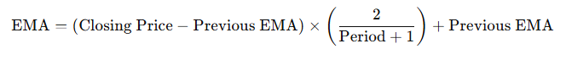

Where "Period" is the number of days used in the calculation.

**Usage**:

* **Trend identification**: When the price is above the EMA, the trend is generally bullish; when below, it’s bearish.
* **Crossovers**: Traders often use two EMAs (e.g., 12-period and 26-period) to find buying or selling signals based on crossovers.
* **Support and Resistance**: The EMA can act as a dynamic support or resistance level in trending markets.

**Pros**:

* More responsive to recent price movements.
* Helps to smooth out price action for a clearer view of trends.

**Cons**:

* Can produce false signals in choppy or non-trending markets.

**Relative Strength Index (RSI)**

**Overview**:  
The Relative Strength Index (RSI) is a momentum oscillator that measures the speed and change of price movements on a scale from 0 to 100. RSI is primarily used to identify overbought or oversold conditions in a market.

**Calculation**:  
RSI is calculated using the formula:

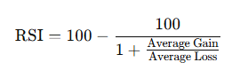​

Typically, RSI is set to a 14-period timeframe.

**Usage**:

* **Overbought/Oversold**: RSI values above 70 indicate overbought conditions (possible reversal), while values below 30 suggest oversold conditions.
* **Divergence**: A divergence between price and RSI can indicate a potential reversal.
* **Centerline (50)**: RSI crossing above or below 50 can signal a shift in trend.

**Pros**:

* Quick indication of momentum and possible trend reversals.
* Works well for identifying entry and exit points.

**Cons**:

* Can produce false signals in strong trends.

**Volume Weighted Average Price (VWAP)**

**Overview**:  
VWAP is a trading benchmark that calculates the average price of a security weighted by its trading volume over a specific period, typically intraday. It's often used by institutional investors to ensure they aren’t impacting the market price too much.

**Calculation**:

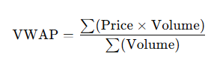

**Usage**:

* **Trend Confirmation**: When the price is above VWAP, it suggests an uptrend; below VWAP suggests a downtrend.
* **Benchmark**: Used to compare intraday price performance, often as a reference for executing trades.
* **Support/Resistance**: VWAP often acts as intraday support and resistance.

**Pros**:

* Useful for volume-weighted average entry/exit levels.
* Works well for intraday trading.

**Cons**:

* Primarily suited for day trading and intraday timeframes.

**Bollinger Bands**

**Overview**:  
Bollinger Bands consist of a simple moving average (SMA) and two standard deviation lines (one above and one below the SMA) that adjust dynamically with price volatility.

**Calculation**:

* **Middle Band**: 20-period SMA
* **Upper Band**: SMA + (2 x Standard Deviation)
* **Lower Band**: SMA - (2 x Standard Deviation)

**Usage**:

* **Volatility Measurement**: Bands expand with high volatility and contract with low volatility.
* **Overbought/Oversold**: When prices touch the upper band, the asset may be overbought; lower band touches indicate oversold conditions.
* **Mean Reversion**: Prices tend to revert to the SMA, especially after hitting extreme bands.

**Pros**:

* Adapts to changing volatility.
* Useful for identifying market reversals.

**Cons**:

* Ineffective in trending markets where price "walks the band."

Moving Average Convergence Divergence (MACD)

**Overview**:  
MACD is a trend-following momentum indicator that shows the relationship between two moving averages of a security’s price. It helps traders spot changes in the strength, direction, and momentum of a trend.

**Calculation**:

* **MACD Line**: 12-period EMA - 26-period EMA
* **Signal Line**: 9-period EMA of the MACD Line
* **Histogram**: MACD Line - Signal Line

**Usage**:

* **Crossovers**: When MACD crosses above the signal line, it’s a bullish signal; below, it’s bearish.
* **Divergence**: Divergence between price and MACD suggests a potential reversal.
* **Zero Line**: MACD crossing above or below zero confirms trend direction.

**Pros**:

* Effective in identifying trend changes.
* Useful for spotting entry and exit signals.

**Cons**:

* Lags in volatile or choppy markets.

**Ichimoku Cloud**

**Overview**:  
The Ichimoku Cloud is a comprehensive indicator combining multiple lines to show support, resistance, trend direction, and momentum. It's widely used to identify potential reversals and support levels in various timeframes.

**Components**:

* **Tenkan-sen**: 9-period high + low / 2
* **Kijun-sen**: 26-period high + low / 2
* **Senkou Span A**: (Tenkan-sen + Kijun-sen) / 2 (shifted 26 periods ahead)
* **Senkou Span B**: 52-period high + low / 2 (shifted 26 periods ahead)
* **Chikou Span**: Closing price shifted 26 periods back

**Usage**:

* **Cloud**: Price above the cloud indicates a bullish trend; below the cloud indicates a bearish trend.
* **Crosses**: Tenkan-sen and Kijun-sen crossovers provide buy/sell signals.
* **Future Cloud**: Thickening of the cloud suggests strong support or resistance.

**Pros**:

* Multi-functional, showing trend, support/resistance, and momentum.
* Great for longer-term trend analysis.

**Cons**:

* Can be complex for beginners.

**Volume Profile**

**Overview**:  
Volume Profile shows the volume traded at different price levels over a specified period, giving traders insight into support and resistance levels based on trading activity.

**Usage**:

* **High-Volume Nodes (HVN)**: Areas with high trading volume indicate strong support/resistance.
* **Low-Volume Nodes (LVN)**: Areas with low trading activity are often bypassed, indicating weaker support/resistance.
* **Point of Control (POC)**: The price level with the highest volume, representing a key area of interest.

**Pros**:

* Provides a clear view of volume-based support/resistance.
* Effective for identifying supply/demand zones.

**Cons**:

* Requires interpretation skills to gauge significance.

**Order Block**

Overview:

Order blocks are price zones where institutional traders place significant buy or sell orders, creating strong support or resistance levels. These zones often cause price to reverse or pause.

Usage:

Support/Resistance: Order blocks act as strong support or resistance levels.

Breakout/Breakdown: Price moving away from an order block suggests a strong trend continuation.

Pros: Provides insight into institutional trading behavior.

Effective in spotting strong support and resistance zones.

Cons: Not always visible without specialized tools

**Stochastic Oscillator**

**Overview**:  
The Stochastic Oscillator is a momentum indicator that compares a particular closing price to a range of its prices over a specified period. It helps identify overbought and oversold conditions.

**Calculation**:

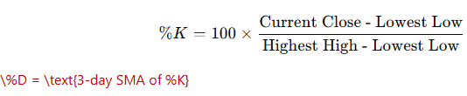

**Usage**:

* **Overbought/Oversold**: Above 80 suggests overbought conditions, and below 20 indicates oversold.
* **Crossovers**: %K crossing above %D is a buy signal; crossing below is a sell signal.

**Pros**:

* Quickly identifies momentum shifts.
* Works well for short-term reversals.

**Cons**:

* Produces false signals in strong trends.

**Bullish Chart Patterns: A Visual Guide**

Bullish chart patterns signal an upcoming rise in the price of an asset. Traders use these patterns to identify potential buying opportunities. Here are some common bullish patterns:

**1. Flag:** A short-term consolidation pattern that resembles a flag on a pole. It forms after a sharp price movement (the "pole") and indicates a continuation of the prior trend.

[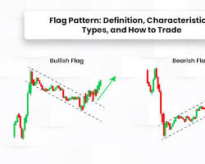Opens in a new window[](https://www.strike.money/technical-analysis/flag-pattern)www.strike.money](https://www.strike.money/technical-analysis/flag-pattern)

Flag pattern

**2. Pennant:** Similar to a flag, but the consolidation area is triangular. It also represents a pause in a strong trend before the trend continues.

[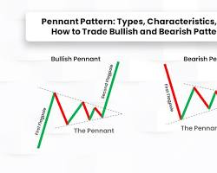Opens in a new window[](https://www.strike.money/technical-analysis/pennant-pattern)www.strike.money](https://www.strike.money/technical-analysis/pennant-pattern)

Pennant pattern

**3. Cup and Handle:** A longer-term pattern that looks like a cup with a handle. The cup is a U-shaped consolidation, and the handle is a slight pullback before the price breaks out to the upside.

[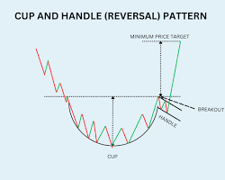Opens in a new window[](https://www.equentis.com/blog/cup-and-handle-pattern-understand-with-an-example/)www.equentis.com](https://www.equentis.com/blog/cup-and-handle-pattern-understand-with-an-example/)

Cup and Handle pattern

**4. Ascending Triangle:** Formed by an upward-sloping lower trendline and a horizontal upper trendline. It suggests increasing buying pressure and a potential breakout above the resistance.

[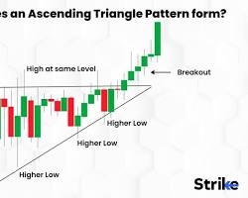Opens in a new window[](https://www.strike.money/technical-analysis/ascending-triangle)www.strike.money](https://www.strike.money/technical-analysis/ascending-triangle)

Ascending Triangle pattern

**5. Symmetrical Triangle:** Characterized by converging trendlines with a similar slope. The price consolidates within the triangle before breaking out in either direction. A breakout above the upper trendline is bullish.

[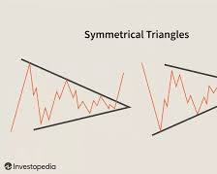Opens in a new window[](https://www.investopedia.com/terms/s/symmetricaltriangle.asp)www.investopedia.com](https://www.investopedia.com/terms/s/symmetricaltriangle.asp)

Symmetrical Triangle pattern

**6. Measured Move Up:** After an initial price increase, the price retraces slightly before rising again by a similar amount. The first move "measures" the potential distance of the second move.

[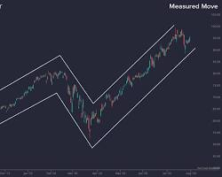Opens in a new window[](https://trendspider.com/learning-center/what-are-measured-moves-in-technical-analysis/)trendspider.com](https://trendspider.com/learning-center/what-are-measured-moves-in-technical-analysis/)

Measured Move Up pattern

**7. Ascending Scallop:** A series of higher highs and higher lows, forming a curved upward trend. It indicates a strong and consistent uptrend.

[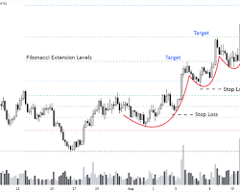Opens in a new window[](https://wealthyeducation.com/ascending-scallop-pattern/)wealthyeducation.com](https://wealthyeducation.com/ascending-scallop-pattern/)

Ascending Scallop pattern

**8. 3 Rising Valleys:** Three consecutive troughs (valleys) that form higher lows. It shows that buyers are stepping in at increasingly higher prices, indicating a potential trend reversal to the upside.

[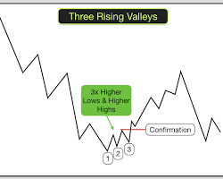Opens in a new window[](https://excellenceassured.com/trading/trade-chart-patterns/three-rising-valleys-chart-pattern)excellenceassured.com](https://excellenceassured.com/trading/trade-chart-patterns/three-rising-valleys-chart-pattern)

3 Rising Valleys pattern

**Note:** These diagrams are simplified representations. In real-world charts, these patterns may not appear as perfect or clear-cut. It's essential to consider other factors like volume and overall market conditions when interpreting chart patterns.

**95% of traders lose money. Here's a breakdown of the key reasons:**

**1. Lack of Discipline and Emotional Trading:**

* **Impulsivity:** Many jump into trades based on hype, "hot tips," or FOMO (fear of missing out) instead of a well-researched strategy.
* **Fear and Greed:** These emotions lead to panic selling during dips and chasing gains at market peaks, resulting in poor entry and exit points.
* **No Trading Plan:** Successful traders have a plan outlining their strategies, risk tolerance, and entry/exit rules.

Most failing traders lack this, leading to inconsistent and emotional decisions.

**2. Insufficient Knowledge and Skills:**

* **Underestimating Market Complexity:** Trading requires understanding technical analysis, fundamental analysis, risk management, and market psychology. Many dive in without adequate knowledge.
* **Ignoring Risk Management:** Failing to use stop-loss orders, overleveraging, and not diversifying are common mistakes that can wipe out accounts.
* **Lack of Adaptability:** Markets are constantly changing. Traders need to adapt their strategies and learn continuously, but many fail to do so.

**3. Overtrading and Chasing Losses:**

* **Revenge Trading:** After a loss, some try to "win it back" quickly by taking larger, riskier trades, often leading to more significant losses.
* **Lack of Patience:** Profitable trading often involves waiting for the right setups. Impatient traders enter trades prematurely or exit too early.
* **Overconfidence:** A few winning trades can lead to overconfidence and taking excessive risks, ultimately leading to losses.

**4. External Factors and Misconceptions:**

* **Unrealistic Expectations:** Many beginners have unrealistic expectations of quick riches. Trading is a skill that takes time and effort to master.
* **Falling for Scams:** The trading world is full of scams and "get-rich-quick" schemes that prey on inexperienced traders.
* **Market Volatility:** Even experienced traders can be affected by unexpected market events and black swan events.

**In essence, successful trading requires a combination of knowledge, discipline, and psychological resilience. Most traders fail because they lack one or more of these crucial elements.**

**Setting daily goals in stock trading** can be a double-edged sword. While it can provide structure and motivation, it can also lead to detrimental trading habits if not done correctly. Here's a breakdown of the pros and cons, and how to set effective daily goals:

**Potential Benefits:**

* **Focus and Discipline:** Having a clear target can help you stay focused on your trading plan and avoid impulsive decisions.
* **Motivation and Consistency:** Working towards a daily goal can keep you motivated and encourage consistent trading habits.
* **Tracking Progress:** Daily goals allow you to track your performance and identify areas for improvement.
* **Risk Management:** Setting a daily profit target can help you avoid overtrading and limit potential losses.

**Potential Drawbacks:**

* **Unrealistic Expectations:** Focusing solely on hitting a daily profit goal can lead to unrealistic expectations and force trades in unfavorable conditions.
* **Emotional Trading:** Missing a daily goal can trigger negative emotions like frustration and anxiety, leading to revenge trading and further losses.
* **Ignoring Market Conditions:** Rigidly pursuing a daily goal can make you ignore changing market conditions and miss out on better opportunities or expose yourself to higher risk.
* **Overtrading:** Trying to reach a daily goal can encourage overtrading, increasing transaction costs and the likelihood of errors.

**How to Set Effective Daily Goals:**

* **Focus on Process over Outcome:** Instead of fixating on a specific profit number, focus on following your trading plan, managing risk, and making informed decisions.
* **Be Realistic and Flexible:** Set achievable goals based on your trading strategy, risk tolerance, and market conditions. Adjust your goals as needed based on your performance and market volatility.
* **Prioritize Risk Management:** Always prioritize protecting your capital. Use stop-loss orders and position sizing strategies to limit potential losses, even if it means missing a daily goal.
* **Track Your Progress and Learn:** Regularly review your trading journal to track your progress, identify areas for improvement, and refine your strategies.
* **Consider Alternative Goals:** Instead of daily profit targets, consider setting goals related to:
  + **Number of successful trades**
  + **Risk-reward ratio**
  + **Accuracy of market analysis**
  + **Emotional control during trading**

**Remember, trading is a marathon, not a sprint. Focus on consistent, disciplined trading over short-term gains. By setting realistic goals and prioritizing risk management, you can increase your chances of long-term success in the markets.**