***“Cut your losses short and let your winners run.”* — Jesse Livermore**

***Cut your losses short***

**Why it matters**: Large losses are hard to recover from. For example, a 50% loss requires a 100% gain to break even.

**How to apply it**:

* Use **stop-loss orders** consistently.
* Only risk a small percentage (e.g., 1–2%) of your capital on any single trade.
* Cut losses quickly instead of hoping a bad position will recover.

*“The first rule of investment is don’t lose money.*

*And the second rule is don’t forget the first rule.”* — Warren Buffett

*Let your winners run*

**Why it matters**: Small profits can’t compensate for occasional larger losses unless gains are allowed to run.

**How to apply it**:

* Avoid taking profits at the first sign of green. Have a clear target or use trailing stops to ride trends.
* Let winning trades grow while monitoring for trend reversals.
* Stay patient—big moves often take time.

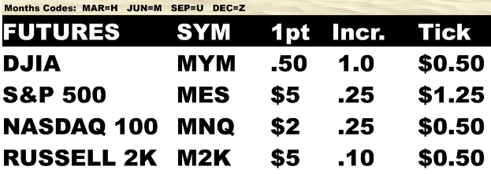

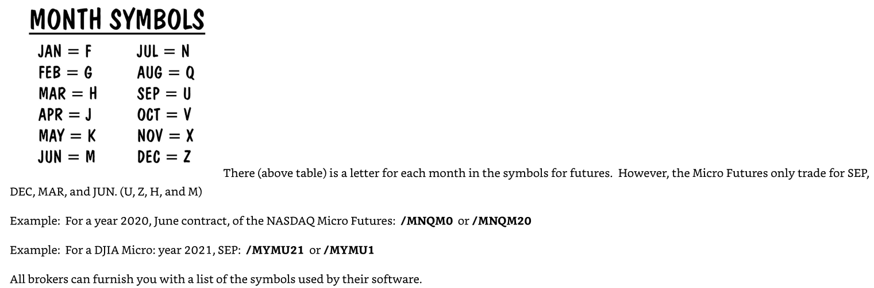

A one-point change for the major S&P 500 futures is valued at: $250

A one-point change for the E-Mini S&P 500 futures is: $50

A one-point change for the Micro S&P 500 Futures is:   Only $5

Index Micro Futures have four monthly contracts: MAR, JUN, SEP, and DEC and there are always 4 consecutive quarterly contracts listed.

Futures contracts are all temporary and all have expiration dates, last trading day dates (LTD), and a final notice date (FND.)  Each contract is named for a month and year.

Normally, you will trade the most nearby contract available because it is the one with the most liquidity, volume, and activity.  Know that the convention is for you to always trade the most nearby. You must be aware of what is called the “roll date.”  Since (unlike stock trading) futures contracts expire, near the contract’s expiration date, you must migrate your trading to the next contract – for it is about to become the ‘nearby’ contract.  The trading floor convention is to roll the expiring quarterly futures contract month eight calendar days before the contract expires. This is known as the roll date.  You can go to this link at CME to get a free calendar of the roll dates:  (or just call your broker)

Futures contracts expire on the 3rd Friday of the contract month, so you can figure it out yourself by counting back 8 trading days from there (excluding holidays.) There’s nothing to stop you from moving out to the next contract a few days early, it usually won’t make much difference.  This is a common practice.

Watch for earnings report or other bad press should cause Apple stock to drop or rise quickly by $10 a share, this can move the Index as much as 40 points or more.  You may even make an event like this a part of a trading strategy.

Study the charts and pay attention to how the trading volume varies as the index moves up and down.  Some days are not as volatile as others.  Watch to see the daily trading ranges of the index.  I suggest you start ‘sizing up’ the S&P 500, the NASDAQ 100, and the DJIA micros.  Think in terms of the dollar value of these daily moves and ranges.

Futures trades: start at Sunday 5pm and ends at Friday 4pm CST. Every day 4 to 5pm cst is off.

(Kinda Saturday and Sunday Off).

**Money Management:** Just because the market is open does not mean you have to trade. Cash is a position too. From The Art of War, here is the secret to money-management: Do not fight battles you cannot win.

**Study Trading as a Business:** Control your own destiny or someone else will.

**Turn Knowledge to Money:** In futures trading, learning probability is the doorway to opportunity.

**The Psychology of Trading:** Doing the same thing over and over again and expecting different results is the definition of insanity. – Albert Einstein

**Learn to Trade on Your Own Terms**: Experience is what you get when you didn’t get what you wanted. Luck is when preparation meets opportunity. While you are learning to trade, try hard to learn to enjoy the journey for in the end even if you make money, it won’t last unless your trading is enjoyable for you.

**Just so you know:**  Some traders will from time-to-time - when they are at the trading screen - do what is called a “mental trailing stop” or a “mental stop.”  This means they do not enter an actual order, but they choose to put in the order manually.

**Types of Stop Orders**

1. **Stop-Loss Order (Sell Stop)**
   * **Purpose**: To limit losses on a long position.
   * **How It Works**: You set a stop price below the current market price. If the price drops to the stop level, the order becomes a *market order* and executes at the next available price.
   * **Example**: You own a stock at $50. You place a stop-loss order at $45. If the stock drops to $45, it sells automatically to prevent further loss.
2. **Buy Stop Order**
   * **Purpose**: To enter a position when the price rises to a certain level, often used to catch breakouts or limit losses on short positions.
   * **How It Works**: You set a stop price above the current market price. When the price hits that level, a *market buy order* is triggered.
   * **Example**: A stock is trading at $40, and you believe it will rally if it breaks $45. You place a buy stop at $45 to catch the upside momentum.
3. **Stop-Limit Order**
   * **Purpose**: To gain more control over the execution price.
   * **How It Works**: Combines a stop order and a limit order. Once the stop price is reached, it becomes a *limit order* (not a market order).
   * **Example**: A stock is at $60. You place a stop-limit sell order with a stop at $55 and a limit at $54. If it drops to $55, it tries to sell, but only at $54 or better. If it falls too fast, it might not execute.
4. **Trailing Stop Order**
   * **Purpose**: To lock in profits while allowing upside movement.
   * **How It Works**: The stop price “trails” the market price by a fixed amount or percentage. If the price rises, the stop moves up. If it falls, the stop stays.
   * **Example**: A stock is at $100, and you place a trailing stop of $5. If the stock goes up to $110, the stop moves to $105. If the stock drops to $105, the order is triggered.

The most common mistakes are for traders to take profits too quickly and to hold losses until they get very big.

**🦈 Index Futures Trading Cheat Sheet**

**💡 Mindset**

* **Learn to swim with the sharks—or be their dinner.**
* Success comes from practice, discipline, and knowing when to trade.

**⏰ Best Times to Trade Index Futures:**

* **High volume occurs during the U.S. market open, followed by the London and Asian sessions.**

**🌍 Major Trading Sessions (CST)**

| **Region** | **Session Time** |
| --- | --- |
| 🇦🇺 Asian/Australia | 6 PM – 3 AM CST |
| 🇬🇧 European/London | 1 AM – 10 AM CST |
| 🇺🇸 U.S./New York | 7 AM – 4 PM CST |

**📈 Index Futures Market Hours**

* **Trades 23/6** (23 hours/day, 6 days/week)
* **Open:** Sunday 5 PM CST
* **Close:** Friday 4 PM CST
* **Daily Pause:** 4 PM – 5 PM CST (Weekdays)

Experience and screen time are the best ways to learn trading. Start with a free demo account and use **TradingView.com** for easy, powerful charting. Their paid plan unlocks 15s and 30s charts—great for precise entries. A small investment in the right tools can make a big difference.

Use Bracket Orders to Protect Your Trades

When entering a trade, it's smart to place a bracket order—this means adding both a stop-loss and a take-profit order at the same time.

**Stop-loss:** Like insurance—it limits how much you can lose if the trade goes against you.

**Take-profit:** Locks in gains when your target price is reached.

This setup helps you manage risk and stick to your trading plan.

**Risk Management Is Everything in Trading**

When risking 2 points on a trade, it’s common to aim for a 3-point profit. That creates a 1.5:1 reward-to-risk ratio, which is especially effective for shorter time frames like 15 minutes or less.

With larger time frames, trades require wider stop losses and allow for larger profit targets, but there are fewer trade setups per day, reducing the chance to recover from losses quickly.

Most trading educators don’t emphasize this, but there are real advantages to shorter time frame trading:

Smaller, more manageable losses

More frequent opportunities

Quick execution in highly liquid markets like Micro Index Futures

The key is to be selective—only high-quality setups should be traded.

Trading success is built on risk management.

Low risk + steady returns = long-term growth.

Greedy traders often fail.

Disciplined, cautious traders survive and thrive.

**Mastering risk is the most important step to becoming a consistent trader.**

Medium reward setups produce better steady profits over time, than low risk, high reward setups.

**Why Stock Index Micro Futures Are Great for Traders**

The three major U.S. stock indices—**NASDAQ, S&P 500, and Russell 2000**—often move together, giving traders clear signals.

**On bullish days (buyers in control):**

* NASDAQ usually moves the most.
* S&P 500 follows.
* Russell 2000 tends to move less, with lower volatility.

**On bearish days (sellers in control):**

* NASDAQ typically drops the hardest.
* S&P 500 and Russell 2000 follow more moderately.

On quiet or mixed days:

* Sometimes NASDAQ and S&P 500 might sell off while Russell 2000 holds steady.
* This can offer unique buy opportunities in the Russell.

By observing how these indices behave together, traders can spot patterns and make smarter trade choices.

**Simple rule:** Buy what’s strong, sell what’s weak.

**Stock Index Micro Futures offer:**

High liquidity

Frequent movement

More daily trade setups

They’re often easier to read and trade than FOREX, which can be indecisive and less predictable.

In short, learning to trade Micro Futures is perfect for active traders and scalpers looking for consistent, reliable opportunities.

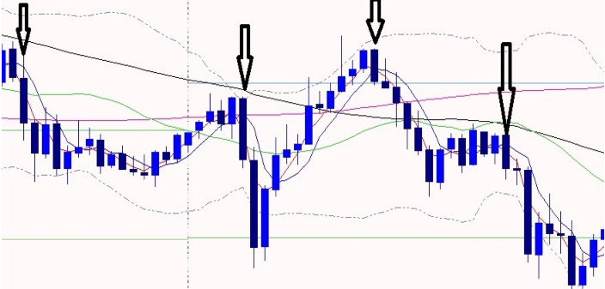

Downtrend

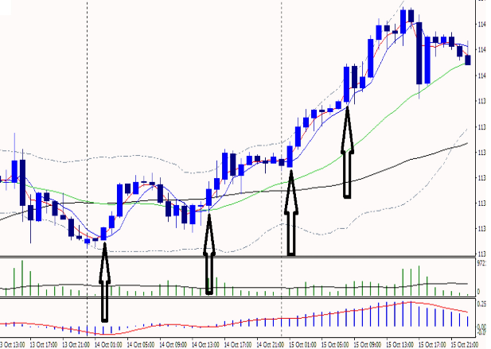

Up Trend

Engulfing Candles, buy at the beginning of the next candle.