1. Never go into a trading day blind. Always spend at least 15-20 minutes analyzing the markets before you take your first trade.

2. Emotional resilience > strategy

3. You will always be tempted to cut your winners short (out of fear) and hold your losers too long (out of hope it'll reverse). Fight this urge.

4. All traders have an emotional weakness (greed, fear, doubt, anxiety). Know which one you have so you can combat it while trading.

5. Take the same amount of time you spent trading to analyze your trades. 30 mins trading = 30 mins analyzing.

6. If you broke your rules but still won a trade, you lost that trade.

7. The more you break your strategy's rules, the more that behavior gets internalized. Cut it immediately.

8. You should NOT be trading for more than 2 hours. The longer you trade the more decision fatigue sets in and the worse your trading performance becomes.

9. As a trader, you are an athlete. Good sleep, good nutrition, focus & energy levels are as important to your performance as they are to an NFL player.

10. Some days you might not see a single set-up that follows your strategy. Resist the urge to take a trade.

11. NOT taking a bad trade is as important (and as difficult) as taking a winning trade.

12. Fridays are the most volatile trading days. Either don't trade or be cautious when you do trade.

13. Economic news makes huge and unpredictable changes in the market. Always keep track of when the FOMC is putting out a press release and don't trade at those times.

14. If you're trading on a funded account, always start with a $50k account. It's easier to pass than a $150k account.

15. You can link multiple funded accounts together so that every trade you take gets executed on all of your accounts.

16. Use Tradingview for charting analysis.

17. Use Take Profit Trader and Apex for funded accounts

18. Take Profit Trader benefit: allows daily payouts. Apex benefit: you can get up to $6M in funding. I recommend starting with Take Profit Trader so you can pay yourself more often and make a consistent income

19. Take Profit Trader and Apex routinely have sales

20. Never take a trade when you're in the middle of something else or have distractions around. Easy way to lose money.

21. R:R is more important than your win rate. You can have a <50% win rate and still make a lot of money if your R:R is high.

22. Use Tradezella to track your trading performance.

23. Stick to ONE strategy. Don't mix strategies and do not add in unnecessary indicators.

24. Trading with the trend is safer than trading against it. Trend is your friend.

25. Always always always set a stop loss.

26. Calculate the maximum stop-loss for futures using this formula -> Maximum stop-loss = Maximum risk/price change per tick

27. Practice risk management by using micros.

28. Always take your trades as close as possible to a level.

29. New York Session is 8:30am to 4:30pm EST. Asian Session is 7pm to 4am EST. London Session is 3am to 12pm EST.

30. The best instrument to trade depends on which session you're trading in.

31. You should ALWAYS set a maximum daily risk. If you hit that amount, you stop trading for the day.

32. Walk away from the trading desk after 2-3 losses. Your judgment will start to deteriorate.

33. Aim for only taking 2-4 trades per day. The more you take, the more you "chase".

34. Focus on good entry and trade selection over number of trades taken per day.

35. Do not try re-entering a trade setup more than two times if it doesn't go in your favor.

36. When in doubt, zoom out. If you're unsure of if you're taking a setup correctly, zoom out to the 15min or 1hr chart.

37. Trim your trades after you hit 2 R:R. This ensures you take profit in case prices reverses.

38. Always calculate your maximum risk per trade before taking a trade and make sure it corresponds to your maximum daily risk.

39. Knowing exactly how much you’re willing to lose per day is important than setting how much you want to make per day.

40. Journal every single day, if you don’t have time to journal your entire trading session, at least journal what trades you took and your R:R

41. Trimming is powerful. You maximize your upside and decrease risk of a trade reversing

42. Consistency is king. Show up everyday and trade. Don’t trade once or twice a week and expect to be profitable. Trading is like training a muscle in gym. The longer you train, the stronger it gets.

43. Remember This. You can never master the market but you can master yourself.

44. Even if you take a trade that fits your setup perfectly, there’s a probability that you will lose the trade. That’s why we trade on probabilities, not absolutes.

45. Focus no what you can control, not controlling the market. AKA- cutting your loses quick, trimming your trades, good entries and exits

46. Trading is long term game, not short term play. Treat it like building any other type of skill.

47. If you hit your maximum daily loss, stop trading for the day. If you struggle to stop trading, change your environment entirely and leave your house

48. Revenge trading will burn you HARD. That’s why you should never overtrade if you make 2 or 3 losses because you will start looking for setups that aren’t there.

49. You don’t need to trade with your own money. You can use funded accounts to trade.

Game Plan As A Trader You Must Have A Game Plan To Help With Consistency

1. What time will I wake up to prepare for the trading day?
2. What Asset/Commodity am I going to trade?
3. What is my primary trading style?
4. What is the market sentiment for the day?
5. What is the economic calendar looking like?
6. Are there any earnings I need to take note of?
7. What timeframe will I be trading?
8. What position size am I comfortable with risking?
9. Are there any FEDS speaking for the day?
10. What strategy will work best for the current market condition/direction?

The image also includes a simple icon at the top showing what appears to be a strategic planning or game plan diagram, and a small logo of what looks like an animal figure.

Trading Rules As A Trader You Must Have Clear Rules For Yourself To Remain Disciplined

1. I will not risk more than 50% of my account per trade.
2. I will follow my % and technical stop loss to cut my losing trades.
3. I will not enter trades blindly and hope the trade goes in my favor.
4. I will wake up 1hr before the market opens to prepare and game-plan for the trading day.
5. I will stop trading after 2 consecutive losing trades.
6. I will not over trade!
7. I will no FOMO (Fear of missing out) on trades.
8. I will not add to my losing positions.
9. I will wait for my trading set up before entering my trades.
10. I will let my runners run and move my stop loss higher.

Position Sizing Position Sizing Is Key To Help Minimize Trading Losses

| **Account Size** | **Risk Per Trade** |
| --- | --- |
| $1000 | $50-100/Trade |
| $2000 | $100-200/Trade |
| $3000 | $100-300/Trade |
| $4000 | $200-400/Trade |
| $5000 | $200-500/Trade |
| $10,000 | $250-500/Trade |
| $25,000 | $500-1000/Trade |

Avoid These Common Emotional Mistakes

1. Rush into new trades after experiencing a few losses in order to win the money back quickly.
2. Fear taking the next valid trade after a series of losses.
3. Stay in a losing trade "hoping" that things will turn around.
4. Focus on short term results and lose their perspective.
5. Fail to stick to consistent percentage risk per trade.
6. Constantly changing trading systems/strategies after experiencing short term losses.
7. Focus on the account balance instead of following the system.
8. Get emotionally affected by losses: fear, stress, loss in confidence.
9. Blame and find external reasons for their losses.
10. Desire to take revenge on a stock or market after experiencing losses.

The image includes the same animal logo at the top as the previous images, and a red exclamation mark icon below the title.

Trading a different kind of work, you will be the most successful when you feel like you are doing the least amount of work because you are submitting.

View the market nothing more than the lines on a screen, that’s all it is, stop overvaluing what it is.

Everything you do in your trading and every mistake that you do and every failure that’s holding you, comes back to the idea that you are more focused on making money, than the process. Money is an outcome stop focusing on making money, disconnect it from your head, come into the market and focus on building good habits.

Institutional traders are taught from their FIRST Day that they buy at good levels or the don’t buy at all.

Trading is 80% waiting and 20 % Execution. Most traders fail because they spend 80% trading and 20% messing, Great traders have learned to sit and wait for the best opportunities

Run your profits and cut your loses but do not confuse this with being greedy, use trailing stops to protect your profits, exit your trade when your targets are hit. Holding on to a trade too long can stop you detecting and entering other potentially profitable trades

**The Only Technical Analysis Video You Will Ever Need... (Full Course: Beginner To Advanced)** <https://www.youtube.com/watch?v=eynxyoKgpng>

**10 Best Trading Indicators After 10,000 Hours of Trading (THE HOLY GRAIL)** <https://www.youtube.com/watch?v=xv_Zwf1-8L8>

So you want to become a full-time trader in 12 months?

Let me tell you what everyone else won’t.

It’s not about making millions overnight.

It’s not about finding some secret indicator.

It’s about building a foundation that lasts.

Month 1-3: You’ll paper trade and lose virtual money.

You’ll feel like giving up.

You’ll wonder if you’re cut out for this.

Good. That’s exactly where you should be.

Month 4-6: You’ll start trading small.

Really small.

So small your friends will laugh.

Let them laugh.

Because while they’re chasing home runs, you’re learning to hit singles.

Month 7-9: You’ll have your first big loss.

It will hurt.

It will test everything you’ve learned.

But this is where traders are made or broken.

Month 10-12: Something will click.

The charts will start speaking to you.

Your emotions will feel different.

You’ll stop chasing trades.

You’ll stop hoping and start knowing.

But here’s what nobody tells you:

Success isn’t about the months at all.

It’s about the hours.

The hours before the market opens.

The hours after it closes.

The hours spent reviewing your trades.

The hours spent doing nothing but watching.

Want to make it in 12 months?

Put in 12 hours a day.

Study like it’s your degree.

Trade like it’s your job.

Because soon, it will be.

The market doesn’t care about your timeline.

It cares about your dedication.

Your discipline.

Your patience.

Are you ready to put in the real work?

Or do you just like the idea of being a trader?

The next 12 months are going to pass anyway.

The question is: Where will you be when they do?

If you want to become successful you will become successful

If you want to become rich you will become rich

If you want to become literate you will become literate

If you want to become well-traveled you will become well-traveled

But you want something and do another hundred things that are completely opposite to the goal ☹

If you want to get rich, I have to pay the price, (Study / Practice).

If I want to travel, I have to pay the price.

Most people only wish things, they truly don’t want them and work towards them.

When in Doubt GET OUT.

Richard Dennis 17 Trading Advice from a Market Wizard

<https://www.tradingwithrayner.com/richard-dennis/>

**1. Whatever method you use to enter trades, the most critical thing is that if there is a major trend, your approach should assure that you get in that trend.**

If you think about it…

Breakouts are the only entries that will ensure you’ll [catch every single trend](https://www.tradingwithrayner.com/trend-trading-strategy/) — every single time.

And that’s why most Systematic Trend Followers trade breakouts as their entry method, including Richard Dennis’ turtle traders.

You might be wondering:

“But what about pullbacks?”

I know [pullbacks](https://www.tradingwithrayner.com/pullback-trading/) are psychologically easier to execute because you’re buying low and selling higher.

But it comes with a price — and that’s missing the entire trend because the market didn’t offer a pullback.

So if you want to be involved in every trend that comes along, then you must [trade breakouts](https://www.tradingwithrayner.com/breakout-trading-guide/).

**2. A good trend following system will keep you in the market until there is evidence that the trend has changed.**

Here’s a fact:

There’s no way to predict how high the market will go.

So, the next best thing you can do is [trail your stop loss](https://www.tradingwithrayner.com/trailing-stop-loss/) as the market moves in your favor.

However, you don’t want to have a tight trailing stop loss as you’ll get stopped out on the retracement.

Instead…

Widen your trailing stop loss to accommodate the deep retracement that might occur — and you have the best chance of riding a trend.

And chances are if you get stopped out, it’s because the [trend has reversed](https://www.tradingwithrayner.com/trend-reversal-trading-strategy/).

**Pro Tip:**

You can use indicators like [Moving Average](https://www.tradingwithrayner.com/moving-average-indicator-trading-strategy/) or the [Average True Range](https://www.tradingwithrayner.com/atr-indicator/) to trail your stop loss.

**3. When you have a position, you put it on for a reason, and you’ve got to keep it until the reason no longer exists.**

This is the opposite of what most traders do — and it HURTS them big time.

Here’s why…

Most of you tell me you want to ride big trends.

And it’s no secret that the KEY to riding massive trends is to trail your stop loss (I covered that earlier).

However…

You have difficulty holding on to your gains because…

You see profits.

You see green.

You see money.

BUT…

You have the FEAR of losing those gains.

So, you exit your trade even though the market hasn’t hit your exit signal.

The end result?

Big losses and small winners.

So here’s the lesson:

If you want to be a consistently profitable trader, you must follow your rules and exit your trades ONLY when the reason no longer exists.

**4. You should expect the unexpected in this business; expect the extreme. Don’t think in terms of boundaries that limit what the market might do.**

Look at the chart below:

[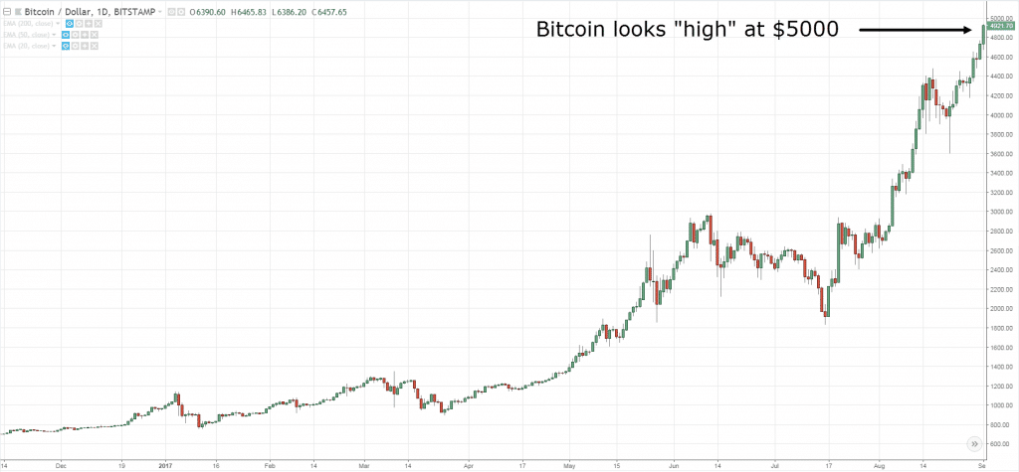](https://www.tradingwithrayner.com/wp-content/uploads/2018/06/1.-bitcoin-high.png)

You’re probably thinking:

“Insane! The price is so high. I’m sure the market is about to reverse lower.”

And here’s what happens next…

[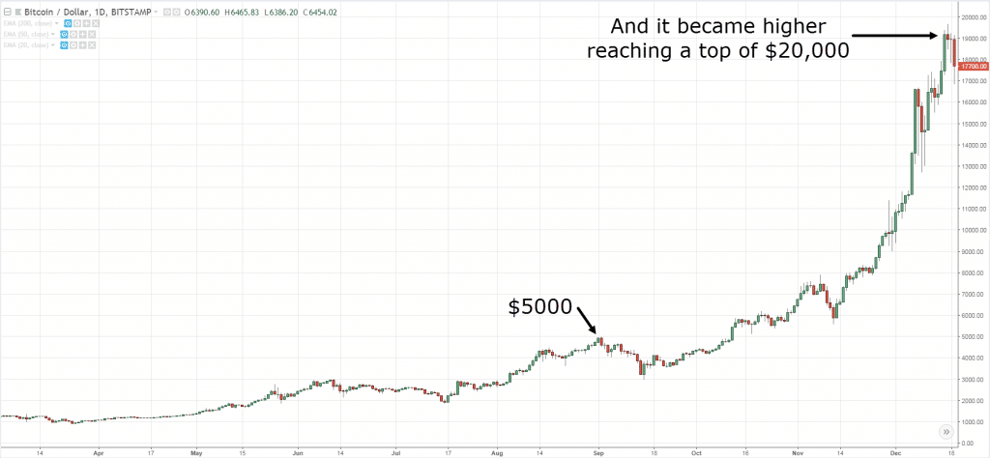](https://www.tradingwithrayner.com/wp-content/uploads/2018/06/2.-bitcoin-even-higher.png)

BOOM!

The market exploded even higher.

I know it’s hard to believe the market can just continue to make new highs especially when it looks “overbought”.

So the lesson is this:

You can never tell if the market is too high to buy or too low to short.

Because what’s high can go higher and what’s lower can go lower.

Now if you want to discover my secret technique of buying high and selling higher, then check out this video:

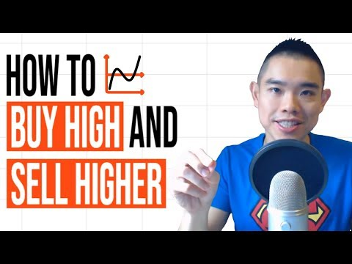

**5. If there is any lesson I have learned in the nearly twenty years that I’ve been in this business, it is that the unexpected and the impossible happen every now and then.**

If you saw the earlier Bitcoin example, you might think that such “extreme” moves rarely occurs.

Wrong!

Here are more examples…

[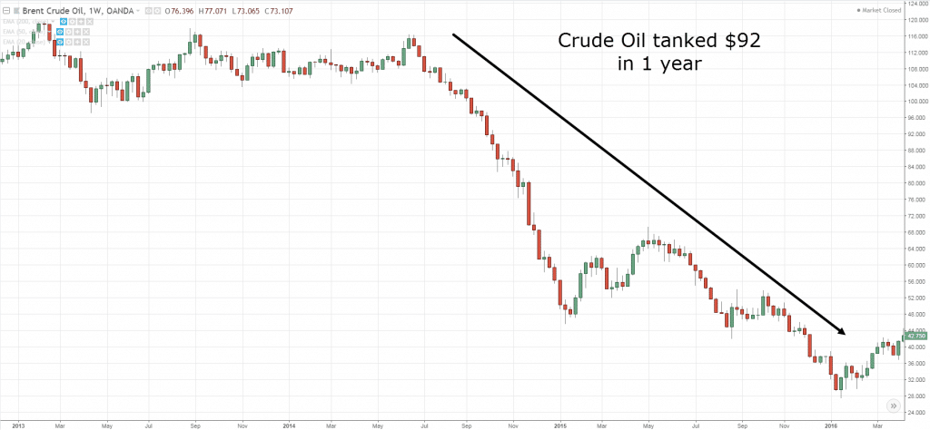](https://www.tradingwithrayner.com/wp-content/uploads/2018/06/3.-crude-oil-tank.png)

[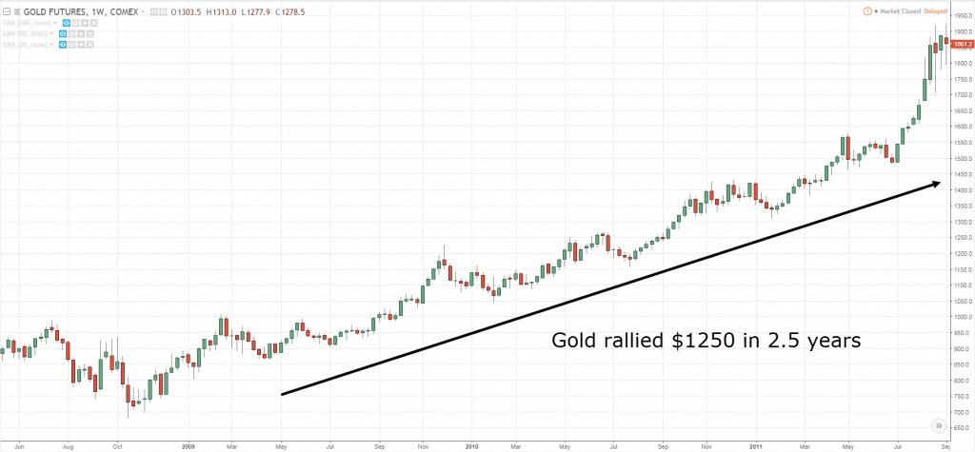](https://www.tradingwithrayner.com/wp-content/uploads/2018/06/4.-Gold-rally.png)

[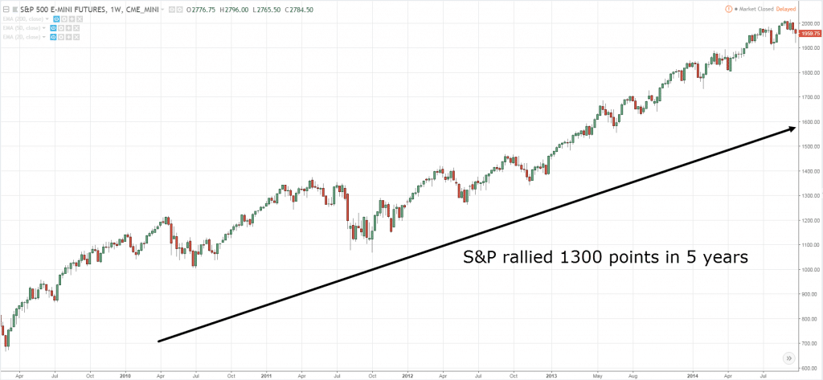](https://www.tradingwithrayner.com/wp-content/uploads/2018/06/5.-snp.png)

Now don’t get me wrong.

You shouldn’t expect these moves every week or month.

But chances are, you can find these trends once every few years (and they can last for YEARS).

The bottom line is this…

If you have the discipline to ride your winners, it’ll be a matter of time before you catch one of these “monsters”.

**6. Trading decisions should be made as unemotionally as possible.**

If you trade based on emotions:

You’ll buy at the highs when things are moving “fast”, hold onto your losses hoping they will rebound, trade larger hoping to make back what you’ve lost, and etc.

Clearly, you know that trading based on emotions is a recipe for disaster,

Instead, you’ve got to think, act, and trade like a machine!

Now the question is, how?

Here are a few tips to get you started…

1. Develop a trading plan with clearly defined buy & sell rules
2. Risk not more than 1% of your capital on each trade
3. Focus on executing your trading plan consistently (this is so important)
4. Don’t get swayed but the short-term results, think long-term

If you want to learn more, then go check out this trading guide: [How to be a Consistently Profitable Trader within the Next 180 days](https://www.tradingwithrayner.com/profitable-trader/).

**7. Trade small because that’s when you are as bad as you are ever going to be. Learn from your mistakes.**

Let me ask you…

If you want to be a brain surgeon, will you immediately operate on a live human brain?

Of course not!

You’ll probably start off practicing on a “dummy” brain.

As you get better, you’ll work on a live human but only on a minor segment of it (so it doesn’t cause danger to the person).

Then as you level up, you’ll work on the major parts and finally, you have the confidence to do it on your own.

And it’s the same for trading!

You want to trade small because you’ll make mistakes — plenty of it.

So, why pay more in “tuition fees” to Mr. Market when you can do so at a fraction of the cost?

**8. I could trade without knowing the name of the market.**

You’re probably wondering:

“How is that possible?”

Well, that’s because you’re trading the price in front of you without concerning where the price is derived from.

It could be Soybean, Crude Oil, Copper, Rubber, or Cotton, who cares.

The only thing that matter is price, and nothing else.

Because the price is moved by an imbalance of buying & selling pressure which is based on emotions like fear, greed, hope, and regret.

These emotions or biases can last for a long time which in turn becomes a trend — something Trend Followers can capitalize on.

And that’s why you don’t need to know the name of the market.

All you need to know is…

1. Buy what’s going up
2. Sell what’s going down
3. Repeat

**9. In the real world, it is not too wise to have your stop where everyone else has their stop.**

Let me ask you…

Do you always get stopped out only to watch the [market reverse](https://www.tradingwithrayner.com/how-to-identify-trend-reversal/) back in your intended direction?

Because you put your stop loss where everyone else puts it (like below Support) — which creates an incentive for the “smart money” to hunt your stop loss.

So, how can you avoid it?

By setting your stop loss AWAY from the obvious market structure.

This means don’t place your stop loss smack under Support, or just above Resistance.

I cover in more details here: [How to Avoid Stop Hunting While Other Traders Get Stopped Out](https://www.tradingwithrayner.com/stop-hunting/)

**10. You could publish trading rules in the newspaper and no one would follow them. The key is consistency and discipline.**

This is true for 99% of traders out there.

Most would not have the conviction to take someone’s trading rules and trade it consistently even though its profitable in the long-run.

Why?

Because when the drawdown comes (which all systems will have), they will abandon it and look for the next trading system — and rinse repeat this cycle again.

So, the question is…

How can you gain confidence in your trading strategy or even someone’s trading system?

There are 2 ways you can go about it…

[**1. Backtest the trading strategy**](https://www.tradingwithrayner.com/how-to-backtest-a-trading-strategy/)

This allows you to understand how a trading strategy performs historically.

If it’s proven to work in the past, there’s a possibility it could continue to work in the future (although no guarantee since it could be curve fitted).

**2. Understand the logic behind WHY a trading strategy works**

Most trading strategy that works have an underlying logic behind it.

For example:

Trend Following works because human biases and emotions cause the market to trend.

So, if a trader can cut his losses and ride his winners, he can capitalize on the long-term trend that comes about.

Or how about Value Investing?

It works because investors dump stock during “bad news” and that pushes the price of the underlying security below its intrinsic value.

This allows savvy investors to buy low (below the intrinsic value), and sell high (when the price increase back towards the intrinsic value).

**11. There are lots more false breakouts, perhaps because there are more computer-based trend followers.**

Here’s the deal:

Not all breakouts will work out.

In fact, half or more of your [breakout trades are likely to fail.](https://www.tradingwithrayner.com/academy/price-action/how-to-avoid-false-breakout/)

However, it doesn’t mean trading breakouts is a losing strategy, far from it.

Remember, it’s not how often you win that’s important.

It’s how much you win when you’re right and how much you lose when you’re wrong — that’s what matters.

Also…

If you want to increase your odds of capturing a trend, you must trade across different markets.

This includes Forex, Indices, Energy, Metals, Agriculture, and etc.

If you want to learn more, then go read [The Ultimate Guide to Trend Following](https://www.tradingwithrayner.com/trend-following/).

**12. It is misleading to focus on short-term results.**

I’ll tell you this:

Your short-term results are random.

Because when you’re dealing with probabilities, anything is possible in the short run.

It’s only in the long run (after a large sample size of trades) that your results will align towards its expectancy.

Don’t believe me?

Then let me prove this to you…

Look at the performance of this trading system over the last 5 months…

[Richard Dennis, R, R](https://www.tradingwithrayner.com/wp-content/uploads/2018/06/6.-drawdown.png)

Now, most of you would say this performance is crap and you’ll likely abandon this system after few losing months.

Now, look at this trading system below…

[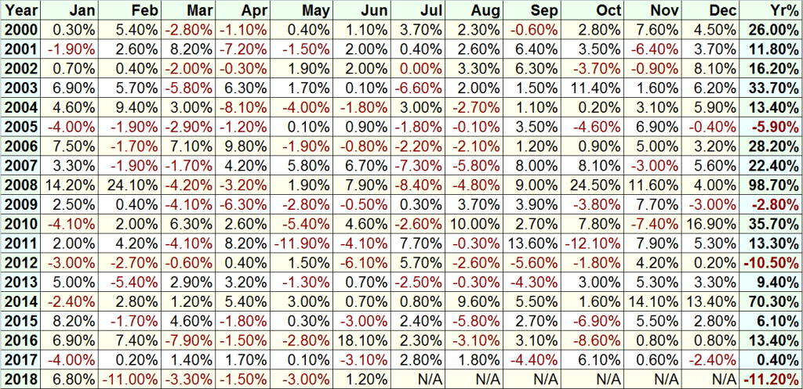](https://www.tradingwithrayner.com/wp-content/uploads/2018/06/7.-Full-results.png)

This looks like a much better system, right?

But guess what?

This is the same EXACT system as the one above.

The only difference is I’ve shared with you the results over the last 18 years instead of the 5 last months.

Do you see my point now?

In the short run your trading results are random but eventually, it’ll align towards it’s expected value.

**13. You have to minimize your losses and try to preserve capital for those very few instances where you can make a lot in a very short period of time. What you can’t afford to do is throw away your capital on suboptimal trades.**

Here’s the deal:

No matter which trading strategy you’re using, there will come a time where trading is so easy and it feels like you’re “printing” money.

But don’t be too happy just yet because…

There are also times where it sucks so bad you feel there’s no light at the end of the tunnel — and you just want to quit trading altogether.

So…

The “trick” is to minimize the damage during the bad times so you can survive and THRIVE during the good times.

This means:

* Have [proper risk management](https://www.tradingwithrayner.com/forex-risk-management/) in every trade
* No revenge trading even if you’re angry with the markets
* No over trading hoping you can make your losses back quickly
* Follow your trading system no matter how hard it is to pull the trigger

If you can do it, then you’ll likely overcome your drawdown and reach new equity high again.

**14. I learned that a certain amount of loss will affect your judgment, so you have to put some time between that loss and the next trade.**

There are 2 ways to look at this…

If you’re a discretionary trader, then yes, it makes sense to put some time between your loss and the next trade (especially if you have sustained a series of losses).

Because as a discretionary trader, your trading decisions are based on your analysis of the markets.

If you are carrying emotional baggage, you won’t objectively analyze the markets which lead to sub-optimal trading decisions.

However, if you’re a systems trader, then things are different.

Because the more losses you face, the closer you’ll be towards your next winning trade.

So, if you have a proven system that works, the last thing you’d want to do is to skip your trades because you have the [fear of losing](https://www.tradingwithrayner.com/how-to-overcome-your-fears-in-trading/).

Instead, you must trade your system consistently so you don’t “mess up” the results of it.

**15. Trading has taught me not to take the conventional wisdom for granted. What money I made in trading is a testimony to the fact that the majority is wrong a lot of the time.**

The reason why most traders fail is that they want to be spoon-fed.

They don’t want to put in the hard work to find out what works and what don’t.

They trust what “gurus” say instead of spending time and effort to figure things out themselves.

Now, is it no wonder that most traders never make it?

So here’s the deal:

If you want to succeed in this business, you must TEST everything.

Trust nothing but question EVERYTHING.

If you’re unsure, backtest it, forward test it, and use your brain to think about it!

**16. Almost anybody can make up a list of rules that are 80 percent as good as what we taught people.**

You’re probably thinking:

“What? I could never come up with a profitable trading strategy.”

Here’s the deal…

Trend Following isn’t a difficult concept.

It’s basically…

1. Trade a broad basket of markets
2. Ride your winners
3. Cut your losses

And that’s it!

How difficult can it be to come up with a set of trading rules based on the above criteria?

Still, I’m going to spoon-feed you further.

Go read the book [Following the Trend by Andreas Clenow](https://amzn.to/2KnJYzc).

This book provides you with the exact strategy and markets to trade — so there’s no excuse anymore.

*But please do your own backtesting first before trading it live.*

Now…

The difficult part isn’t formulating the strategy but the execution of it — especially when the drawdown comes.

Will you be able to execute your trades consistently when you’re down 10%, 20%, or even 40% of your trading capital?

**17. I’ve learned that markets, which are often just mad crowds, are often irrational; when emotionally overwrought, they’re almost always wrong.**

After many years of trading, the one thing I’ve learned is to NOT trade with the crowd.

For example:

[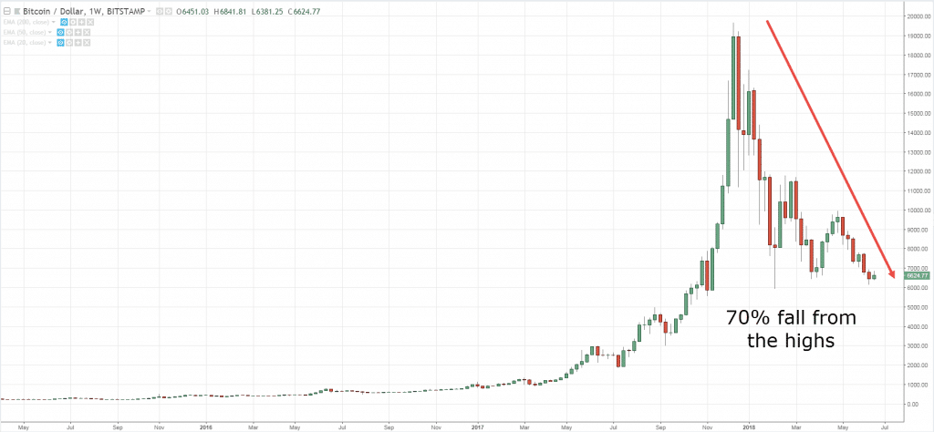](https://www.tradingwithrayner.com/wp-content/uploads/2018/06/8.bitcoin-collapse.png)

Back in 2017, Bitcoin was making new highs with a lot of attention from the media and the public.

To an astute trader, it’s a warning sign that the “party” is about to end.

*Now, I don’t expect you to short Bitcoin because the market could continue to trend higher.*

However, if you’re long, then you should tighten your stop loss and be prepared to BAIL OUT the moment the market show signs of reversal.

Because when the whole world has already bought, who’s left to buy?

Nobody.

And if there’s no one left to buy, the path of least resistance is DOWN.

Here’s a quote by Warren Buffet that says it best…

“Be greedy when others are fearful and fearful when others are greedy.”

**Frequently asked questions**

**#1: How can a small trader like me with limited capital trade a diverse range of markets simultaneously?**

You’ll probably want to trade with a broker who allows you to trade nano lots (as they are probably going to be market makers too).

**#2: Hey Rayner, where are the results on point 12 from?**

This is a systematic trend following system that I’ve developed.

**Conclusion**

The wisdom shared by Richard Dennis is still as applicable as they were decades ago.

Now, some of you might argue that Richard Dennis strategy doesn’t work anymore.

Well, the exact parameters used in Richard Dennis’ trading strategy might not work anymore.

But the principles of Trend Following still works and is currently used by some of the biggest hedge funds in the world (like Winton Capital).

So, don’t get caught up by the specific tactics but look at the big picture and understand the concepts behind it.

Now it’s over to you…

What’s the biggest takeaway you had from Richard Dennis quotes?

Leave a comment below and share your thoughts with me.

**5. If there is any lesson I have learned in the nearly twenty years that I’ve been in this business, it is that the unexpected and the impossible happen every now and then.**

If you saw the earlier Bitcoin example, you might think that such “extreme” moves rarely occurs.

Wrong!

Here are more examples…

[](https://www.tradingwithrayner.com/wp-content/uploads/2018/06/3.-crude-oil-tank.png)

[](https://www.tradingwithrayner.com/wp-content/uploads/2018/06/4.-Gold-rally.png)

[](https://www.tradingwithrayner.com/wp-content/uploads/2018/06/5.-snp.png)

Now don’t get me wrong.

You shouldn’t expect these moves every week or month.

But chances are, you can find these trends once every few years (and they can last for YEARS).

The bottom line is this…

If you have the discipline to ride your winners, it’ll be a matter of time before you catch one of these “monsters”.

**6. Trading decisions should be made as unemotionally as possible.**

If you trade based on emotions:

You’ll buy at the highs when things are moving “fast”, hold onto your losses hoping they will rebound, trade larger hoping to make back what you’ve lost, and etc.

Clearly, you know that trading based on emotions is a recipe for disaster,

Instead, you’ve got to think, act, and trade like a machine!

Now the question is, how?

Here are a few tips to get you started…

1. Develop a trading plan with clearly defined buy & sell rules
2. Risk not more than 1% of your capital on each trade
3. Focus on executing your trading plan consistently (this is so important)
4. Don’t get swayed but the short-term results, think long-term

If you want to learn more, then go check out this trading guide: [How to be a Consistently Profitable Trader within the Next 180 days](https://www.tradingwithrayner.com/profitable-trader/).

**7. Trade small because that’s when you are as bad as you are ever going to be. Learn from your mistakes.**

Let me ask you…

If you want to be a brain surgeon, will you immediately operate on a live human brain?

Of course not!

You’ll probably start off practicing on a “dummy” brain.

As you get better, you’ll work on a live human but only on a minor segment of it (so it doesn’t cause danger to the person).

Then as you level up, you’ll work on the major parts and finally, you have the confidence to do it on your own.

And it’s the same for trading!

You want to trade small because you’ll make mistakes — plenty of it.

So, why pay more in “tuition fees” to Mr. Market when you can do so at a fraction of the cost?

**8. I could trade without knowing the name of the market.**

You’re probably wondering:

“How is that possible?”

Well, that’s because you’re trading the price in front of you without concerning where the price is derived from.

It could be Soybean, Crude Oil, Copper, Rubber, or Cotton, who cares.

The only thing that matter is price, and nothing else.

Because the price is moved by an imbalance of buying & selling pressure which is based on emotions like fear, greed, hope, and regret.

These emotions or biases can last for a long time which in turn becomes a trend — something Trend Followers can capitalize on.

And that’s why you don’t need to know the name of the market.

All you need to know is…

1. Buy what’s going up
2. Sell what’s going down
3. Repeat

**9. In the real world, it is not too wise to have your stop where everyone else has their stop.**

Let me ask you…

Do you always get stopped out only to watch the [market reverse](https://www.tradingwithrayner.com/how-to-identify-trend-reversal/) back in your intended direction?

Because you put your stop loss where everyone else puts it (like below Support) — which creates an incentive for the “smart money” to hunt your stop loss.

So, how can you avoid it?

By setting your stop loss AWAY from the obvious market structure.

This means don’t place your stop loss smack under Support, or just above Resistance.

I cover in more details here: [How to Avoid Stop Hunting While Other Traders Get Stopped Out](https://www.tradingwithrayner.com/stop-hunting/)

**10. You could publish trading rules in the newspaper and no one would follow them. The key is consistency and discipline.**

This is true for 99% of traders out there.

Most would not have the conviction to take someone’s trading rules and trade it consistently even though its profitable in the long-run.

Why?

Because when the drawdown comes (which all systems will have), they will abandon it and look for the next trading system — and rinse repeat this cycle again.

So, the question is…

How can you gain confidence in your trading strategy or even someone’s trading system?

There are 2 ways you can go about it…

[**1. Backtest the trading strategy**](https://www.tradingwithrayner.com/how-to-backtest-a-trading-strategy/)

This allows you to understand how a trading strategy performs historically.

If it’s proven to work in the past, there’s a possibility it could continue to work in the future (although no guarantee since it could be curve fitted).

**2. Understand the logic behind WHY a trading strategy works**

Most trading strategy that works have an underlying logic behind it.

For example:

Trend Following works because human biases and emotions cause the market to trend.

So, if a trader can cut his losses and ride his winners, he can capitalize on the long-term trend that comes about.

Or how about Value Investing?

It works because investors dump stock during “bad news” and that pushes the price of the underlying security below its intrinsic value.

This allows savvy investors to buy low (below the intrinsic value), and sell high (when the price increase back towards the intrinsic value).

**11. There are lots more false breakouts, perhaps because there are more computer-based trend followers.**

Here’s the deal:

Not all breakouts will work out.

In fact, half or more of your [breakout trades are likely to fail.](https://www.tradingwithrayner.com/academy/price-action/how-to-avoid-false-breakout/)

However, it doesn’t mean trading breakouts is a losing strategy, far from it.

Remember, it’s not how often you win that’s important.

It’s how much you win when you’re right and how much you lose when you’re wrong — that’s what matters.

Also…

If you want to increase your odds of capturing a trend, you must trade across different markets.

This includes Forex, Indices, Energy, Metals, Agriculture, and etc.

If you want to learn more, then go read [The Ultimate Guide to Trend Following](https://www.tradingwithrayner.com/trend-following/).

**12. It is misleading to focus on short-term results.**

I’ll tell you this:

Your short-term results are random.

Because when you’re dealing with probabilities, anything is possible in the short run.

It’s only in the long run (after a large sample size of trades) that your results will align towards its expectancy.

Don’t believe me?

Then let me prove this to you…

Look at the performance of this trading system over the last 5 months…

[Richard Dennis, R, R](https://www.tradingwithrayner.com/wp-content/uploads/2018/06/6.-drawdown.png)

Now, most of you would say this performance is crap and you’ll likely abandon this system after few losing months.

Now, look at this trading system below…

[](https://www.tradingwithrayner.com/wp-content/uploads/2018/06/7.-Full-results.png)

This looks like a much better system, right?

But guess what?

This is the same EXACT system as the one above.

The only difference is I’ve shared with you the results over the last 18 years instead of the 5 last months.

Do you see my point now?

In the short run your trading results are random but eventually, it’ll align towards it’s expected value.

**13. You have to minimize your losses and try to preserve capital for those very few instances where you can make a lot in a very short period of time. What you can’t afford to do is throw away your capital on suboptimal trades.**

Here’s the deal:

No matter which trading strategy you’re using, there will come a time where trading is so easy and it feels like you’re “printing” money.

But don’t be too happy just yet because…

There are also times where it sucks so bad you feel there’s no light at the end of the tunnel — and you just want to quit trading altogether.

So…

The “trick” is to minimize the damage during the bad times so you can survive and THRIVE during the good times.

This means:

* Have [proper risk management](https://www.tradingwithrayner.com/forex-risk-management/) in every trade
* No revenge trading even if you’re angry with the markets
* No over trading hoping you can make your losses back quickly
* Follow your trading system no matter how hard it is to pull the trigger

If you can do it, then you’ll likely overcome your drawdown and reach new equity high again.

**14. I learned that a certain amount of loss will affect your judgment, so you have to put some time between that loss and the next trade.**

There are 2 ways to look at this…

If you’re a discretionary trader, then yes, it makes sense to put some time between your loss and the next trade (especially if you have sustained a series of losses).

Because as a discretionary trader, your trading decisions are based on your analysis of the markets.

If you are carrying emotional baggage, you won’t objectively analyze the markets which lead to sub-optimal trading decisions.

However, if you’re a systems trader, then things are different.

Because the more losses you face, the closer you’ll be towards your next winning trade.

So, if you have a proven system that works, the last thing you’d want to do is to skip your trades because you have the [fear of losing](https://www.tradingwithrayner.com/how-to-overcome-your-fears-in-trading/).

Instead, you must trade your system consistently so you don’t “mess up” the results of it.

**15. Trading has taught me not to take the conventional wisdom for granted. What money I made in trading is a testimony to the fact that the majority is wrong a lot of the time.**

The reason why most traders fail is that they want to be spoon-fed.

They don’t want to put in the hard work to find out what works and what don’t.

They trust what “gurus” say instead of spending time and effort to figure things out themselves.

Now, is it no wonder that most traders never make it?

So here’s the deal:

If you want to succeed in this business, you must TEST everything.

Trust nothing but question EVERYTHING.

If you’re unsure, backtest it, forward test it, and use your brain to think about it!

**16. Almost anybody can make up a list of rules that are 80 percent as good as what we taught people.**

You’re probably thinking:

“What? I could never come up with a profitable trading strategy.”

Here’s the deal…

Trend Following isn’t a difficult concept.

It’s basically…

1. Trade a broad basket of markets
2. Ride your winners
3. Cut your losses

And that’s it!

How difficult can it be to come up with a set of trading rules based on the above criteria?

Still, I’m going to spoon-feed you further.

Go read the book [Following the Trend by Andreas Clenow](https://amzn.to/2KnJYzc).

This book provides you with the exact strategy and markets to trade — so there’s no excuse anymore.

*But please do your own backtesting first before trading it live.*

Now…

The difficult part isn’t formulating the strategy but the execution of it — especially when the drawdown comes.

Will you be able to execute your trades consistently when you’re down 10%, 20%, or even 40% of your trading capital?

**17. I’ve learned that markets, which are often just mad crowds, are often irrational; when emotionally overwrought, they’re almost always wrong.**

After many years of trading, the one thing I’ve learned is to NOT trade with the crowd.

For example:

[](https://www.tradingwithrayner.com/wp-content/uploads/2018/06/8.bitcoin-collapse.png)

Back in 2017, Bitcoin was making new highs with a lot of attention from the media and the public.

To an astute trader, it’s a warning sign that the “party” is about to end.

*Now, I don’t expect you to short Bitcoin because the market could continue to trend higher.*

However, if you’re long, then you should tighten your stop loss and be prepared to BAIL OUT the moment the market show signs of reversal.

Because when the whole world has already bought, who’s left to buy?

Nobody.

And if there’s no one left to buy, the path of least resistance is DOWN.

Here’s a quote by Warren Buffet that says it best…

“Be greedy when others are fearful and fearful when others are greedy.”

**Frequently asked questions**

**#1: How can a small trader like me with limited capital trade a diverse range of markets simultaneously?**

You’ll probably want to trade with a broker who allows you to trade nano lots (as they are probably going to be market makers too).

**#2: Hey Rayner, where are the results on point 12 from?**

This is a systematic trend following system that I’ve developed.

**Conclusion**

The wisdom shared by Richard Dennis is still as applicable as they were decades ago.

Now, some of you might argue that Richard Dennis strategy doesn’t work anymore.

Well, the exact parameters he used to trade might not work anymore.

But the principles of Trend Following still works and is currently used by some of the biggest hedge funds in the world (like Winton Capital).

So, don’t get caught up by the specific tactics but look at the big picture and understand the concepts behind it.

Now it’s over to you…

What’s the biggest takeaway you had from Richard Dennis quotes?

Leave a comment below and share your thoughts with me.

Value Investing

Definition: Value investing involves picking stocks that appear to be trading for less than their intrinsic or book value. Investors look for undervalued companies that the market has overlooked.

Characteristics:

Low P/E Ratios: Value stocks typically have lower price-to-earnings (P/E) ratios.

High Dividend Yields: These companies often pay higher dividends.

Stable Businesses: Value stocks are usually well-established companies with steady cash flows.

Examples: Traditional industries like banking, energy, and consumer staples.

Famous Proponents: Warren Buffett and Benjamin Graham.

Growth Investing

Definition: Growth investing focuses on companies that are expected to grow at an above-average rate compared to other companies. These stocks are bought for their potential future earnings.

Characteristics:

High P/E Ratios: Growth stocks often have higher P/E ratios, reflecting expectations for future growth.

Reinvestment of Profits: These companies often reinvest earnings back into the business rather than paying high dividends.

Innovation-Driven: Growth stocks are typically in sectors like technology, healthcare, and biotechnology.

Examples: Tech giants like Apple, Amazon, and Google.

Famous Proponents: Peter Lynch and Philip Fisher.

Key Differences:

Risk and Reward: Value stocks are considered safer but offer moderate returns. Growth stocks are riskier but have the potential for higher returns.

Income vs. Capital Gain: Value investors often seek income through dividends, while growth investors look for capital appreciation.

Conclusion:

Both strategies have their merits and can be effective depending on market conditions and individual risk tolerance. Some investors adopt a blend of both strategies to diversify their portfolios.

My Father used to tell me, focused fool can accomplish more than a distracted genius and so your most valuable asset isn’t your time, its your attention.

A man with time and distractions will always lose to a man with a deadline and a singular focus, so it’s never been easier to be successful than it is today. It is just also never been easier to be distracted.

Nothing is free, you have want to be successful, You have to pay the price. Nothing is easy, easy means

You have to think different, you have to do different. For example, Early days in my company where some ideas come to my desk, “Jack it’s a great idea”

And I look at everybody. Everybody say it is a good idea. I normally threw into the rubbish because everybody said is good then all the other people think, if everybody say. “This is going to very tough” I am very interested in that tough question and I pick up and say “How can we do in a different way”. This is to be unique, to be different.

**Resources:**

<https://www.youtube.com/c/TrendSpider/videos> (trendspider, **weekend videos**)

<https://www.youtube.com/user/thermal1/videos> Brian Shannon, Alphatrends **Weekend Videos**

<https://www.youtube.com/user/tradersfly/videos> (never used his stuff, but it looks very good, tons of **educational videos**)

<https://www.youtube.com/user/jc4x4> (his **weekend videos** cover 3 picks usually. Anyone who has that many members and puts that much research into 3 tickers is of interest to me.

<https://www.youtube.com/c/RealLifeTrading/videos> (he's a character. has some good **interviews** with very successful traders that I respect he is a good **options** trader. New channel but so far its pretty good.

<https://www.youtube.com/channel/UCQO8KW89UmUxltx8pQPrDRQ> Don't mind his videos of a Ferrari, most of his content is totally serious and he is a **very good penny trader**. He goes over all kinds of very useful info like float, market cap, turnover, volume, premarket etc.(free penny stock videos, never bought his service but if I wanted to get into penny stocks, this is the program I would buy)

<https://www.youtube.com/channel/UCcIvNGMBSQWwo1v3n-ZRBCw> She is the most unassuming yet fowlmouthed person I've ever seen. She only does **penny stocks premarket** but she's has good technical skill and highly amusing!

<https://www.youtube.com/c/ukspreadbetting/videos?pbjreload=101> I have never decided if I like this guy or not. I agree with some of his stuff and disagree with some. But I find him oddly hypnotic for some reason. Anyone who **teaches** stocks on a **chalk board** is **retro** cool to me.

<https://www.youtube.com/user/smithsintheblack/videos> (**#thestrat**, mastering this is a a big focus for me right now)

<https://www.youtube.com/channel/UCmc61xgk3ENtp8geUPycmHw> All he does is "**100 dollars a day scalping futures**" and he does it every day (much more usually). The most consistent trader I think I've ever seen. You can learn a lot from different traders (not just millionaires). I've never used his setups but I do trade futures occasionally and he's not bad. (I don't like his "take profits when you make 1%" rule. You sell at resistance or when price turns against you, not just because you made some money. A common theme taught by people who just are bad at exits and won't admit it and then pass on their bad habits to new traders)