**Trading Principles**

**If you are determined to learn, no one can stop you.**

**Don’t front run, don’t Guess, don’t Gamble, Be surgical and reactive.**

Follow YouTube channel

<https://www.youtube.com/@parkevtatevosiancfa9544> (Stock Selection)

<https://www.youtube.com/@FiredUpWealth> (Stock Selection)

<https://www.youtube.com/@tastyliveshow> (Deep advanced Analysis).

<https://www.youtube.com/@juniortrader> (Chart Analysis)

<https://www.youtube.com/@ChrisSain1> (Chart Analysis)

**Strategy**

**1. Selling Covered Call Weekly (with or without Wheel Strategy)**

**2. YieldMax**

**3. Daily 50Cents to 1$ or 1percent**

**4. Earning date play. (Buy 3 weeks before and sell 2 or 3 days before Earnings Date.**

**5. Bull Put Spread / Bear Call Spread.**

----------------------------------------------------------------------------------------------------------------------------------------------------------------

**Wheel Strategy**

* You sell put options to collect premium
* You might get assigned on expiration date.
* If you assigned. You sell call options and collect premium

Exercise Cut-off time for expiring options – Finra says 4.30pm cst on the day of expiration.

Market closes at at 3pm est and you have 90 minutes to decide on assignment.

Tastyworks until 3.30pm cst

Robinhood until 4pm cst

Own the Shares before selling covered call. So wait till Monday to sell covered call instead of selling it on Friday.

**Tickers to watch**

<https://www.yieldmaxetfs.com/our-etfs/> .Tier1: CONY | MSTY | NVDY

Tier2: ULTY | TSLY | CRSH | AMZY | NFLY | YMAG | YMAX

<https://www.roundhillinvestments.com/etf/> XDTE, QDTE, YBTC, RDTE

<https://www.proshares.com/our-etfs/find-strategic-etfs?strategy=all-etf> BITO

<https://graniteshares.com/institutional/us/en-us/fund-map/> NVDL, CONL

**Best High Volatile stocks for selling options:** NVDA, TSLA, LULU, SOXL, MARA, TSLL, NVDX, XOM, BITO, OXY, DELL

**Venkat Recommended Courses – on Options. (Paid Training, buy these courses on thanks giving/ new year etc.)**

[**https://www.udemy.com/course/learn-stock-trading-from-scratch**](https://www.udemy.com/course/learn-stock-trading-from-scratch)

[**https://www.udemy.com/course/the-ultimate-stock-options-training-cours**](https://www.udemy.com/course/the-ultimate-stock-options-training-cours)

[**https://www.udemy.com/course/how-to-trade-options-on-earnings-for-quick-profit**](https://www.udemy.com/course/how-to-trade-options-on-earnings-for-quick-profit)

[**https://www.udemy.com/course/the-complete-technical-analysis-candlestick-secret-trading**](https://www.udemy.com/course/the-complete-technical-analysis-candlestick-secret-trading)

[**https://www.udemy.com/course/10-powerful-tradingview-indicators**](https://www.udemy.com/course/10-powerful-tradingview-indicators)

**Venkat Recommended Courses – on Day Trading.**

[**https://www.udemy.com/course/daytrading/learn/lecture**](https://www.udemy.com/course/daytrading/learn/lecture)

[**https://www.udemy.com/course/the-complete-day-trading-course/learn**](https://www.udemy.com/course/the-complete-day-trading-course/learn)

**Trade double tops, cup and handle, flags and pennants, head and shoulder.**

**Other Courses**

[**https://www.udemy.com/course/day-trading-how-to-profit-in-bear-markets**](https://www.udemy.com/course/day-trading-how-to-profit-in-bear-markets)

[**https://www.udemy.com/course/stock-trading-masterclass**](https://www.udemy.com/course/stock-trading-masterclass)

[**https://www.udemy.com/course/candlestick/learn**](https://www.udemy.com/course/candlestick/learn)

<https://www.youtube.com/watch?v=EMgNk50a-to>

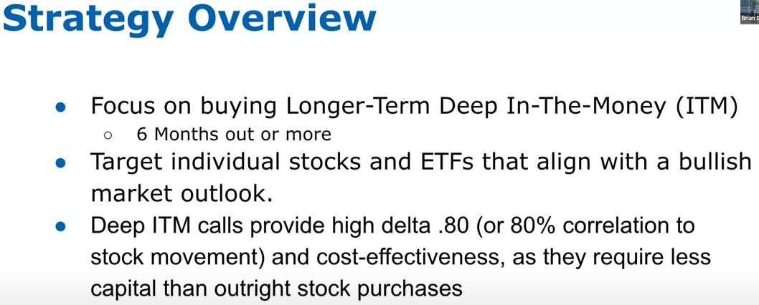

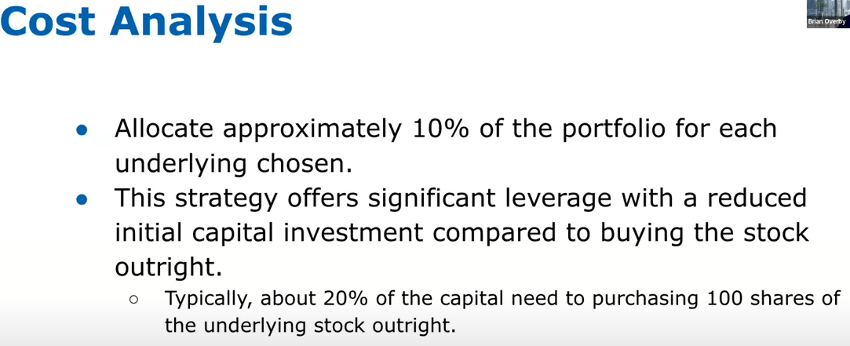

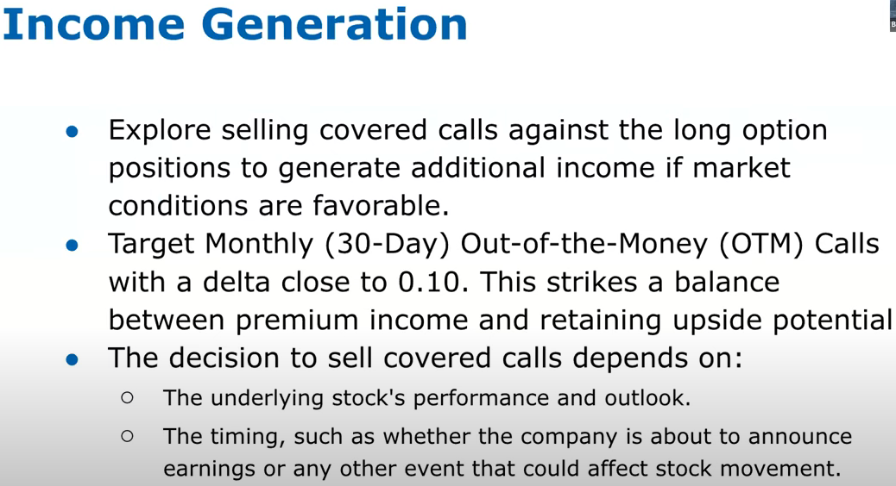

**Remember desire to impress others results in the acceptance of extra risk.**

* + All the below stocks are good for Covered Call as well;
    - **Growth Stock:** MSFT, AAPL, NVDA, AMZN, GOOGL, TSLA, WMT, PLTR, COIN, MSTR, LULU, TXN, PM, AMD, DELL, NKE, TGT, ADBE, IBM, TSM, SBUX, COP
    - **Day Trade:** KHC, AAL, CMG, DIS, INTC, WM, HPE, HPQ, WDC, MU, STX, HAL, XOM, OXY, MRO, PYPL, BAC, UBER, LUV, T, VZ
    - **Only for Experienced:** SOXL, TSLL, TNA, BITO, NVDL, MARA, RIOT, SOFI, TSLR
  + **Dividend Only Stock:** TSLY, NVDY, CONY, MSTY, ULTY

