**Trading Principles**

**If you are determined to learn, no one can stop you.**

**Don’t front run, don’t Guess, don’t Gamble, Be surgical and reactive.**

**Ten Commandments of Trading**

***1.*** Your motivation is well-executed trade, based on good setup (deep technical and fundamental research)

With the accomplished feeling that comes from a well-executed trade. Trade for success, not for money.

***2. Be disciplined.*** The one quality that traders must possess above all others is discipline. The ability to master your mind, your body, and your emotions is the key to trading. You can have the best technical analysis available, but without discipline, it will be difficult—if not impossible—to execute trades consistently and profitably.

Remember this: The disciplined trader—regardless of profit or loss—comes back to trade another day.

***3. Know yourself.*** Understand your tolerance for risk. If taking risks causes you anxiety, consider sticking with low-risk investments. If you can handle risk with discipline, trading might be a good fit. Remember, trading isn’t gambling—it's about making informed, well-executed decisions based on analysis.

**4.** **Lose your ego**. Let go of your ego to be a successful trader. Don’t let pride influence your decisions; focus on what the market tells you, not what you think it should do. Stay humble, especially during wins, and don’t let losses crush your confidence. Accept that losing is part of trading, and get out of bad trades quickly without letting it hurt your self-esteem.

**5**. **Don't rely on hope, wishes, or prayers in trading**. The market moves based on supply and demand, not on personal desire. If a trade goes against you, accept it and exit when it hits your stop-loss level. Having the discipline to follow your exit plan is more important than waiting for a reversal. Good money management means you can handle losses and keep trading responsibly.

**6.** **Let your profits run and cut your losses quickly**. Set a stop-loss level to protect yourself, and exit the trade if it reaches that point. When a trade is profitable, don’t hang on too long out of greed. Instead, follow your pre-set profit targets to lock in gains. This disciplined approach helps prevent small losses from turning big and ensures that you capture profits before market conditions change.

**7.** **Trade selectively and know when to step back**. You don’t need to trade all the time. Enter the market only when your analysis and strategy signal a clear buy or sell opportunity. If market direction is unclear, stay on the sidelines and wait for the right moment. Monitor the market, but keep your money out until conditions align with your strategy. Patience is key.

**8. Treat losing trades as valuable lessons,** maybe even more valuable than winning ones. Every loss can reveal a flaw in your analysis, timing, or judgment. Sometimes the market just doesn’t align with your expectations. Reflect on what went wrong—whether you misread a trend, jumped in too late, or tried to trade in unfavorable market conditions. Learn from it objectively, adjust your approach if needed, and prepare for the next opportunity. Losses help refine your strategy and improve your future trades.

***9.* If you experience three losses in a row, it's a signal to pause and regroup**. Avoid jumping back into the market with more trades, as frustration can cloud judgment. Instead, step back, watch the market from the sidelines, and take some time to clear your mind. Use this break to analyze your approach and reassess your strategy with a calm perspective. When you’re ready, ease back into trading with smaller positions to rebuild confidence gradually. This disciplined reset can prevent impulsive decisions and help maintain a focused, long-term approach to successful trading

***10.* Observe the unbreakable rule.** If you continually violate these Ten Commandments of Trading, you will eventually pay for it with your profits.

Follow YouTube channel

<https://www.youtube.com/@parkevtatevosiancfa9544> (Stock Selection)

<https://www.youtube.com/@FiredUpWealth> (Stock Selection)

<https://www.youtube.com/@tastyliveshow> (Deep advanced Analysis).

<https://www.youtube.com/@juniortrader> (Chart Analysis)

<https://www.youtube.com/@ChrisSain1> (Chart Analysis)

**Strategy**

**1. Selling Covered Call Weekly (with or without Wheel Strategy)**

**2. YieldMax**

**3. Daily 50Cents to 1$ or 1percent**

**4. Earning date play. (Buy 3 weeks before and sell 2 or 3 days before Earnings Date.**

**5. Bull Put Spread / Bear Call Spread.**

* **Risk-Reward Ratio**: Before entering any trade, always calculate the **risk-reward ratio**. A good rule of thumb is to ensure that your potential reward is at least 2–3 times greater than the risk. For example, if you're risking $100, you should aim to make at least $200 to $300 in return.
* **Position Sizing**: Focus on **position sizing** based on your overall capital and risk tolerance. Even if you have a high conviction on a trade, never risk more than 1–2% of your capital on any single trade. This protects you from catastrophic losses if the market goes against you.
* **Diversification**: While you've focused on high-moat stocks, consider **diversifying across sectors**. This can help mitigate risks from any specific industry downturns. For example, in addition to tech stocks like NVDA, diversify into healthcare, consumer goods, or financials to balance your portfolio.
* **Trade Small and Trade Often (TSTO)**: This method, popularized by experienced traders, advocates for making small trades more frequently instead of going all-in on a few trades. It helps you learn, manage risk, and stay nimble in the market. For example, trade 10 smaller positions instead of one large position to spread your risk and give you more flexibility.
* **The "90/90/90 Rule"**: This is a popular phrase in trading which states that **90% of traders lose 90% of their money in the first 90 days**. Keeping this in mind helps to focus on **longevity** and survival in the market. Avoid trying to "get rich quick," and focus on small, consistent profits.
* **Market Conditions Matter**: Different strategies work in different market conditions (bull, bear, or sideways). It’s essential to know whether the overall market is trending up, down, or moving sideways. Adjust your strategy accordingly:
* **In bull markets**: Momentum strategies work well. Ride the upward wave.
* **In bear markets**: Defensive strategies like hedging, buying protective puts, or even cashing out work better.
* **In sideways markets**: Neutral strategies like **iron condors** or **straddles/strangles** can help take advantage of low volatility.
* **Understand Liquidity**: Focus on stocks or options with good **liquidity** (high volume and open interest). Illiquid stocks or options have wider bid-ask spreads, which can increase costs when entering or exiting trades. You might lose money just from the spread if the asset is not liquid enough.
* **Volatility Indicators**: You mentioned keeping an eye on the VIX. To refine this further, learn how to **use volatility indicators like ATR (Average True Range)**. This can help you gauge expected price movement and determine optimal stop-loss levels.
* **Patience & Focus on the Big Picture**: While short-term trades are exciting, it’s critical to maintain a **long-term vision** as well. Sometimes, holding quality stocks for years will yield better results than chasing daily or weekly moves. Balance short-term trading with long-term investing.
* **Continuous Learning and Adaptation**: The markets are ever-evolving, and what worked a few months ago may not work today. Always stay adaptable, continue reading books, attend webinars, and network with other traders to sharpen your skills. Some additional trading resources include:
* **Books**: *“Reminiscences of a Stock Operator”* by Edwin Lefèvre, *“Market Wizards”* by Jack D. Schwager.
* **Webinars/Online Courses**: Follow top educators like Investopedia, TastyTrade, and other platforms that regularly update trading strategies.
* **Set Realistic Expectations**: It's easy to get caught up in big wins, but **focus on steady, realistic gains**. The compounding effect over time can create significant wealth even with a modest 1-2% gain per week.
* **Know When to Walk Away**: Sometimes, the best trade is no trade at all. If the markets are choppy or unpredictable, it's okay to sit out and wait for a better opportunity. Trading when you're emotional or frustrated often leads to poor decisions.
* **Understand Taxes**: Be aware of the tax implications of your trades. In some countries, short-term capital gains (investments held for less than a year) are taxed at a higher rate than long-term capital gains. Keep this in mind, especially if you're frequently trading in and out of positions.
* **Paper Trading**: If you're trying a new strategy or working with options, consider starting with **paper trading** (using simulated trades without real money) until you are confident. This can help you practice and develop a strategy without the risk of losing money upfront.
* **Mentorship**: Trading can sometimes feel isolating, but learning from a **mentor or community** can accelerate your learning curve. Joining a trading group or finding a seasoned investor to guide you can help you avoid common pitfalls.
* **Mindfulness**: Trading can be stressful, and maintaining your mental health is crucial. Incorporate practices like meditation, exercise, or other activities to keep yourself focused and balanced.
* Backtesting**: Always backtest your strategies on historical data to understand their effectiveness in different market conditions before risking real money.**
* Avoid Overleveraging**: Leverage can amplify both gains and losses. Use it cautiously to avoid large drawdowns.**
* Embrace Losses**: Accept that losses are part of trading. Learn from each one, but don’t let them dictate your emotional state or subsequent trades.**
* Stay Informed**: Beyond financial news, stay updated on technological advancements, geopolitical events, and macroeconomic trends that can impact markets.**
* Environmental, Social, Governance (ESG) Investing**: Consider the impact of ESG factors on your investment decisions. Companies with strong ESG practices may have long-term growth potential.**
* Sector Rotation**: Keep an eye on which sectors are performing well and consider rotating your investments into sectors that are trending upwards.**
* Risk Management Tools**: Use advanced tools like options for risk management (e.g., buying puts as insurance).**
* Market Sentiment Analysis**: Pay attention to market sentiment and investor behavior. Use tools and indicators like the Fear & Greed Index.**
* Algorithmic Trading**: If you're tech-savvy, explore algorithmic trading to automate your strategies and remove emotion from the equation.**
* Financial Health Check**: Regularly review your financial situation, goals, and risk tolerance to ensure your trading strategy aligns with your overall financial health.**
* **Risk Management**
* **Position Sizing**: Never risk more than 1-2% of your total trading capital on a single trade. This protects you from significant losses if a trade goes against you.
* **Risk-Reward Ratio**: Before entering any trade, ensure that your potential reward is at least 2-3 times greater than the risk. For example, if you're risking $100, aim to make at least $200-$300 in return.
* **Market Analysis**
* **Multiple Time Frame Analysis**: When analyzing a stock, look at multiple time frames to get a complete picture. Start with a longer time frame to identify the overall trend, then move to shorter time frames for entry and exit points.
* **Correlation Awareness**: Be aware of correlations between different assets. Diversification doesn't work if all your assets move in the same direction.
* **Trading Psychology**
* **Emotional Discipline**: Develop a system to manage your emotions. Consider keeping a trading journal to track not just your trades, but also your emotional state during trading.
* **Advanced Techniques**
* **Options Strategies**: Learn advanced options strategies like iron condors, butterfly spreads, or calendar spreads to take advantage of different market conditions.
* **Algorithmic Trading**: If you're tech-savvy, consider learning about algorithmic trading to remove emotion from your trading decisions and to backtest your strategies.
* **Continuous Improvement**
* **Post-Trade Analysis**: After each trading session, review your trades. What worked? What didn't? How can you improve?
* **Stay Informed**: Beyond financial news, stay updated on technological advancements, geopolitical events, and macroeconomic trends that can impact markets.

Remember, the key to successful trading is continuous learning, disciplined risk management, and consistent application of your trading strategy.

----------------------------------------------------------------------------------------------------------------------------------------------------------------

**Wheel Strategy**

* You sell put options to collect premium
* You might get assigned on expiration date.
* If you assigned. You sell call options and collect premium

Exercise Cut-off time for expiring options – Finra says 4.30pm cst on the day of expiration.

Market closes at at 3pm est and you have 90 minutes to decide on assignment.

Tastyworks until 3.30pm cst

Robinhood until 4pm cst

Own the Shares before selling covered call. So wait till Monday to sell covered call instead of selling it on Friday.

**Tickers to watch**

<https://www.yieldmaxetfs.com/our-etfs/> .Tier1: CONY | MSTY | NVDY

Tier2: ULTY | TSLY | CRSH | AMZY | NFLY | YMAG | YMAX

<https://www.roundhillinvestments.com/etf/> XDTE, QDTE, YBTC, RDTE

<https://www.proshares.com/our-etfs/find-strategic-etfs?strategy=all-etf> BITO

<https://graniteshares.com/institutional/us/en-us/fund-map/> NVDL, CONL

**Best High Volatile stocks for selling options:** NVDA, TSLA, LULU, SOXL, MARA, TSLL, NVDX, XOM, BITO, OXY, DELL

**Venkat Recommended Courses – on Options. (Paid Training, buy these courses on thanks giving/ new year etc.)**

[**https://www.udemy.com/course/learn-stock-trading-from-scratch**](https://www.udemy.com/course/learn-stock-trading-from-scratch)

[**https://www.udemy.com/course/the-ultimate-stock-options-training-cours**](https://www.udemy.com/course/the-ultimate-stock-options-training-cours)

[**https://www.udemy.com/course/how-to-trade-options-on-earnings-for-quick-profit**](https://www.udemy.com/course/how-to-trade-options-on-earnings-for-quick-profit)

[**https://www.udemy.com/course/the-complete-technical-analysis-candlestick-secret-trading**](https://www.udemy.com/course/the-complete-technical-analysis-candlestick-secret-trading)

[**https://www.udemy.com/course/10-powerful-tradingview-indicators**](https://www.udemy.com/course/10-powerful-tradingview-indicators)

**Venkat Recommended Courses – on Day Trading.**

[**https://www.udemy.com/course/daytrading/learn/lecture**](https://www.udemy.com/course/daytrading/learn/lecture)

[**https://www.udemy.com/course/the-complete-day-trading-course/learn**](https://www.udemy.com/course/the-complete-day-trading-course/learn)

**Trade double tops, cup and handle, flags and pennants, head and shoulder.**

**Other Courses**

[**https://www.udemy.com/course/day-trading-how-to-profit-in-bear-markets**](https://www.udemy.com/course/day-trading-how-to-profit-in-bear-markets)

[**https://www.udemy.com/course/stock-trading-masterclass**](https://www.udemy.com/course/stock-trading-masterclass)

[**https://www.udemy.com/course/candlestick/learn**](https://www.udemy.com/course/candlestick/learn)

<https://www.youtube.com/watch?v=EMgNk50a-to>

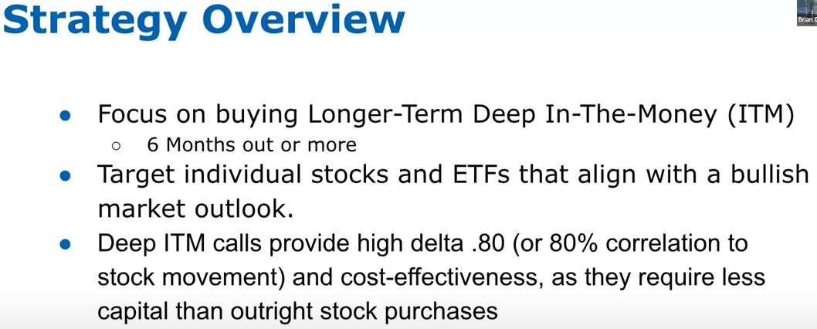

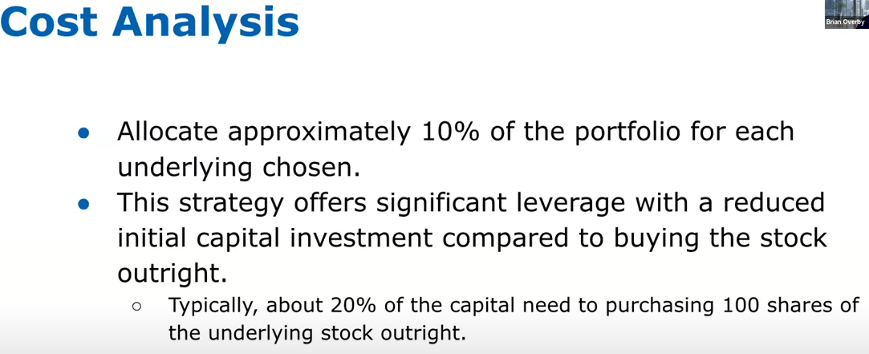

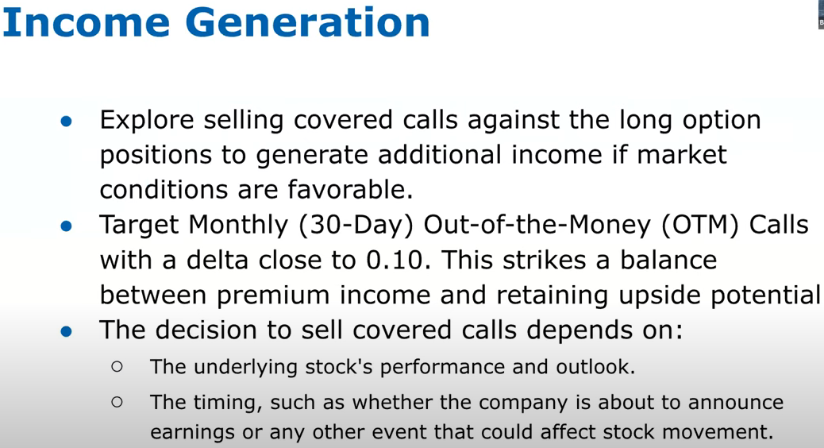

**Remember desire to impress others results in the acceptance of extra risk.**

* + All the below stocks are good for Covered Call as well;
    - **Growth Stock:** MSFT, AAPL, NVDA, AMZN, GOOGL, TSLA, WMT, PLTR, COIN, MSTR, LULU, TXN, PM, AMD, DELL, NKE, TGT, ADBE, IBM, TSM, SBUX, COP
    - **Day Trade:** KHC, AAL, CMG, DIS, INTC, WM, HPE, HPQ, WDC, MU, STX, HAL, XOM, OXY, MRO, PYPL, BAC, UBER, LUV, T, VZ
    - **Only for Experienced:** SOXL, TSLL, TNA, BITO, NVDL, MARA, RIOT, SOFI, TSLR
  + **Dividend Only Stock:** TSLY, NVDY, CONY, MSTY, ULTY