**Day Trade: 10 Mins Trade** (Beginners Paper Trade)

**Learn and do. Don’t just watch videos, you want to Do after you learn. Do this for 2 weeks in paper trade.**

Use 8,23 EMA

There is lot of price gap between 8 and 23 EMA. If there is less gap then don’t trade and wait for opportunity to get in.

Call Option:

When and 8 and 23 are both going up.

When 8 EMA is having higher price than the price of 23 EMA

Exit when there are 2 consecutive candles crossing below 8 EMA (on the down side.)

Put Option:

When and 8 and 23 are both going down.

When 8 EMA is having lower price than the price of 23 EMA

Exit when there are 2 consecutive candles crossing above 8 EMA (on the upside side)

Placing the Trade

• Look to see which direction the 8 and 23day moving average is trending.

• If they are trending up you are going to buy Call options; if they are trending down you are going to buy Put options.

If you like what you see go to the option chain and see if you can find a few options to suit your needs. Be sure to pick an option that has an open interest of at least 100, expires in 45 or more days, and then invest roughly $500 into the trade.

To keep things simple, we are trading the at-the-money or slightly out-of-the-money option.

**Exit Criteria** Exit on 2 consecutive price closes above or below the 8-day moving average.

Red Blue both going opposite direction (No Trade).

Red going down, Blue Going Up.

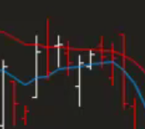

Red Blue both going same direction (Trade).

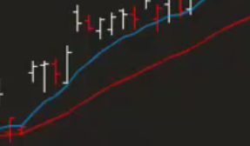

The 7 Steps.

**What to Trade**

* 1. Fundamental Analysis
  2. Creating a Watch List

**When to Trade**

* 1. Technical Analysis
  2. Potential Trades
  3. Follow through

**How to Manage risks and Profits**

* 1. Exit Strategy

Money Management