Click on positions in Fidelity.

Click on Positions

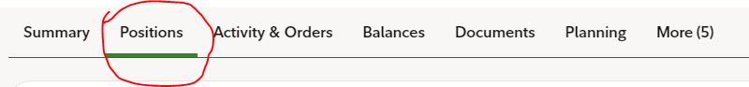

Select the stock you want run covered call. By expanding the stock

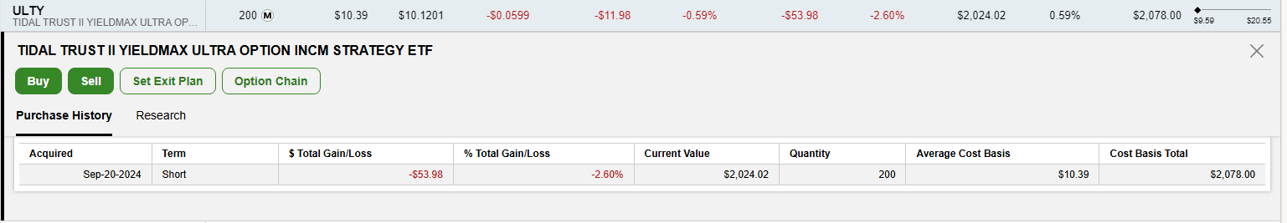

Click on Option Chain in the above document.

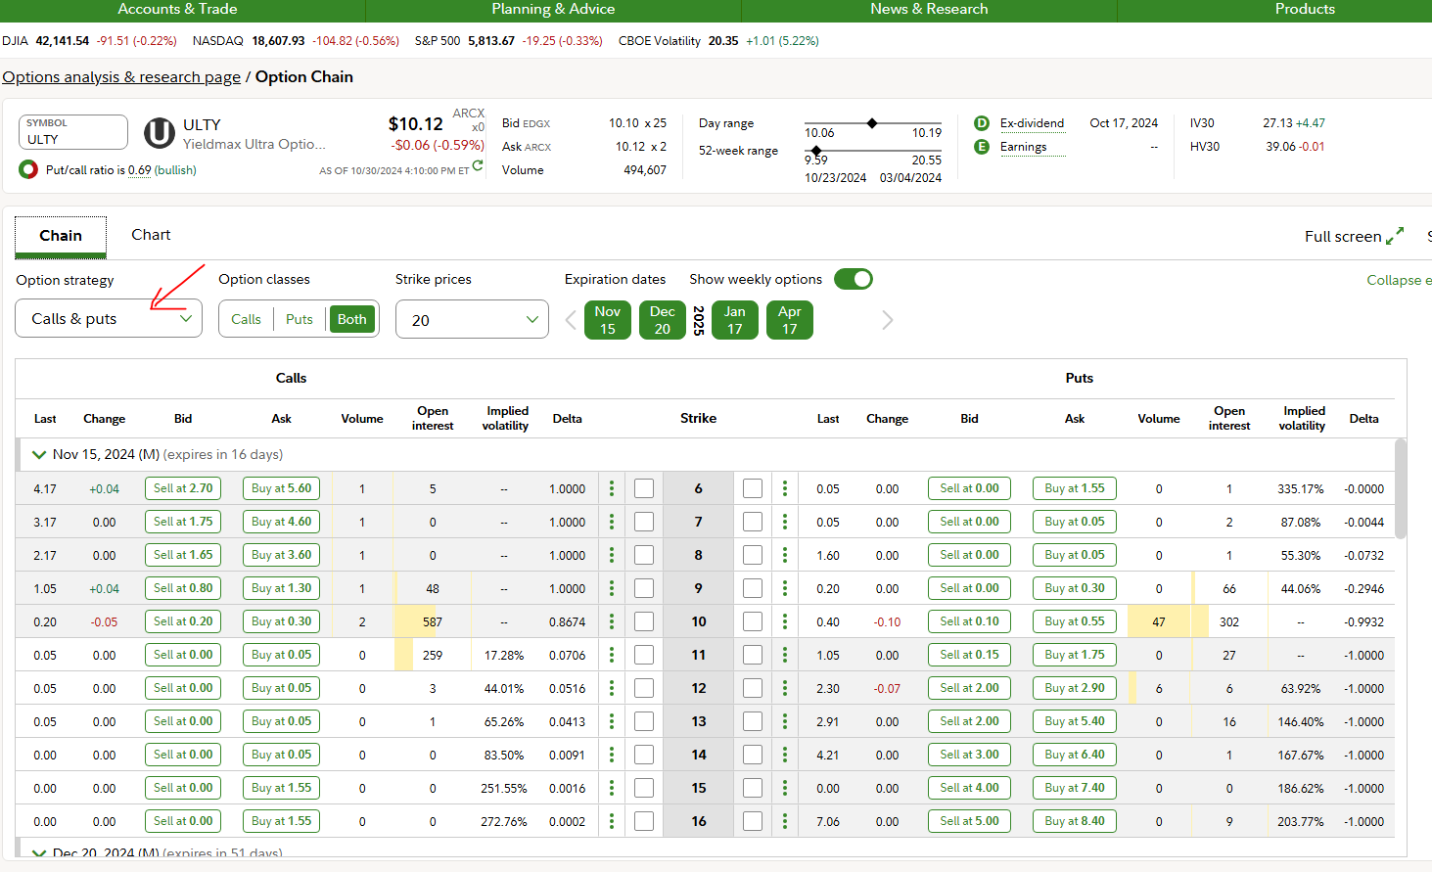

Select calls in dropdown.

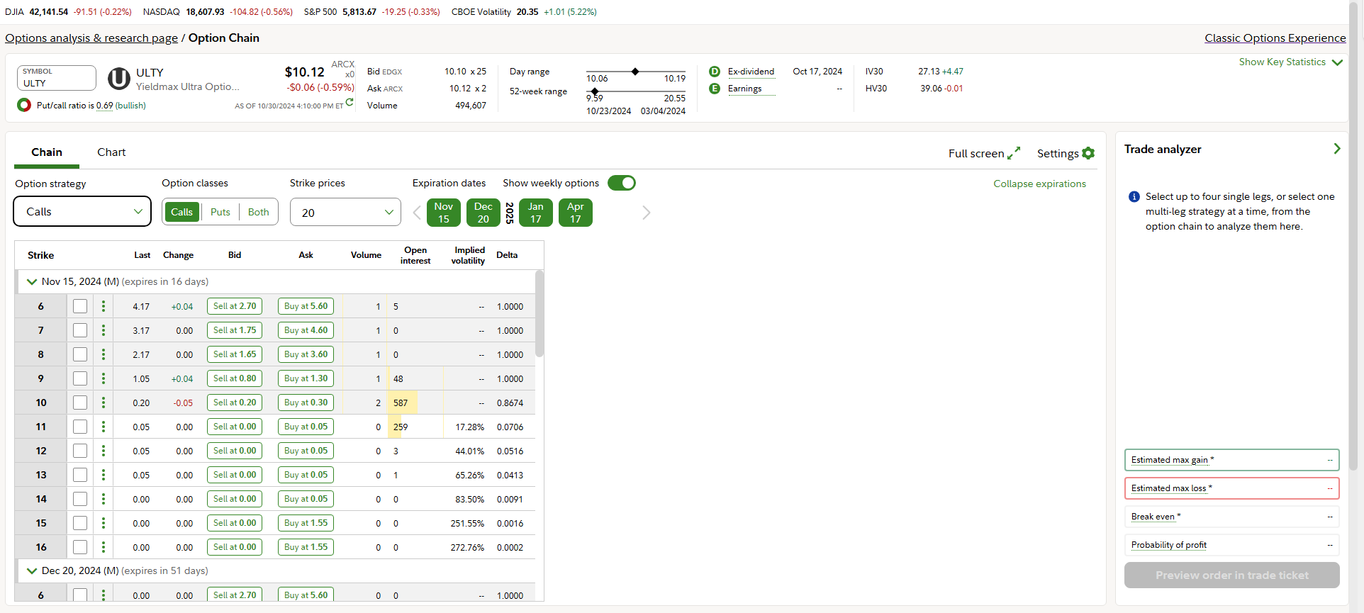

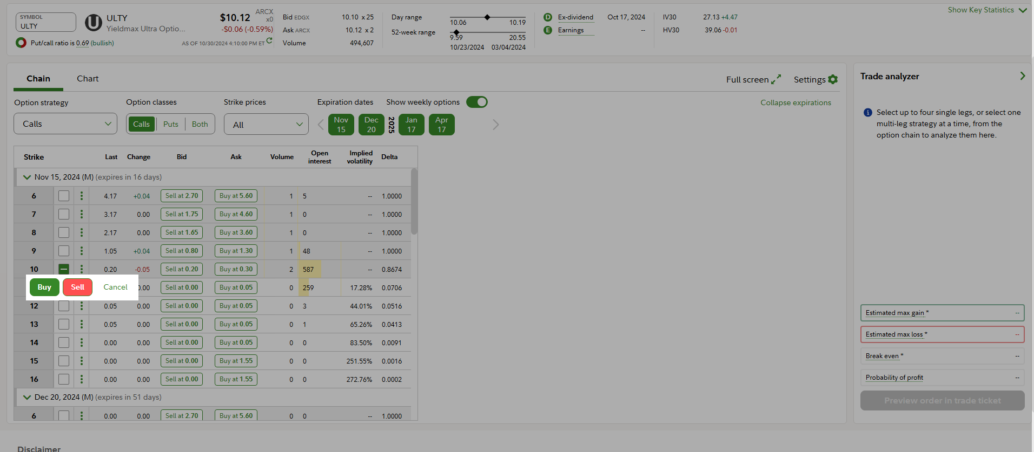

Select the price, here I have selected 10$ as strike price and click on SELL ( the red button )

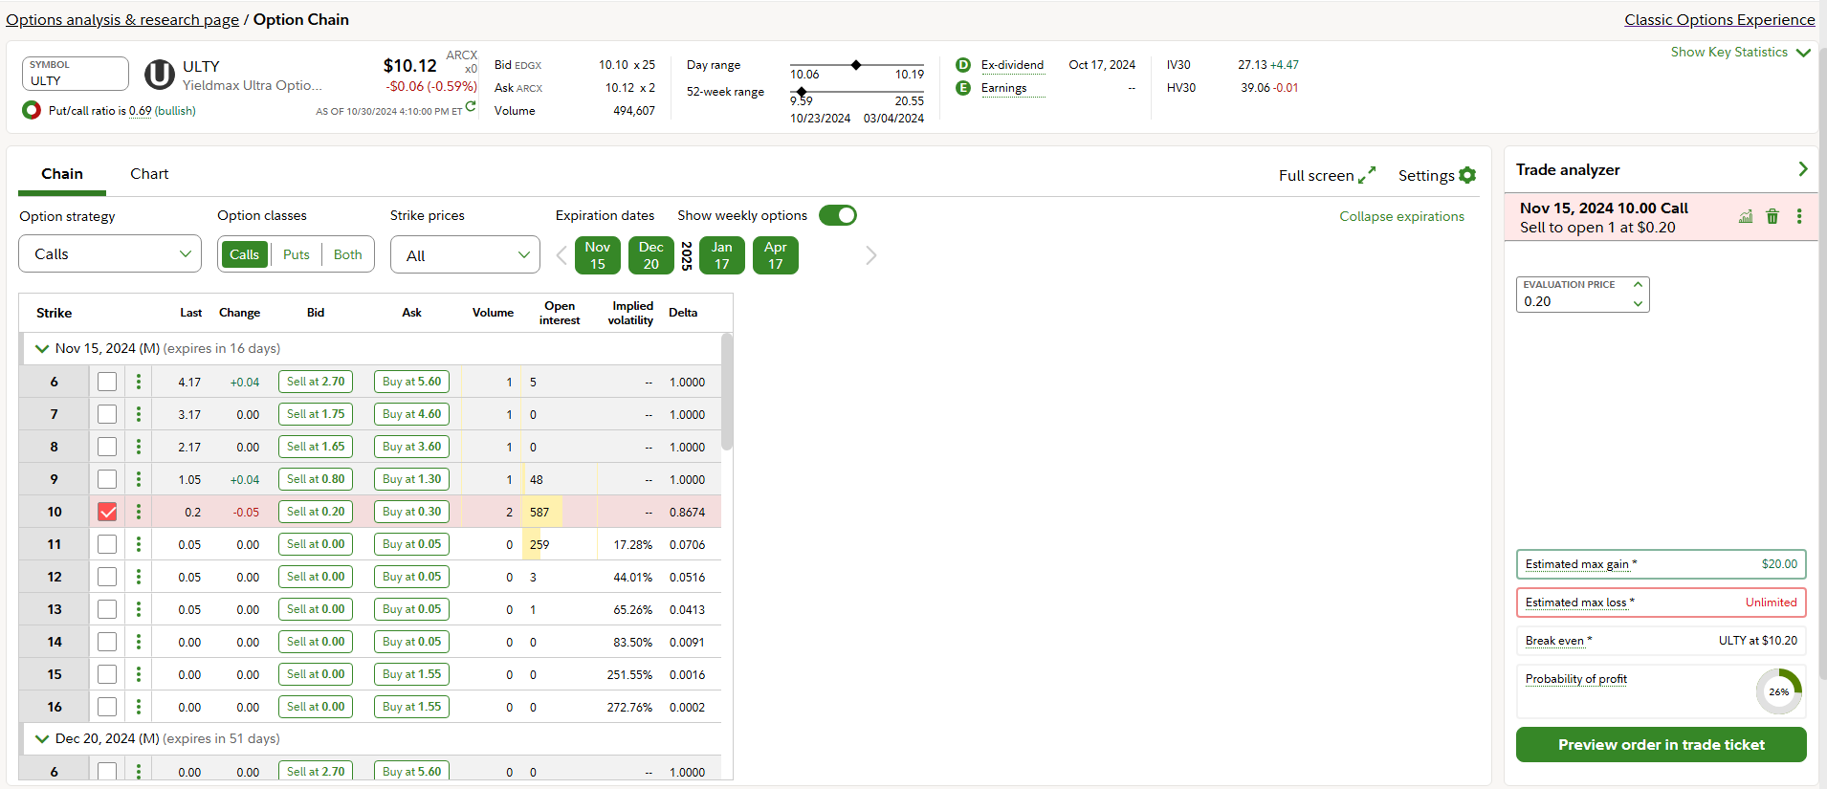

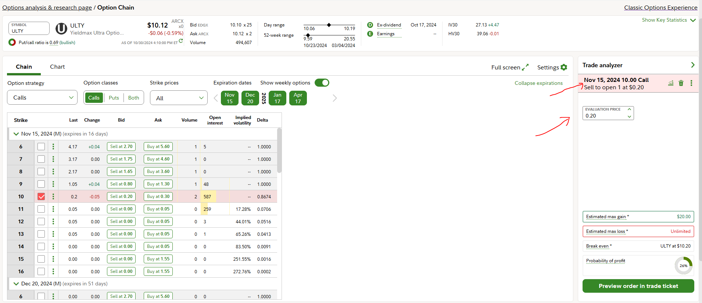

Click on that first arrow (it should be 1 if you have 100 stocks, and 2 if you have 200,. So on and so forth).

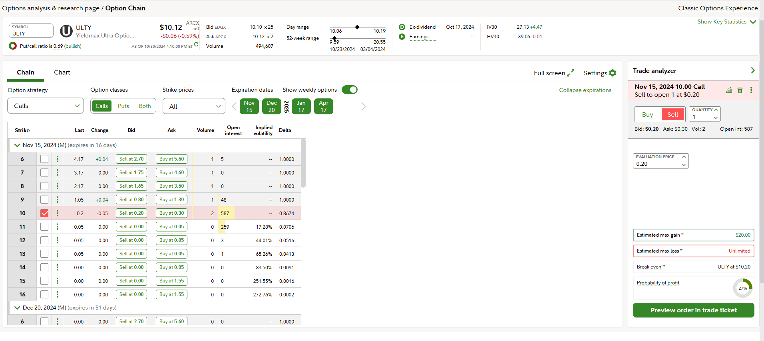

Update the quantity.   
  
And finally click on “preview order trade ticket” Green Button.

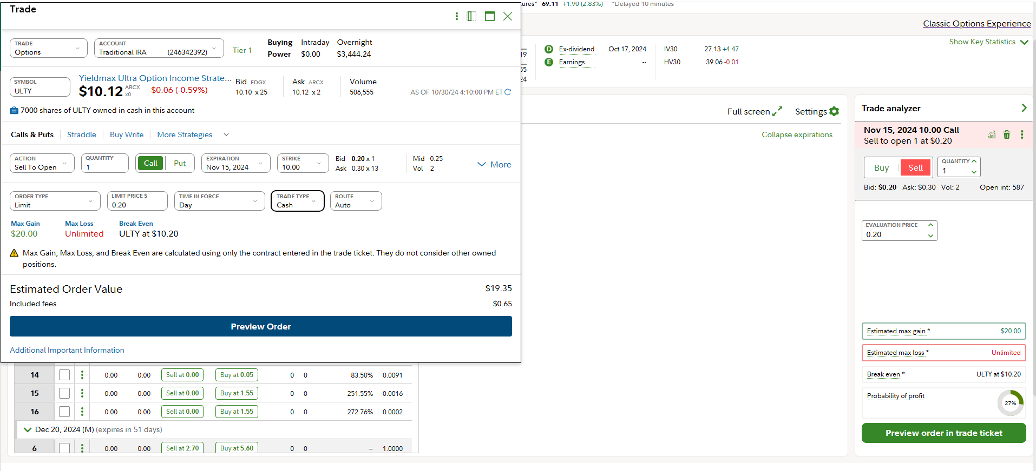

This popup comes check everything check everything is correct and click preview order (Blue Button).

And finally there will be a submit button I think.