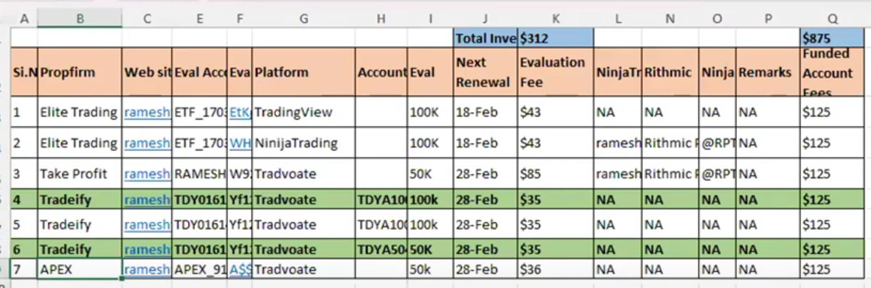

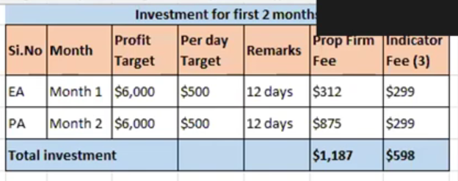

<https://www.youtube.com/watch?v=50eU3t3hUbI>

T5

Price Pulse