**Buy to Open**: Buying a CALL / PUT option

**Sell to Open**: selling a CALL / PUT option (Covered Calls / Cash Secured Puts).

**Buy to Close**: Closing out the CALL / PUT option you sold.

**Sell to Close**: Closing out the CALL / PUT option you bought.

**Entering Credit Spreads on Robinhood:** [**https://youtu.be/XdCa0nl9Ed8**](https://youtu.be/XdCa0nl9Ed8)

**PUT CREDIT SPREADS ON ROBINHOOD** [**https://youtu.be/wcJnHyijMus**](https://youtu.be/wcJnHyijMus)

**PUT CREDIT SPREADS** [**Put Credit Spread Explained (Setup, Trade Examples, & More)**](https://www.youtube.com/watch?v=nVN7lpKMNnM)

**Credit Spread Options Strategies Explained (Top 3 Benefits)** [**https://www.youtube.com/watch?v=6VPPI-MNUDM**](https://www.youtube.com/watch?v=6VPPI-MNUDM)

**Lower-Risk Strategies:**

<https://www.tastylive.com/concepts-strategies/bull-put-spread>

**Bull Put Spread (Price at Support, best for moderate price increases, Low-Risk Bullish Trade)**

**Other Names: Put Credit Spread, Short Put Spread, Bull Put Spread,**

This is a **credit spread**, used when you expect the stock price to rise or remain above a certain level.

**You sell a put option and buy another put option with lower-strike price** (with the same expiration date)

**Stock**: XYZ is trading at $50.

**Strategy**: Sell a $48 strike put for $2.50 and buy a $45 strike put for $1.00.

* **Net Credit**: $2.50 - $1.00 = $1.50 ($150 per contract).
* **Maximum loss**: Difference in strike prices ($48 - $45 = $3) - Net Credit ($1.50) = $1.50 ($150 per contract).
* **Maximum Profit**: The net credit received ($1.50 or $150 per contract).

**Scenarios**:

* **If stock stays above $48**: Both puts expire worthless. You keep the net credit = $150 profit.
* **If stock falls below $45**: Both puts are exercised. Loss = $150 (maximum risk).

**Important Considerations**

1. **Time Decay**: This strategy benefits from time decay because you receive a premium upfront. The options lose value over time, especially the short call, which helps increase profit as expiration approaches.
2. **Implied Volatility**: High implied volatility can increase premiums, which may result in a higher net credit at the start. However, if volatility drops, it can make it easier for the options to expire worthless, benefitting the trade.

<https://www.tastylive.com/concepts-strategies/bear-call-spread>

**Bear Call Spread (Price at Resistance, best for moderate price decreases, Low-Risk Bearish Trade) (a) Call Credit Spread.**

This is a **credit spread**, used when you expect the stock price to fall or remain below a certain level.

You sell a call option and **buy another call option with a higher strike price** (with the same expiration date)

**Stock**: XYZ is trading at $50.

**Strategy**: Sell a $52 strike call for $2.00 and buy a $55 strike call for $1.00.

* **Net Credit**: $2.00 - $1.00 = $1.00 ($100 per contract).
* **Maximum Risk**: Difference in strike prices ($55 - $52 = $3) - Net Credit ($1.00) = $2.00 ($200 per contract).
* **Maximum Profit**: The net credit received ($1.00 or $100 per contract).

**Scenarios**:

* **If stock stays below $52**: Both calls expire worthless. You keep the net credit = $100 profit.
* **If stock rises above $55**: Both calls are exercised. Loss = $200 (maximum risk).

**Important Considerations**

1. **Time Decay**: This strategy benefits from time decay because you receive a premium upfront. The options lose value over time, especially the short call, which helps increase profit as expiration approaches.
2. **Implied Volatility**: High implied volatility can increase premiums, which may result in a higher net credit at the start. However, if volatility drops, it can make it easier for the options to expire worthless, benefitting the trade.

**Summary of Risks and Rewards**

|  |  |  |  |  |  |
| --- | --- | --- | --- | --- | --- |
| Trade Type | Risk | Reward | Best Market Condition | Price At | Other Names |
| Naked Calls | Unlimited loss | Unlimited profit | Strongly bullish | Support |  |
| Naked Puts | High (to $0 stock price) | Substantial profit | Strongly bearish | Resistance |  |
| Bull Put Spread  **Put Credit Spread** | Limited (strike difference - credit) | Limited (net credit) | Moderately bullish | Support |  |
| Bear Call Spread  **Call Credit Spread** | Limited (strike difference - credit) | Limited (net credit) | Moderately bearish | Resistance |  |

**To Easily Remember:**

Bull Put Spread: The stock is Slightly bullish, so we play the opposite side ie down side to collect premium.

Bear Call Spread: The stock looks slightly Bearish, so we play to the opposite side ie call side to collect premium

Bull Put Spread and Bear Call Spread **(limited profit potential, careful strike selection, time decay works against)**

These strategies offer limited risk and limited reward, making them suitable for more conservative traders.

**Lost $30,000 on a $1-Wide Credit Spread (Options Traders MUST Watch This)**

[**https://www.youtube.com/watch?v=rtVFj9nRRDo**](https://www.youtube.com/watch?v=rtVFj9nRRDo)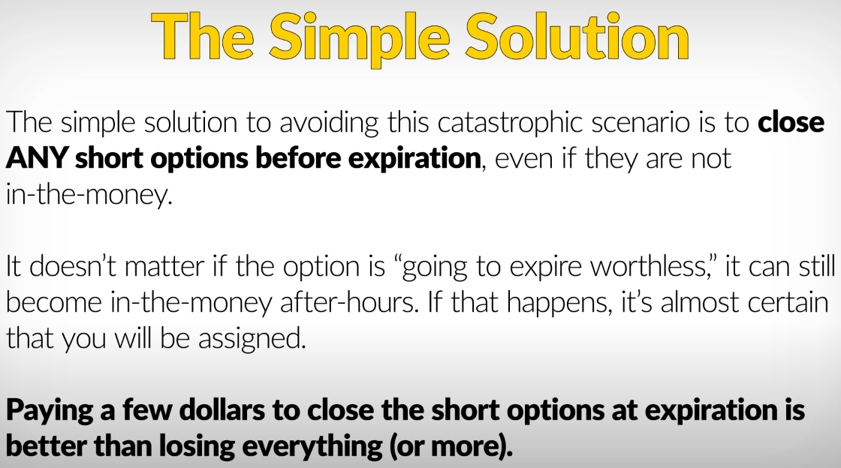

[**Beware Of Credit Spreads On Robinhood - Very Dangerous**](https://www.tenpercentcreditspreads.com/beware-of-credit-spreads-on-robinhood/)

**Sample**

SPX 5980/5970 BULL PUT for today and collect 50$ premium.

**Sell SPX 5980 Put Option**

**Buy SPX 5970 Put Option:**

**Sellers of credit spreads hope to sell high and buy low.**

**Potential advantages of credit spreads: Time is on your side when you’re a premium seller. Every day that goes by, options will lose some of their value (all other things remaining equal), which is what we call time decay. Sellers of credit spreads look to profit from this, referring to it as “collecting theta,” which is the fancy term for time decay.**

**Credit spreads are also directional; meaning, if you are bullish you can sell a put credit spread, and**

**if you’re bearish you can sell a call credit spread.**

**Credit spread allows you to have a directional opinion on the stock while having time decay working for you.**

**Another reason traders sell credit spreads is to possibly take advantage of stocks exhibiting high implied volatility. Remember, when implied volatility is high, option prices are high, relatively speaking. As we mentioned in**[**Volatility Explained**](https://learn.robinhood.com/articles/volatility-explained/)**, volatility is like a rubber band, and tends to revert back to its historical average. Selling credit spreads attempts to take advantage of this by selling options with relatively high prices, hoping implied volatility recedes back to normal levels.**

**One very important note: credits spreads are almost always done using out of the money options.**

**If you sell a credit spread with deep in the money options, you are immediately putting yourself at risk for early-assignment on the short leg of your credit spread.**

**As you can see, for certain investors, selling credit spreads can pack a powerful 1-2-3 punch—they are directional, while taking advantage of time decay and high implied volatility. This is a big reason why this strategy is commonly used by professional and experienced traders alike.**

**Lower-Risk Strategies: Bull Put Spread**

<https://www.tastylive.com/concepts-strategies/bull-put-spread>

[**https://www.youtube.com/watch?v=j4VddcIlDkQ**](https://www.youtube.com/watch?v=j4VddcIlDkQ)

**Bull Put Spread (Slightly Bullish, Price at Support | Low-Risk |**

**Names: Bull Put Spread, Put Credit Spread, Short Put Spread, Short Put Vertical |**

**1. Bull Put Spread**

A Bull Put Spread is a bullish options strategy that involves selling a higher-strike put and buying a lower-strike put, both with the same expiration date. It is designed to profit from a stock staying above a certain level (the higher strike price).

**How It Works:**

* **Slightly Bullish Outlook:**If you expect the stock price to stay above a certain level but don’t anticipate a big move upward, this strategy works well.  
  Example: If a stock is trading at $100, you might sell a $95 put and buy a $90 put.

**Why "Play the Opposite Side"?**

* **Selling puts** means **you're betting the stock won’t fall significantly.**
* You sell the higher-strike put (closer to the current price) because it has a higher premium, and buy the lower-strike put for protection, limiting potential losses.

**Profit and Loss:**

* Maximum Profit: Premium collected when the stock stays above the higher strike price (all options expire worthless).
* Maximum Loss: The difference between the strike prices minus the premium collected, if the stock price falls below the lower strike.

**Ideal Scenarios for Bull Put Spreads:**

* You expect the stock to stay flat or rise slightly.
* Example: A stock trading at $100; you sell a $95 put, buy a $90 put, and collect premium if the stock remains above $95.

**Lower-Risk Strategies: Bear Call Spread ** Bear Call => Elevator down, so better of the 2 credit Spreads \*\***

<https://www.tastylive.com/concepts-strategies/bear-call-spread>

<https://www.youtube.com/watch?v=iATEuiE42uY>

**Bear Call Spread (Slightly Bearish, Price at Resistance | Low-Risk |**

**Names: Call Credit Spread, Bear Call Spread, Short call spread, short call vertical**

This is a **credit spread**, used when you expect the stock price to fall or remain below a certain level.

**Bear Call Spread**

A Bear Call Spread is a bearish options strategy that involves selling a lower-strike call and buying a higher-strike call, both with the same expiration date. It is designed to profit from a stock staying below a certain level (the lower strike price).

**Bull Put Spread (Sell Puts): Slightly bullish outlook → expect the stock to stay above a certain level (sell puts).**

**Bear Call Spread (Sell Calls): Slightly bearish outlook → expect the stock to stay below a certain level (sell calls).**

**Key Differences Between Bull Put Spread and Bear Call Spread:**

| **Feature** | **Bull Put Spread** | **Bear Call Spread** |
| --- | --- | --- |
| Market Outlook | Slightly **Bull**ish | Slightly **Bear**ish |
| Risk Side | Downside (price falling below short put) | Upside (price rising above short call) |
| Premium Collected | From selling a higher-strike put | From selling a lower-strike call |
| Maximum Profit | Stock stays above the higher put strike | Stock stays below the lower call strike |
| Maximum Loss | Stock falls below the lower put strike | Stock rises above the higher call strike |

Why Use These Strategies?

* Defined Risk: Your potential loss is capped by the long option.
* Income Generation: You collect premium upfront and profit if your outlook holds.
* High Probability: These strategies often involve selling options with a lower probability of being in the money.

Both strategies are excellent tools when you expect the stock to remain stable or move slightly in a particular direction. Let me know if you'd like examples with real numbers!

**Short means Selling.**

**Long means Buying.**

Question

**To close one leg of a bull put spread, you would buy to close (BTC) the short put option which is the sold put option in the spread; while leaving the long put option (the bought put) open if you only want to close one side of the position; essentially, you are buying back the short put to exit that part of the trade while maintaining the long put position**

**what does this mean**

Answer

**This means that you are partially closing your bull put spread position. You are buying back the put option that you initially sold (the short put) to close that part of the trade. However, you are keeping the put option that you initially bought (the long put) open. This means that you are no longer obligated to sell the underlying stock at the strike price of the short put, but you still have the right to sell the stock at the strike price of the long put.**

**Here is a breakdown of the steps involved in closing one leg of a bull put spread:**

**Identify the short put: This is the put option that you sold when you initiated the bull put spread.**

**Buy to close (BTC) the short put: This means that you are buying back the short put option to close out that position.**

**Leave the long put open: This means that you are keeping the put option that you bought when you initiated the bull put spread.**

**There are a few reasons why you might want to close one leg of a bull put spread:**

**You no longer believe that the stock price will increase: If you think that the stock price is likely to decrease, you may want to close the short put position to avoid a potential loss.**

**You want to take profits on the short put: If the short put option has increased in value, you may want to sell it to lock in a profit.**

**You want to adjust your position: You may want to close the short put position and open a new position with a different strike price or expiration date.**

**It is important to note that closing one leg of a bull put spread can change the risk and reward profile of the position. It is important to carefully consider the implications of closing one leg of the position before taking any action.**

**In General, the less you trade, the more profitable would be. One to 3 trades for day and one to 3 trades week for position trading.**

**1 percent growth on your portfolio with 10,000$ account, you can make 1.4 million in 2 years.**

**The goal should be to make one good trade and another, another etc.**

**Control your emotions**

Fear

Greed

Anxiety

Boredom

Depression

Desperation

**Bear Call is one better.**

**Elevator down and Stairs back up.**

**Credit spreads (aka short vertical spreads) Bear Call Spread**

**Credit spreads are usually an eye-opener for options traders, and they do take some getting used to since most new options traders are familiar with buying options or spreads. For most, selling options doesn’t enter the equation other than with covered calls or cash secured puts. So what actually is a credit spread?**

**Credit spreads enable traders to become “premium sellers,” which is a fancy way of saying, they collect a credit to open a position. Unlike “premium buyers” where they hope to buy low and sell high, sellers of credit spreads hope to sell high and buy low. This has a number of potential advantages, but the main one is that time is on your side when you’re a premium seller. Every day that goes by, options will lose some of their value (all other things remaining equal), which is what we call time decay. Sellers of credit spreads look to profit from this, referring to it as “collecting theta,” which is the fancy term for time decay.**

**Credit spreads are also directional; meaning, if you are bullish you can sell a put credit spread, and if you’re bearish you can sell a call credit spread. Why might you do this instead of buying a debit spread? Once again, this allows you to have a directional opinion on the stock while having time decay working for you.**

**Another reason traders sell credit spreads is to possibly take advantage of stocks exhibiting high implied volatility. Remember, when implied volatility is high, option prices are high, relatively speaking. As we mentioned in**[**Volatility Explained**](https://learn.robinhood.com/articles/volatility-explained/)**, volatility is like a rubber band, and tends to revert back to its historical average. Selling credit spreads attempts to take advantage of this by selling options with relatively high prices, hoping implied volatility recedes back to normal levels.**

**One very important note: credits spreads are almost always done using out of the money options. If you sell a credit spread with deep in the money options, you are immediately putting yourself at risk for early-assignment on the short leg of your credit spread.**

**As you can see, for certain investors, selling credit spreads can pack a powerful 1-2-3 punch—they are directional, while taking advantage of time decay and high implied volatility. This is a big reason why this strategy is commonly used by professional and experienced traders alike.**

**Here are the details on both a call credit spread and a put credit spread.**

**CALL CREDIT SPREAD (other names: short call spread or short call vertical)**

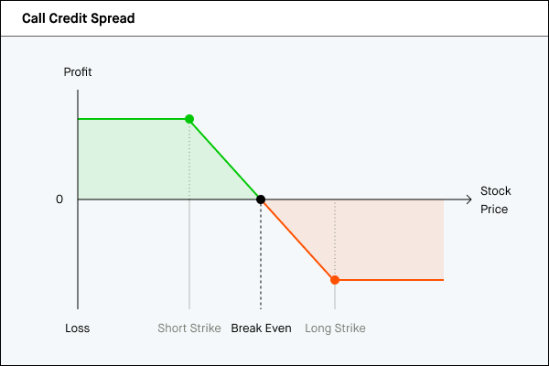

**WHY TRADE IT? You think a stock is going down within a certain time frame**

**OPTIMAL CONDITIONS: Medium to high volatility, bearish stock, sector, and market**

**SETUP: Short call + long higher strike call in the same expiration**

**EXAMPLE: Sell August 50 Call for $5 + buy August 55 Call for $2. Net credit = $3 (x100 = $300 per spread)**

**TOTAL CREDIT: Credit of short call, less premium paid for long call (In this example, $3)**

**THEORETICAL MAX PROFIT: Limited to the total credit received (In this example $3 x 100; $300)**

**THEORETICAL MAX LOSS: Difference between the strikes minus the credit (55 - 50 = $5 -$3 credit = $2 max loss)**

**BREAKEVEN AT EXPIRATION: There’s one breakeven point (at expiration) at the short strike plus the credit (50 + $3 = $53 breakeven)**

**BEST CASE TO NAIL IT: The stock moves lower. A range-bound stock can help the trade profit, but this takes time. The stock can even go up as long as it stays below the short strike. A drop in volatility can also help.**

**WHAT CAN GO WRONG? A quick, and/or big move to the upside. Worst case is the stock breaks through the strike prices of both options.**

**A rise in implied volatility could inflate the option premiums while the trade is on. The short option can suffer from the rising price. However, since there is a long option (benefitting somewhat from inflating value), the impact overall is less than if it were just a short call position.**

**CLOSING THE TRADE: Ideally, the stock stays below your short call strike and both options lose their value and expire worthless. In this case, you keep the entire credit that you collected when you sold the spread, and the options are removed from your account.**

**If you have a profit on the trade before expiration and are worried that the stock may rebound and start moving higher, you can buy the spread back by effecting an opposite transaction–buy the lower strike call and sell the higher strike call, for a debit, as a package.**

**If the stock rallies and your credit spread gains in value (resulting in a loss on the trade), you can also attempt to cut your losses by buying the spread back for more than you paid. If the spread is trading at max value (the width of the strikes), you may have to place a bid slightly higher than max value to get out of the position, or allow both legs of the spread to be exercised and assigned.**

**KEEP AN EYE OUT FOR… Never “set and forget” a position with a short call option. You could be assigned and receive a short stock position. If you do get assigned, DON’T PANIC. Simply exercise your long call immediately to buy back and close the short stock position.**

**Also keep an eye out for underlying’s that are due to pay a dividend. One of the biggest risks of short calls is dividend risk. Dividend risk is the risk that you’ll get assigned on your short call option before the dividend’s ex-date. This includes short calls that are a part of a spread. When this happens, you’ll open the ex-date with a short position and actually be responsible for paying that dividend yourself. You can avoid this by closing your spread before the end of the regular-hours trading session the night before the ex-date.**

**Note: The day before the ex-dividend your broker may take action in your account to close any positions that have dividend risk. It’s important to read and understand your specific broker’s options agreement to know if that is the case.**

**PUT CREDIT SPREAD (other names: short put spread or short put vertical) Bull Put Spread**

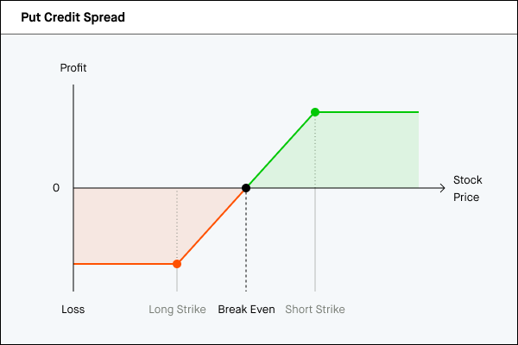

**WHY TRADE IT? You think a stock is either staying in a range or going higher within a certain time frame**

**OPTIMAL CONDITIONS: Medium to high volatility, bullish stock, sector, and market**

**SETUP: Short put + long lower strike Put in the same expiration**

**EXAMPLE: Sell August 50 Put for $5 + buy Aug 45 put for $2. Net credit = $3 (x100 = $300 per spread)**

**TOTAL CREDIT: Credit of short put, less premium paid for long put (In this example, $3)**

**THEORETICAL MAX PROFIT: Limited to the total credit received (In this example $3)**

**THEORETICAL MAX LOSS: Difference between the strikes minus the credit received (50 - 45 = $5 - $3 credit received = $2 max loss)**

**BREAKEVEN AT EXPIRATION: There’s one breakeven point (at expiration) at the short strike less the credit ($50 - $3 = $47 breakeven)**

**BEST CASE TO NAIL IT: The stock moves higher. A range bound stock can help the trade profit, but this takes time. Stock can even go down as long as it stays above the short strike. A drop in volatility can also help.**

**WHAT CAN GO WRONG? A quick, and/or big move to the downside. Worst case is the stock drops below the strike prices of both options.**

**A rise in implied volatility could inflate the option premiums while the trade is on. The short option can suffer from the rising price. However, since there is a long option (benefitting somewhat from inflating value), the impact overall is less than if it were just a short put position.**

**CLOSING THE TRADE: Ideally the stock stays above your short put strike and both options lose their value and expire worthless. In this case, you keep the entire credit that you collected when you sold the spread, and the options are removed from your account.**

**If you have a profit on the trade before expiration and are worried that the stock may begin to drop, you can buy the spread back by effecting an opposite transaction–buy the higher strike put and sell the lower strike put, for a debit, as a package.**

**If the stock falls and your credit spread gains in value (resulting in a loss on the trade), you can also attempt to cut your losses by buying the spread back for more than you paid. If the spread is trading at max value (the width of the strikes), you may have to place a bid slightly higher than max value to get out of the position, or allow both legs of the spread to be exercised and assigned.**

**KEEP AN EYE OUT FOR… Never “set and forget” a position with a short option. You could be assigned and receive a long stock position. If you do get assigned, DON’T PANIC. Simply exercise your long put immediately to sell and close the long stock position.**