**Overview of Data Preprocessing in Orange**

The data set that I used is brown selected.

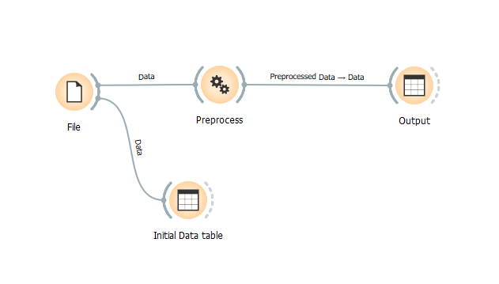

It has got 186 instances and 1.5% data missing.

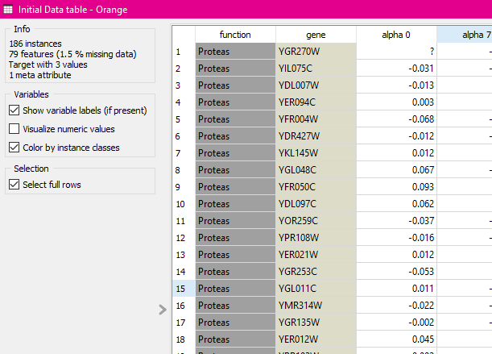

For data cleaning I used impute missing value with the average/most frequent option.

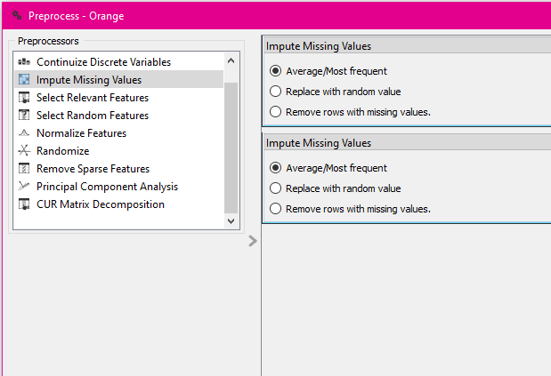

After the preprocess, I had another data table to show the output. As shown below, the data table have no missing value as I have used imputation.

