Overview of data preprocess using orange:

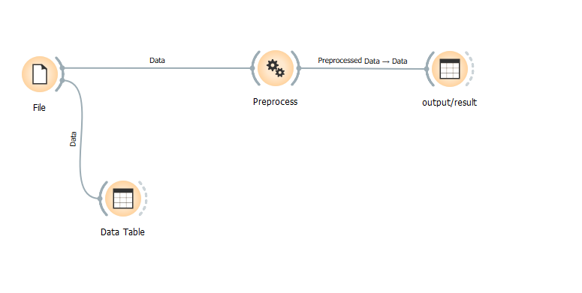

Dataset used: heart_disease.tab which has got the missing value of 0.2 %.

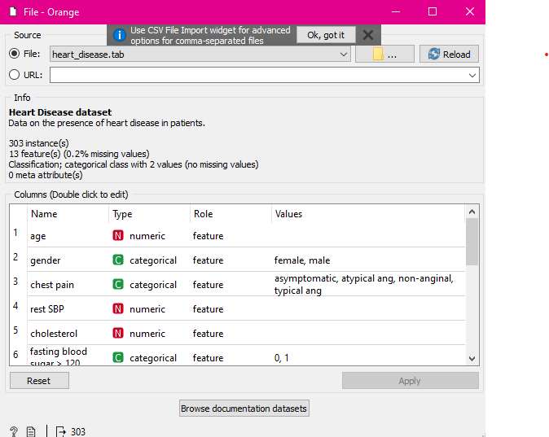

I have taken an example of a missing value which is present at serial number 167 as shown below.

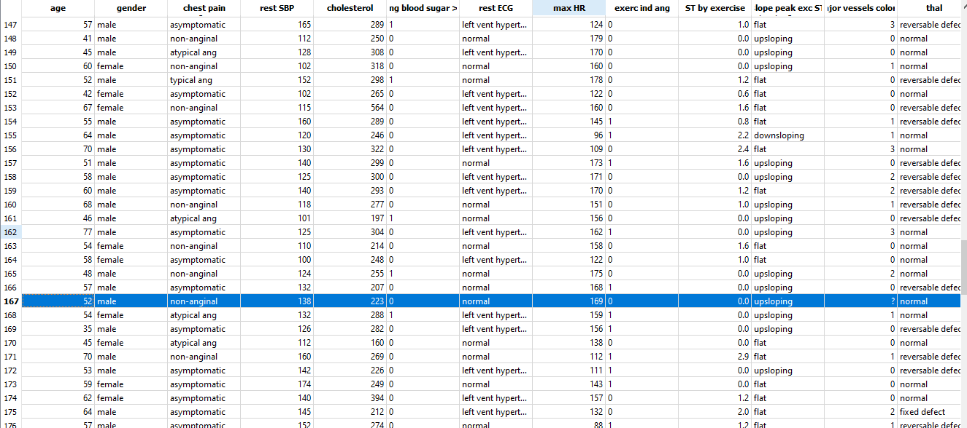

Now in order to clean this data I used data preprocess method where this value is imputed with Average/Most frequent

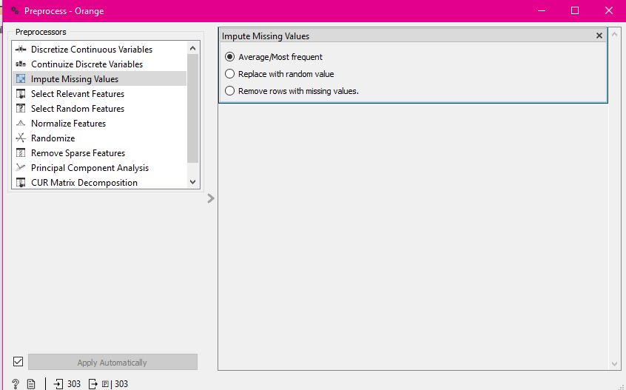

After data preprocessing, I have used another table which is the result/output with no missing values.

