Problem 1

a)

The feasible solution is our starting dictionary in b.

b)

Starting dictionary:

Pivots and x1,x2,x3,x4 after each pivot:

x1,x2,x3,x4 = 1/10, 1/100, 1/1000, 1/10000

w2 leaves, w1 enters

x1,x2,x3,x4 = 9/10, 9/100, 9/1000, 9/10000

w4 leaves, w3 enters

x1,x2,x3,x4 = 9/10, 91/100, 91/1000, 91/10000

w1 leaves, w2 enters

x1,x2,x3,x4 = 1/10, 99/100, 99/1000, 99/10000

w6 leaves, w5 enters

x1,x2,x3,x4 = 1/10, 99/100, 901/1000, 820/9101

w2 leaves, w1 enters

x1,x2,x3,x4 = 9/10, 91/100, 909/1000, 908/9989

w3 leaves, w4 enters

x1,x2,x3,x4 = 9/10, 9/100, 991/1000, 11/111

w1 leaves, w2 enters

x1,x2,x3,x4 = 1/10, 1/100, 999/1000, 899/8999

w7 enters, w8 leaves

x1,x2,x3,x4 = 1/10, 1/100, 999/1000, 901/1001

w2 leaves, w1 enters

x1,x2,x3,x4 = 9/10, 9/100, 991/1000, 100/111

w4 leaves, w3 enters

x1,x2,x3,x4 = 9/10, 91/100, 909/1000, 4091/500

w1 leaves, w2 enters

x1,x2,x3,x4 = 1/10, 99/100, 901/1000, 818/899

w5 leaves, w6 enters

x1,x2,x3,x4 = 1/10, 99/100, 99/1000, 100/101

w2 leaves, w1 enters

x1,x2,x3,x4 = 9/10, 91/100, 91/1000, 980/989

w3 leaves, w4 enters

x1, x2,x3,x4 = 9/10, 9/100, 9/1000, 1

w1 leaves, w2 enters

x1, x2,x3,x4 = 1/10, 1/100, 1/1000, 4999/500

Final dictionary and optimal solution

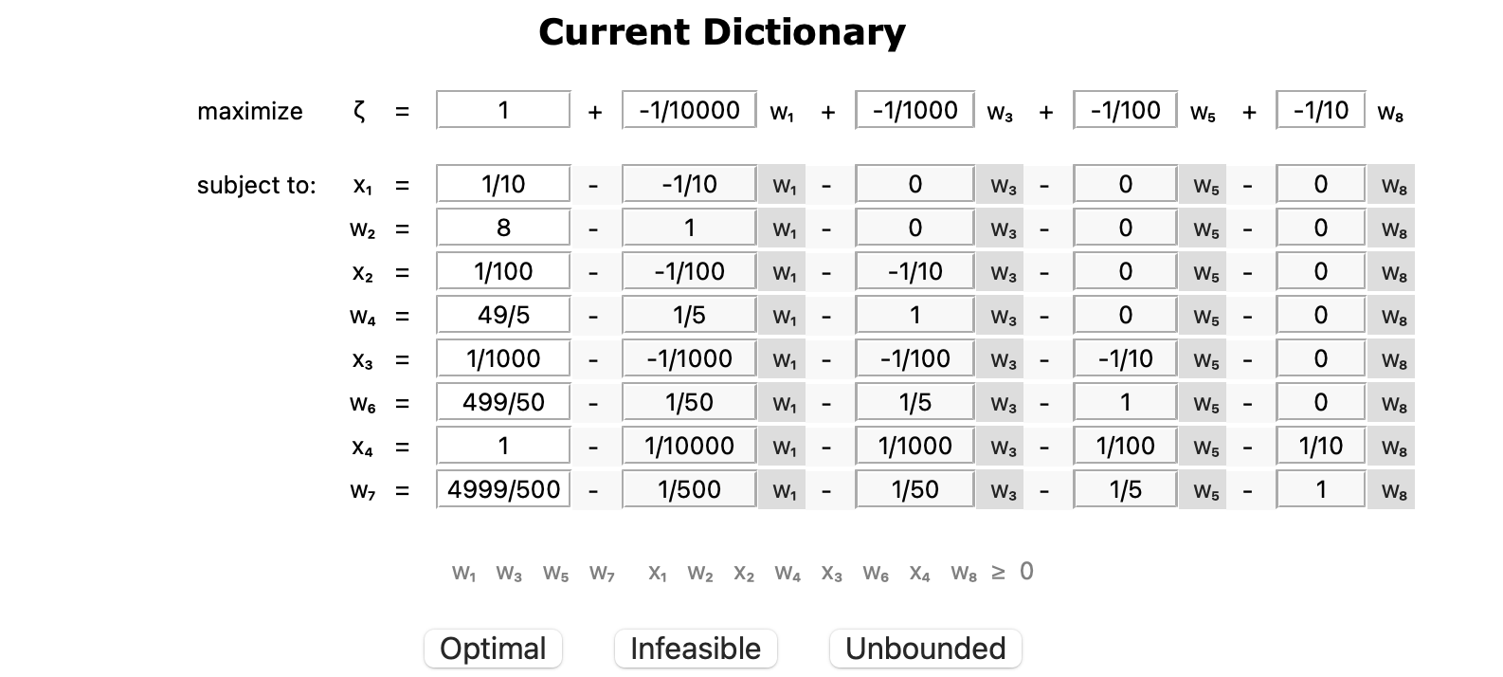

c) Assuming that our optimal solution and the origin lays in a vertex in our solution space. The number of vertices grows with $2^{n}$ as n grows. If our solution is in a neighboring vertex to the origin, but that pivot requires us to do a swap with the highest numbered and qualified column in the objective function. By Bland’s rule we will choose the lowest numbered and qualified column in the objective function to enter the basis. Then the next variable to enter the basis is what was the second lowest numbered and qualified column, that is now the lowest numbered and qualified column. Then the first variable that entered the basis will now leave and we get a pattern where we alternate between these variables $2^{n-1}$ times. A similar pattern appears for the following variables that enters and leaves the basis, where we will alternate between this respectively $2^{n-2}$, $2^{n-3}$ and $2^{n-4}$ times. In this case we get $2^{n-4}+2^{n-3}+2^{n-2}+2^{n-1}=2^{n}-1$ iterations. This makes intuitive sense when we know we start at the origin and our solution space has $2^{n}$ vertices. The maximum number of vertices we will need to visit then is $2^{n}-1$ vertices in order to find our optimal solution.

d) When applied to ${CUBE}_{4}$ x1 will either leave or enter the dictionary every second pivot. It alternates between the values 9/10 and 1/10. When w1 enters the basis x1 takes the value 9/10 and when w2 enters the basis x1 takes the value 1/10. It will alternate between this value 8 times as w2 and w1 alternates between each other 8 times when applied to ${CUBE}_{4}.$

|  |  |
| --- | --- |
| Pivot number | X1 value |
| 0 | 1/10 |
| 1 | 9/10 |
| 2 | 9/10 |
| 3 | 1/10 |
| 4 | 1/10 |
| 5 | 9/10 |
| 6 | 9/10 |
| 7 | 1/10 |
| 8 | 1/10 |
| 9 | 9/10 |
| 10 | 9/10 |
| 11 | 1/10 |
| 12 | 1/10 |
| 13 | 9/10 |
| 14 | 9/10 |
| 15 | 1/10 |

Problem 2

a)

Done in assignment1_script.py

b)

Done in assignment1_script.py

c)

Highest bid on input capacity: 0.0

Highest bid on output capacity: 1.5555555555555556

Done in assignment1_script.py