**COMPSCI – 1 – PROJECT – 4**

**Movie Ticket System**

**May 21, 2019**

**Team Members**

Kyle Petty, Ashley Calderon, Wilson Garcia

This program was developed to incorporate everything we have learned in Computer Science Course 1 into a program. Within a theater setting, the objective of this program is to allow a user to input and reserve seating from a list of movies. Requirements for this project included classes within object-orientated programming, functions, 2-dimensional arrays and the use of various libraries like *fstream,* to input and output files. Our team also implemented the use of repositories like **github.com**, and interactive programming environments like **repl.it**, to work collaboratively in an effort to remain on task despite differing schedules. By designing a friendly user interface, the user is able to quickly check if a seat is reserved or open for purchase. The feedback provided by the program’s output is visually pleasing and provides the user with tabular formats that are easy-to-read. Lastly, a seating chart and receipt are provided at the end, while a separate text file records the occupied/open seats for the next person to use the terminal[1]. We integrated this method of data collection because we felt it would increase program modularity and appeal.

**Pseudocode**

1. Begin the program by greeting the customer and display the current listings and showtimes
   1. Before the greeting, open the seating chart from a text file and create a temporary array
   2. Display an error message if no seating chart is found
2. Run a function to display the current seating chart
   1. Display the seating arrangement in a tab format so that it is easy to read
3. Prompt the user to enter the movie they would like to watch
   1. Synchronize the movie request and showtime in order to confirm the request in the final program output (receipt)
   2. After the user selects a movie, display the latest seating arrangement for that specific movie
4. Run a function that prompts the user to enter the amount of tickets to be purchased
   1. If a user requests an X number of tickets then the user will be able to input an X number of requests to reserve seats
   2. If a user inputs the location of a seat deemed occupied then the program will prompt to reenter a new location until one has been chosen that is not occupied
   3. Continue to run the program as needed until all of the requested tickets are assigned
5. Display an array of the updated seating chart with the final output with requested seats
6. Print a receipt in a table format
   1. Receipt confirms the title of the movie chosen with showtime
   2. The number of seats requested and a grand total for the ticket cost
7. Print a final greeting to enjoy the show
   1. save the latest seating array to a text file

**Screenshots**

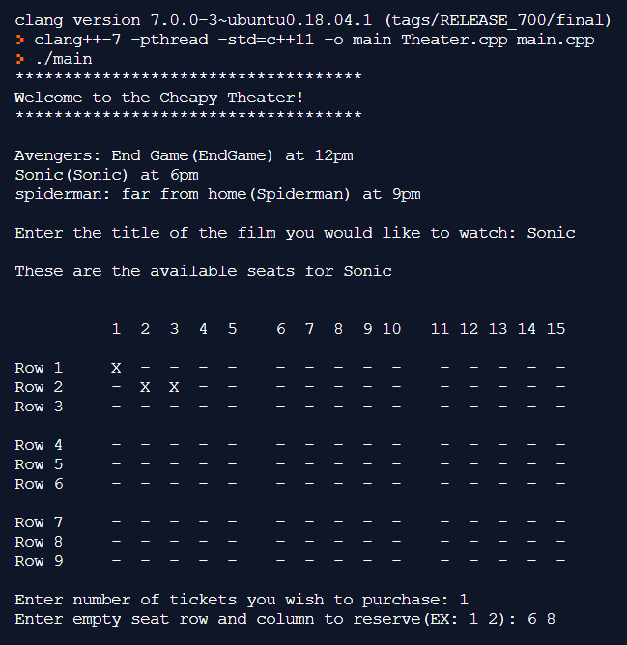

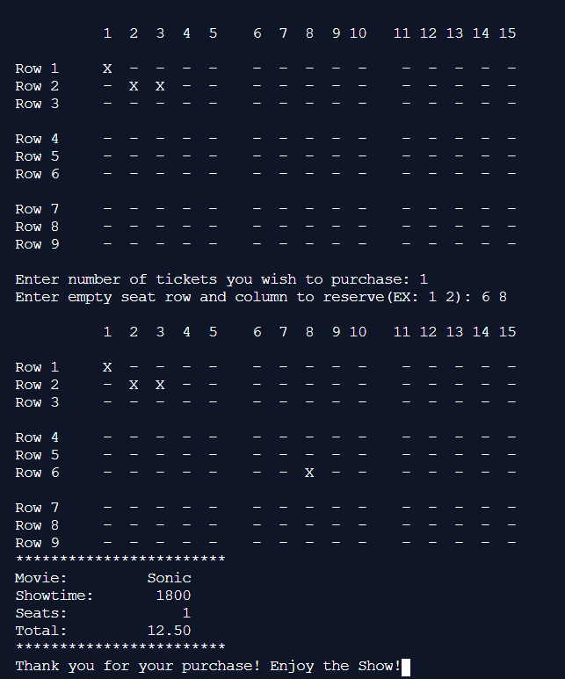

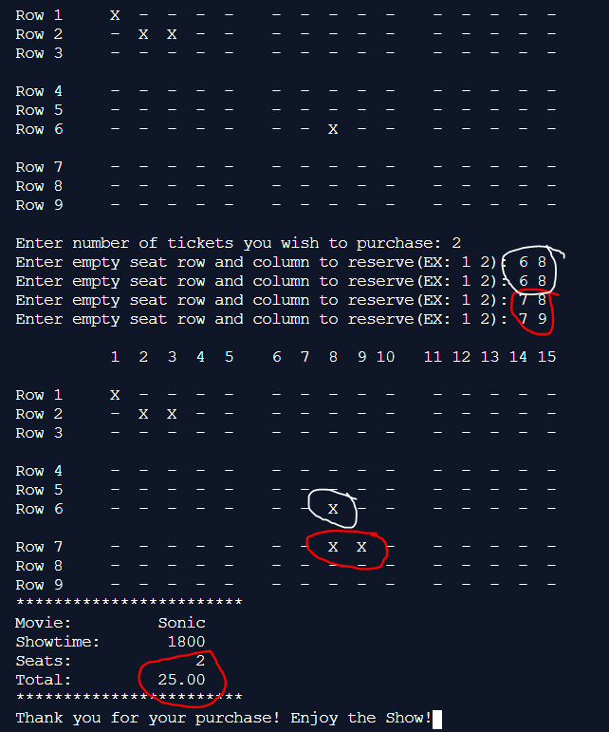

**Use of Repository**

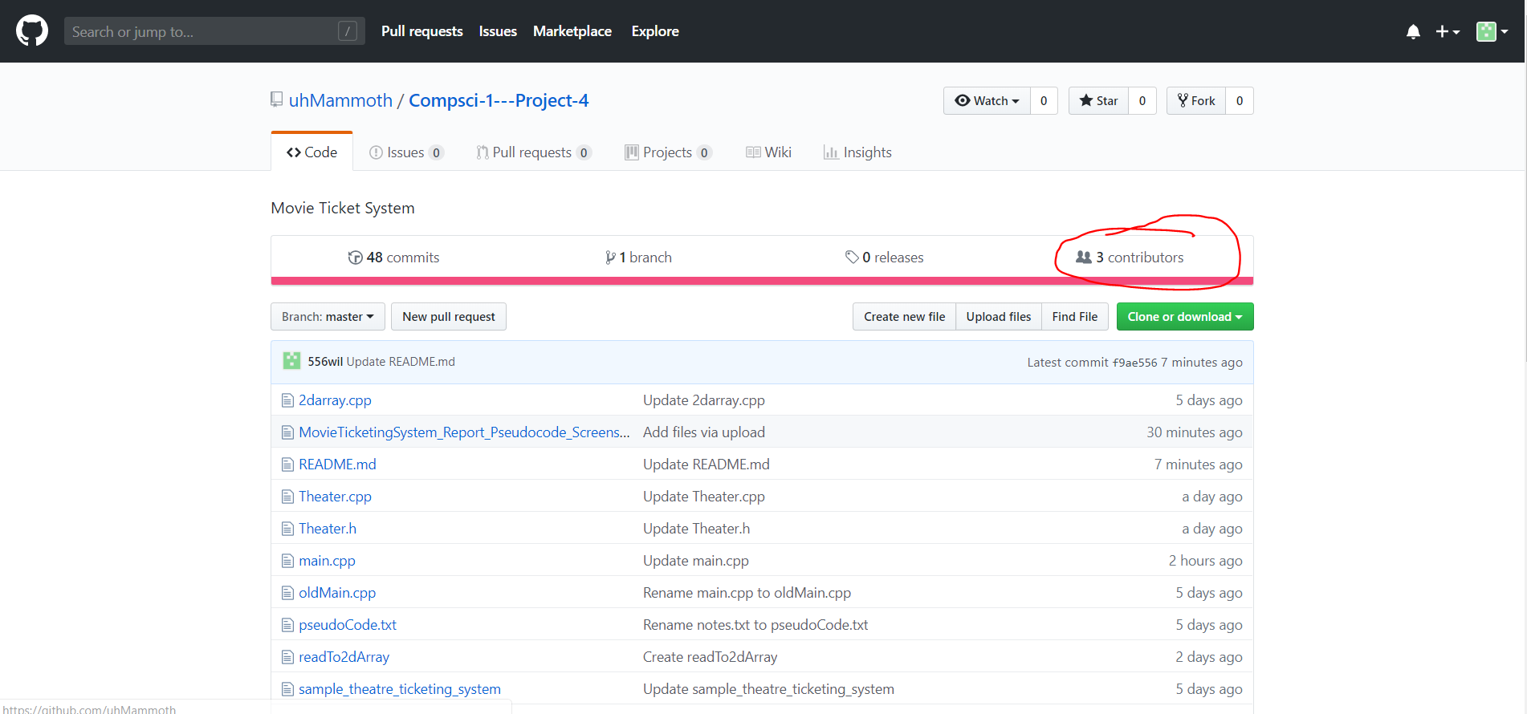

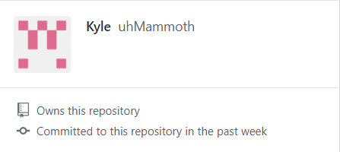

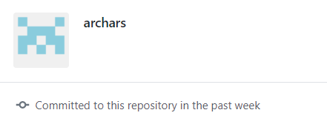

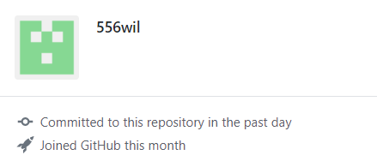

1. The active files for this program include: main.cpp, Theater.h, Theater.cpp, seating.txt