Document title
  - Subtitle of document
Author name(s)
2026-03-14

1. Introduction

1.1 YAML header
Configure the YAML header including the following elements:
- title: Title
- subtitle: Subtitle; remove option completely if you don’t need a subtitle.
- author: Character of single or multiple author(s)
- date: A date
- abstract: The abstract will be shown right after the title in smaller font size.
- lang: The language of the document. Default is English (‘en’). For German use ‘de’.
- bibliography: A path to the bibliography file to use for references (BibTeX .bib file). The current file includes 3 dummy references; either insert your references into this file or replace the file with your own.
- csl: The style is provided in the ‘sage-harvard.csl’ file, which adopts the SAGE Harvard reference style. Just leave the file as it is.
- format - docx: In this template many of the Quarto options for Word output are listed in the YAML header. If you want to know more about these settings I recommend the MS Word format reference for a complete list of available options. For instance, you can adjust the figure and table references with fig-title, tbl-title, fig-prefix, and tbl-prefix.
- execute: Global options for customizing output from executed code are specified within this execute key.
This Quarto template uses a ‘uhh-template.docx’ Word file, which is based on the standard template file of the University of Hamburg (UHH) except for the font type, which is by default ‘Helvetica’. If you are associated with the UHH you are allowed to use the University’s own font style ‘TheSansUHH’. You can choose between both fonts when running the function, e.g., UHHformats::create_quarto_doc(dirname = "your_word_doc", template = "word_doc", font = "TheSansUHH").
If you feel like using your own template or the standard Word template (i.e. the Normal.dot file), simply provide the path to your file or comment/delete this line, respectively.

1.2 Code blocks
Code blocks in Quarto documents are treated in similar way as in Markdown documents. One important difference is that code chunk options (in Quarto also called ‘cell level options’) are typically included in special comments using #| at the top of code chunks rather than within the line that begins the chunk:
Please note that individual words are separated with a hyphen, not a dot, followed by a colon, not an equal sign as in R Markdown documents. Quarto uses this approach to both better accommodate longer options like fig-cap, fig-subcap, and fig-alt as well as to make it straightforward to edit chunk options within more structured editors that don’t have an easy way to edit chunk metadata (e.g. most traditional notebook UIs).
However, if you prefer it is still possible to include chunk options on the first line (e.g. ```{r, echo = FALSE}) as in R Markdown documents.

1.3 Callout blocks
Quarto provides five different types of callouts that are an excellent way to draw extra attention to certain concepts.
 Note
The color and icon will be different depending upon the type that you select. You can choose between: note, warning, important, tip, and caution.

 Tip With Caption
This is an example of a callout with a caption.

2. Methods

2.1 Cross-referencing
External images and R figures can be referenced with @fig-label, where ‘label’ is the name of the code chunk. These label names should not contain underscores to separate words, use hyphens here instead. Note that figures need to have a caption to be numbered and for cross-referencing, The caption is also set in the chunk option with #| fig-cap: "Your caption".
Tables require similarly a label and table caption for cross-referencing. But here, the cross-reference contains the prefix ‘tbl’: @tbl-label.
Cross-references to individual sections can simply be made with the prefix ‘sec’ and by adding a ‘{#sec-identifier}’ to any heading.
This is for example a cross-reference to Table 1 in Section 3.2 and a cross-reference to Fig. 4 in Section 3.3.
To create a reference-able code block, add a #lst-identifier along with a lst-cap attribute inside the curly braces (see code chunk example Listing 1). Note that the indication of the programming language requires for this static code block a dot set before the ‘r’.
Listing 1: Example for a referenceable code block
4+4

2.2 Mathematical equations
Use mathematics as usual with the dollar sign $ at the beginning and end of the equation; either in inline mode with one dollar sign such as $E=mc^{2}$ or in display mode with two dollar signs:
$$E=mc^{2}$$
Important to note: do not leave a space between the ‘$’ and your mathematical notation.
Alternatively, you can use LaTeX for more control and when equations are more complicated. LaTeX equations are also automatically numbered if you define a label within the equation environment, which is useful if you have many equations and want to cross-reference them. The equation label needs to be written with ‘#eq:label’ before the end of the equation (see Equation 1):
$$\overset{‾}{X}=\frac{\sum_{i=1}^{n}{X_{i}}}{n} \left(1\right)$$
Formulas and corresponding explanations should be integrated into the sentence and, thus, end with a comma or period. Here comes an example:
If the random variable $Y$ follows a standard normal distribution, i.e. $Y∼N\left(0,1\right)$, its density function can be described with
$$f_{Y}\left(y\right)=φ\left(y\right)\overset{def}{=}\frac{1}{\sqrt{2π}}exp\left\{−\frac{y^{2}}{2}\right\}, y∈R. \left(2\right)$$
$π$ represents the circle number or Ludolph’s number. The function
$$F_{Y}\left(y\right)=Φ\left(y\right)\overset{def}{=}\int_{−∞}^{y}{φ}\left(x\right) dx, y∈R \left(3\right)$$
represents then the distribution function of Equation 2.
The numbering of equations, as in Equation 2, should only be done if they are referred to in the rest of the text. Especially if there are many equations in the thesis, the use of LaTeX seems to make more sense.

2.3 Images
Quarto includes several features aimed at making it easier to work with figures and subfigures, as well as for laying out panels that contain multiple figures, tables, or other content.
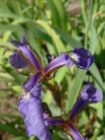
Single image of Iris setosa with URL link but no cross-reference.
For instance, if you have several figures that appear as a group, you can create a figure div to enclose them (see Fig. 1 and Fig. 2).
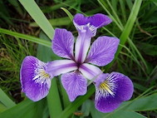
Figure 1: Iris versicolor

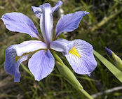
Figure 2: Iris virginica

The layout attribute enables the creation of much more complex layouts. Fig. 3 provides an example with a common figure caption and one identifier for all three.
  Iris setosa |  |   Iris versicolor |  |   Iris virginica
Figure 3: Custom layout of images

3. Results

3.1 R output
R output is typically shown in the monospace font (here an example with the mtcars dataset in the subfolder data/):
mpg cyl disp hp
Min. :10.40 Min. :4.000 Min. : 71.1 Min. : 52.0
1st Qu.:15.43 1st Qu.:4.000 1st Qu.:120.8 1st Qu.: 96.5
Median :19.20 Median :6.000 Median :196.3 Median :123.0
Mean :20.09 Mean :6.188 Mean :230.7 Mean :146.7
3rd Qu.:22.80 3rd Qu.:8.000 3rd Qu.:326.0 3rd Qu.:180.0
Max. :33.90 Max. :8.000 Max. :472.0 Max. :335.0

3.2 Tables
If the output format is Word tables are generated best using R packages instead of R Markdown syntax. The following two sections demonstrate some useful packages.

3.2.1 Using the knitr package
Table 1 is an example of using knitr::kable() to generate the table.
Table 1: This is a table produced with knitr::kable().
 | mpg | cyl | disp | hp | drat | wt
Mazda RX4 | 21.0 | 6 | 160 | 110 | 3.90 | 2.620
Mazda RX4 Wag | 21.0 | 6 | 160 | 110 | 3.90 | 2.875
Datsun 710 | 22.8 | 4 | 108 | 93 | 3.85 | 2.320
Hornet 4 Drive | 21.4 | 6 | 258 | 110 | 3.08 | 3.215
Hornet Sportabout | 18.7 | 8 | 360 | 175 | 3.15 | 3.440

3.2.2 The flextable package
flextable creates tables that work well in both PDF and Word output. Table 2 shows an example:
Table 2: Overview of the first rows and columns in the mtcars dataset.
mpg | cyl | disp | hp | drat | wt
21.0 | 6 | 160 | 110 | 3.90 | 2.620
21.0 | 6 | 160 | 110 | 3.90 | 2.875
22.8 | 4 | 108 | 93 | 3.85 | 2.320
21.4 | 6 | 258 | 110 | 3.08 | 3.215
18.7 | 8 | 360 | 175 | 3.15 | 3.440
Tip: Another excellent table package is gt, which provides a tidyverse-compatible grammar for tables.

3.3 Figures
A base graphics scatterplot (Fig. 4).
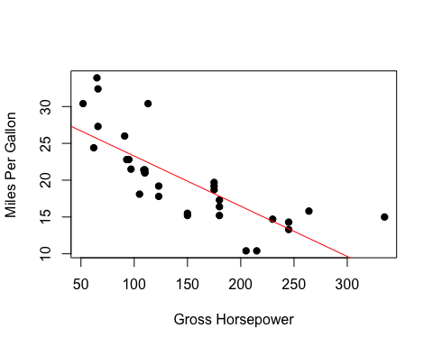
Figure 4: Relationship between horsepower and fuel economy.
Here for comparison a boxplot with a different image height (Fig. 5).
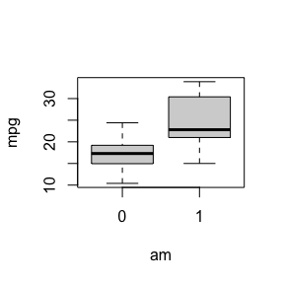
Figure 5: Fuel differences between transmission types (0 = automatic, 1 = manual).

3.4 Diagrams
Quarto has native support for embedding Mermaid and Graphviz diagrams. This enables you to create flowcharts, sequence diagrams, state diagrams, Gantt charts, and more using a plain text syntax inspired by markdown.

3.4.1 Mermaid
Mermaid is a Javascript based diagramming and charting tool that uses Markdown-inspired text definitions and a renderer to create and modify complex diagrams (see Fig. 6).
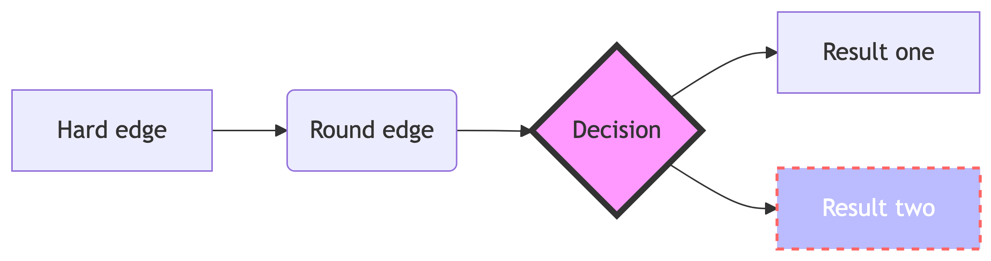
Figure 6: Simple flowchart based on the JS-tool Mermaid.
 Note
Cell level options are here indicated with %%| instead of #|!

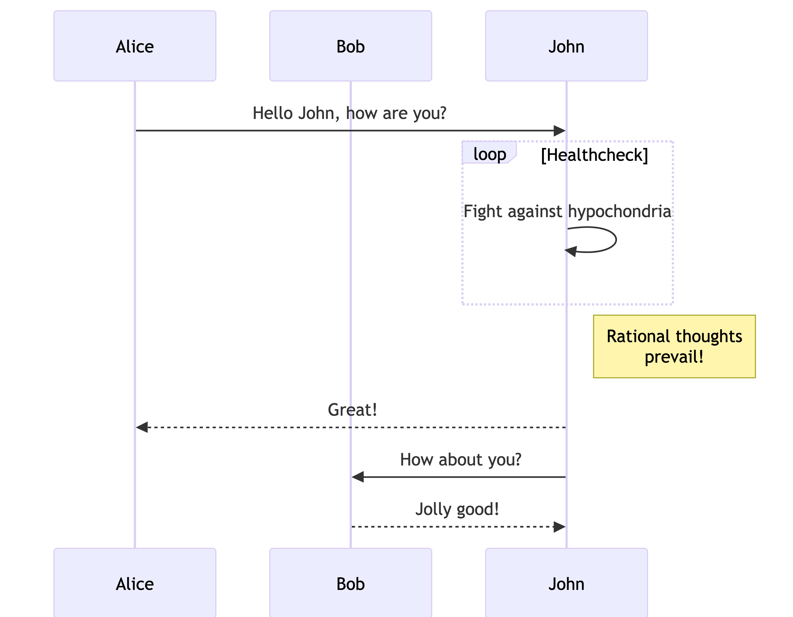
Figure 7: A sequence diagram based on Mermaid.
Useful links:
- https://mermaid-js.github.io/mermaid/#/
- https://mermaid.live

3.4.2 Graphviz
The Graphviz layout programs take descriptions of graphs in a simple text language and make diagrams in useful formats. Graphviz has many useful features for concrete diagrams, such as options for colors, fonts, tabular node layouts, line styles, hyperlinks, and custom shapes (see Fig. 8).
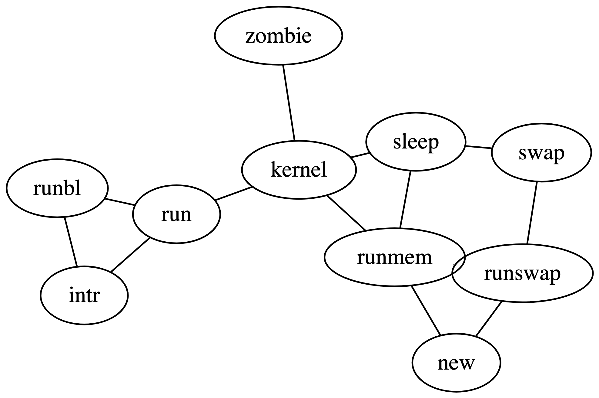
Figure 8: An example for a diagram made with Graphviz.
 Note
Cell level options are here indicated with //|!

4. Adding citations and bibliography
Link a .bib document via the YAML header, and the bibliography will be printed at the end. The default bibliography style is provided in the sage-harvard.csl file (do not delete), which adopts the SAGE Harvard reference style.
References can be cited directly within the document using the Quarto equivalent of the citation system [@key], where key is the citation key in the first line of the entry in the .bib file. Example: (Taylor and Green, 1937). To cite multiple entries, separate the keys by semicolons (e.g., (Kamm, 2000; Knupp, 1999)). You can also write in-text citations, as follows: Taylor and Green (1937) say this and that.
There is also the package citr which I highly recommend: citr provides functions and an RStudio add-in to search a BibTeX-file to create and insert formatted Markdown citations into the current document. If you are using the reference manager Zotero the add-in can access your reference database directly.

4.1 Software
If you want to include a paragraph on the software used, here is some example text/code to get the current R and package versions. The code to create a separate bibliography file named ‘packages.bib’ with all package references has already been added at the beginning of this script (code chunk ‘generate-package-refs’).
All analyses were performed using the statistical software R (version 4.5.2) (R Core Team, 2025). This thesis, including tables, was generated using the R packages ‘rmarkdown’ (version 2.30) (Allaire et al., 2025), ‘UHHformats’ (version 1.1.0.9000) (Otto, 2026), and ‘knitr’ (version 1.51) (Xie, 2025).

4.2 Examples for footnotes
Here is a footnote reference, and another.

5. References
Allaire J, Xie Y, Dervieux C, et al. (2025) Rmarkdown: Dynamic Documents for r. Available at: https://github.com/rstudio/rmarkdown.
Kamm J (2000) Evaluation of the Sedov-von Neumann-Taylor blast wave solution. Technical Report LA-UR-00-6055. Los Alamos National Laboratory.
Knupp P (1999) Winslow smoothing on two-dimensional unstructured meshes. Eng Comput 15: 263–268.
Otto S (2026) UHHformats: Templates for HTML and PDF/LaTeX Output Formats Designed for the UHH. Available at: https://github.com/uham-bio/UHHformats.
R Core Team (2025) R: A Language and Environment for Statistical Computing. Vienna, Austria: R Foundation for Statistical Computing. Available at: https://www.R-project.org/.
Taylor G and Green A (1937) Mechanism of the production of small eddies from large ones. P Roy Soc Lond A Mat 158(895): 499–521.
Xie Y (2025) Knitr: A General-Purpose Package for Dynamic Report Generation in r. Available at: https://yihui.org/knitr/.

Acknowledgments
Lorem ipsum dolor sit amet, consectetur adipiscing elit. Aenean ut elit odio. Donec fermentum tellus neque, vitae fringilla orci pretium vitae. Fusce maximus finibus facilisis. Donec ut ullamcorper turpis.

Here is the footnote.
Here’s one with multiple blocks. Subsequent paragraphs are indented to show that they belong to the previous footnote. { some.code } The whole paragraph can be indented, or just the first line. In this way, multi-paragraph footnotes work like multi-paragraph list items.

