Thesis title
submitted by
Mandy Mustermann
born on 31. January 1970
Bachelor’s / Master’s Thesis
in the degree program Biology
at the University of Hamburg
submitted on 1. April 2000
Advisor: Prof. A
Advisor: Prof. B
Table of Contents

Abstract
The abstract comes always first and should raise the readers interest in reading further.
The abstract summarizes, usually in one or two paragraph (here max. 1 page), the major aspects of the entire thesis in a prescribed sequence. This should include:
- the overall purpose of the study and the research problem(s) you investigated
- the basic design of the study
- the major findings or trends found as a result of your analysis
- a brief summary of your interpretations and conclusions.

Zusammenfassung
The thesis should always provide a German summary after the abstract, independent of the language of the main sections. Its content should not deviate from the abstract.

List of Abbreviations
You can provide a table of abbreviations in R Markdown syntax as demonstrated here.
ATP | Adenosintriphosphat
CoA | Coenzym A
DNA | Desoxyribonukleinsäure
mtDNA | Mitochondriale DNA

1 Introduction
The introduction should move from the general to the specific. Address the following points:
- What is the general topic and why is it relevant?
- What is the current state of research? Which gaps or contradictions exist?
- What is the specific research question of this thesis?
- Which hypotheses are tested?
- How is the thesis structured? (chain of argumentation, subproblems)

1.1 Literature tips
Use Google Scholar or Web of Science (accessible via UHH VPN) to find relevant publications. Further useful databases in biology include the Electronic Journals Library of the UHH and ScienceDirect.
A reference manager such as Zotero helps organise your sources and export .bib files automatically. For citation syntax and bibliography setup, see the tutorial.

2 Material and Methods
The structure of this chapter depends very much on the type of research study, whether it is a field, laboratory or modelling study or a literature review. For field studies, the typical subsections are the
- study site
- experimental set-up
- sampling design
- statistical analysis with information on the used computer program

2.1 Study site
External images (e.g. maps) are embedded with knitr::include_graphics(). The caption is set via fig.cap:
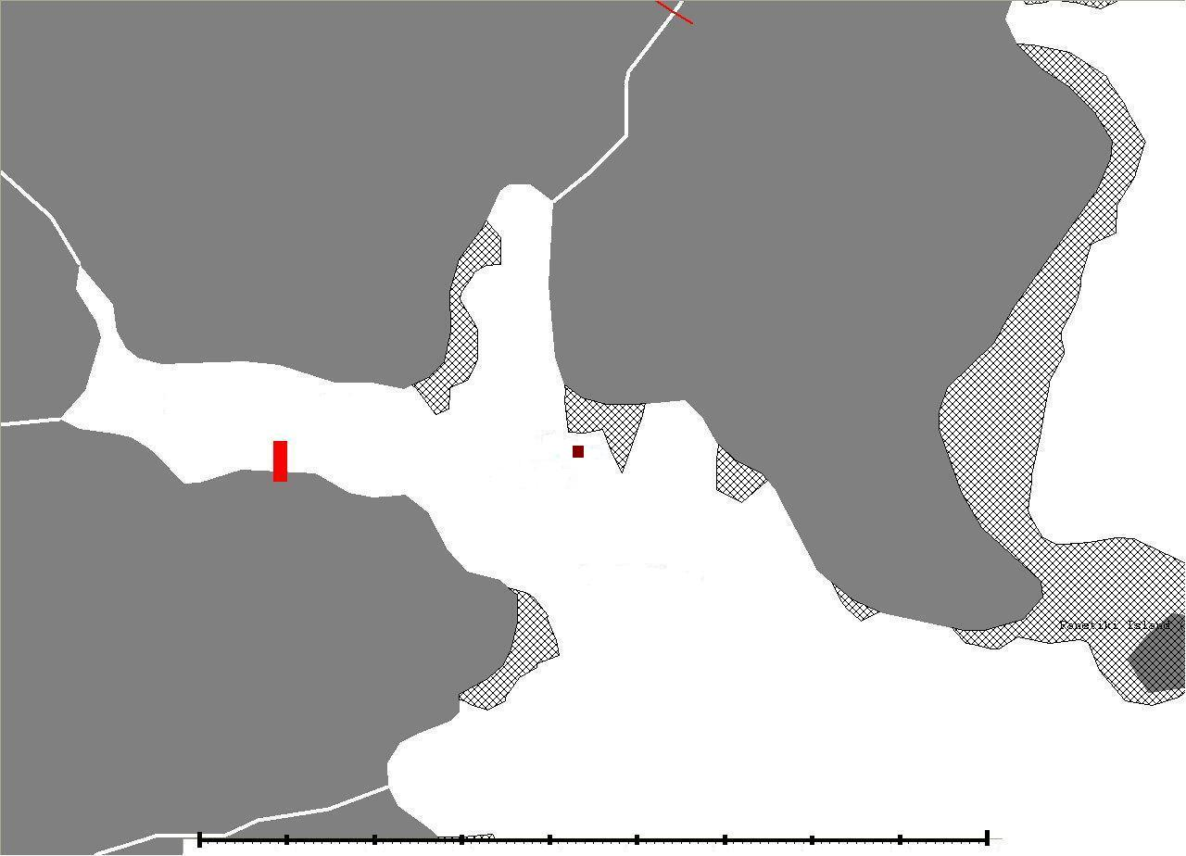
Figure 2.1: Location of sampling site….
Note that in Word output, images are always displayed at full width. The out.width chunk option does not work for Word. For external images, the width can be adjusted via the image file size itself:
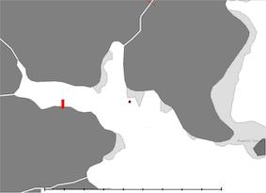
Figure 2.2: Map of the sampling location in reduced size.

2.2 Cross-references
Figures are referenced with \@ref(fig:<chunk-label>), tables with \@ref(tab:<chunk-label>). Chunk labels must not contain underscores — use hyphens instead. Sections can be linked via [Section name], e.g. Discussion. For a full overview, see the tutorial.

2.3 Mathematical equations
Inline equations use single dollar signs: $E=mc^{2}$. Display equations use double dollar signs:
$$E=mc^{2}$$
For numbered equations with cross-references, use the LaTeX equation environment (see eq. (2.1)):
$$\overset{‾}{X}=\frac{\sum_{i=1}^{n}{X_{i}}}{n} (2.1)$$
Formulas should be integrated into sentences and end with a comma or period.

2.4 Chemical formulas
Use $\mathrm{...}$ to avoid automatic italicisation in math mode:
- Subscript: $CH_{4}$
- Superscript: $O^{−}$
- Combined: $Fe_{2}^{2+}Cr_{2}O_{4}$ via $\mathrm{Fe_2^{2+}Cr_2O_4}$
- Hydrate bullet: CuCl $•$ $7H_{2}O$
- Arrows: $→$ (reaction), $⇌$ (reversible), $↔$ (resonance)
- Delta: $Δ$
Numbered reaction equations use the equation environment:
$$C_{6}H_{12}O_{6}+6O_{2}→6CO_{2}+6H_{2}O (2.2)$$
Reference via (2.2). Unnumbered inline reactions use dollar signs: $NH_{4}Cl_{(s)}⇌NH_{3(g)}+HCl_{(g)}$

2.5 Software
This section should always come at the end of the method chapter. You should list here the R version you used and each package with its version number, including the reference. The following text creates everything necessary automatically. You only need to update the packages used:
All analyses were performed using the statistical software R (version 4.5.2) (R Core Team, 2025). This thesis, including tables, was generated using the packages ‘bookdown’ (version 0.46) (Xie, 2025a), ‘rmarkdown’ (version 2.30) (Allaire et al., 2025), ‘knitr’ (version 1.51) (Xie, 2025b), and ‘flextable’ (version 0.9.10) (Gohel and Skintzos, 2025).

3 Results
The result chapter is of great importance in an empirical study and should comprise a good mix of text, tables and figures. Use your research questions and hypothesis for structuring this chapter to provide the reader some structure and to not lose the thread.
Figures and tables should be continuously numbered and referred to in the main text. LaTeX places figures and tables automatically were they fit best, which is sometimes on the next page. This is fine since they are cross-referenced anyway.
Tables have generally a caption at the top, while figures have a caption at the bottom. This has to be considered in some of the R functions (see below).

3.1 Tables

3.1.1 R Markdown table
When writing a table using R Markdown syntax, as shown in the following table, the table caption is defined right before with Table: …. (Attention: You do not need quotation marks here!)
This is a table written in R Markdown.
A | New | Table
left-aligned | center-aligned | right-aligned
$123 | $456 | $789
italics | normal | boldface
The current disadvantage of tables written in R Markdown syntax in the Word document version is the lack of any numbering. Also cross-referencing based on LaTeX notation is not possible. Both are currently only available when creating tables using R (see next section).

3.1.2 Tables generated with R
Creating tables with R and packages like ‘knitr’ is much easier (and protects against typing errors!) than manually entering values into a table by copying and pasting them into Excel or LaTeX. This shows once again how beautiful reproducible documents can be!
Another advantage is that tables generated with R automatically receive a number and can be cross-referenced. To do this, simply assign a label for the R code chunk (directly after the ‘{r’). The cross-reference is then made with \@ref{tab:code-chunk-label}.

3.1.2.1 Using the knitr package
Table 3.1 is an example of using knitr::kable() to generate the table. The function has an explicit argument named caption where you can place your caption text.
Table 3.1: This is a table produced with knitr::kable().
 | mpg | cyl | disp | hp | drat | wt
Mazda RX4 | 21.0 | 6 | 160 | 110 | 3.90 | 2.620
Mazda RX4 Wag | 21.0 | 6 | 160 | 110 | 3.90 | 2.875
Datsun 710 | 22.8 | 4 | 108 | 93 | 3.85 | 2.320
Hornet 4 Drive | 21.4 | 6 | 258 | 110 | 3.08 | 3.215
Hornet Sportabout | 18.7 | 8 | 360 | 175 | 3.15 | 3.440

3.1.2.2 The flextable package
flextable creates tables that work well in both Word and PDF output. Table 3.2 shows an example:
Table 3.2: Overview of the first lines and columns in the mtcars dataset.
mpg | cyl | disp | hp | drat | wt
21.0 | 6 | 160 | 110 | 3.90 | 2.620
21.0 | 6 | 160 | 110 | 3.90 | 2.875
22.8 | 4 | 108 | 93 | 3.85 | 2.320
21.4 | 6 | 258 | 110 | 3.08 | 3.215
18.7 | 8 | 360 | 175 | 3.15 | 3.440
Tip: Another excellent table package is gt, which provides a tidyverse-friendly grammar of tables.

3.2 Figures
Figures can directly be produced with R and displayed here. The ggplot2 package provides a powerful and flexible system for creating publication-quality graphics. Similar to external images, figure captions and labels are placed inside the chunk options for cross-referencing (see Fig. 3.1).
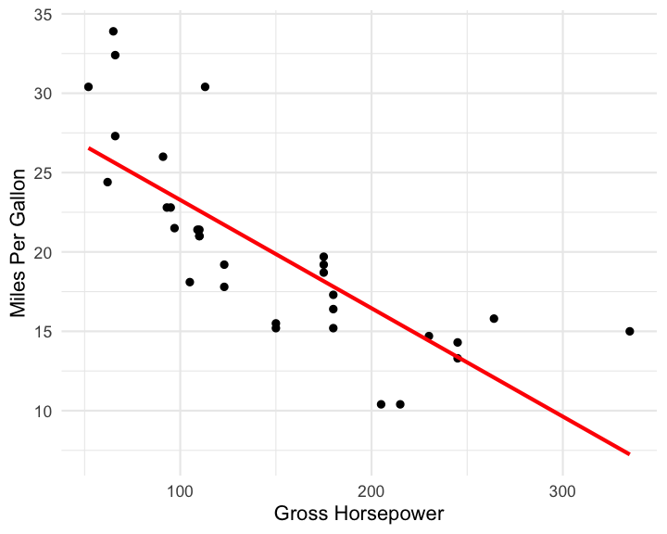
Figure 3.1: Relationship between horsepower and fuel economy.
Here for comparison a boxplot with a different image height (Fig. 3.2).
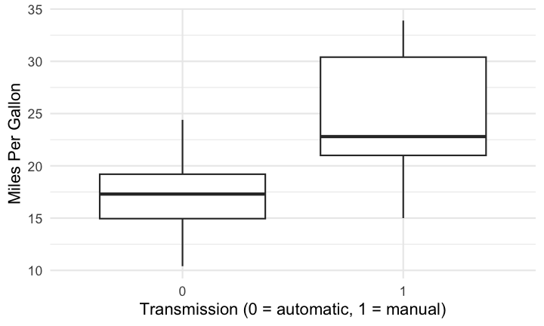
Figure 3.2: Fuel differences between transmission types (0 = automatic, 1 = manual).

4 Discussion
Providing strict guidelines and rules for a good discussion is difficult. But the following recommendations might be helpful:
- The discussion follows the opposite structure than the introduction and should move from the specific to the more general topics.
- Summary/recapitulation: You should start the discussion with a short summary of your main results and whether they support your hypothesis/hypotheses or not. Avoid here any statistical language as in the result section. You should again sketch out your line of argumentation in this section.
- Continue with the main messages of your empirical or theoretical study or your literature review: What are new insights from your results?
- Discussion of individual findings: expose results concisely and evaluate them critically. Potential questions that could be addressed here:
  - Are the findings convincing?
  - In empirical studies: which conclusions about the problem studied can be drawn? What are the implications of your findings? Which theories and previous studies support your results, which are contradicting?
  - In literature reviews: how many of the publications included in your analyses were high-quality and most recent? How many were outdated or had methodological flaws? Is there consensus across studies? Or are there group of studies that found different results?
  - Which questions remain still unanswered? Which come out as important due to your findings?
- Point out the limitations of your study (assist reader in judging validity of findings). Are there any results that contradict your hypothesis and how can they be explained? Discuss to which extent your results can be generalized.

4.1 Conclusion
- Which take home messages do you like to give the reader? What is the relevance of your study for future research and potential applications? Suggest issues for future research.
- One final sentence the complete the thesis.

5 References
Allaire J, Xie Y, Dervieux C, et al. (2025) Rmarkdown: Dynamic Documents for r. Available at: https://github.com/rstudio/rmarkdown.
Gohel D and Skintzos P (2025) Flextable: Functions for Tabular Reporting. Available at: https://ardata-fr.github.io/flextable-book/.
R Core Team (2025) R: A Language and Environment for Statistical Computing. Vienna, Austria: R Foundation for Statistical Computing. Available at: https://www.R-project.org/.
Xie Y (2025a) Bookdown: Authoring Books and Technical Documents with r Markdown. Available at: https://github.com/rstudio/bookdown.
Xie Y (2025b) Knitr: A General-Purpose Package for Dynamic Report Generation in r. Available at: https://yihui.org/knitr/.

Acknowledgements
I want to thank the following people …

6 Appendix
All relevant information has to be included in the main text. Irrelevant information as to be completely left out. Content that is related to the topic but not essential can be included in the appendix. Such could be the derivation of equations, additional information on statistical or laboratory analyses, source code of computer programs or any other comprehensive (data) material.
The appendix has to be similar to figures and tables cross-referenced and should not stand by itself. All figures and tables in the appendix should also have captions.

6.1 Figures
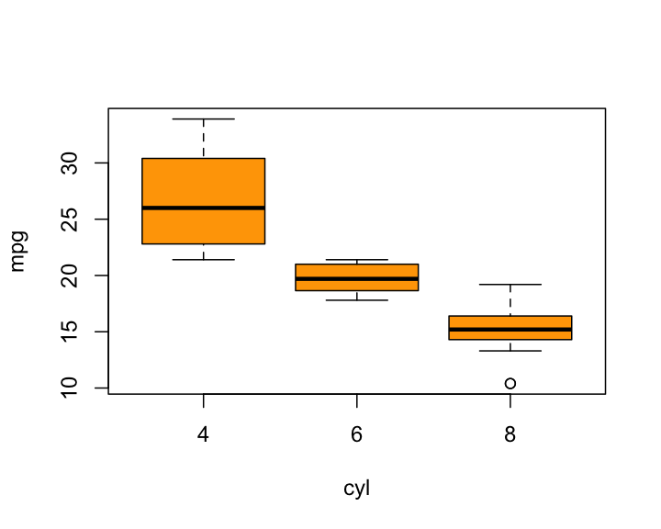
Figure 6.1: Fuel economy in cities, grouped by the number of cylinders.

6.2 Tables
Here is another table that is created with R Markdown.
Descriptive statistics of ….
3m | 6m | 1yr | 2yr | 3yr | 5yr | 7yr | 10yr | 12yr | 15yr
Mean | 3.138 | 3.191 | 3.307 | 3.544 | 3.756 | 4.093 | 4.354 | 4.621 | 4.741
Median | 3.013 | 3.109 | 3.228 | 3.490 | 3.680 | 3.906 | 4.117 | 4.420 | 4.575
Min | 1.984 | 1.950 | 1.956 | 2.010 | 2.240 | 2.615 | 2.850 | 3.120 | 3.250
Max | 5.211 | 5.274 | 5.415 | 5.583 | 5.698 | 5.805 | 5.900 | 6.031 | 6.150
StD | 0.915 | 0.919 | 0.935 | 0.910 | 0.876 | 0.825 | 0.803 | 0.776 | 0.768

Declaration of Authorship
I hereby declare in lieu of an oath that I have authored the present [BACHELOR/MASTER THESIS] independently and without use of others than the indicated sources - in particular of internet sources other than the one mentioned in the list of sources. The [BACHELOR/MASTER THESIS] has not been submitted by me to any other examination procedure before. The submitted written version corresponds to the version on the electronic storage medium. I agree that the [BACHELOR/MASTER THESIS] may be published.
[Hiermit erkläre ich an Eides statt, dass die vorliegende [BACHELORARBEIT/MASTERARBEIT] von mir selbständig verfasst wurde und ich keine anderen als die angegebenen Hilfsmittel – insbesondere keine im Quellenverzeichnis nicht benannten Internet–Quellen – benutzt habe und die Arbeit von mir vorher nicht einem anderen Prüfungsverfahren eingereicht wurde. Die eingereichte schriftliche Fassung entspricht der auf dem elektronischen Speichermedium. Ich bin damit einverstanden, dass die [BACHELORARBEIT/MASTERARBEIT] veröffentlicht wird.]
Hamburg, [DATE]
. . . . . . . . . . . . . . . . . . . . . . . . . . . . . . .
[FIRST NAME AND SURNAME]

such as R - this is an example of a footnote

