Rectangle test case 1

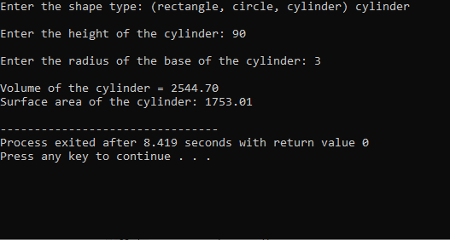

Circle test case 1

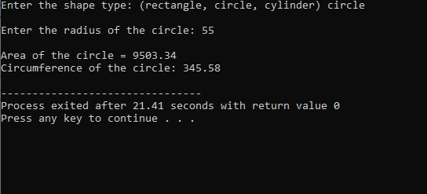

Cylinder test case 1

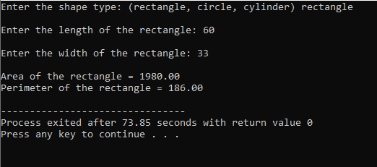

Other Shape-- test case

-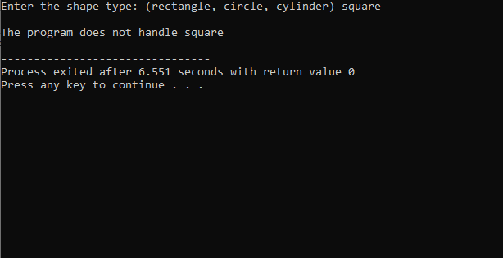-

Program:

#include <iostream>

#include <string>

#include <cmath>

#include <iomanip>

using namespace std;

int main()

{

string shape;

double height;

double length;

double width;

double radius;

const double PI = 3.1416;

cout << "Enter the shape type: (rectangle, circle, cylinder) ";

cin >> shape;

cout << endl;

if (shape == "rectangle")

{

cout << "Enter the length of the rectangle: ";

cin >> length;

cout << endl;

cout << "Enter the width of the rectangle: ";

cin >> width;

cout << endl;

cout << fixed << showpoint << setprecision(2);

cout << "Area of the rectangle = "<< length \* width << endl;

cout << "Perimeter of the rectangle = "<< 2 \* (length + width) << endl;

}

else if (shape == "circle")

{

cout << "Enter the radius of the circle: ";

cin >> radius;

cout << endl;

cout << fixed << showpoint << setprecision(2);

cout << "Area of the circle = "<< PI \* pow(radius, 2.0) << endl;

cout << "Circumference of the circle: "<< 2 \* PI \* radius << endl;

}

else if (shape == "cylinder")

{

cout << "Enter the height of the cylinder: ";

cin >> height;

cout << endl;

cout << "Enter the radius of the base of the cylinder: ";

cin >> radius;

cout << endl;

cout << fixed << showpoint << setprecision(2);

cout << "Volume of the cylinder = "<< PI \* pow(radius, 2.0)\* height << endl;

cout << "Surface area of the cylinder: "<< 2 \* PI \* radius \* height + 2 \* PI \* pow(radius, 2.0)<< endl;

}

else

{

cout << "The program does not handle " << shape << endl;

}

return 0;

}