[recursive1(Links to an external site.)](https://www.codesdope.com/blog/article/backtracking-explanation-and-n-queens-problem/" \t "_blank)

If N=4 then it will solve the Challange

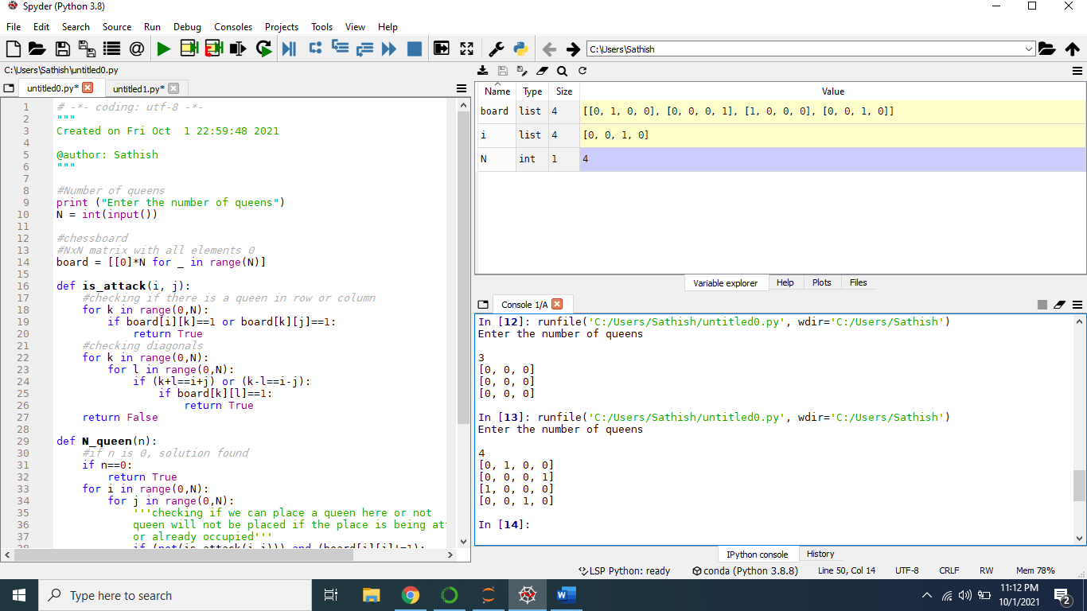

If N=3 then it is not working and Queens will be 0.

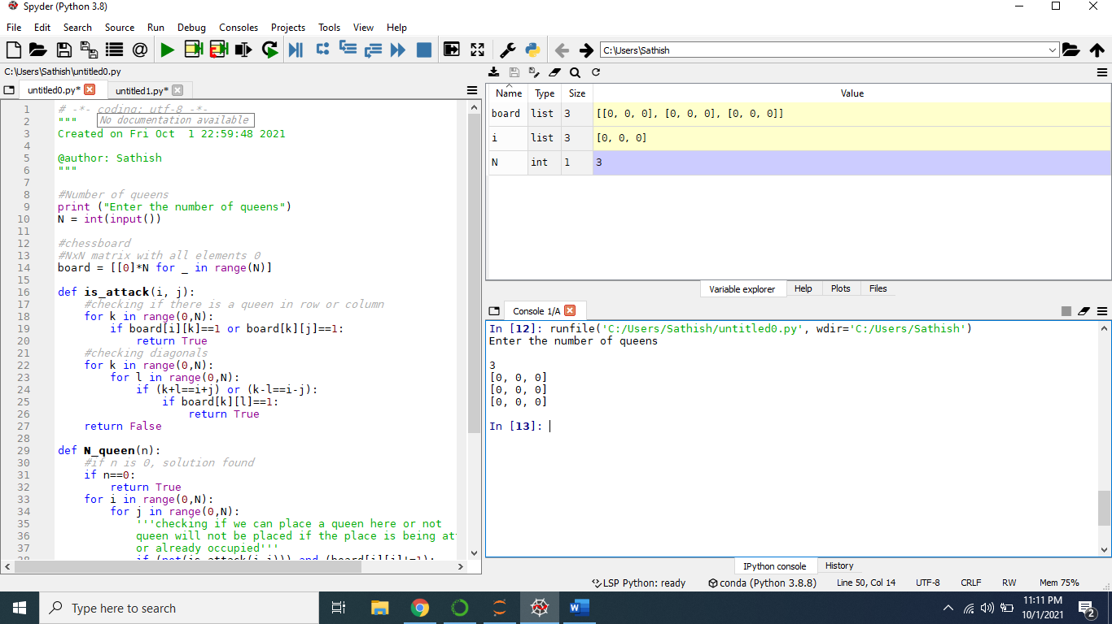

[recursive2(Links to an external site.](https://www.geeksforgeeks.org/n-queen-problem-backtracking-3/))

if N=4 Result will be solved for K Queens Challange

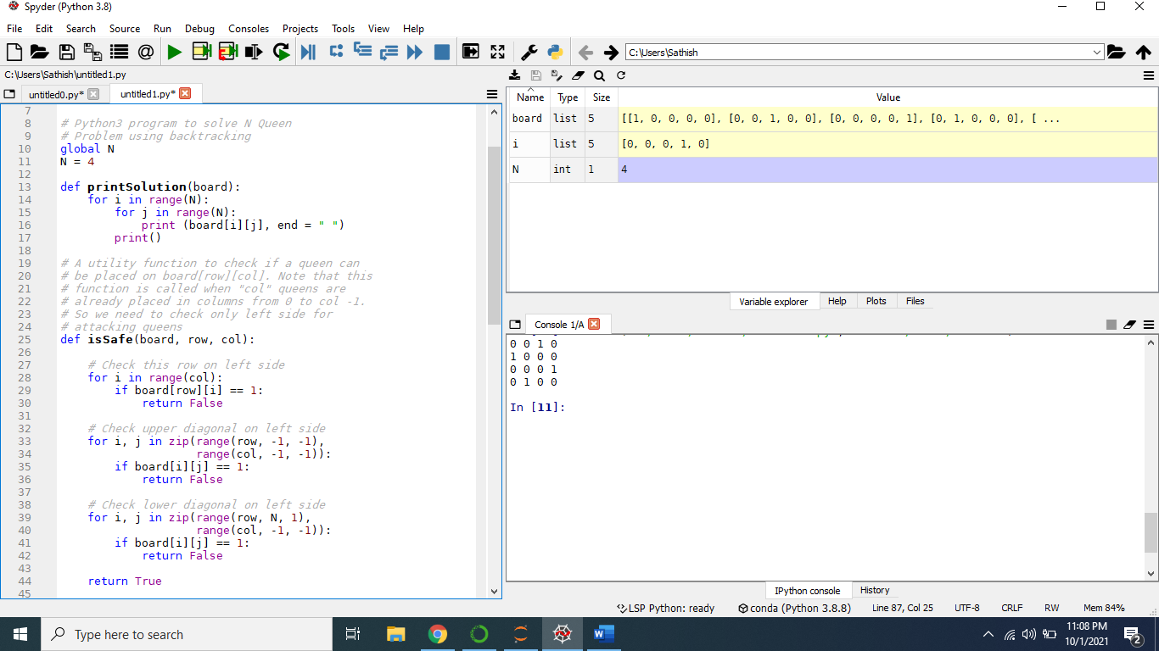

If N=3 then results is unsolved



Question1: For each algorithm, how many operations does it take to solve the challenge for 4,5, 6, 7 queens?

[recursive1(Links to an external site.)](https://www.codesdope.com/blog/article/backtracking-explanation-and-n-queens-problem/)

N-Q------No of Operations

4-----------------19

5------------------5

6------------------more than 492

7-------------------11

[recursive2(Links to an external site.](https://www.geeksforgeeks.org/n-queen-problem-backtracking-3/))

N-Q------No of Operations

4-----------------8

5------------------5

6------------------31

7-------------------9

Question2: What are the key differences between the two approaches in terms of efficiency?

[recursive2(Links to an external site.](https://www.geeksforgeeks.org/n-queen-problem-backtracking-3/)) is more efficient than [recursive1(Links to an external site.)](https://www.codesdope.com/blog/article/backtracking-explanation-and-n-queens-problem/). Acording to the number of operations taken for N-Queen Challenge and Back tracing.

No of recursion is more in [recursive1(Links to an external site.)](https://www.codesdope.com/blog/article/backtracking-explanation-and-n-queens-problem/).