**1. Suppose you are at the time when eBooks are about to be launched to the market. The Bass Model parameters for eBook *annual* adoption are p = 0.0395, q = 0.556, M = 21 million.**

**(1) Plot adoptions of eBooks, N(t), as a function of time for this new product for 30 years.**

**Report N(t) for the first five years.**

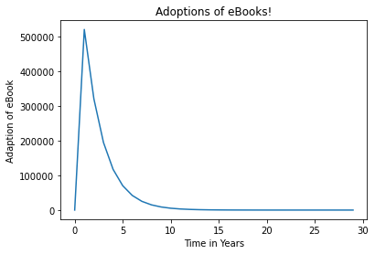

**Adoptions of eBooks for first five years!**

|  |
| --- |
| 0 |
| 521580.63439471816 |
| 321057.1260318899 |
| 195047.9073499192 |
| 117552.48828833972 |

**(2) What is the predicted peak time of adoption for eBooks? How many adoptions will**

**occur for eBooks during its peak time of adoption?**

Peak time of adoption is year 2 and the number of adoption during the peak time is 521580

Furthermore, suppose each adopter of eBooks will purchase 4 electronic books per year

after becoming an adopter of eBooks.

**(3) Plot sales of electronic books, S(t), as a function of time for this new product for 30**

**years.**

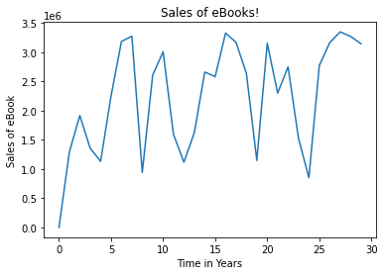

**(4) How does the plot above differ from the plot in question (1)? Why does the difference**

**occur?**

It is vary based on the previous and new adopter.

**2. Using the dataset titled “CoffeeDataStoreB.csv,” run a Scan*Pro model for Maxwell House in**

**Store B. Then run a Scan*Pro model for Folgers in Store B.**

a. Between Maxwell House and Folgers, which brand has higher brand equity? Explain its brand

equity in words.

Answer:

Folger brand has higher brand equity. Brand equity refers to a value premium that a company generates from a product with a recognizable name when compared to a generic equivalent. Companies can create brand equity for their products by making them memorable, easily recognizable, and superior in quality and reliability.

When a company has positive brand equity, customers willingly pay a high price for its products, even though they could get the same thing from a competitor for less. Customers, in effect, pay a price premium to do business with a firm they know and admire. Because the company with brand equity does not incur a higher expense than its competitors to produce the product and bring it to market, the difference in price goes to their margin. The firm's brand equity enables it to make a bigger profit on each sale.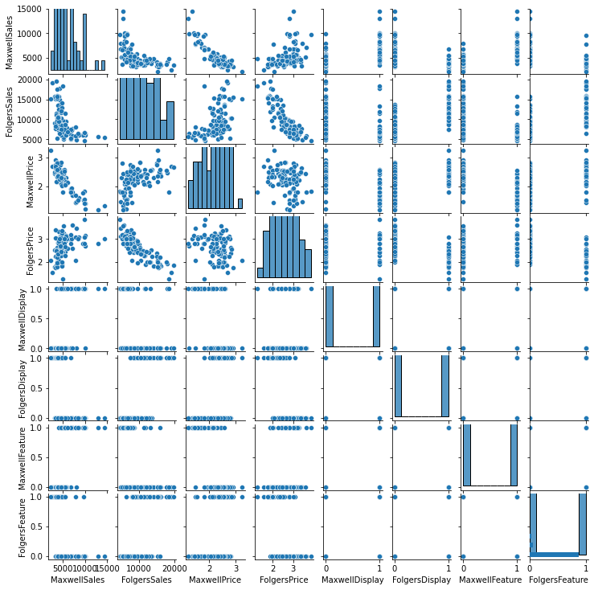

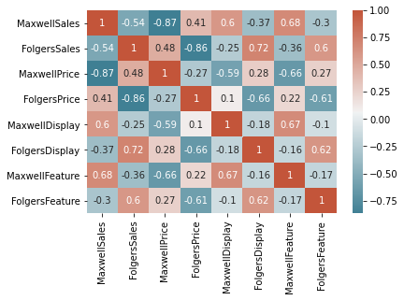

b. Between Maxwell House and Folgers, which brand has higher vulnerability to its competitor’s

price cut? Explain the quantity of the vulnerability in words.

If competitor has price cut then it has vulnerability. Maxwell House has vulnerability while Folgers’s price cut.

**3. Consider the following AR perceptual map reporting the brand positions, as perceived by**

**survey respondents, of 12 beer brands relative to each other.**

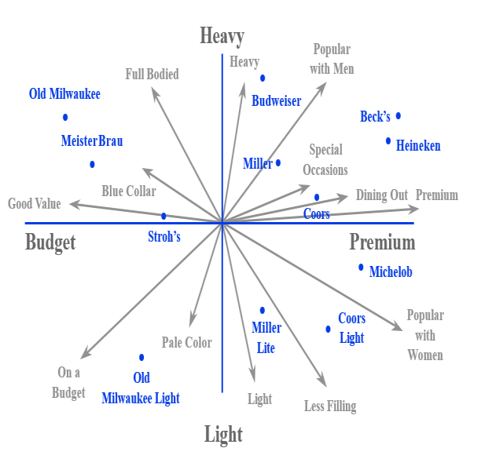

**Answer the following questions and explain your answers.**

**Question-a. Between Miller and Miller Lite, which brand is perceived as more popular with women?**

Answer:

Miller Lite is more popular with women. Because it is light and less filling.

**Question- b. Between Old Milwaukee and Old Milwaukee Light?**

Answer:

Old Milwaukee Light is more popular with women. Because it is light and low budget.

**Question- c. Suppose Miller wants to reposition itself to be perceived to be more popular with women. In achieving so, can Miller also be perceived to be more popular with men?**

Answer:

Yes, It remains the same based on its features.