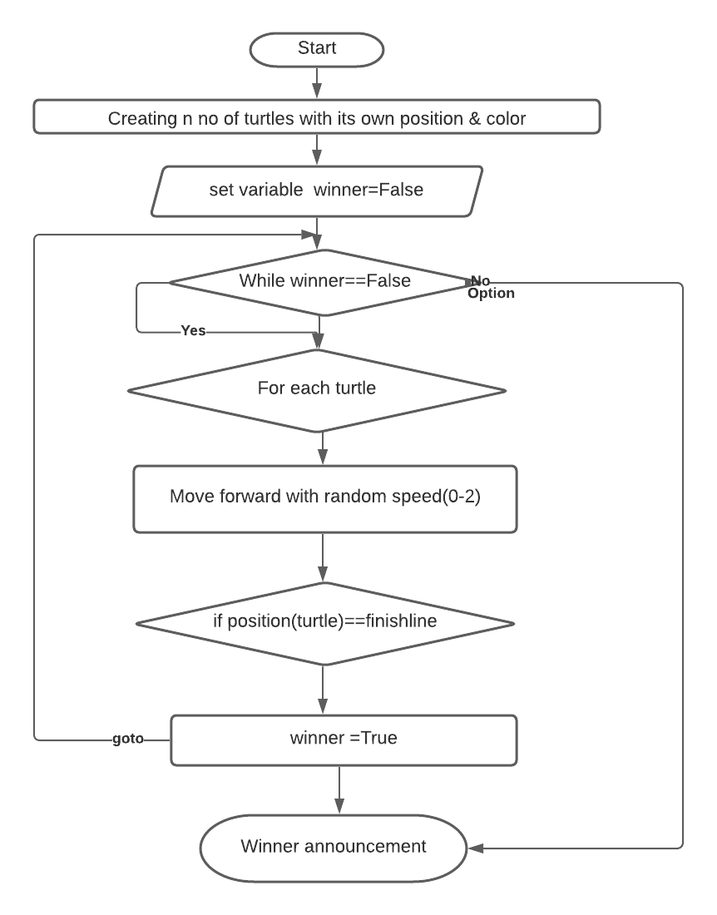

Q2 OUTPUT TESTING:

INPUT:

Enter student name:Alex

Enter student ID:MIT107

Enter student unitsEnrolledList1:BN123

Enter student unitsEnrolledList2:BN1456

Enter student unitsEnrolledList3:BN135

OUTPUT:

[['Shankar', 'MIT123', ['BN101', 'BN102', 'BN103']], ['John', 'MIT124', ['BN103', 'BN104', 'BN105']], ['Alex', 'MIT107', ['BN123', 'BN1456', 'BN135']]]

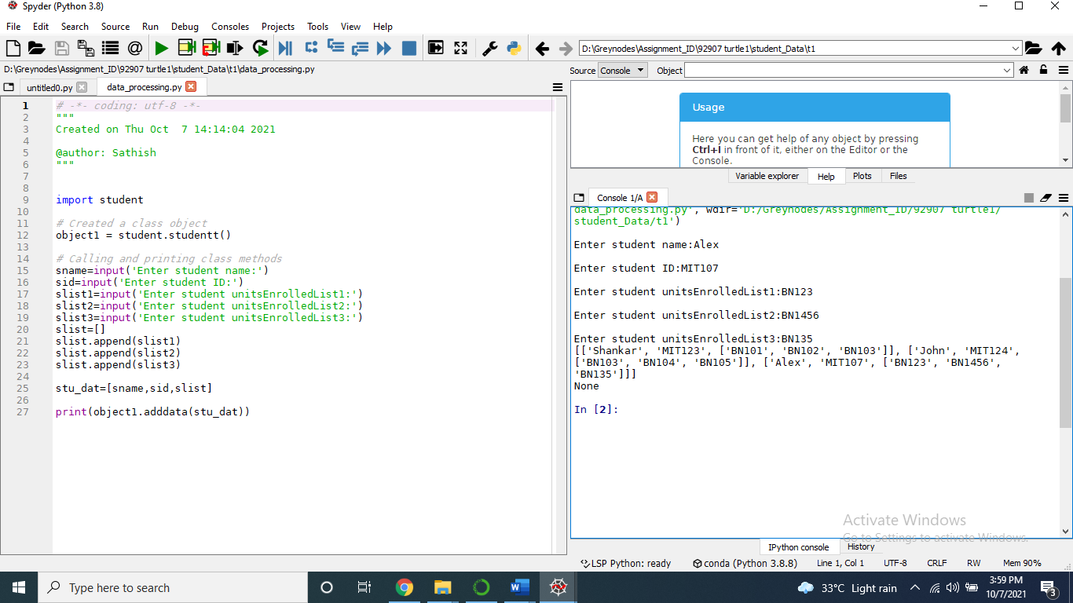

Search student ID output:

Student data already stored:

Shankar", "MIT123",90,95

"John", "MIT124",87,79

"Alex", "MIT125",95,87

Output Screen1:

Enter Student Id to search database:MIT123

Name : Shankar

RollNo : MIT123

Score1 : 90

Score2 : 95

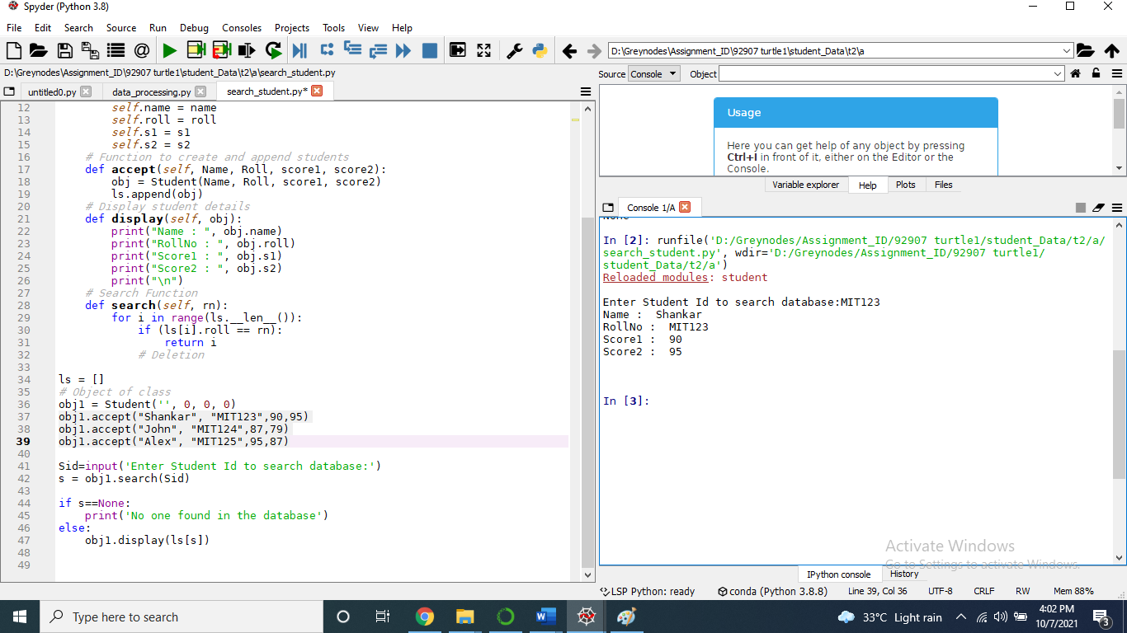

Output Screen1:

Enter Student Id to search database:MIT666

No one found in the database

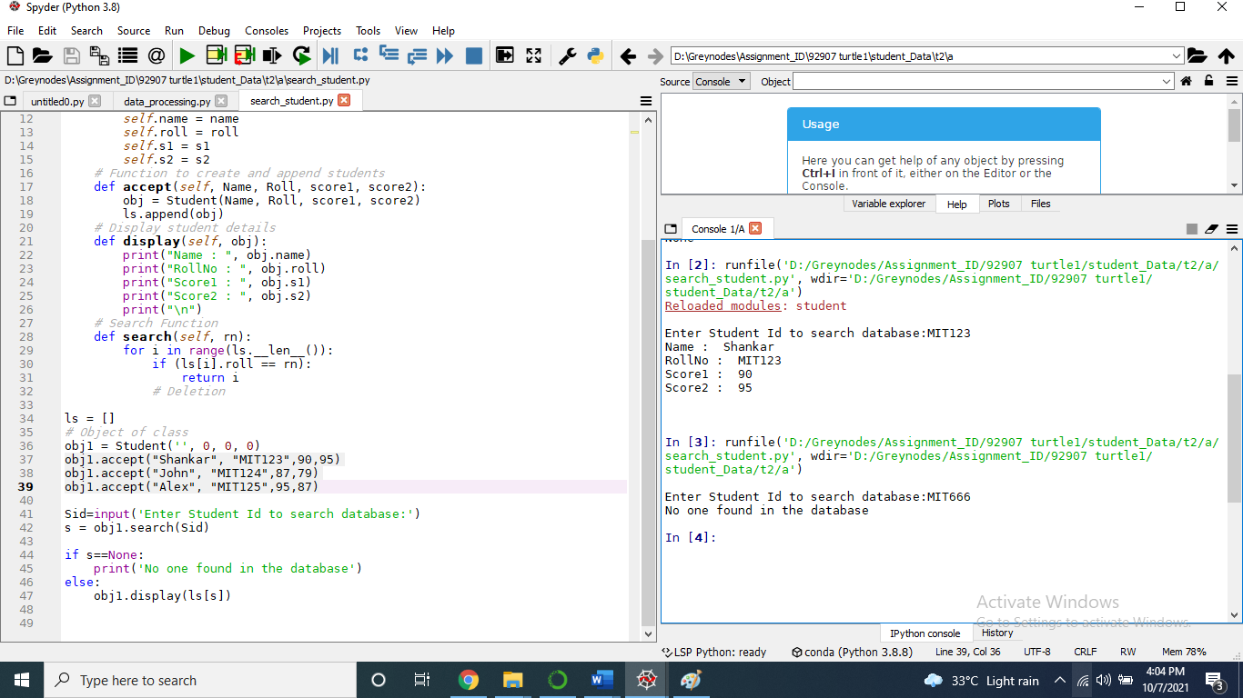

Enrolled list matching:

INPUT:

Enter student name:Alex

Enter student ID:MIT256

Enter student unitsEnrolledList1:BN101

Enter student unitsEnrolledList2:BN109

Enter student unitsEnrolledList3:BN194

OUTPUT:

Dear Alex,you and John are studying same unit {'BN101'}

