Internship System

Team – Data Dragons
Bhavya Gedi | 801019706
Priyanka Manusanipally | 801017222
Uha Rani Gunupuru | 801027906
xxx | 800957982
xxx | 800953520

Contents

Scope of Work 3

Business Rules 3

Constraints 4

ER Diagram 4

Triggers 8

Procedures 9

Transaction 10

Performance – Using Indexes 11

Performance – Using Views 11

Performance – Avoiding certain things 12

Implementation 12

Future Scope 12

Team Leaders and other positions 12

Contact Information for Members 13

Method of Communication and File Sharing for Team 13

Meeting Dates/Times 13

Project plan 14

Scope of Work

- To design and implement a database for the Internship System
Database used - My SQL.

- Create a Web site interface

Technology used - HTML, PHP, CSS and BOOTSTRAP.

- Implementing functionalities like creating database and tables, inserting, updating and deleting records present in the tables.

- Using Indexes, Views, Triggers and Stored Procedures on the Database.

Business Rules

Individuals can donate [1...N] items but items donated can be associated to

[1...1] individual.

A donation receipt will be associated with [1...1] donor [1..1] recipient. A donation receipt can have [1...N] items.

An item can be on [1...1] donation receipt An item can be in [1...N] items.

A person can buy [0...N] items, but an item can be brought by [1...1]

person.
EERD model for person.
Constraints

User must sign in before using the system.

User can enter only 3 categories while donating the item. User can enter only 2 colors while donating the item.

Admin can only change of the donated item or delete the item.

ER Diagram

LIST OF TABLES

- PERSON TABLE

ATTRIBUTES | DATA TYPE
PERSON_ID(PK) | INT
NAME | VARCHAR(20)
CELL_PHONE | INT
EMAIL | VARCHAR(20)

NOTE- THE STUDENTS, FACULTY AND SUPERVISORS TABLES ARE INHERITED FROM PERSON TABLE. ALSO, THE TABLES ARE DISJOINT.

- FACULTY TABLE

ATTRIBUTES | DATA TYPE
PERSON_ID(PK) | INT
FACULTY_TYPE | VARCHAR(20)

- STUDENTS TABLE

ATTRIBUTES | DATA TYPE
PERSON_ID(PK) | INT
STUDENT_ADDRESS | VARCHAR(20)
STUDENT_MINOR | VARCHAR(10)
GRAD_YEAR | YEAR(4)
SKILL_ID | VARCHAR(20)
STUDENT_MAJOR | VARCHAR(10)

- SUPERVISORS TABLE

ATTRIBUTES | DATA TYPE
SUPERVISOR_ID(PK) | INT
SUPERVISOR _TYPE | VARCHAR(20)

- INTERNSHIPS TABLE

ATTRIBUTES | DATA TYPE
INTERNSHIP_ID(PK) | INT
DESCRIPTION | VARCHAR(20)
LOCATION | VARCHAR(30)
COMPANY_ID(FK) | VARCHAR(10)

- PLACEMENTS TABLE

ATTRIBUTES | DATA TYPE
STUDENT_ID(PK) | INT
SUPERVISOR_ID(PK) | INT
INTERNSHIP_ID | VARCHAR(10)
NOTE | VARCHAR(50)
EVOLUTION_ID | VARCHAR(10)
STUDENT_PERFORMANCE | VARCHAR(10)

7. COMPANIES TABLE

ATTRIBUTES | DATA TYPE
COMPANY_ID(PK) | VARCHAR(10)
COMPANY_PHONE | INT
COMPANY_ADDRESS | VARCHAR(30)
COMPANY_NAME | VARCHAR(20)
COMPANY_EMAIL | VARCHAR(20)

8. INTERNSHIP_SKILL TABLE

ATTRIBUTES | DATA TYPE
INTERNSHIP_ID(PK) | VARCHAR(10)
SKILL_ID(FK) | VARCHAR(10)
9. SKILLTABLE

ATTRIBUTES | DATA TYPE
SKILL_ID(PK) | VARCHAR(10)
SKILL_DESC | VARCHAR(20)

10. HOURLY_WAGE TABLE

ATTRIBUTES | DATA TYPE
INTERNSHIP_ID(PK) | VARCHAR(10)
IS_PAYABLE | TINYINT(1)
HOURLY_PAY | DOUBLE

11. STIPEND TABLE

ATTRIBUTES | DATA TYPE
INTERNSHIP_ID(PK) | VARCHAR(10)
STIPEND | DOUBLE
12. TEMP TABLE

ATTRIBUTES | DATA TYPE
INTERNSHIP_ID | VARCHAR(10)
START_DATE | DATE
END_DATE | DATE

Triggers

- Event – Based on Internship duration (in hours) the salary of an Hourly wage worker is calculated.
Action – Calculate and update the salary of worker based on the hourly rate

- Event - Whenever an internship is inserted/updated the salary of worker is updated

Action - Calculate and update the salary of worker based on the hourly

3. Event – Count of the Placements Students obtained

Action – Updates the Placement count respective to Student

Example of Trigger

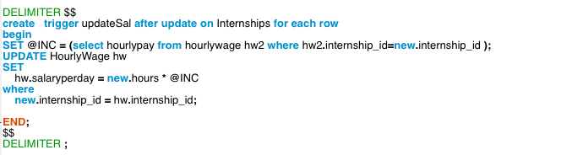

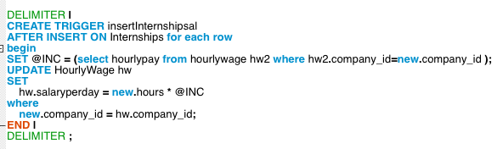

Procedures

- A procedure is like a function stored in the database. It is usually called as “Stored Procedure”.
- Stored procedures are fast as the time required for computing multiple statements, loop statements are reduced in a single procedure call statement.
- Stored Procedures are also portable. That is, they can be run on different platforms.

Scenario 1:
Procedure to find the student with highly paid stipend.

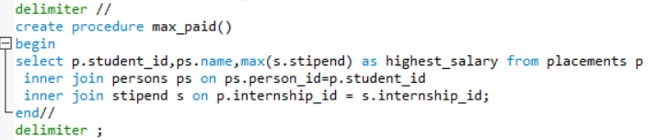

Calling the procedure:

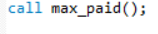

After implementation on the database:

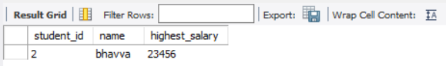

Scenario 2:
Procedure to find the supervisor list assigned to students.

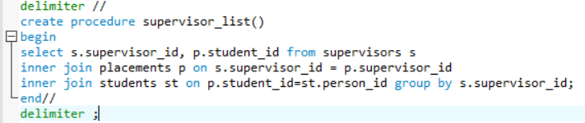

Calling the procedure:

After implementation on database:

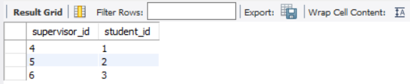

Views

- A view is a virtual table based on the result-set of an SQL statement.
- A view contains rows and columns, just like a real table. The fields in a view are fields from one or more real tables in the database.

Scenario 1:
Student with a Particular Skill matched to Placements requiring that particular skill
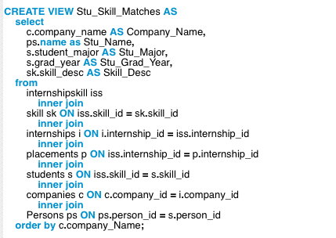

After Implementation
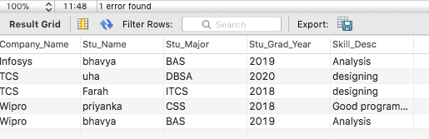

Scenario 2:
Internships associated with particular company

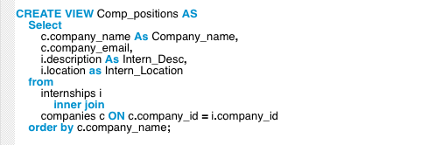

After Implementation

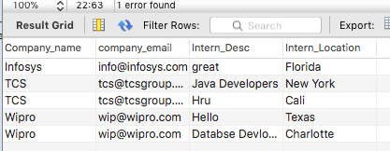

Scenario 3:
Placements associated with companies

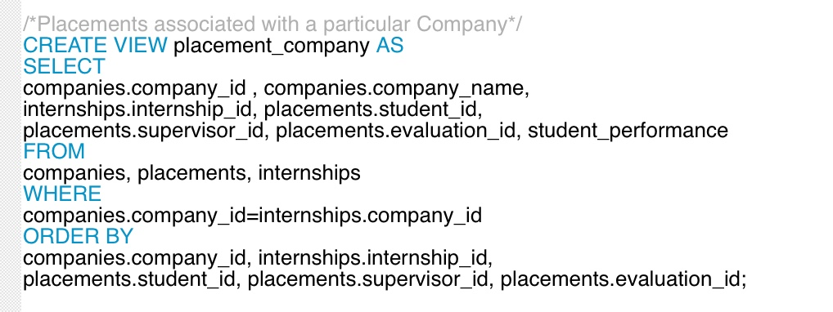

After Implementation
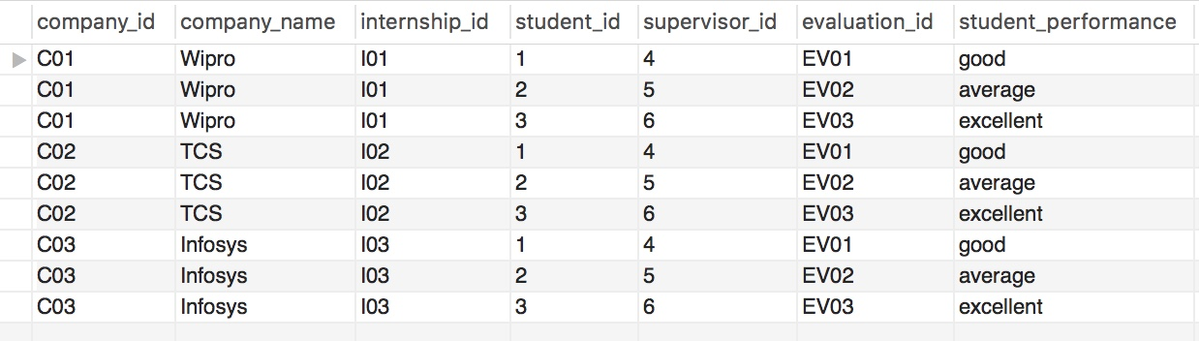

Scenario 4:
Students and the number of evaluation they get.
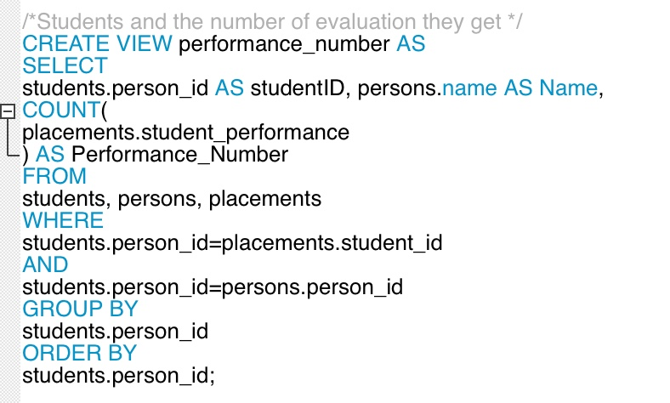
After Implementation
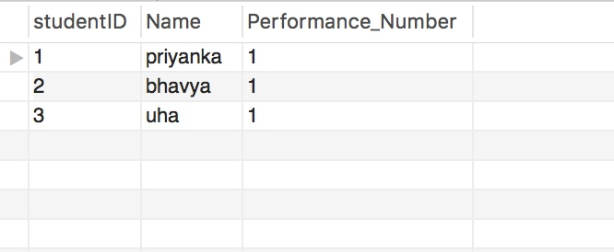

Scenario 5:
NO OF DAYS REMAINING IN THE INTERNSHIP PERIOD
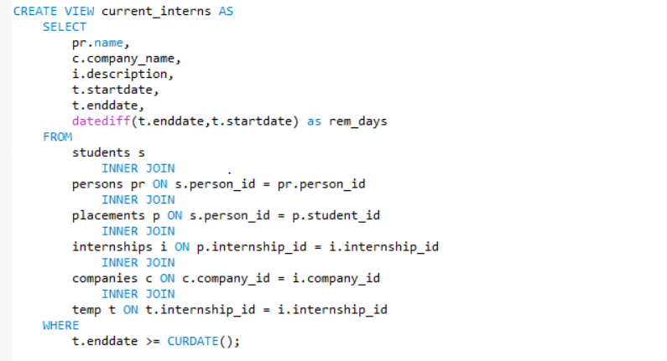
AFTER IMPLEMENTATION
Performance – Using Indexes

- The easiest way to achieve better performance is by using indexes without changing the schema.

- We have implemented an index on student_id to improve the actions performed on that column as it is one of the most frequently used column in our queries.

Scenario 1:
An index on student_ID column to improve the performance of the column.

Index Creation:

After implementation:

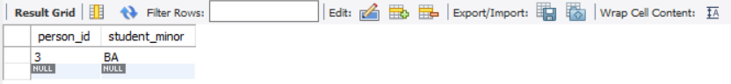

To identify whether a table is associated with an index or not, we use “SHOW INDEX” command.

After implementing this on the database

Scenario 2:

An index on placement_id.

Index creation:

After implementing and the below query on the database,

select student_id, note from placements group by supervisor_id;

we observe the following output results:

Student_id | Note
1 | IBM
2 | Virtusa
3 | TCS
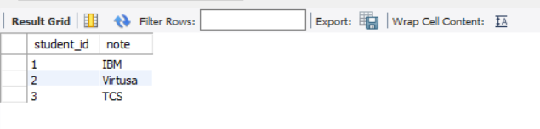

Data Dictionary:

Data dictionary is a file or set of files that contains database metadata. It usually describes about the objects present in the database i.e. ownership, tables, relationships, etc.

We have used dataedo tool to extract the data dictionary for our database.

When the database is loaded into the tool, we observe all the tables, views, procedures, indexes, etc associated in the database along with their relationships.

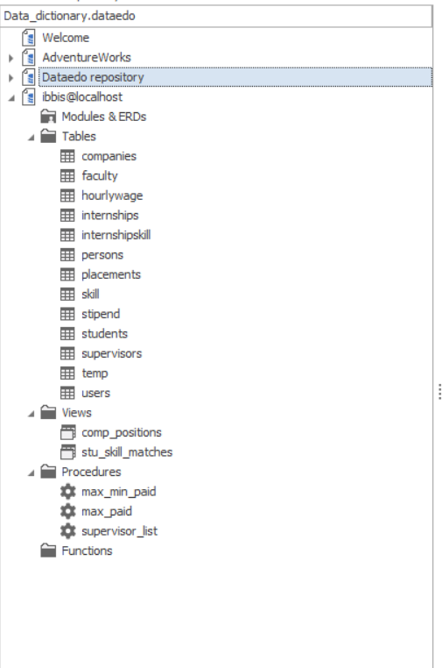
We can observe the relationships associated between each table, dependencies if any along with the keys associated.

For example:
When clicked on the companies table under tables tab in the tool, we observe the following.
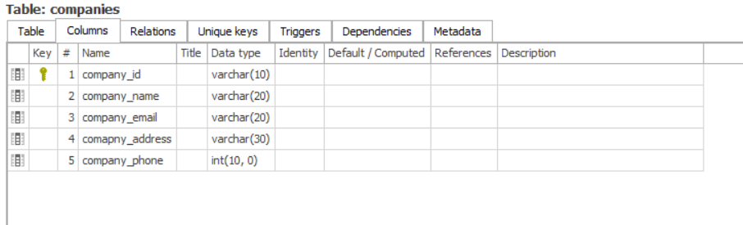

On clicking the relations tab in the companies table, we will be able to see all the other tables with which the companies table is associated.

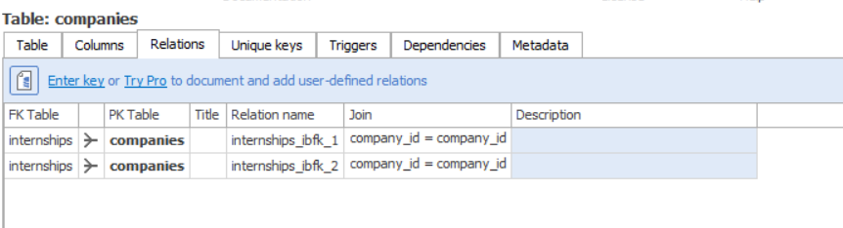

On clicking the “unique keys” tab, we observe the following.

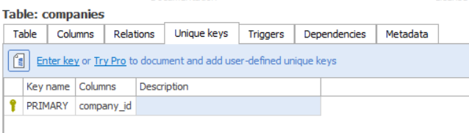

To find out all the view associated with the database, we click on the views tab that is available.

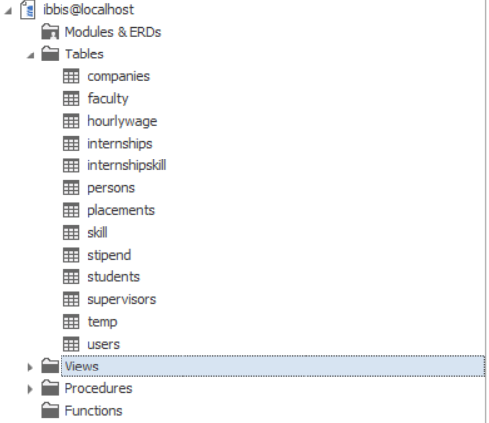

We also observe the following,

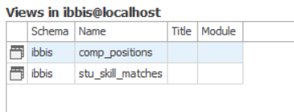

Similarly, with the procedures.

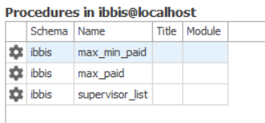

We will also be able to view the scripts of both “views” and “procedures” in the data dictionary.

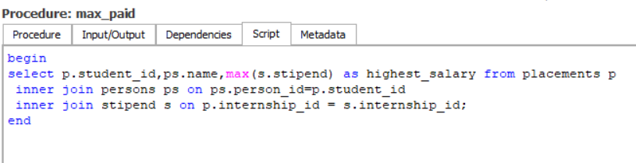
Apart from the viewing the script, the main purpose of the data dictionary is to understand the data of the database. This can be done by adding descriptions to the columns of the database tables.

For user understandability we describe the actual functionality of the columns of a table by mentioning the function in the description field available in the tool.

For example, consider companies table:
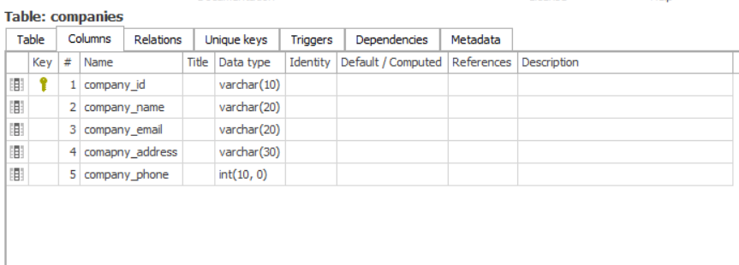

On giving description to each field of the companies table,

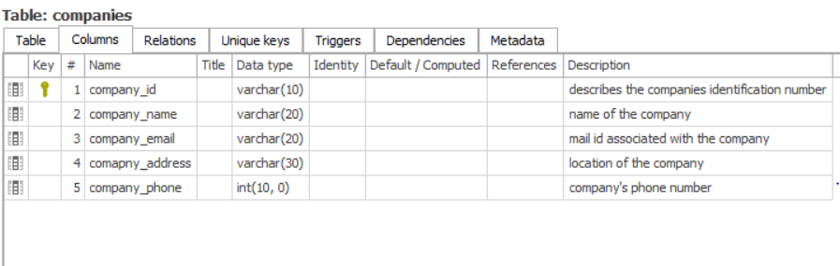

Similarly, we can do this for all the tables, views, procedures present in the database. This improves the understandability of the tables, views, procedures in the database.

One important feature of the dataedo tool is that we can save the data dictionary of a database in a pdf format.
Performance – Avoiding certain things

- INDEXING every column

- Placing more columns per index

- Usage of operators >, <, !=, BETWEEN, LIKE in WHERE clause

- Usage of “OR’s” in WHERE clause

Implementation


SQL Script.zip Source Code.zip

Future Scope

- Payment Gateway

- Mobile Application

- Email notifications

- Provide searching facility

Team Leaders and other positions

Harish Pendyala | Project Manager, SQL

Indraneel Bende | Project Co-Manager, PHP
Jerin Roy | Team Member, SQL
Febin Zachariah | Team Member, PHP
Neeraj Kumar Nittoori | Team Member, SQL
Ajaykumar Prathap | Team Member, HTML, CSS
Siva Rama Praneeth Vemula | Team Member, PHP

Contact Information for Members

Name | Mail ID | Phone Number
Harish Pendyala | hpendyal@uncc.edu | 425-213-0467
Indraneel Bende | ibende@uncc.edu | 980-318-3960
Jerin Roy | jroy10@uncc.edu | 704-957-9491
Febin Zachariah | fzachari@uncc.edu | 704-954-9990
Neeraj Kumar Nittoori | nnittor@uncc.edu | 980-422-4056
Ajaykumar Prathap | aprathap@uncc.edu | 704-906-4562
Siva Rama Praneeth | Svemula5@uncc.edu | 704-905-5223
Vemula

Method of Communication and File Sharing for Team

Method of Communication: WhatsApp

Method of File sharing: Google Drive, Email

Meeting Dates/Times

Every week Monday 2:00 – 6:00 pm at library

Project plan

Sr. No. | Project Activity | Date
1 | Create Project Part I | Oct 7th, 2016
1 | report | Oct 7th, 2016
2 | Create Project Part II | Oct 14th, 2016
2 | Report | Oct 14th, 2016
3 | Project Part III Report | Oct 28th, 2016
3 | and SQL Script File | Oct 28th, 2016
4 | Project Part IV GUI/Final | Dec 12th, 2016
 | Report

