Done & Reviewed By:

Chandra Mouli Basava

Anusha Samudrala

Tejaswi Yallualla

Siva Kiran Reddy Telluri

Kavya Kiran Kammaripalle

Aditya Thummala

Nikhil Mayukuntla

Hilary Mokolo

Vrunda Rana

Sameer Walunj

Manish Toutireddy

**Architecture diagram:**

**Version 1.1:**

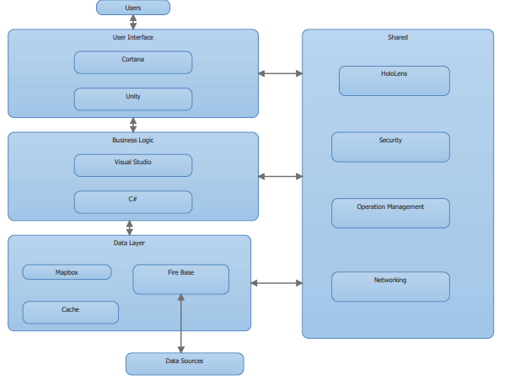

**Version 1.2:**

