Team#:

Team Project Title:

|  |  |  |  |  |
| --- | --- | --- | --- | --- |
|  | First Name | Last Name | CSUSM account ID | Contribution Percentage |
| 1 | Race |  |  |  |
| 2 | Janik |  |  |  |
| 3 | Bryce |  |  |  |
| 4 |  |  |  |  |
| 5 |  |  |  |  |

**Grading Rubrics (for instructor only):**

|  |  |  |  |  |
| --- | --- | --- | --- | --- |
| Criteria | 1. Beginning | 2. Developing | 3. Proficient | 4. Exemplary |
| Use Case Diagram | 0-16 | 16-26 | 27-34 | 35-40 |
| many use cases and relations are not correct | many use cases or relations are not correct | A few use cases or relations are not correct | Diagram is complete, all relations are correct |
| Summary level use case description table | 0-5 | 6-9 | 10-14 | 15-20 |
| Missing important elements | Information provided is insufficient | Some minor issues | Information provided is sufficient and appropriate |
| Use case description tables for primary task use cases | 0-16 | 16-26 | 27-34 | 35-40 |
| Missing important elements | Information provided is insufficient | Some minor issues | Information provided is sufficient and appropriate |
| Total Grade (100) |  | | | |

**Problems:**

Each team works together on use cases for your course project.

Your submission should include:

* A UML use case diagram
* The use case description table of at least one use case at the summary level
* The use case description table of multiple use cases at the primary level
* The use case description table of use cases at the sub-function level, if applicable

You should start each use case description table in a new page

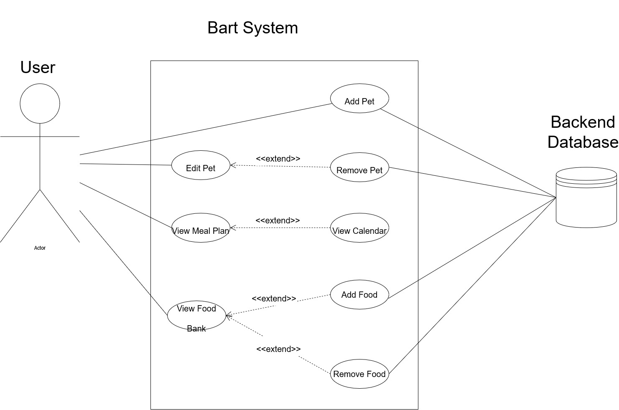

|  |  |  |
| --- | --- | --- |
| Project Name | Bartagamen | |
| Use Case ID | BART_UC-001 | |
| Use Case Name | User – View Meal Plan | |
| User Goal | A user accesses and interacts with Bart while assembling their meal plan | |
| Scope | Bart System | |
| Level | Summary | |
| Primary Actor | User accessing the system | |
| Precondition | A user has already added their pet to the list. A user has already updated their food bank | |
| Minimal Guarantee | The user will be able to open the home page. | |
| Success Guarantee | The user will be able to see their daily meal plan. | |
| Trigger | The user selects a pet from their list. | |
| Success Scenario | Step | Action |
|  | 1. | User selects Bartagamen Mobile Application on their smart phone |
|  | 2. | System loads info from Backend Database |
|  | 3. | System updates daily meal plan for all pets based on Database info. |
|  | 4. | System displays Home Screen |
|  | 5. | User selects a pet from their pet list |
|  | 6. | System displays individual meal plan for the selected pet |
| Extensions | Branch Scenarios | |
| 4a, 5a, 6a | User selects Home Screen from the navigation bar | |

|  |  |  |
| --- | --- | --- |
| Project Name | Bartagamen | |
| Use Case ID | BART_UC-001 | |
| Use Case Name | User – Add Pet | |
| User Goal | A user accesses and interacts with Bart to add a new pet to their pet list | |
| Scope | Bart System | |
| Level | Primary | |
| Primary Actor | User accessing the system | |
| Precondition | N/A | |
| Minimal Guarantee | The user will be able to open the home page. | |
| Success Guarantee | The user will be able to add their new pet to the pet list | |
| Trigger | The user selects Add Pet option on the pet list | |
| Success Scenario | Step | Action |
|  | 1. | User selects *Add Pet* option from the pet list |
|  | 2. | System displays new pet form |
|  | 3. | User enters pet name, size, date of birth |
|  | 4. | User selects *Save Pet* |
|  | 5. | System updates *Database* with new pet info |
|  | 6. | System displays *Home Screen* |
| Extensions | Branch Scenarios | |
| 4a, 5a, 6a | User selects *Home Screen* from the navigation bar | |
| 2a, 3a | User selects *Cancel* option | |

|  |  |  |
| --- | --- | --- |
| Project Name | Bartagamen | |
| Use Case ID | BART_UC-001 | |
| Use Case Name | User – Remove Pet | |
| User Goal | A user accesses and interacts with Bart to remove a Pet from the list | |
| Scope | Bart System | |
| Level | Sub-function | |
| Primary Actor | User accessing the system | |
| Precondition | A user has already added their pet to the list | |
| Minimal Guarantee | The user will be able to open the home page. | |
| Success Guarantee | The user will be able to remove a pet from their list. | |
| Trigger | The user selects *Remove* option on the *Edit Pet Screen*. | |
| Success Scenario | Step | Action |
|  | 1. | User selects a Pet from their *Pet List* |
|  | 2. | System displays *Individual Pet Screen* |
|  | 3. | User selects *Edit* option on *Individual Pet Screen* |
|  | 4. | System displays *Edit Pet Screen* |
|  | 5. | User selects *Remove* option on the *Edit Pet Screen* |
|  | 6. | System displays *Home Screen* |
| Extensions | Branch Scenarios | |
| 4a, 5a, 6a | User selects Home Screen from the navigation bar | |