Student Name | CSUSM account | Contribution Percentage
Bryce Tuller | Tulle003 | 33
Janik Wolf | Wolf038 | 33
Race Bays | Bays001 | 33

Tasks
- If you have not done so, your team should create a GitHub project for every team member, including the instructor (Simon-CSU)
- Teams that work on the same project should meet and discuss about must-have and nice-to-have features, and potential collaborations (if you anticipate that the system should be decomposed into several components or subsystems).
- Each team should work together to identify work items for your Product Backlog. Remember the DEEP principle: the backlog is not supposed to be complete at this point and you may only have a few described in detail. Pick 3 from the Product Backlog, and use one of the two user story templates we learned in class to describe the work items. You may also start to estimate story points for each user story.
- You should start to use your committed time on the project to code, or prototype/learn skills needed in your project.

Problem 1: In this lab report, paste your response to Task 3 below.

- As a user, I want AI to decide my pets’ daily meal plan so that I don’t have to think about it.
- As a user, I want the app to tell what day it is, so that I don’t have to tap extra buttons.
- As a user, I want the calendar to auto-update so that I don’t have to manually.

Problem 2: Java Programming (you may practice Pair Programming while working on this lab exercise). In the last Lab we have practiced drawing bar chart using Java Graphics API.
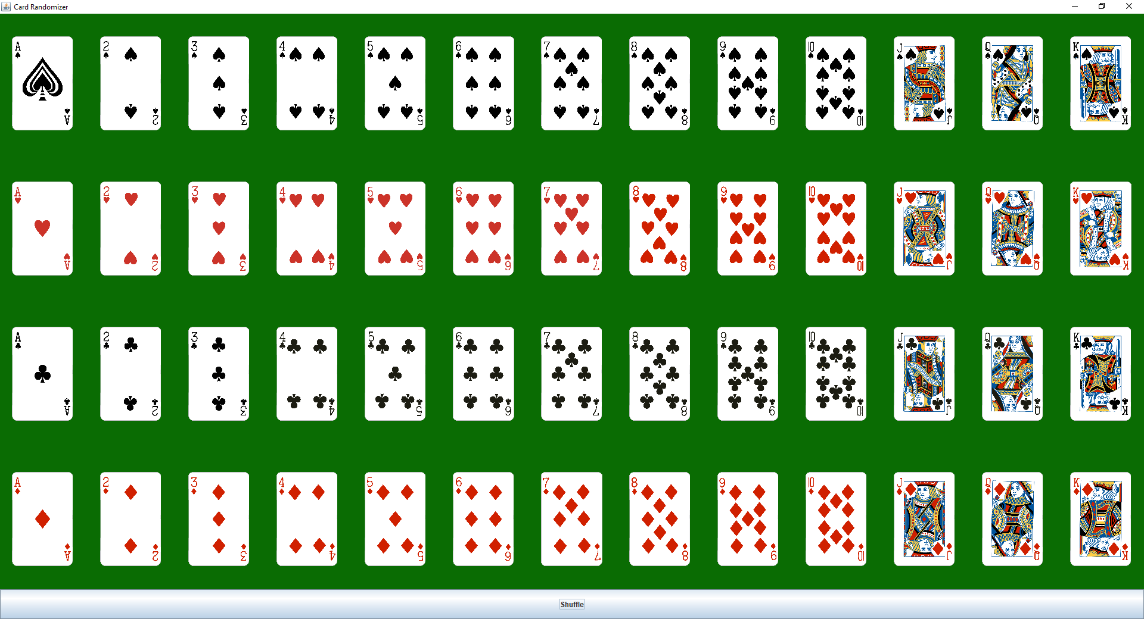
This time we will learn displaying images using javax.swing.ImageIcon. You need to display a lot of images on the GUI. First you need to manually download all poker card images from some sources.
- Since this time the program will use resources like images, you should create a folder named “cards” within your project folder (the “src” folder and the “cards” folder should have the same parent folder).
- You should display all the poker card images on the main GUI, and a button at the bottom. Every time the button is clicked, the poker cards should be shuffled and redisplayed. Use your creativity to implement your GUI.

Solution:
- First, remember to zip the src folder of your project and the image folder containing all card images, and submit the zip file to the ungraded assignment named “Lab3CodeSubmission”. One submission from each team.
- Paste all you source code here (for grading and comments).
- Paste a screenshot of your system running.
- Save this report in PDF, then each team submit your pdf report to the graded assignment named “Lab3ReportSubmission”. One submission from each team.

