Hocus Locus Backend
Database & DB_Manager

Hocus Locus backend is made up of 2 parts. The first is an array of MySQL databases. There is a root database called 'hlroot', which stores information about all the other databases in the system. It holds the list of species + assembly databases ("spass" DBs for short) that are available, as well as other global information - such as table type enumerations, descriptions, etc. Each spass database contains a special table which describes what annotation sets are available for that particular database - for example RefSeq, Genbank, CCDS, etc. Each of these annotation tables is designated as a certain "table type", which allows for homogenous types to utilize shared logic. The basis for the annotation tables is derived from UCSC's schema (any data sets downloaded from them will remain unchanged), however any other data set can be added to a spass as long as it is coordinate based data.
In addition to annotation data which remains unchanged from the UCSC format, each spass database may also contain whole-genome descriptive data - such as genomic sequence, and phastCons scores. These tables are structured in a proprietary format which allows for maximum efficiency of retrieval.

The second part of the Hocus Locus backend is an interface layer called the HLDBManager (Hocus Locus DataBase Manager). The HLDBManager is implemented as a Java class which can be instantiated by any module in the system. All data lookups are accomplished via this interface. HLDBManager presents many functions that can be carried out on the data such as ID lookups, sequence retrieval, and more.

The following illustrates an average client interaction with HLDBManager:
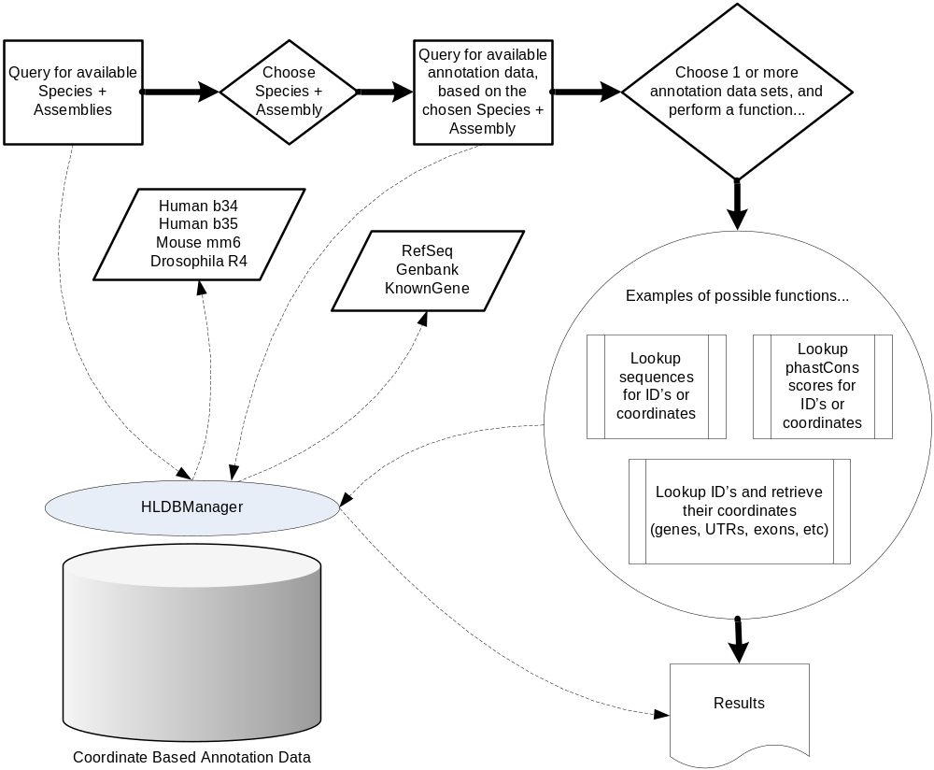

The HLDBManager uses BioJava data structures, as well as a special set of descriptors to communicate genomic data. These descriptors are a way to format and organize the information in a meaningful way. A client using HLDBManager must be able to understand BioJava data structures as well as the descriptors. There are currently only a small number of descriptors defined, and more can be added as needed:
Sequence Set - Holds all the data for a given annotation ID. E.g. if "NM_12345" was queried, the sequence set can hold each record that was returned from the database (for example, multiple records could indicate multiple isoforms). Each record would contain coordinates (transcription start/end, possible exons, possible UTR/CDS regions, etc.), as well as possibly containing the nucleotide sequence and additional annotation info about the item. Programmatically, a Sequence Set is simple an array of BioJava "Sequence" objects.
Database Descriptor - Holds 'spass' database information such as the literal string which defines the name of the database, a 'friendly' name for the database, and a description of the database.
Table Descriptor - Holds the annotation table information such as the literal string which defines the name of the table, a 'friendly' name for the table, a description, a date stamp, etc.

The Hocus Locus backend database can be described as self-annotated - it can dynamically tell the client what data is available to be queried.
Example:
- which species are currently available
- for each species which assemblies are available
- for each assembly what annotation data is available
- etc.
This also allows the Hocus Locus annotation to grow dynamically and any new species/assembly/annotation data can be "plugged in" on the fly.

Hocus Locus Database ERD:

