EEL 3801 Final Dr. Fernando Gonzalez Summer 2005

NAME Christian Vazquez

1. (20% Short questions)

Declare a 2 dimensional array (10 X 15) of pointers to doubles called aapd.

double *aapd[10][15];

Declare an array of 5 elements of pointers to class Person called app.

Person *app[5];

What is polymorphism and what can it do for you?

Polymorphism allows for you to create multiple objects and essentially put them within one main parent field. For example, an array of class Animals can contain objects that are declared as other classes, I.E. Birds, dogs, and cats. Using polymorphism, I can create one function that shows the sound each animal makes, and call it within each of the child classes respectively.

What is the difference between the two declarations?
void Bill (int *x);
void Bill (int &x);

The first line passes in the pointer, whereas the second line passes in the address of x, or in other word, whatever is stored at that location.

What is the difference between a friend function and a member function?
A friend function can have access to anything that is previously declared as public, private, or protected. The access modifier is essentially overwritten. The member function only has permission to access whatever values are public or within the same function.
2. (20% Inheritance and polymorphism ) indicate to the right of each executable statement if the statement will generate an error. Enter error or OK in the space provided. Note many errors are produced by access violation (accessing a member of a class that is not accessible from the location of the statement). The printf statements deal with inheritance. Pay close attention to the inheritance rules when evaluating the printf statements. The statements that are not printf deal with polymorphism. Pay close attention to the type of pointer and the inheritance structure. The code continues on the next page.

class One
{
private:
int a;
protected:
int b;
public:
int c;
void One_function( );
};

class Two: private One
{
private:
int d;
public:
int e;
void Two_function( )
{
printf(" %d\n",a); Not OK
printf(" %d\n",b); OK
printf(" %d\n",c); OK printf(" %d\n",d); OK
}
};

class Three: public Two
{
public:
void Three_function( )
{
printf(" %d\n",a); Not OK
printf(" %d\n",b); Not OK
printf(" %d\n",c); OK printf(" %d\n",d); Not OK
printf(" %d\n",e); OK
}
};
void main()
{
One One_obj;
Two Two_obj, *p2;
Three Three_obj;

printf(" %d\n",One_obj.a); OK error
printf(" %d\n",One_obj.b); OK error
printf(" %d\n",One_obj.c); OK
printf(" %d\n",One_obj.d); not OK undef
printf(" %d\n",One_obj.e); not OK undef

printf(" %d\n",Two_obj.a); not OK
printf(" %d\n",Two_obj.b); OK error
printf(" %d\n",Two_obj.c); OK error
printf(" %d\n",Two_obj.d); OK error
printf(" %d\n",Two_obj.e); OK

printf(" %d\n",Three_obj.a); not OK
printf(" %d\n",Three_obj.b); not OK
printf(" %d\n",Three_obj.c); OK error
printf(" %d\n",Three_obj.d); not OK
printf(" %d\n",Three_obj.e); OK

p2 = &Two_obj; OK
p2->One_function( ); not OK error
p2->Two_function( ); OK
p2->Three_function( ); OK undef

p2 = &One_obj; not OK
p2 = &Two_obj; OK
p2 = &Three_obj; OK
}
3. (20% Scope, program walk-through, default parameters and function overloading). On the right side show what is the output of this program. Note, do not over look the default parameter or the functional overloading.

int a = 10, b = 20, c = 30,d = 40;

void bill (int b, int c);

void bill(int x, int y) Output C 37 3 31 42
{
int b = 100;
a++;
b++;
c++;
d++;
x++;
y++;
prinf(“ A %d, %d, %d, %d, %d, %d \n”, a, b, c, d, x, y);
}

void bill(int a, double b)
{
int c = 200;
a++;
b++;
c++;
d++;
prinf(“ B %d, %lf, %d \n”, a, b, c);
}

void main( )
{
int a = 37;
double b = 3;
bill (3, a);
bill (3, b);
printf(" C %d, %lf, %d, %d \n", a, b, c, d);
}

global bill(int,int) bill(int,double) main
a b c d b x y a b c a b
10 20 30 40 100 3 37 3 3 200 37 3
11 31 41 101 4 38 4 4 201
42
4. (20% Pointers and Arrays) On the right side show what is the output of this program.

main( )  {  int a[5][4],b[7],*p;  b[1] = 1;  p = b + 1;  p[2] = 2;  *(p++) = 3;  p = b;  (*p) = 4;  *(b + 6) = 5;  a[1][3] = 1;  p = a + 9;  *(p+3) = 2;  p = &(a[4][3]);  *p = 3;  *(a + 11) = 4;  *(a + 3 * 4 + 2) = 5; | 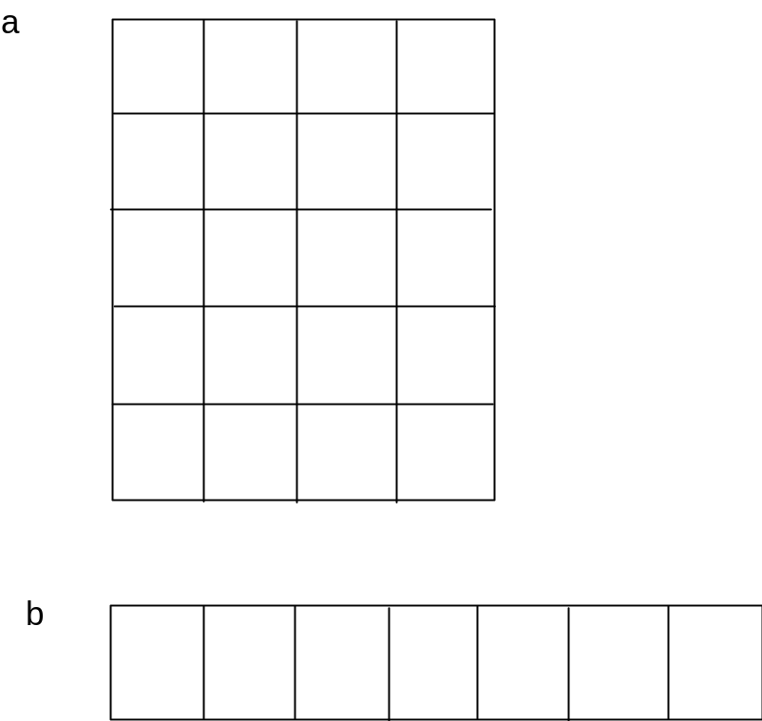

A[1][3] = 1;
A[2][3] = 4;
A[2][0] = 2 (p+3);
A[2][2] = 5;
A[4][3] = p, 3;

B[0] = 4, P
B[1] = 3
B[3] = 2
B[6] = 5

Could not draw on word document

5. (Classes 20 %)
Declare a class called Machine that holds as private the type of the machine as an integer called Type, the horsepower called Power, and a pointer to a character called Name. Include a constructor that allocates an array of n characters dynamically and stores its pointer in Name where n is an argument passed to the function. Add a function called display() to display all of the data. Finally add a destructor that returns the dynamically allocated string to the operating system. Write the code for the member functions. Next create a class called DiggingMachine that inherits class Machine as public. Add a double that holds the digging capacity called Capacity. Add a member function to display all of the data in this class and calls the display function in the parent class Machine. Finally add a constructor that initializes the capacity to a value passed as an argument and calls the parent’s class constructor.

class machine
{
private:
int Type;
int Power;
char *name;
public:
machine(int n)
{
name = new char[n];
}
void display()
{
printf(“%d, %d, %s”, Type, Power, name);
}
~machine()
{
delete name;
}
};
class diggingMachine : public machine
{
private:
double capacity;
public:
diggingMachine(int n, double c) : machine(n)
{
capacity = c;
}
void display()
{
machine::display();
printf(“%d\n”, Capacity);
}
};

